高雄縣縣立林園高中國中部九十五學年度第一學期第三次段考二年級英語科試題卷
一、聽力測驗
Part A 將你聽到的字之代號，填入卡中。
1 (A)Apple (B)shows (C)be (D) May
2. (A)Christ (B)in (C)December (D)fourteenth
3. (A) In (B)June (C)the thirty (D)Saturday
4. (A)They’re (B)stores (C) summer (D)Tainan
5. (A)Taiwan (B)cost (C)in (D)October or September
Part B. Pictures
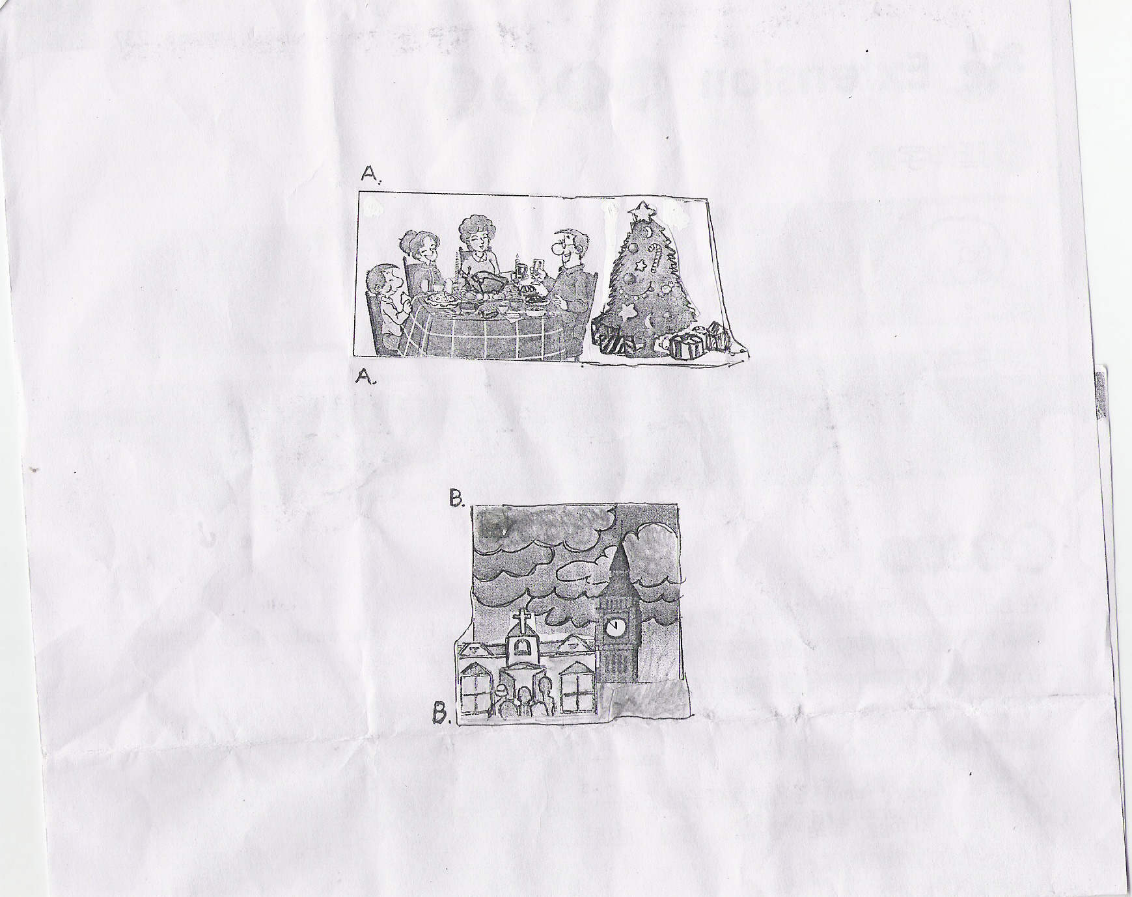
6.
7.
8.
9 .
10.

Part C. Short Conversations

11.(A)Cool weather (B)Sunny days (C)Snowy days (D)Showers
12. (A)March (B)May (C) July (D)November
13. (A)By bus (B)Walk (C)By train (D)Drive a car
14.(A) He has to work. (B) He has to take a trip. (C) He has to play ball. (D) He has to sing songs.
15. (A) Summer (B)Spring (C)Fall (D) Winter
二、字彙測驗：根據文意，選出最適當之答案代號，並劃入在答案卡上。
16.A: What time did you ? B: I got here at 3 p.m.
(A) away (B) have (C) ask (D) arrive
17. A: You should get some before tomorrow's test. Go to bed early tonight. B: Yes, mom.
(A) party (B) water (C) rest (D) money
18.There isn’t a 30th day in . There are usually only 28 or 29 days.
(A) February (B) March (C) January (D) August
19. A:I don’t know the way to the library. Can you me? B: Ok. Let me see.
(A) start (B) jog (C) show (D) invite
20. The weather was nice yesterday, so I went to the with my friends and swam there.
(A) bench (B) beach (C) back (D) breakfast
- Joe really wants to do well on today’s test, so last night he studied 3 a.m.
(A) for (B) until (C) away (D) with
22.Don’t Grandma when she’s sleeping.
(A) receive (B) play (C) disturb (D) bring
- Is your father going on ________?
(A) special (B) summer (C) business (D) kind
- There are two _______ in a school year in the junior high school in Taiwan.
(A) months (B) summers (C)semesters (D) hours
- A: What happened to you? B: I hurt my ____ when I was playing basketball last Friday.
(A)weather (B) vacation (C) mile (D) knee
二、翻譯：根據中文語意，選出最正確的英文句
26. 水很重要，所以我們非常需要雨水。
(A)Water is very important. So we need raining very much.
(B)The water is very important, so we very much need the rainy.
(C)The water is very interesting, so we very need the rainy water.
(D) Water is very important for us, so we need rain very much.
27..不要只知道尋歡作樂而忘記了這一天的意義。
(A) Don’t just look for fun, and forget the meaning of the day.
(B)Don’t just look fun, and do remember the day means.
(C)Just find out the fun, and don’t remember what the day means to you.
(D)They just find out the fun, but forget the meaning of the day.
28.這個寒假你將做什麼?
(A)What are you do this winter vacation?
(B)What will you do on this coming vacation?
(C) What are you going to do this coming winter vacation?
(D)What are you doing in summer vacation?
29.很多小孩子相信耶誕老公公帶禮物給他們。
(A) Many child believes that Santa Claus will bring gifts for them.
(B) Many childs believe the Santa Claus is gong to give them the presents.
(C) Many children believe Santa Claus will buy the presents for them.
(D)Many children believe Santa Claus will bring gifts for them.
30 .臺灣和澳洲的天氣是不同的。
(A)The weathers in Taiwan and in Australia are different.
(B) Taiwan weather is different to Australia.
(C)The weather in Taiwan and in Australia are different.
(D)Taiwanese weather is not same as Australian.

三. 閱讀測驗：
A.
Christmas is the birthday of Jesus Christ. Many people in the world celebrate it. People send Christmas cards before Christmas. Through the cards, they send their greetings to show their love for their friends and family. On Christmas Eve, people sometimes have their Christmas trees at home and they always have big dinners with Christmas puddings and cakes. It's also a time for family reunion. Family members always have fun together. On the morning after Christmas, the British usually put a little money or gifts in small boxes and give them to their servants. So they call it Boxing Day. We can say Christmas is a day of peace and friendship.
 through 透過 greeting 問候；賀詞 pudding 布丁 members 成員 British 英國人 servant 僕人
31. When is the Boxing Day?
(A) December 23.
(B) December 24.
(C) December 25.
(D) December 26.
32.What's the meaning of Christmas?
(A) It's a day for fun.
(B) It's a day for family.
(C) It's a day for dogs.
(D) It's a day of peace and friendship.

B.
Allen: Is that rain I feel?
Amy: Yes, but …it’s meant to be 29℃ today!
Allen: Yeah, I know. I heard the weather forecast this morning, but I just can’t remember if it said showers or not.
Amy: I think it said summer showers in the morning, then turning fine in the afternoon.
Allen: Yes, well, we will just have to wait and see whether that turns out to be true or not.
Amy: You never can tell.
Allen: Well, I hope it’s true. We are going to play tennis this afternoon, right?
Amy: Not if the summer showers decide to stay for the day. Then we are staying home
forecast預報
33. How is the weather now?
(A)It’s cold. (B)It is hot . (C)It is snowy. (D)It’s foggy..

C.
We are having the craziest weather over here in Melbourne, Australia. There are only a few weeks left until we hit summer. We are all expecting temperatures in the thirties so that we can go to the beach all day and sunbathe. But this week the weather took a turn for the worse. First it started with a light drizzle. Then came the howling winds. Then came the downpour of rain that lasted for two days, and the hail in the city and the snow in the mountains! Everyone was looking so confused and scratching their heads. Even the weatherman, who usually has all the answers, said that the weather was crazy! Everyone was getting worried, too. Would Australia have a rainy Christmas? The weather, however, has decided to confuse us again. Right now it is boiling hot and beautiful beach weather, but in Melbourne who knows how long that will last?
Crazy瘋狂 expect希望 temperature溫度 sunbathe日光浴 worse更糟 drizzle毛毛雨
Howling狂風 downpour 傾盆大雨 hail靄 confused迷惑 boiling熱的 according to 根據
34. According to the reading, what month is it now?
(A)July (B)December (C)August (D)September
35.What does “scratching their heads” in line 6 mean?
It means people(A)don’t know what will happen. (B)will be very happy. (C) do exercise. (D)will see with their eyes.
D.
Taiwan-born New York Yankees pitcher Wang Chien-ming gave $5,000 to an office that helps the poor. If you like to play baseball, you may know him well. If you are not a baseball fan, it’s OK. Now let me tell you something about him. His birth date was on March 31,1980. When he was in the fourth grade, he started to play baseball. His coach thought he was an excellent baseball player so he made him practice it very hard. After he went to college, he still did his best to practice playing baseball. In 2005, he joined The New York Yankees. At first, his English was not good so he didn’t play well. His teammates thought he was quiet. After one year, he was one of the best pitchers on his team. I am sure he will be the best soon.
Born出生 pitcher投手 teammate隊員 best最好的
36.How old was Wang Chien-ming when he joined the Yankees?
(A)20 (B)35 (C)25 (D)18
37.When did Wang start playing baseball?
(A)In 1980 (B)In his elementary school days (C)In college days (D)In his ninth grade

.
Peter: I can't believe it! Christmas is not a holiday in Taiwan.
Sam: No, it's not, but it was.
Peter: That's too bad.
Sam: How did you celebrate it before?
Peter: Well, the weather was very cold in winter in my hometown. On Christmas Day, I always played in the snow with my parents. We would also receive some presents from Santa Claus.
Sam: Wow! I envy you. A white Christmas is beautiful.
38. Which is true?
(A) Christmas is a holiday in Taiwan.
(B) Everyone goes to church on Christmas.
(C) Christmas was a holiday in Taiwan before.
(D) Everyone celebrates Christmas.
39. How was the weather in winter in Peter’s hometown?
(A) It rained a lot.
(B) It was a cloudy day.
(C) It was sunny.
(D) There was a lot of snow.

F.
The Dragon Boat Festival is an important holiday to Chinese people. We celebrate it on the fifth day of the fifth lunar month. This day has a story behind it. It is about a man. He died in the river for telling people how true he was. People were afraid fish would eat him. They put food in the river to feed the fish so they wouldn’t eat him. Now, we use sticky rice to remember him.
Dragon Boat Festival 端午節 lunar 農曆的 river 河 for 為了 sticky rice 糯米

40. What’s the best title for this story? the best title 最好的標題
(A) The Sticky rice.
(B) The Story of the Dragon Boat Festival.
(C) The Fish and The Man.
(D) How to Feed Fish in The River.
41. What does “It” in line 3 mean?
(A) The fifth lunar month.
(B) The name of the poet.
(C) The story of the festival.
(D) The boat and sticky rice.

G.
Radio: You're listening to ICRT. Today is Thursday, January 24th . It's cloudy here in Taipei. The temperature is 18℃. It may rain in the afternoon, so don't forget to bring your umbrella with you when you go out. Have a wonderful day!
Radio 收音機
42. What day is January 25th ?
(A) Monday. (B) Wednesday.
(C) Friday. (D) Saturday.
43. Which is true about the weather in Taipei today?
(A) It is snowing today.
(B) There is no cloud in the sky.
(C) The weather is sunny and hot.
(D) It’s cool or even cold.
44. Tina wants to visit her friend, Helen, at about 4: 00 p.m. in the afternoon. What should she take with her?
(A) A present. (B) Some fruit.
(C) An umbrella. (D) A radio.
H.
Jacob: Are you going to Gary’s party tonight?
Helen: Maybe not. Are you?
Jacob: Of course. It will be fun. What’s your plan?
Helen: I’m going to visit a friend in a hospital with Mark. And we are going to a French restaurant for dinner. What time will the party start?
Jacob: Gary said we could go at 9 o’clock.
Helen: So late?
Jacob: Yeah, Gary will have dinner with his high school classmates before that. They’re going to celebrate his birthday, too.
Helen: I see. I think we can join you after 9: 30.
plan 計畫 hospital 醫院
45. Is Jacob going to the party?
(A) Yes, he is.
(B) Yes, but tomorrow.
(C) No, he’s having dinner with Gary.
(D) No, he’s going to the party at 9: 30.
46. Where is Helen going with Mark?
(A) A farm.
(B) A hospital.
(C) A class reunion.
(D) A museum.
47. What’s the party for?
(A) To see Gary.
(B) To have a dinner with Gary.
(C) To celebrate Gary’s birthday.
(D) To welcome Gary.

I.
Super Winter Language Camp
Date: January 29th —February 9th
Time: 8: 05 a.m.～4: 45 p.m.
Place: Seaside Language School, Linyuan
We have all kinds of fun language programs for you.
You’ll have the best teachers in town and make many new friends.
This is the best chance in your life to improve your language skills!
super 超級 program 課程 chance 機會 improve 增進 skill 技巧
48. What’s this poster about? poster 海報
(A) Finding teachers.
(B). Having a party.
(C) Making new friends.
(D) A language learning camp
49. When will the camp start?
(A) In the fall.
(B) In the winter
(C) In 2001
(D) In the summer.

K.
New Year’s Eve Dance Party 2007
All are welcome!
Date: December 31, 2006 Time: 11: 00 p.m.
Place: City Gym
Join this coming New Year’s Eve Dance Party. Come and have a lot of fun. We have many wonderful singers here. Let’s sing and dance together. Come and enjoy the final count down of the coming new year at midnight!! You can also get a secret present.
join 參加 gym 體育館 secret 神秘的
50. What is true about the reading?
(A) The party is for Christmas.
(B) The party is at the end of the year. .
(C) There will be a lot of games there.
(D) The people are going to get much lucky money there.

