高雄縣立林園高中國中部 九十五學年度 一年級下 英語 科第二次段考
英語科範圍：L3 P40~L6 年 班 號 姓名：
壹.聽力測驗（30%）
一、單字題型 (5題，共10分)
依據錄音內容，完成以下的填空。
Lucy has (1) and (2) classes today.
Does he (3) his (4) every night?
When do you have (5) (6) class?
Ms. Lee is our (7) teacher.
Amy’s cousin is (8) today.

二、答句題型 (一題，共10分)
依據錄音內容，選出適當的答句。
（ ）(１)(Ａ) He has math class today. (Ｂ) She likes milk tea.
(Ｃ) No, she doesn’t like milk tea (Ｄ) He doesn’t like hot dogs.
（ ）(２)(Ａ) He is cooking fried rice. (Ｂ) She is making pizza.
(Ｃ) She gets up at 6:30. (Ｄ) Aunt Lucy is making apple pie.
（ ）(３)(Ａ) Yes, I want some orange juice.(Ｂ) No, I want some apple juice.
(Ｃ) Yes, I want some egg soup. (Ｄ) No, I don’t want any apple juice.
（ ）(４)(Ａ) She likes pizza. (Ｂ) No, he doesn’t like fried rice.
(Ｃ) He likes pork noodles. (Ｄ) Yes, he likes pork noodles.
（ ）(５)(Ａ) I am on a diet. (Ｂ) No, I can’t.
(Ｃ) I like apple juice. (Ｄ) No, I don’t like milk tea.

三、圖片題型 (一題，共10分)
為相符的圖片寫上正確的題號。
貳.紙筆測驗（70%）
二、字彙測驗(一題，共10分)
1.___________ A: Is e_______g OK? B: Sure, no problem.
2.___________ She can cook noodles and d_________gs.
3.___________ A: How much money do we need? B: One t__________d dollars.
4.___________ Mr. Lee is our new s________e teacher this school year.
5.___________ Dream mall(夢時代) has the largest(最大) s__________t in Asia(亞洲).
二、文法選擇 (十題，共20分)
（ ）A: Let’s go ___ a picnic. B: Sure, but what can we eat the picnic?(Ａ)on; on (Ｂ)in; with (Ｃ)on; at(Ｄ)to; about
（ ）A: What is _____now? B: It’s six ten. (Ａ) time; its (Ｂ) month; it (Ｃ) time; it (Ｄ) year; it
（ ）Mary has lunch at twelve __________. (Ａ) on morning (Ｂ) every mornings (Ｃ) on mornings (Ｄ) any mornings
（ ）A: _____ do we need ______the picnic? B: We need paper plates and paper cups.
(Ａ) Why ; at (Ｂ) Which ; for (Ｃ) Who ; at (Ｄ) What ; for
（ ）She’s a baby. (Ａ) month old (Ｂ) two-month-old (Ｃ) three months old (Ｄ) four months
6. ( ) Look ___ sweet face. How cute! (Ａ) to her (Ｂ) at she (Ｃ) at her (Ｄ) in her
（ ）Mary goes to the game two o’clock the afternoon. (Ａ) in; in (Ｂ) at; in (Ｃ) in; at (Ｄ) at; on
（ ）A: do you have PE class? B: _____ Monday mornings.
(Ａ) Where; At (Ｂ) Why; On (Ｃ) What; Every (Ｄ) When; On
（ ）Oh, no! My little brother . He must be (一定是) hungry.
(Ａ) cries (Ｂ) doesn’t cry (Ｃ) is crying (Ｄ) don’t cry
（ ）Lisa wants . (Ａ) tomatos soups (Ｂ) tomatos soup (Ｃ) tomatoes soup (Ｄ) tomato soup

三、對話 (5題，共10分)
（ ）A: Excuse me. Do you have the time? B:
(Ａ) Be quiet.
(Ｂ) Yes, it’s 4:18.
(Ｃ) No, thanks.
(Ｄ) No, I have a computer class.
2.（ ）A: How old is that cat? B:
(Ａ) It is old, not new. (Ｂ) It is two years old.
(Ｃ) The old cat is crying. (Ｄ) The old cat bites.
3.（ ）A: B: On mornings and nights.
(Ａ) What time do you go to bed?
(Ｂ) What days do you go to school?
(Ｃ) When do you brush your teeth?
(Ｄ) Do you get up in the morning and go to bed at night?
4.（ ）A: B: I’m going to the show.
(Ａ) What time is the show?
(Ｂ) Where are your brother and sister?
(Ｃ) When do you go to the show?
(Ｄ) Where are you going?
5.（ ）A: _______ B: It’s five dollars.
(A) How much is a lemon?
(Ｂ) How many apples do you need?
(Ｃ) How much are the tomatoes?
(Ｄ) How many apple pies are there?

四、閱讀測驗 (每題2分,共20分)

This is Yvonne’s morning schedule. Read and answer the questions.
（ ）(１) What day does Yvonne have not English class?
(Ａ) On Monday. (Ｂ) On Tuesday. (Ｃ) On Thursday. (Ｄ) On Friday.
（ ）(２)Yvonne plays basketball in class on .
(Ａ) Tuesday (Ｂ) Thursday (Ｃ) Wednesday (Ｄ) Saturday
（ ）(３) What time does Yvonne have Music class?
(Ａ) At eight ten. (Ｂ) At nine ten. (Ｃ) At ten ten. (Ｄ) At eleven ten.
（ ）(４) What class does Yvonne have before（在…之前）lunch on Monday?
(Ａ) Science. (Ｂ) Social studies. (Ｃ) Chinese. (Ｄ) English.
（ ）(５) Yvonne has English classes a week.
(Ａ) four (Ｂ) two (Ｃ) three (Ｄ) five

依價目表回答問題
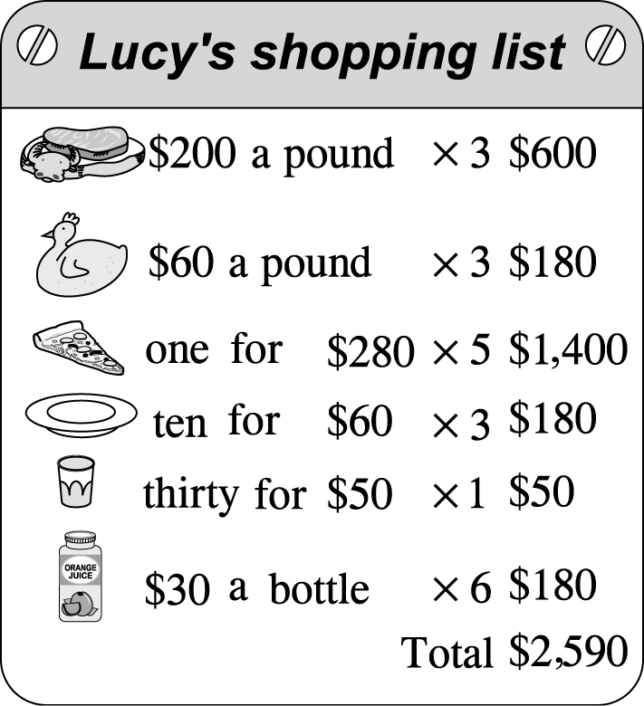
（ ）(6) How many paper cups does Lucy need?
(Ａ) Ten. (Ｂ) Twenty. (Ｃ) Thirty. (Ｄ) Forty.
（ ）(7) How much are twenty paper plates?
(Ａ) NT$200. (Ｂ) NT$160. (Ｃ) NT$60. (Ｄ) NT$120.
（ ）(8) What doesn’t Lucy need?
(Ａ) Chicken. (Ｂ) Pizza. (Ｃ) Beef. (Ｄ) Forks.
（ ）(9) How much are three pieces(片) of pizza ?
(Ａ) NT$940. (Ｂ) NT$540. (Ｃ) NT$840. (Ｄ) NT$640.
（ ）(10) How many bottles of juice does Lucy need? (Ａ) 3. (Ｂ) 4. (Ｃ) 5. (Ｄ) 6.

五、中翻英(每題2分,共10分)
- 你喜歡哪一個,炒飯還是牛肉麵?
- 每個週六和週日,Vicky會在家裡煮飯。
- 安靜。我的小妹妹正在睡覺。
- 麵包和水果是多少錢?
- 我們班只有三十個學生。

高雄縣立林園高級中學國中部 一年級下 英語 科第二次段考卷
範圍：L3 P40~L6 班級： 姓名： 座號：
壹、聽力測驗(共三十分)
一、單字題型 (5題，共10分)依據錄音內容，完成以下的填空。
第7、8題二分，其餘一分
1 |  | 2 |  | 3 |  | 4 |  | 5
6 |  | 7 |  | 8
二、 答句題型 (一題，共10分)
依據錄音內容，選出適當的答句。
1 |  | 2 |  | 3 |  | 4 |  | 5

三、圖片題型 (一題，共10分)
為相符的圖片寫上正確的題號。
A |  | B |  | C |  | D |  | E

貳、紙筆測驗(共七十分)
一、字彙測驗(每題二分，共10分)
1 |  | 2 |  | 3 |  | 4 |  | 5
二、文法選擇 (每題二分，20%)
1 |  | 2 |  | 3 |  | 4 |  | 5
6 |  | 7 |  | 8 |  | 9 |  | 10
三、對話(每題二分，10%)
1 |  | 2 |  | 3 |  | 4 |  | 5
四、閱讀測驗(每題二分，20%)

1 |  | 2 |  | 3 |  | 4 |  | 5
6 |  | 7 |  | 8 |  | 9 |  | 10
五、中翻英(每題二分，10%)
1.
_____________________________________________________________________________
2.
_____________________________________________________________________________
3.
_____________________________________________________________________________
4.
_____________________________________________________________________________
5.
_____________________________________________________________________________

高雄縣立林園高級中學國中部 一年級下 英語 科第二次段答案卷
範圍：L3 P40~L6 班級： 姓名： 座號：
壹、聽力測驗(共三十分)
一、單字題型 (5題，共10分)依據錄音內容，完成以下的填空。
第7、8題二分，其餘一分
1 | tennis | 2 | piano | 3 | brush | 4 | teeth | 5 | social
6 | studies | 7 | math | 8 | sick
二、 答句題型 (一題，共10分)
依據錄音內容，選出適當的答句。
1 | B | 2 | B | 3 | D | 4 | C | 5 | A

三、圖片題型 (一題，共10分)
為相符的圖片寫上正確的題號。
A | 2 | B | 4 | C | 1 | D | 5 | E | 3

貳、紙筆測驗(共七十分)
一、字彙測驗(每題二分，共10分)
1 | everything | 2 | dumplings | 3 | thousand | 4 | science | 5 | supermarket

二、文法選擇 (每題二分，20%)
1 | C | 2 | C | 3 | C | 4 | D | 5 | B
6 | C | 7 | B | 8 | D | 9 | C | 10 | D
三、對話(每題二分，10%)
1 | B | 2 | B | 3 | C | 4 | D | 5 | A
四、閱讀測驗(每題二分，20%)
1 | C | 2 | C | 3 | B | 4 | C | 5 | D
6 | C | 7 | D | 8 | D | 9 | C | 10 | D

五、中翻英(每題二分，10%)
- Which do you like, fired rice or beef noodles?
- Every Saturday and Sunday, Vicky cooks at home.
- Be quiet, my little sister is sleeping (now).
4. How much are the bread and fruit?
5. There are only thirty students in our class.

