高雄縣立林園高中95學年度國中部第二學期英文科第三次段考試題
- 聽力測驗（Listening Comprehension)：30% （每小題2分)
Part A：聽CD，若符合圖意或表格內容的選A，否則選B。
（ )1. （A) True （B) False （ ) 2. （A) True （B) False
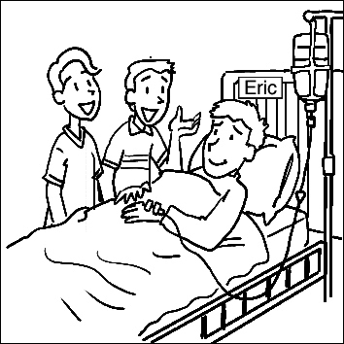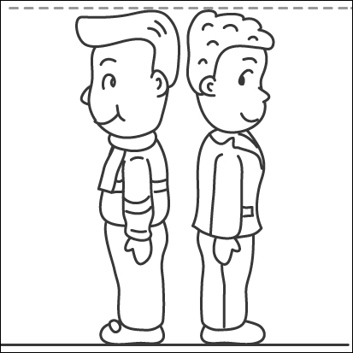
（ )3. （A) True （B) False （ ) 4. （A) True （B) False
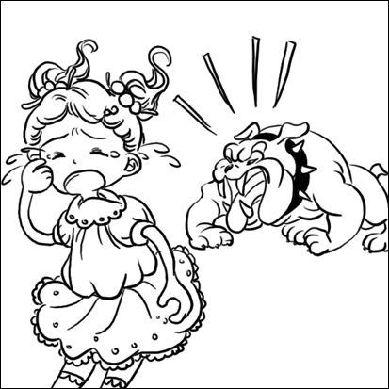
（ )5. （A) True （B) False
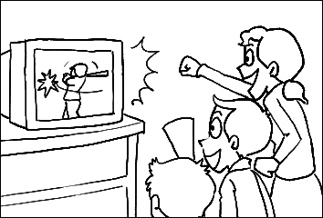
Part B：聽CD中的敘述，填寫出最符合圖意的句子。
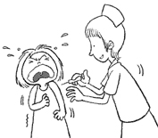
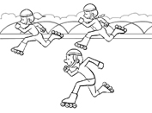
（ )1. （ ) 2.

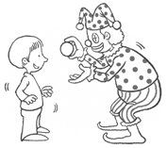
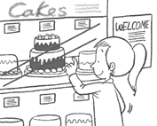
（ )3. （ ) 4.

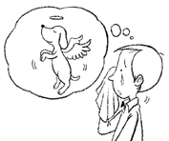
（ )5.

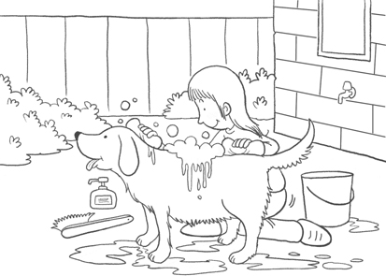
Part C：聽CD，選出最適當的答案。
（ ) 1. Question 1
（ ) 2. Question 2
（ ) 3 Question 3
（ ) 4. Question 4
（ ) 5. Question 5
二、紙筆測驗：70%
Part A：字彙測驗（Vocabulary)10%
1.（ ）They can’t which one they want because both cars are very nice.
(A) decide (B) make (C) have (D) let
2. （ ）John： What animals do you like? Mary： _______. They have the longest necks.
(A) Tigers (B) Giraffes (C) Bears (D) Elephants
3. （ ）The police officer caught the thief at the when he tried to fly to Japan.
(A) airport (B) beach (C) museum (D) park
4. （ ）Jimmy has to take ______ because he has a serious problem with his heart.
(A) pain (B) future (C) candy (D) medicine
5. （ ）It is important to ______ in class and read them after class.
(A) take a bath (B) take pictures (C) take medicine (D) take notes
6. （ ）The Internet is very for people to learn new things quickly.
(A) helpful (B) comfortable (C) illegal (D) difficult
7. （ ）The is one of the most popular animals in Taiwan. They sleep all the time and move slowly. (A) tiger (B) lion (C) koala (D) dog
8. （ ）Cell phones are because we can use them to call from anywhere.
(A) lonely (B) useful (C) blind (D) illegal
9. （ ）Sammy: Mom, can I go to the to play basketball?
Mom: No way! You didn’t finish your homework.
(A) room (B) lamp (C) playground (D) grass
10.（ ）You shouldn’t put so much food in your at one time. It can be very dangerous.
(A) hair (B) knee (C) heart (D) mouth
Part B：文法測驗（Grammar) 30 %
1.（ ）A：I do not like the color of the coat. Please show me .
B：Here you are.
(A) another one (B) other one (C)the another one (D) the other one
2. （ ）Some of the children study hard； are noisy.
(A) others (B) another (C) the other (D) the others
3. （ ） （4/5) of the class will go to Tina’s party.
(A) five fourths (B) four fifths (C) four fifth (D) fourth fifth
4. （ ）No one is taller than David in my class. That means David is taller than classmates in my class. (A) all the other (B) any other (C) everyone else (D) the other
5. （ ）The clothes on sale are than usual.
(A) very cheaper (B)very cheap (C) much cheaper (D) a little more cheaper
6. （ ）Of all the girls, Lucy is .
(A) the more beautiful (B) the most beautiful (C) beautiful (D) most beautiful
7. （ ）Dad plans to start a business on his birthday.
(A) fourty (B) fourtieth (C) fortieth (D) forty
8. （ ）The funny clown（小丑) made many people .
(A) to laugh (B) laughing (C) happily (D) happy
9. （ ）Tomorrow is Mother’s Day. Should we give ？
(A) some flowers to Mom (B) some flowers for Mom
(C )to Mom some flowers (D) Mom with some flowers
10.（ ）My younger sister was late for work she got up late this morning.
(A)when (B) because (C) so (D) before
11.（ ）請選出正確的句子。(A) The girl paid 250 dollars for the necklace.
(B) The girl spent 250 dollars to buy the necklace.
(C) The girl took 250 dollars to buy the necklace.
(D) The girl cost 250 dollars to buy the necklace.
12.（ ） my parents are going to America on business next month.
(A)Two of (B) One of (C)All of (D) Both of
13.（ ）The English teacher is very strict. She always asks her students .
(A) study hard (B) studying hard (C) to study hard (D) for studying hard
14.（ ）May is Steve’s favorite friend. May had Steve violin.
(A) practice playing (B) practice playing the (C) practice to play the (D) to practice playing
15.（ ）Bride Peter is one of my movie stars.
(A) most favorite (B) more favorite (C) the most favorite (D) favorite
Part C：閱讀測驗（Reading) 30%
1. Money can buy medicine, but it cannot buy health.
Money can buy flowers, but it cannot buy love for you.
Money can buy books, but it cannot buy knowledge.
Money can buy houses, but it cannot buy home for you.
Money can buy toys, but it cannot buy happiness.
Money can buy gold and silver, but it cannot buy friendship for you.
Money can buy watches, but it cannot buy lost time.
（ ）1. Which do you think money can buy? (A) Talent. (B) Future. (C) Hope. (D) Medicine.
（ ）2. What does the writer want to tell the readers?
(A) Money is important, and it can buy everything.
(B) Money is important, but it isn’t everything.
(C) Money is not important, and it can buy nothing.
(D) Money is not important, but it means a lot.
（ ）3. What does the last sentence mean?
(A) People who have watches use their time well.
(B) People who have watches don’t care about what time it is.
(C) People should use their time well, because time waits for no man.
(D) People can waste time if they have money.
2.My name is Coco. Jasmine is my best friend. We’re excited we joined the cheerleader club this semester. There’s one problem. We had to choose a lucky animal, like every cheerleader club did. Jasmine surfed on Net and found much information（資訊) about animals. I also checked in some books and asked my family’s ideas. My brother thought monkeys are the most active one. But another club already chose monkeys. Jasmine thought giraffe is the most graceful of all. But lions are good, too. They are stronger than all the other animals.
On the weekend, we not only looked for the books but also took notes. We went to meet the other cheerleader at school the next day. Some of the girls picked lions. The others picked giraffe. Then Jennifer came; she decided bear was our lucky animal. Because she is the leader of our team, most of us said yes. That’s OK for me. After all, bears are cute. But Jasmine was very angry, and she decided to quit.
（ ）1. To decide a lucky animal for the club, what did Coco and Jasmine do?
(A) They went to the library. (B) They spent the weekend to look for information.
(C) They had a meeting at school. (D) They asked their teacher’s idea.
（ ）2. What animal can’t they pick?(A) Giraffe. (B) Tigers. (C) Monkeys. (D) Lions.
（ ）3. What day did Coco and Jasmine meet the other cheerleader?
(A) Weekend. (B) Monday. (C) Friday. (D) Tuesday.
（ ）4. What animal will be the cheerleader club’s lucky animal?
(A) Bear. (B) Lion. (C) Giraffe. (D) Tiger.
（ ）5. How does Coco feel about bears?
(A) She is afraid of bears. (B) She thinks Teddy Bears are OK.
(C) She doesn’t like bears. (D) She thinks bears are cute.
（ ）6. Who are the members（成員）of cheerleader club now?
(A) Coco and Jennifer. (B) Coco and Jasmine.
(C) Jasmine and Jennifer. (D) Coco, Jasmine and Jennifer.
3. A new law will be made soon. The law says all the parents in Taiwan can’t leave their children alone in the car. It will make parents take good care of their children. We often saw a little child sit in a car before. His parents didn’t stay with him. They might just have gone shopping or do something else, so they thought their child could be safe. However some careless parents might also leave their key in the car. How terrible! Maybe someone could steal not only their car but also their child. We believe there won’t be so many missing children after the law is enforced（執行).
（ ）1. From this reading, what can a thief NOT steal?
(A) A child. (B) A car. (C) A parent. (D) I don’t know.
（ ）2. In which sentence can the word careless be used?
(A) Though Bill is careless, he can’t play football.
（B) It’s raining today, so we can’t go mountain climbing. I am so careless.
(C) Kelly is a careless girl because she always makes breakfast for her family.
(D) How careless I am! I had a P.E. class today, but I didn’t bring my jogging shoes.
（ ）3. Which one is true?
(A) The new law says how to leave your children in a car.
(B) One of the parents usually stayed with their child in the car before.
(C) Parents left their child in the car because they didn’t want to have him.
(D) After the law is enforced, there will be fewer missing children in Taiwan.
4. A-tong： I’m back.
Mr. Wu： Hi, A-tong. How was your school trip?
A-tong： Great! My teacher took us to Blue Water Zoo. It was so much fun. My classmates and I had a very good time. Dad, do you know what Mola mola is?
Mr. Wu： I have no idea. What is it?
A-tong： It’s the most interesting fish I’ve ever seen. It looks like it has a big head but doesn’t have body. It’s so special. I hope you can see it, too. There are so many interesting fished and see animals in the water zoo.
Mr. Wu： It sounds interesting. Maybe we can find time to go there together. We can also take Grandpa and Grandma with us.
A-tong： How about next Friday? It’s a holiday. You don’t have to work, right?
Mr. Wu： Right. Call Grandma to see if she and Grandpa have time on Friday.
A-tong： Yeah!
（ ）1. What may Mola mola look like？
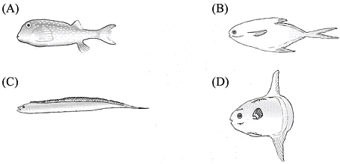
（ ）2. Who is Mr. Wu？
(A) A-tong’s father.
(B) A-tong’s friend.
(C) A-tong’s teacher.
(D) A-tong’s grandpa.
（ ）3. What does there mean?
(A) A-tong’s school.
(B) Blue Water Zoo.
(C) Mr. Wu’s office.
(D) Grandparent’s house

