高雄縣立林園高級中學 國中部95學年度 第二學期 三年級 英文科第一次段考考卷
範圍：B6, L2~L3 班級： 姓名： 座號：
Part A. Reading Comprehension (80%)
- 下列各題，請依文意選出一個正確或最佳的答案
- Don’t at anyone just because of his appearance. (Ａ) laugh (Ｂ) bark (Ｃ) notice (Ｄ) smile
- Where there’s a fire, there’s . (Ａ) star (Ｂ) smoke (Ｃ) snake (Ｄ) flash
- My grandpa lives in the forest（森林）. His house is the trees.
(Ａ) between (Ｂ) among (Ｃ) through (Ｄ) below
- It’s not polite to ask questions. (Ａ) plastic (Ｂ) popular (Ｃ) personal (Ｄ) purple
- The of the country is very wise and kind. Everyone in the country loves her.
(Ａ) queen (Ｂ) king (Ｃ) son (Ｄ) stranger
- Wearing a helmet when you ride can you from getting hurt. (Ａ) cross (Ｂ) reduce (Ｃ) prepare (Ｄ) protect
- He has trouble English sentences. (Ａ) writes (Ｂ) written (Ｃ) to write (Ｄ) writing
- Not only you but also Lily a red puppy. (Ａ) have (Ｂ) is having (Ｃ) has (Ｄ) are having
- If you don’t want carbon monoxide poisoning , open the windows when you heat something.
(Ａ) happening (Ｂ) happens (Ｃ) to happen (Ｄ) happened
- What happened your sister? She looked strange. (Ａ) with (Ｂ) up (Ｃ) about (Ｄ) to
- I don’t like durians（榴槤）. Can you ?
(Ａ) take them away (Ｂ) take away them (Ｃ) took them away (Ｄ) took away them
- We should at the next stop. (Ａ) get off the bus (Ｂ) get the bus off (Ｃ) get the bus on (Ｄ) get it on
- When he here tomorrow, I’ll ask him by myself. (Ａ) will come (Ｂ) came (Ｃ) comes (Ｄ) coming
- My brother forgot to finish his homework last night. =
(Ａ) My brother has finished his homework. (Ｂ) My brother didn’t have any homework yesterday.
(Ｃ) My brother didn’t do his homework last night. (Ｄ) My brother asked me to do his homework.
- Both of Mrs. Brown’s children aren’t sons. =
(Ａ) Mrs. Brown doesn’t have any sons. (Ｂ) Mrs. Brown has two daughters.
(Ｃ) Mrs. Brown has a son and a daughter. (Ｄ) Mrs. Brown doesn’t have any children.
- My sister, Candy, is a couch potato. =
(Ａ) My sister, Candy, likes eating potatoes. (Ｂ) My sister, Candy, always puts a potato on the couch.
(Ｃ) When Candy sits on the couch, she looks like a potato. (Ｄ) Candy spends a lot of time sitting and watching TV.
- Mom: Andy, don’t take any food from strangers. Andy: I see.
(Ａ) Andy sees someone take food from strangers. (Ｂ) Andy’s mom asks him not to take any food from strangers.
(Ｃ) Andy sees his mom give food to children. (Ｄ) Andy was scolded by his mom because he ate others’ food.
- Either John or Tim will join the basketball club. =
(Ａ) One of the two boys will take part in the basketball club. (Ｂ) Both John and Tim will join the basketball club.
(Ｃ) John has joined the basketball club, but Tim hasn’t. (Ｄ) John won’t go to the basketball club, and neither will Tim.

- 題組：請依據所附資料、圖、表或選文，選出一個正確或最佳的答案
(一)
Some parents don’t let their children (１) computers because they are afraid (２) their children may be crazy (３) computer games, the Internet or (４) with Net pals. If so, they won’t study. However, many children go to Net café secretly and they (５) hours there. And all they think about (６) just computers even if their parents may punish（處罰）them.
- (Ａ) using (Ｂ) to use (Ｃ) used (Ｄ) use
- (Ａ) of (Ｂ) to (Ｃ) that (Ｄ) about
- (Ａ) ╳ (Ｂ) about (Ｃ) of (Ｄ) at
- (Ａ) chatting (Ｂ) chat (Ｃ) to chat (Ｄ) chatted
- (Ａ) cost (Ｂ) spend (Ｃ) pay (Ｄ) pass
- (Ａ) are (Ｂ) ╳ (Ｃ) is (Ｄ) do

(二)

Public Safety
motorcyclist 機車騎士 look out 小心；注意 exit 出口 elevator 電梯
    - What should you do if there is a fire?
(Ａ) Use the elevator to get out of the building. (Ｂ) Go to either the hospital or the doctor.
(Ｃ) Stay low to the ground. (Ｄ) Look out for people crossing the street.
    - What is important to remember for motorcyclists?
(Ａ) They shouldn’t use the elevator. (Ｂ) They should look out for people crossing the street.
(Ｃ) They should rinse the burn with cold water. (Ｄ) They should never wear a helmet.
    - Where is it most likely（很可能的）for you to find the “Hot water!” poster?
(Ａ) On the sidewalk. (Ｂ) In the classroom. (Ｃ) In the kitchen. (Ｄ) On the train.

(三)
How do people go to work in Taipei?
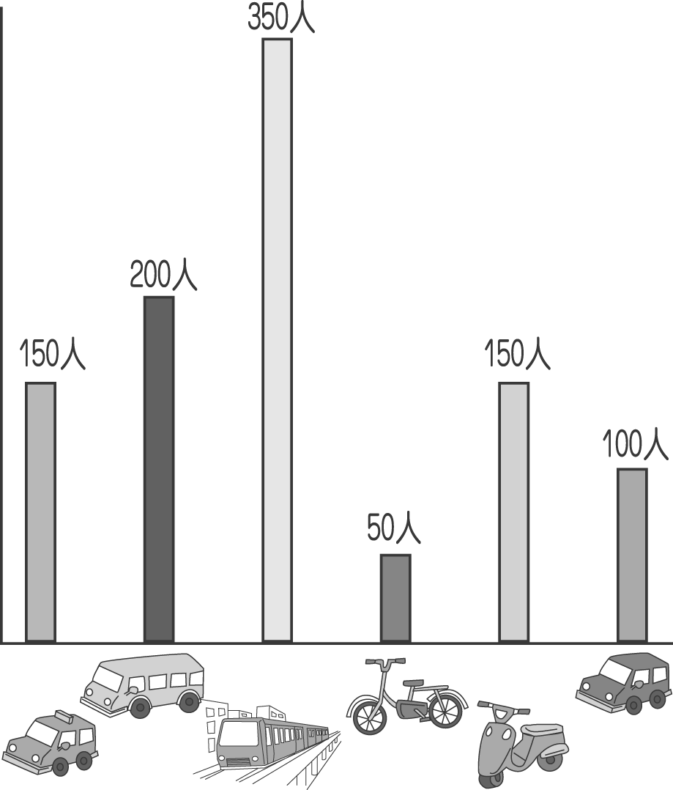
1. There are people in the survey（調查）. (Ａ) 1,100 (Ｂ) 1,000 (Ｃ) 950 (Ｄ) 900
2. The number of people who go to work by is the least. (Ａ) bicycle (Ｂ) bus (Ｃ) MRT (Ｄ) taxi
3. The percentage（百分比）of people who take a bus to work is . (Ａ) 20 ％ (Ｂ) 15 ％ (Ｃ) 10 ％ (Ｄ) 35 ％
4. The percentage of people who take the MRT to work is higher than that of people who drive to work by themselves.
(Ａ) 25 ％ (Ｂ) 20 ％ (Ｃ) 35 ％ (Ｄ) 10%

(四)
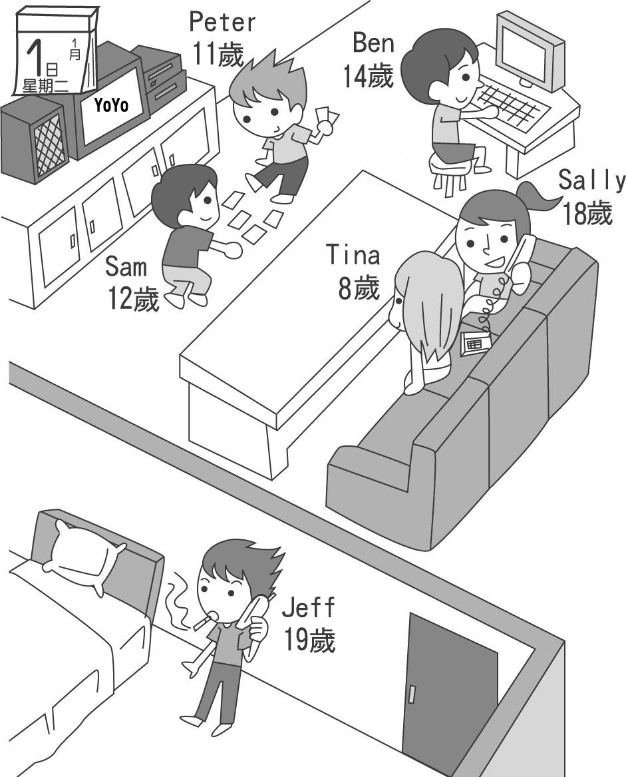
- What holiday is it? (Ａ) It’s Christmas. (Ｂ) It’s Father’s Day. (Ｃ) It’s New Year’s Day. (Ｄ) It’s Halloween.
- There are teenager(s) in the house. (Ａ) two (Ｂ) three (Ｃ) four (Ｄ) five
- What is Tina doing? (Ａ) Watch TV. (Ｂ) Talk on the phone. (Ｃ) Play computer games . (Ｄ) Play card games.
- Who can smoke? (Ａ) Jeff. (Ｂ) Peter. (Ｃ) Tina. (Ｄ) Ben.

(五)
Many teenagers think they have a generation gap with their parents because their parents don’t understand what they say or how they feel. They don’t want to share their feelings and thoughts with their parents, but they share everything with friends because friends can fully realize what they want to express. Thus, they care more about friends than parents.
What teenagers like to do at home is watching TV, talking to friends on the phone, playing computer games and talking to others by MSN. They want everything modern others have, such as cell phones and MP3s. They like to follow the fashion and care about their own appearance. They think they are adults and they hate to be treated as young children.

fully 完全地 realize 了解 express 表達 thus 因此 fashion 時尚
1. In the paragraph,“a generation gap”means that .
(Ａ) children have trouble communicating with parents (Ｂ) there’s something between children and parents
(Ｃ) children will give parents a big surprise. (Ｄ) parents want to tell their children a meaningful（有意義的）story
2. Which is more important to teenagers, friends or parents? (Ａ) Both. (Ｂ) Parents. (Ｃ) Friends. (Ｄ) None.
3. Which of the following will teenagers want to have most?
(Ａ) A bike. (Ｂ) A technological product（科技產品）. (Ｃ) Snacks. (Ｄ) A house.
4. When we say Mike is talking to his friends by MSN, it means that Mike is .
(Ａ) spelling words (Ｂ) studying English (Ｃ) making posters (Ｄ) chatting online
5. When teenagers have trouble, they will tell . (Ａ) their parents (Ｂ) their teachers (Ｃ) their friends (Ｄ) their pets

Part B. Writing Comprehension (20%)
- He wonders. / Does she have a boyfriend? (用if合併為一句)
- The teacher asked me to write down the word.（畫線部分用代名詞改寫）
- I often had afternoon tea with Judy before.（用 used to 改寫）
- She is good at English. / She is good at math, too. （用 not only… but also…合併）
- Vivian likes the basketball player. / The basketball player was the MVP last year. （用關係代名詞合併句子）
- Angel moved to Tainan when she was ten. / Angel still lives in Tainan now. （用 since 合併為一句）
- These parents won’t give up looking for their missing（失蹤的）children.（用代名詞受格代替畫線部分）
- Amy ate the doughnuts. / Jason bought the doughnuts for her this morning. (用關係代名詞合併句子)
- Not only candy but also junk food is bad for your health.（用 Both…改寫）
- People shouldn’t drive on sidewalks, and they shouldn’t drive on bicycle lanes, either.（用 neither... nor...改寫）
高雄縣立林園高級中學 國中部95學年度 第二學期 三年級 英文科第一次段考 答案卷
範圍：B6, L2~L3 班級： 姓名： 座號：
Part A. Reading Comprehension (80%，每題2分)
I.
1. | 2. | 3. | 4. | 5. | 6. | 7. | 8. | 9. | 10.
11. | 12. | 13. | 14. | 15. | 16. | 17. | 18.
II.
(一)  1. | 2. | 3. | 4. | 5. | 6.
(二)  1. | 2. | 3.
(三)  1. | 2. | 3. | 4.
(四)  1. | 2. | 3. | 4.
(五)  1. | 2. | 3. | 4. | 5.

Part B. Writing Comprehension (20%，每題2分)
1.
2.
3.
4.
5.
6.
7.
8.
9.
10.

高雄縣立林園高級中學 國中部95學年度 第二學期 三年級 英文科第一次段考 答案卷
範圍：B6, L2~L3 班級： 姓名： 座號：
Part A. Reading Comprehension (80%，每題2分)
I.
1. A | 2. B | 3. B | 4. C | 5. A | 6. D | 7. D | 8. C | 9. C | 10. D
11. A | 12. A | 13. C | 14. C | 15. C | 16. D | 17. B | 18. A
II.
(一)  1. D | 2. C | 3. B | 4. A | 5. B | 6. C
(二)  1. C | 2. B | 3. C
(三)  1. B | 2. A | 3. A | 4. D
(四)  1. C | 2. B | 3. A | 4. A
(五)  1. A | 2. C | 3. B | 4. D | 5. C

Part B. Writing Comprehension (20%，每題2分)
1. He wonders if she has a boyfriend.
2. The teacher asked me to write it down.
3. I used to have afternoon tea with Judy.
4. She is good at not only English but (also) math.
5. Vivian likes the basketball player who / that was the MVP last year.
6. Angel has lived in Tainan since she was ten.
7. These parents won’t give up looking for them.
8. Amy ate the doughnuts (which / that) Jason bought for her this morning.
9. Both candy and junk food are bad for your health.
10. People should drive neither on sidewalks nor on bicycle lanes.

