高雄縣立林園高級中學 國中部 95學年度 性向班考試「英語科」試題
- 本試題採電腦閱卷，請將答案以2B鉛筆於答案卡上劃記。
- 做答完畢之後，試題與答案卡均需繳回，攜帶試題與答案卡出試場者，一律以零分計。
※ 本試卷共五十題，一題兩分，請按題號作答。
I.文意字彙：30％ (1~7題請根據圖片回答，8~15題根據文意回答問題)
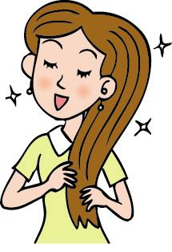

1. Tina：Wow！Your is so beautiful. Linda：Thank you.
(A) head (B) hair (C) hands (D) skirt

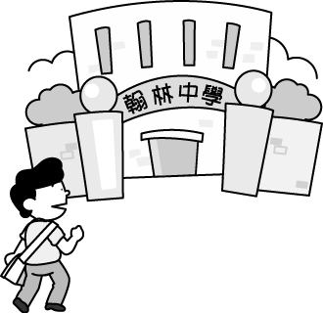
2. My brother goes to every day. (A) movies (B) museum (C) market (D) school

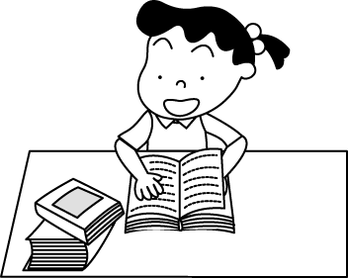
3. A：What is the girl doing? B：She is . (A) reading (B) watching TV (C) playing
(D) writing

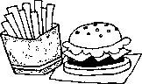
4. John eats a lot of . He is very heavy. (A) milk tea (B) fast food (C) fruit
(D) corn soup

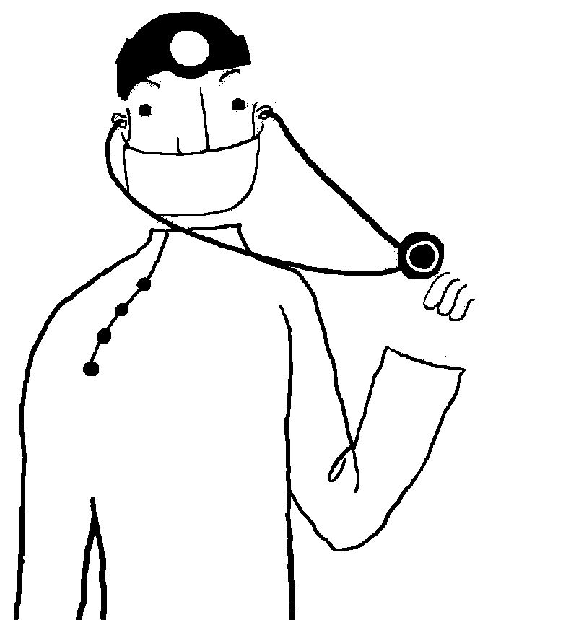
5.
Mr. Lin：I work in a every day and take care a lot of people. (A) garage (B) library
(C) bakery (D) hospital

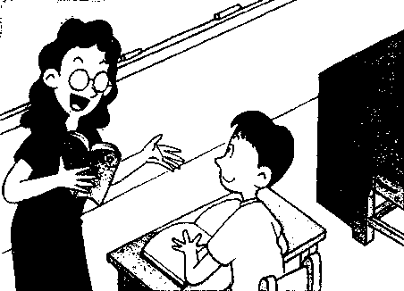
6. Miss Wang：Jay, please answer me the .
(A) question (B) college (C) computer (D) program

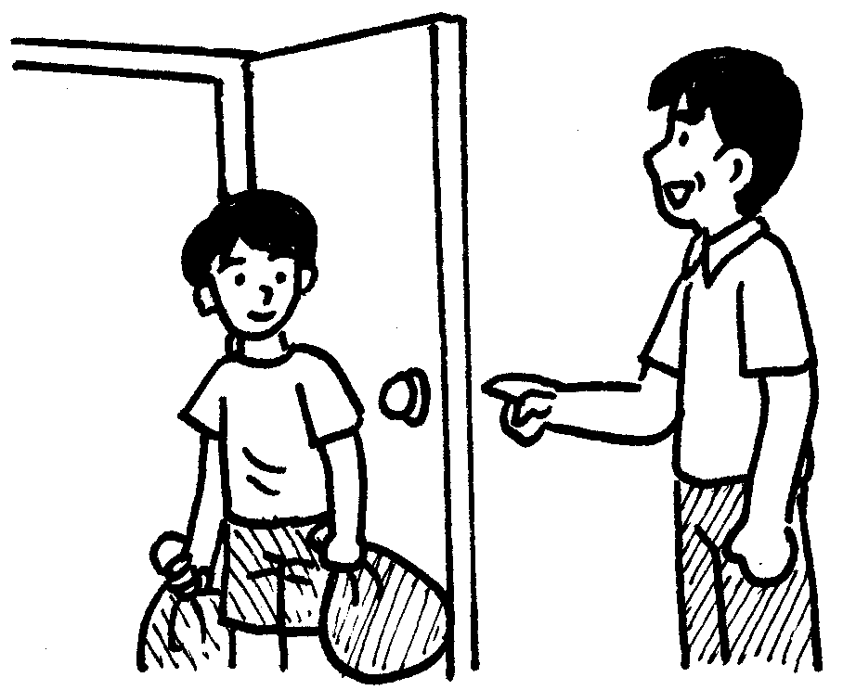
7. The boy’s father made him take out the yesterday.
(A) chicken (B) piano (C) trash (D) brush

8. My English teacher, Erica, comes from the USA. She is an . (A) Japanese (B) American (C) Frenchman
(D) Taiwanese
9. I have a cup of coffee, and she a hamburger. (A) had (B) eat (C) drink (D) has
10. These are comic books. (A) Mary (B) Mary’s (C) she (D) them
11. Her father is the living room now. He is watching a baseball game on TV. (A) on (B) at (C) in (D) under
12. David：Lucky, here and shake . Lisa：Wow！Your puppy is great！ (A) say/mouth (B) going/hand
(C) to run/tail (D) come/hands
13. Charlene：The weather is so . Gillian：Put on the sweater. You’ll feel better. (A) cold (B) warm (C) hot
(D) clean
14. We like to music in our free time. (A) watch (B) listen to (C) taste (D) smell
15. Mom：Shh…the baby is . Ted：Okay, mom. (A) jump (B) jumping (C) sleep (D) sleeping

II.克漏字測驗：30% (根據文意選出最適當之答案)
A.
John: Good evening, Mike. 16 are you going?
Mike: I’m going to the library.
John: 17 do you do there?
Mike: Oh, I read a lot of comic books and play computer games.
John: 18 don’t you do these things at home?
Mile: Because my parents wouldn’t like me to do these things.
They just ask me to study and study.
By the way, 19 you want to go with me?
John: No, I have to go to a piano class now. Goodbye.
Mike: Bye.
16. (A) What (B)Who (C)Where (D) How
17. (A)What (B)When (C)Where (D)Whom
18. (A)What (B)Why (C)How (D)Where
19. (A)are (B) can (C) may (D) do

B.
(Lily and Robert are talking on the phone)
Robert: Hello.
Lily: 20
Robert: This is Robert.
Lily: Hi, Robert. This is Lily. How are you doing?
Robert: 21
Lily: Not bad. Can we go to a movie on Friday evening?
Robert: Sorry, I can’t. I have to study on Friday evening.
Lily: Can Kevin go?
Robert: 22
Lily: And Jolin?
Robert: No, she wants to help her mother cook.
Lily: 23
Robert: We can go to a movie on Sunday afternoon. Is it fine?
Lily: Sure, that will be fine. So see you on Sunday afternoon.
Robert: See you then.
20. (A) Can I see May? (B)May I call you John? (C) Can I speak to Robert? (D) Can I speak to Sara?
21. (A)Pretty good. And you? (B) So so, but very good. (C) Can you play baseball well? (D) I can’t do it.
22. (A)Yes, she can. (B)No, she has a music class. (C)No, he can go. (D)No, he has to study in the library.
23. (A)Oh, how nice. I envy you. (B)Ok, what day can you go? (C)Ok, can you watch TV today?
(D)Ok, what time is it now?

C.
Look at the picture. It is a restaurant. There are some flowers in the vase on the table.
A waitress is 24 the man and woman. She is waiting on them. The man and the woman
are holding a menu 25 their hands. They are thinking of what they want to order. They
both like rice, fish, and vegetables, but they don’t like pork. They also like cookies, lemon
tea, and ice cream. They keep talking and thinking 26 a long time, but they still don’t
know what to order. Maybe they will order nothing and will just leave the restaurant.
24. (A)over (B)of (C)beside (D)under
25.(A)of (B)in (C)out (D)at
26.(A)for (B)up (C)with (D)by

D.
I 27 good times when I studied in elementary school. Those days were a long time ago, but I will never forget them. I remember Ms. Rice was my Chinese teacher at that time. She was a genius. She read many books and knew so many things. Besides, she was pretty, slender, and energetic. She always 28 us a lot of interesting stories, and sometimes she even let us
29 role-playing games. We were the happy or sad writers, or those handsome boys and beautiful girls. It was fun to study Chinese and to act out. Now I teach Chinese in a junior high school, and I am also a writer. I like to write stories about my students. Next Sunday, my classmates and I will 30 . I hope the day is coming soon, and I can’t wait to see my Chinese teacher and my old friends. I would like to tell them how much I miss them, and I believe we will have a lot of fun.
27. ( A) am have (B)have (C)has (D)had
28. (A) tell (B) talk (C) told (D) talked
29. (A) play (B) played (C) playing (D) to play
30. (A) have a math class (B) play baseball (C) give a test (D) have a class reunion

III. 閱讀測驗：40％
A
Tom’s family who lived in Seattle went to the park on April 1st. There were four children in this family. They played frisbee on the grass in the park and ate their lunch there. After lunch, the father was reading while he was resting under the trees. At the close of the day, they all went home, leaving the ground covered with papers. Other careless persons did the same thing. The park was a mess the next day! Papers and trash should be placed in the large cans that were in parks and along streets. People should be as careful of public property as they are of their own.

31. What did the children do in the park?（A）read（B）rested under a tree （C）ate lunch（D）slept on the grass
32. Who was careful of public property（財產）? （A）each child（B）the mother（C）the father（D）none of the family
33. The family lived in（A）New York（B）the park（C）Chicago（D）Seattle.
34. They went to the park on（A）Friday（B）Saturday（C）April 1st（D）Sunday
35. What had they thrown on the ground? （A）trees（B）grass（C）lunch（D）papers
36. In the family, there were how many children? （A）two（B）three（C）four（D）five
37. Where should trash be placed? （A）in cans（B）in parks（C）in paper（D）along the street
38. Choose the best title: （A）Playing in the Park（B）Reading the Newspaper（C）The People of Seattle（D）Taking Care of Public Property

B.
What’s his name?
What do you want to call the newborn panda baby?
December 11-19
Write down the name and put it in the box.
Get yourself a chance to win a great prize !
Panda’s name will be known at 3:00p.m. On December 20
at The Parking II
Taipei City Zoo No. 1, Zoo Road 02-27413564

39. What is this poster about ?
（A）Invite people to visit the zoo.（B）Invite people to think of a name for the newborn panda.
（C）Invite children to see the Pandas（D）Invite people to write down their names and to give the newborn panda some presents.
40. How long can people vote for the name of the newborn panda?
（A）A week.（B）Eight days.（C）Nine days.（D）Eleven days.
41.The activity is held in .
（A）City Zoo（B）City Library（C）City Hospital（D）City Hall

C. Tom’s class schedule

 | Monday | Tuesday | Wednesday | Thursday | Friday
8:00-8:50 | Civics | Science | Math | Science | English
8:50-9:00 | Break
9:00-9:50 | Chinese | History | Chinese | Chinese | History
9:50-10:00 | Break
10:00-10:50 | English | P.E. | English | History | Geography
10:50-11:00 | Break
11:00-11:50 | Counseling | Art | Music | Biology | Math
（Counseling輔導 / Geography地理 / Civics公民）

42.How many classes does Tom have every day ?
（A）Four. （B）Five.（C）Twenty. （D）Twenty-four.
43. How many English classes does Tom have every week?
（A）Four.（B）Three.（C）Two.（D）One.
44. What class is NOT on Tom’s Thursday schedule?
（A）Science.（B）Biology.（C）Geography.（D）Chinese.
45. It is 10:30a.m on Tuesday now. What is Tom doing?
（A）Playing baseball.（B）Reading.（C）Singing.（D）Drawing.

D. Welcome to Johnson’s Fast Food Restaurant

Hamburger……………………… ＄30 Coke………………………＄20
Fries…………………………… ＄20 Soda………………………＄20
Hamburger＋Fries……………… ＄40 Fried Chicken………………＄50
Pizza…（S）＄60（M）＄80（L）＄100 Milk………………………＄10
Special Dish Set Tea ……………………… ＄15
- One Hamburger＋One Coke＋（S）Pizza ………………………＄ 99
- One Hamburger＋3 Cokes＋one Fries＋（M）Pizza ………………＄180
Special Dish Set（特餐） Soda（汽水）

46.How much are a hamburger and fries?
（A）Thirty dollars.（B）Forty dollars.（C）Sixty dollars.（D）Seventy dollars.
47.Tom has＄50. He can have .
（A）a small pizza（B）fried chicken and a coke（C）a hamburger and soda（D）a hamburger, fries and tea
48.How much are a hamburger, fries, and a coke?
（A）Fifty dollars.（B）Sixty dollars.（C）Eighty dollars.（D）Ninety dollars.
49.Lisa and her two friends have＄80. They can have .
（A）a large pizza（B）2 small pizzas（C）the Special Dish Set A（D）4 fries
50.Bill has＄100. He has two fries. How much change does the waiter give him?
- Sixty dollars.（B）Forty dollars.（C）Eighty dollars.（D）Twenty dollars.

英語答案
一題兩分

01-05：BDABD

06-10：ACBDB

11-15：CDABD

16-20：CABDC

21-25：ADBCB

26-30：ADCAD

31-35：CDDCD

36-40：CADBC

41-45：AABCA

46-50：BCBDA

