高雄縣立林園高級中學國中部 一 年級 英語 科第一次段考考卷
範圍：L1~L3 班級： 姓名： 座號：

- 聽力測驗30%
一、 選出出現在CD句中的單字10%
( ) 1. (A) father (B) mother (C) great (D) there
( ) 2. (A) here (B) hello (C) hand (D) hat
( ) 3. (A) lunch (B) listen (C) chair (D) desk
( ) 4. (A) stand (B) ruler (C) friend (D) right
( ) 5. (A) class (B) classmate (C) classroom (D) close

二、根據錄音內容，填入正確的圖片代號10%
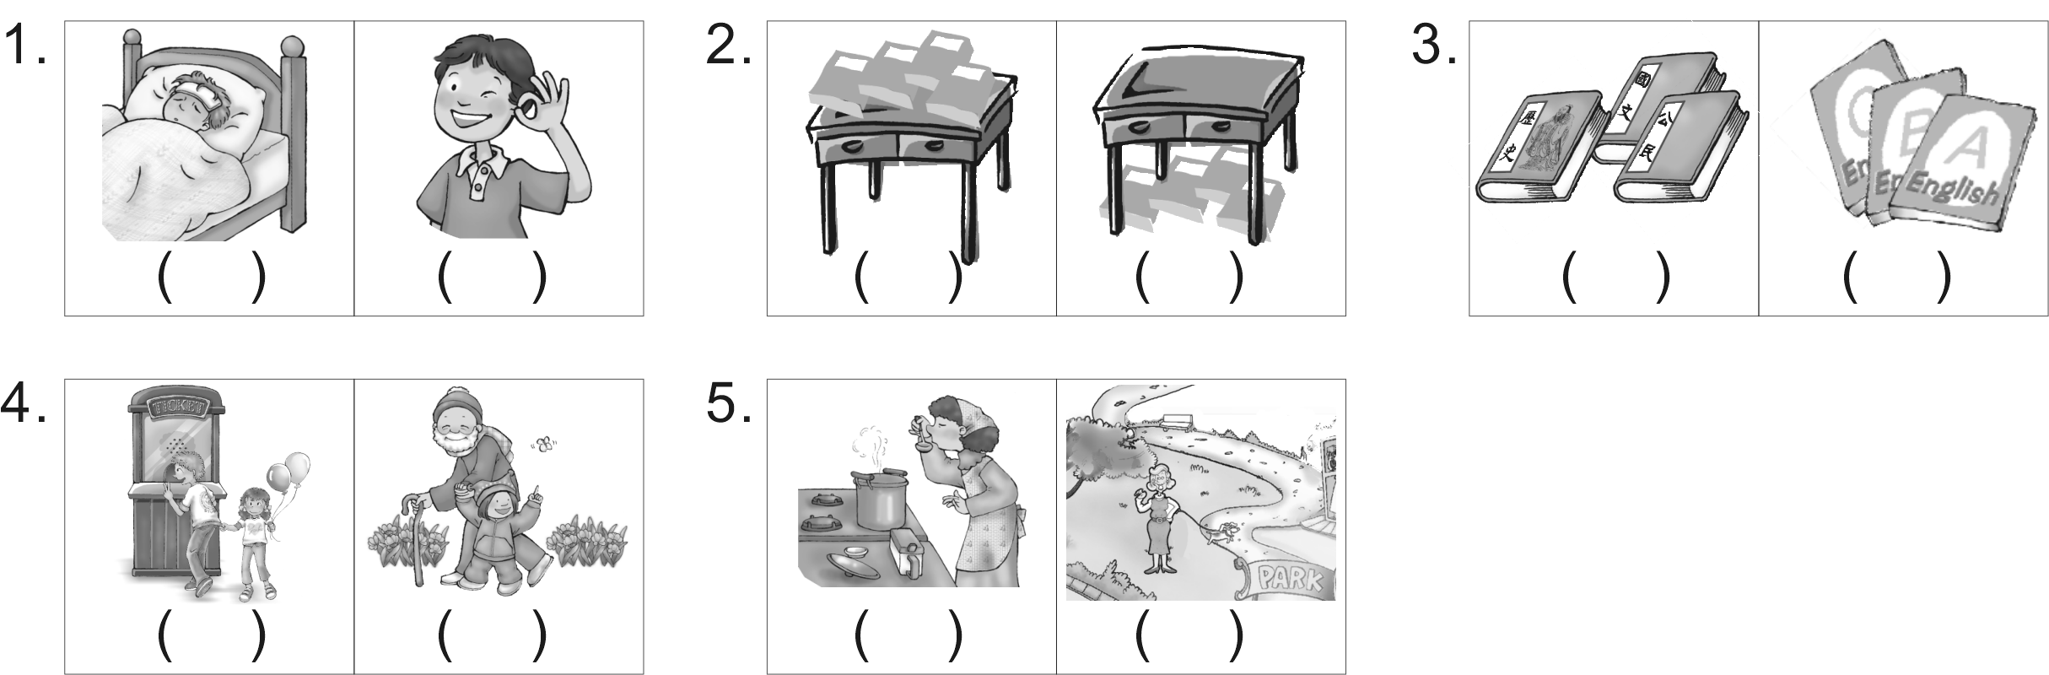

三、根據錄音內容選出適當的答句10%
1、 (Ａ) Yes, it’s very easy. (Ｂ) Yes, it is in the classroom.
(Ｃ) No, it is not a dog. (Ｄ) Yes, it is in the kitchen.
2、 (Ａ) My brother’. (Ｂ) On the desk. (Ｃ) Yes, on the desk.
(Ｄ) No, they are not on the chair.
3、 (Ａ) Yes, she is. (Ｂ) She is in the bedroom. (Ｃ) She is my friend.
(Ｄ) She is not Mimi.
4、 (Ａ) He is Jack. (Ｂ) He is at home. (Ｃ) He’s fine, thanks.
(Ｄ) He is a student.
5、 (Ａ) A pencil. (Ｂ) Yes, it is a book. (Ｃ) No, it is my pen
(Ｄ) Its name is Lucky.

- 紙筆測驗70%
四、將大寫字母改小寫，小寫字母改大寫6%（全對才給分）
1. lesson 2. summer 3. orange 4. DICTIONARY 5. COMPUTER 6.MOVIE
五、文意字彙20%
1、This is our new C e teacher.
2、I’m h y. Where is my lunch?
3、How about your h k. Is it easy?
4、My book is u r the chair, not on the desk.
5、I have a sister and three b rs.
6、A：Is that your r r? B：Yes, it is.
7、Andy and his father are in the l g room.
8、This is my new s g.
9、Good a n, Glenda. How are you?
10、You are my good friend, r t?
六、語法選擇20%
( ) 1、_____ Lee is our teacher. She is very beautiful (漂亮的). (A) Mr. (B) Mrs (C) Miss. (D) Miss
( ) 2. A：Is this your magazine (雜誌)? B：No, _______.
(A) this’s not (B) this is (C) it is (D) it’s not
( ) 3. Those are ______, not keys. (A) my watch (B) your watchs (C) watches (D) her watchies
( ) 4. A：Are you sure, Lisa? B：_______
(A) Yes, you are. (B) Yes, she is. (C) No, I’m sure not. (D) Yes, I am.
( ) 5. How _____ your mother and sister? (A) am (B) is (C) are (D) be
( ) 6. This boy is my classmate. ______ name is Bill. (A) He (B) His (C) He’s (D) Boy’s
( ) 7. Is your mother in the kitchen?
(A) She’s in the bedroom. (B) No, she is in the park. (C) Yes, she’s in the bedroom. (D) No, she is.
( ) 8. A：Andy, where are your classmates? B：__________ (A) He is at school.
(B) They are in the classroom. (C) Yes, they are in the park. (D) No, I’m not sure.
( ) 9. My name’s Boyd Jones. Jones is my ______ name. (A) last (B) thank (C) first (D) fine
( ) 10. That boy is ______, not very tall. (A) short (B) new (C) well (D) fine

七、克漏字選擇＆閱讀測驗14%
(一)
Tom：Hi, my name is Tom. 1. your name?
Mary：I’m Mary.
Tom： 2. a student?
Mary：Yes, 3.
Tom： 4. that tall girl?
Mary：That’s Jane. She’s 5. sister.
( ) 1. (A) How’s (B) What’s (C) Who’s (D) Where is
( ) 2. (A) You are (B) You is (C) Is you (D) Are you
( ) 3. (A) I’m. (B) I am. (C) I am, too. (D) I am not.
( ) 4. (A) How’s (B) What’s (C) Who’s (D) Where
( ) 5. (A) you (B) my (C) John (D) my a

(二)
Sam：Good morning, Miss Wu.
Atchoo 哈啾
terrible 很糟
had a cold 感冒
poor 可憐的
take care of 照顧
yourself 你自己
Miss Wu：Good morning, Sam. How are you?
Sam：Terrible. (Atchoo!)
Miss Wu：What’s wrong with you?
Sam：I had a cold.
Miss Wu：Poor boy. Take care of yourself.
Sam：Thank you.

( ) 6. How is Sam? (A) Fine. (B) Great. (C) Too bad. (D) Very well
( ) 7. 根據上下文選出『What’s wrong with you?』的最佳中文解釋。
(A)你好嗎？ (B)你怎麼了呢？ (C)你錯了嗎？ (D)你感冒了嗎？
八、依提示作答（需加標準符號）10%
- at/ Her/ the door/ dog/ is （重組句子）
2、My father is in the park. （依劃線部份造原問句）
3、Those are English books. （改為單數句）
4、Bill生病。他沒來上課。
5、他們的英文老師是從美國來的。

高雄縣立林園高級中學國中部 一 年級 英語 科第一次段考答案卷
範圍：L1~L3 班級： 姓名： 座號：

- 聽力測驗30%
一、選出出現在CD句中的單字10%
1. | 2. | 3. | 4. | 5.
二、根據錄音內容，填入正確的圖片代號10%
1. | 2. | 3. | 4. | 5.
三、根據錄音內容選出適當的答句10%
1. | 2. | 3. | 4. | 5.

貳、紙筆測驗70%
四、將大寫字母改小寫，小寫字母改大寫6%（全對才給分）
1. |  | 2. |  | 3.
4. |  | 5. |  | 6.

五、文意字彙20%
1. | 2. | 3. | 4. | 5.
6. | 7. | 8. | 9. | 10.
六、語法選擇20%
1. | 2. | 3. | 4. | 5.
6. | 7. | 8. | 9. | 10.
七、克漏字選擇＆閱讀測驗14%
1. | 2. | 3. | 4. | 5.
6. | 7.
八、依提示作答（需加標準符號）10%

1.

2.

3.

4.

5.

高雄縣立林園高級中學國中部 一 年級 英語 科第一次段考答案
壹、聽力測驗30%
一、選出出現在CD句中的單字10%
1.  B | 2.  D | 3.  A | 4.  C | 5.  B
二、根據錄音內容，填入正確的圖片代號10%
1.  A | 2.  A | 3.  B | 4.  A | 5.  B
三、根據錄音內容選出適當的答句10%
1.  D | 2.  B | 3.  C | 4.  C | 5.  A

貳、紙筆測驗70%
四、將大寫字母改小寫，小寫字母改大寫6%（全對才給分）
1. |  | 2. |  | 3.
4. |  | 5. |  | 6.

五、文意字彙20%
1.  Chinese | 2.  hungry | 3.  homework | 4.  under | 5.  brothers
6.  ruler | 7.  living | 8.  schoolbag | 9.  afternoon | 10.  right
六、語法選擇20%
1.  D | 2.  D | 3.  C | 4.  D | 5.  C
6.  B | 7.  B | 8.  B | 9.  A | 10.  A
七、克漏字選擇＆閱讀測驗14%
1.  B | 2.  A | 3.  B | 4.  C | 5.  B
6.  C | 7.  B
八、依提示作答（需加標準符號）10%

1. Her dog is at the door.

2. Where is your father?

3. That is an English book.

4. Bill is sick. He is not in class.

5. Their English teacher is from America.

