高雄縣立林園高級中學 國中部96學年度 第一學期 一 年級 英文 科第二次段考考卷
範圍：第一冊第4課至復習二 班級： 姓名： 座號：
I.聽力測驗 Listening Comprehension 30%
A. 聽到問題，根據圖片選出最適當之答案，每題二分。
1. 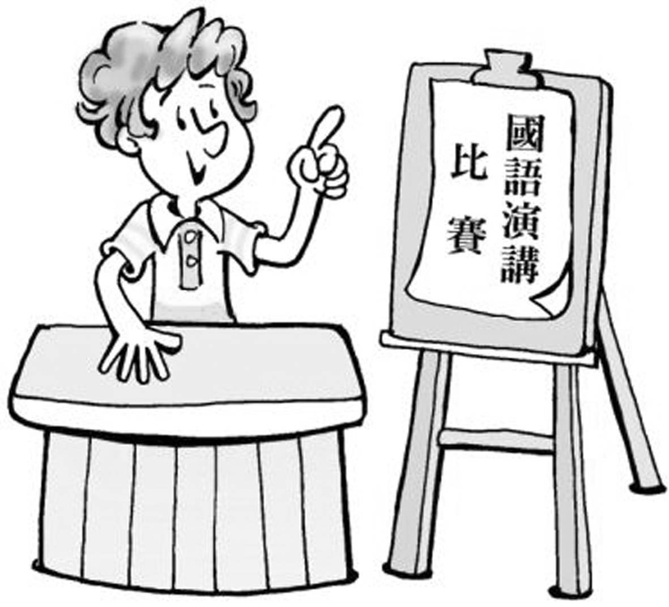 | 2. 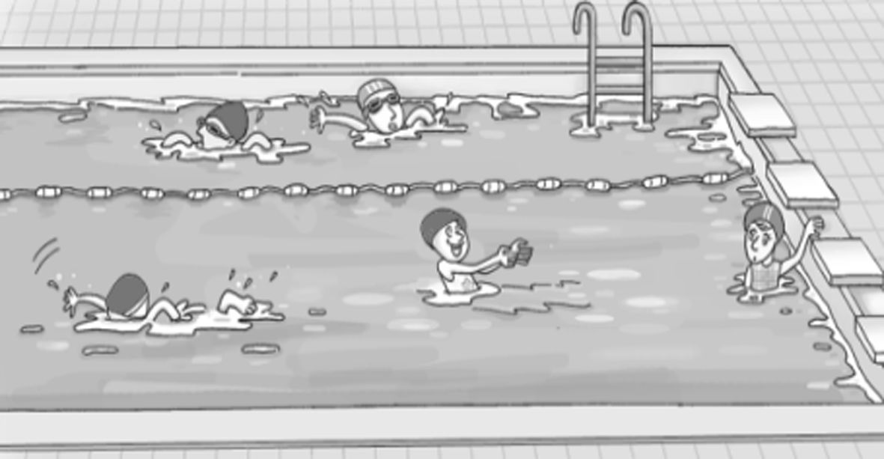 | 3. 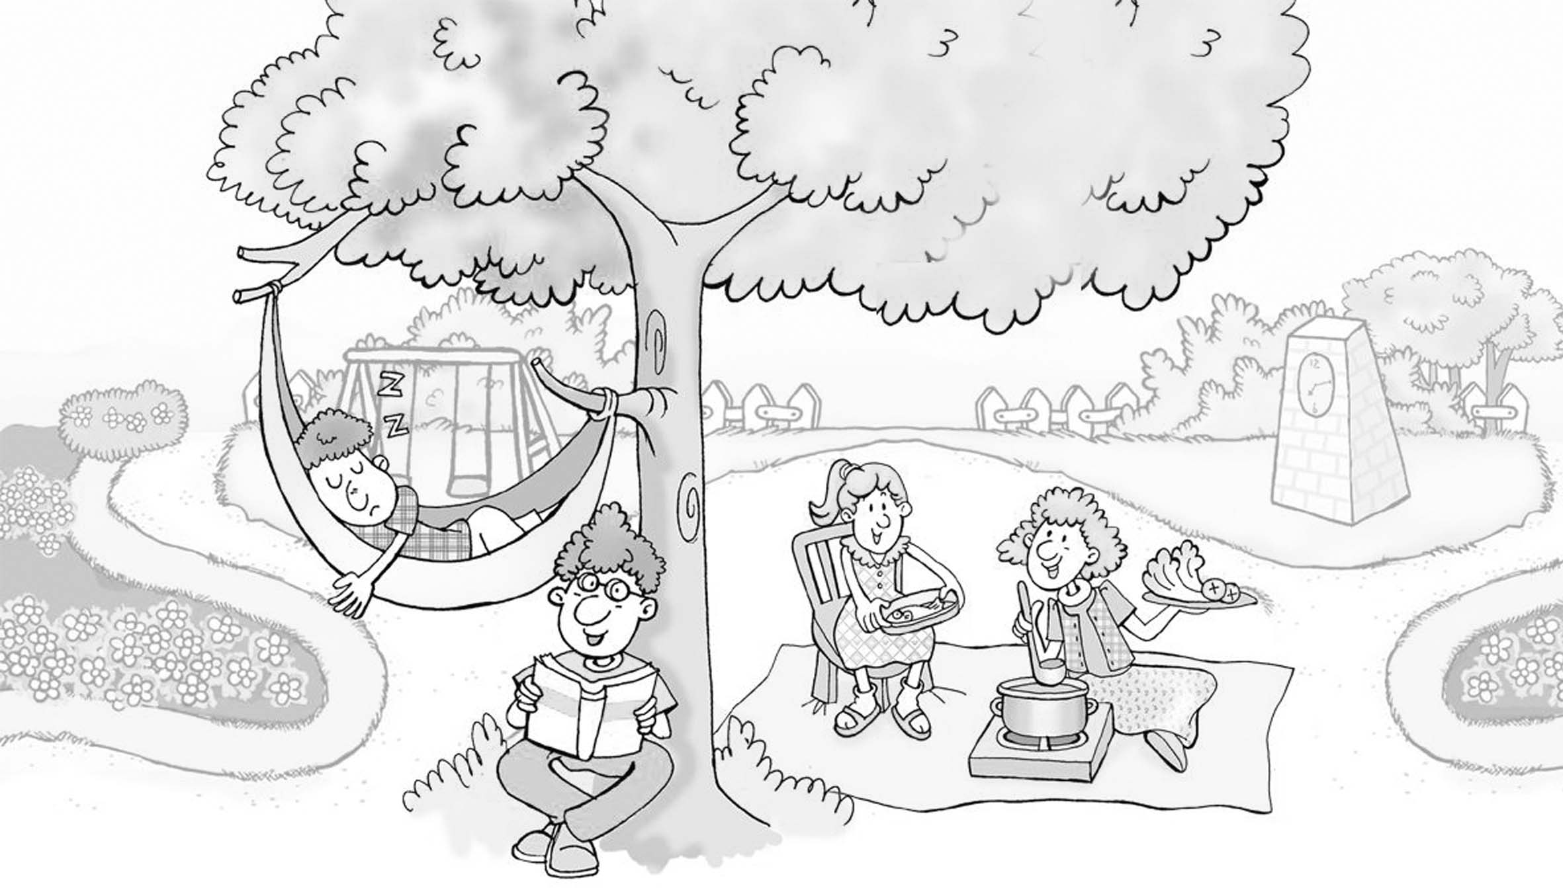
4. 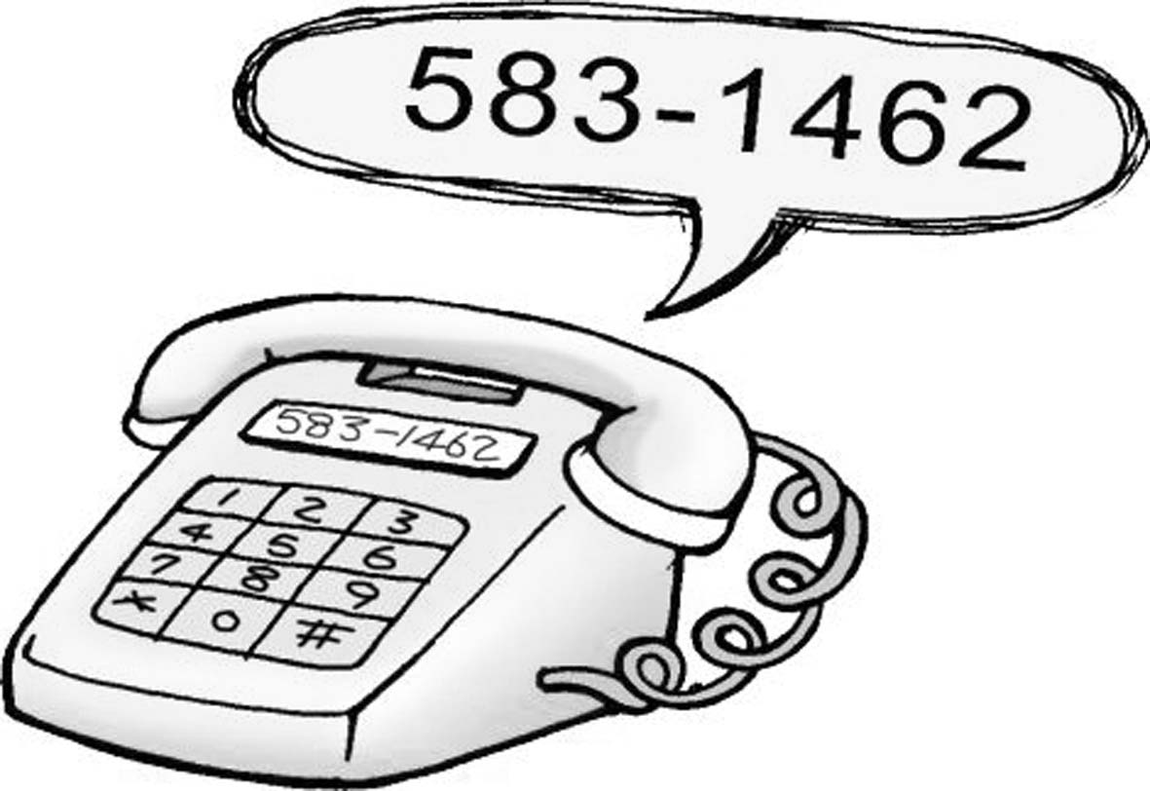 | 5. 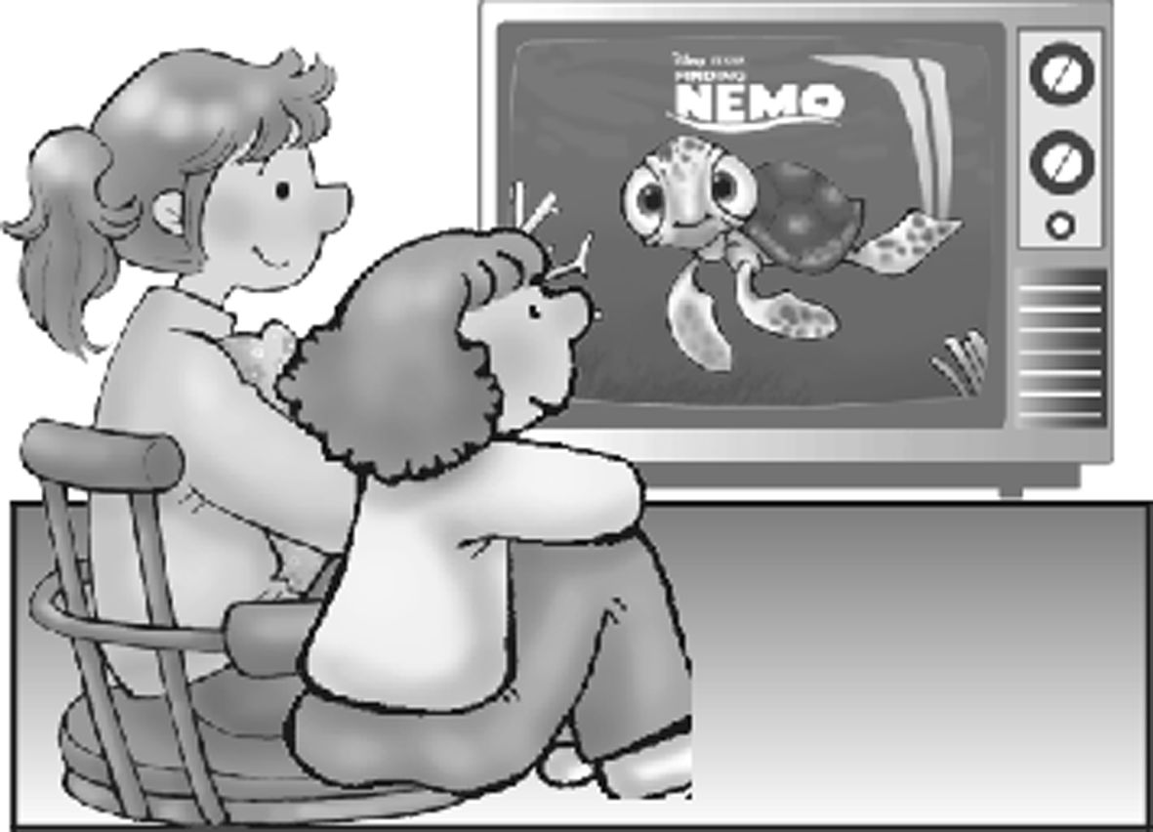 | Yummy 好好吃
B. 選出最適當之應答句代號，每題二分。
Choose the correct response to the speaker..
1. (A) Too bad. (B) Sorry, I am not. (C) Who? (D) Thanks!
2. (A) No, thanks. (B) That's sorry. (C) That's OK. (D) I'm just fine, thank you.
3. (A)Yes, I am. (B)No. I am not tall enough. (夠..) (C) No, I can. (D)Yes, thanks.
4. (A) In my room. (B) I can swim, too. (C) I'm not sorry.. (D) Yes, sit down.
5. (A) Who are you, please? (B) Who's calling, please? (C) Yes, I am. (D) Yes, I'm Mike

C. 聽下列三則對話，根據題意，選出最適當之答案，每題二分。
一1. _____ 2._____ 二3._____ 4._____ 三5.______
筆試題
II.文意字彙 根據題意填入符合的單字，每題二分。 20%
1. Mother is b y cooking in the kitchen.
2. He is talking to his friend on his c l phone.
3. Please come o r and play with me. I can’t wait.（我等不及了！）
4. That w n is my mother. She's talking to the boy.
5. My sister and I are s____g an English song. La la la…
6.There are many things in the p______o. You can look at them in it.
7. My mother is reading my r_______ card, and she is very happy. I get 100 on my English test.
8. Everyone is playing co games now. Everyone is having fun.
9.Students like to play b__t____l or tennis.
10. Jimmy is my l________e brother. He is just 3 years old. (歲)
III. 文法選擇 10%
1. You are happy, I am not. (A) and (B) but (C) well (D) sorry
2. I can play tennis. What you? (A) in (B) at (C) on (D) about
3. They home now. (A) are coming to(B) are coming (C) are come (D) come to
4. They a big house here (A) are (B) have (C) there are(D) there is
5. A: Are you reading an English book? B: Yes, .
(A) I can read (B) I read (C) I am (D) I can
6. There are many boys under the tree.
(A) sit (B) siting (C) sitting (D) sat
7. A: What are you ? B: I'm playing.
(A) playing (B) doing (C) reading (D) cooking
8. Andy is playing, .
(A) not work (B) no working (C) no work (D) not working
9. A: Where is Benny from? B: .
(A)In his room (B)America (C) She is from Taiwan. (D) Yes, he is.
10. A: Are there books on the chair? B: No, .
(A) there are two (B) there aren't (C) there is (D) it can't
IV..依提示填入適當的字 10%
- Get up, ______. (boys)
- Are you talking to _____ (he)?
- The boys are playing with _____ (we).
- Call ____ (I) tonight.
- This is ____ (she) desk.
- _______ (Jack) father is working in the park.
- Don’t open the book. Close ____ .(it)
- Can ____ (Amy) play tennis?
- Look at _____. (they) They are _____ (I) students.
V.對話選擇 5%
1. A: Can you play tennis? B:
(A) Yes, I'm sorry. (B) At home. (C) Me? No, I can't. (D) Yes, he is.
2. A: Sit down, please. B:
(A) Thanks! (B) Too bad. (C) Sorry, I can't. (D) Who?
3. A: Thanks. See you. B:
(A) Bye. (B) That's OK. (C) All right. (D) Sorry.
4. A. What's Father doing on his chair? B: ______
(A) Yes, he is sleeping. (B) He is reading. (C) He's at home. (D) There.
5. A: We are going to play tennis. B:
(A) Have fun. (B) What can you do? (C) Sorry for saying that. (D) That's all right.
VI. 翻譯 15%
- 請給她一枝原子筆。
Please 1 a ball pen 2 her.
- 你們明天能到Kelly家一起看電視嗎？
3 you come to my home and 4 TV 5 6 ?
3.A.房間裡有一個女孩嗎？ B 不，沒有。
A: 7 8 a girl in the room? B: No, there 9.
- 請掛斷電話，拿你的國文作業來。。
Please 10 11 the 12 and 13 me your 14 15.
VII. 看圖作答及根據提示作答 10% 每題錯一字，扣一分

1. What is he doing?  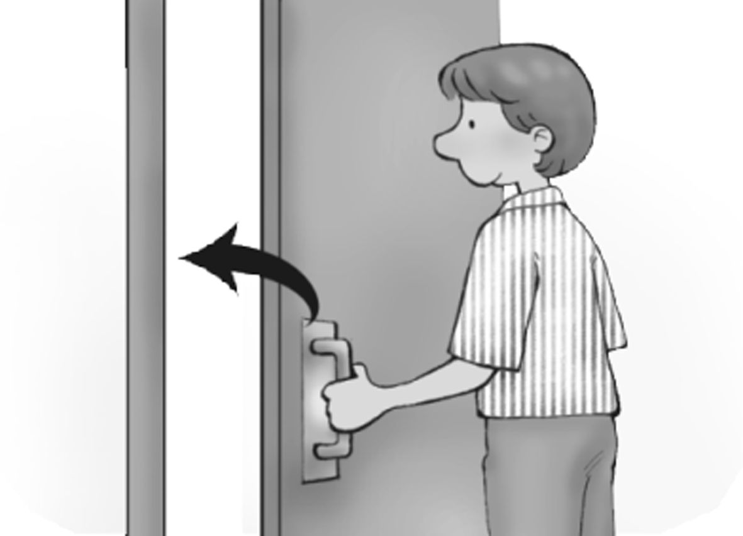 | 2.What is there under the chair?  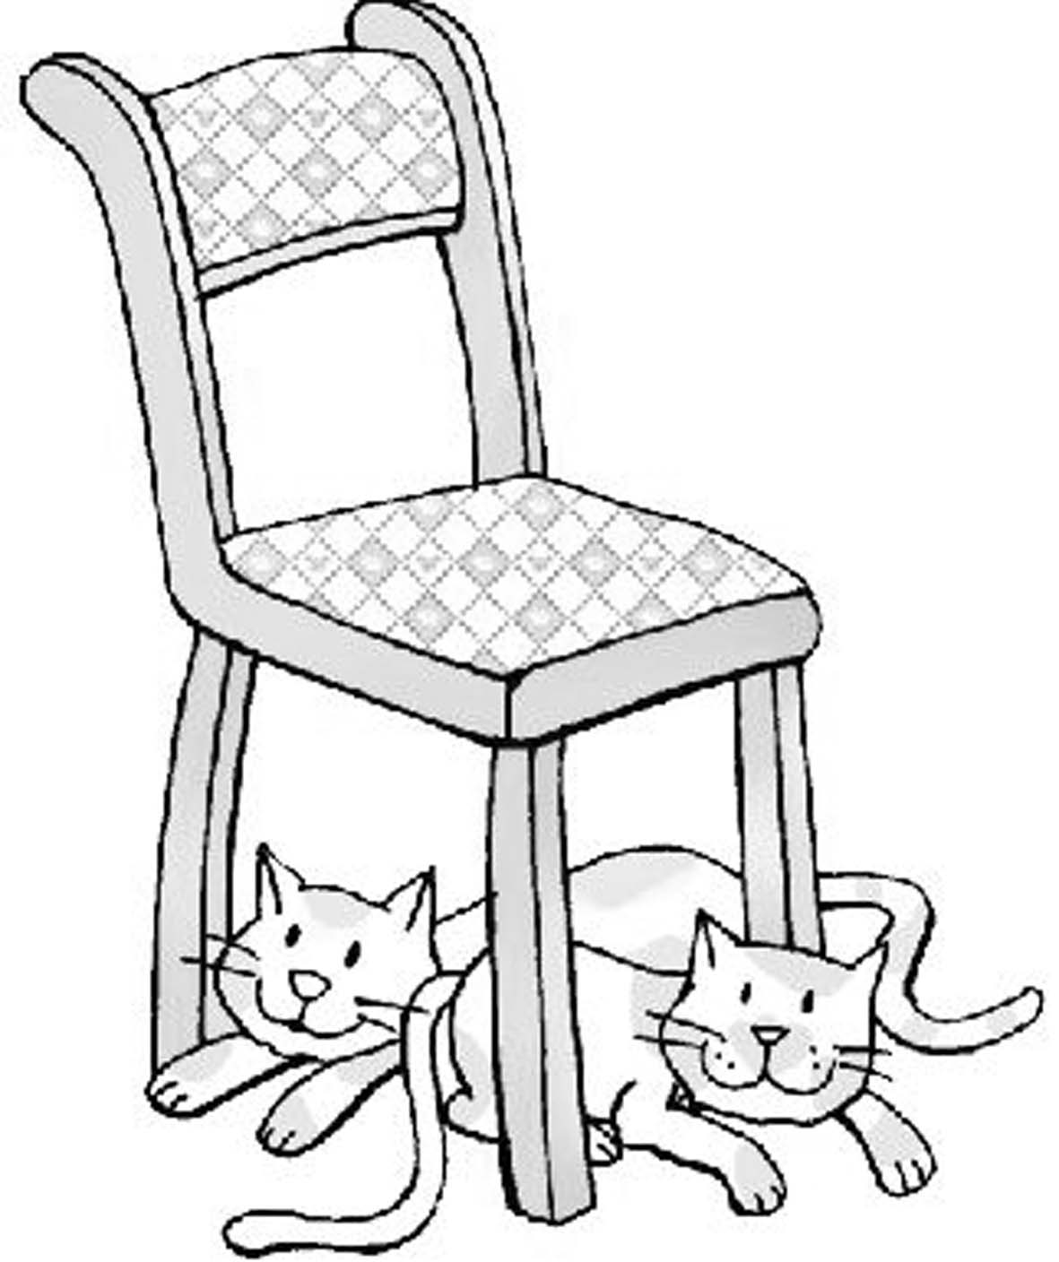

- You're a good student, Amy. (改為祈使句，用 Be 開頭）
4. No, I can't go to your house. (根據劃線部分造原問句)
5. She can play tennis. ( 用 but 合併 )
I can't play tennis.

高雄縣立林園高級中學 國中部96學年度 第一學期 一年級 英文科第二次段考解答卷
範圍：Book 1 L 4-6 班級： 姓名： 座號： 得分:
I. 聽力測驗 30分
A.1 B | 2 C | 3 C | 4 A | 5 C
B 1. D | 2 C | 3 B | 4 B | 5 B
C.1 C | 2 A | 3 C | 4 D | 5 D
II.文意字彙 20分
1 busy | 2 cell | 3 over | 4 woman | 5 singing
6 photo | 7 report | 8 computer | 9 basketball | 10 little
III. 文法 10分
1  B | 2 D | 3 B | 4 B | 5 C
6  C | 7 B | 8 D | 9 B | 10 B
IV.提示填充 10分
1  boys | 2 him | 3 us | 4 me | 5 her
6 Jack’s | 7 it | 8 Amy | 9 them | my
V. 對話 5分
1 C | 2 A | 3 A | 4 B | 5 A
VI.翻譯填充 15分
1 give | 2 to | 3 Can | 4 watch | 5 together
6 tomorrow | 7 Is | 8 there | 9 isn’t | 10 hang
11 up | 12 telephone | 13 get | 14 Chinese | 15 homework
VII. 看圖及根據提示作答 每題二分 錯一字 扣一分 10分
1 He is closing the door.

2 There are (two) cats under the chair.

3 Be a good student, Amy.

4 Can you go to my house?

5 She can play tennis, but I can’t .(play tennis.)

