高雄縣立林園高級中學 國中部96學年度 第一學期 一 年級 英語 科第三次段考考卷
範圍： L 7~ReviewIII 班級： 姓名： 座號：
A部份：聽力評量（30%）
一、聽CD的句子，選出相符的圖片，並將其句子的英文代號填入空格中：10％
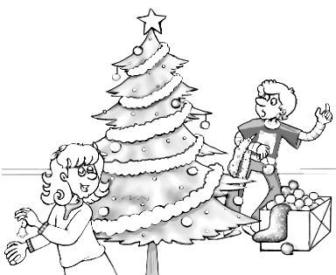  1. |   2. |   3. | 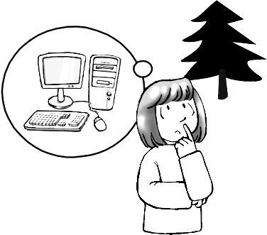  4. | 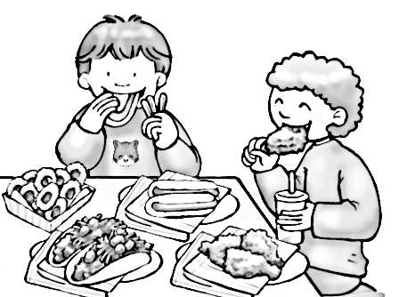  5.
( ) | ( ) | ( ) | ( ) | ( )
二、選出出現在CD句中的單字：10％
( ) 1. (A) everyone (B) lesson (C) tired (D) weekday
( ) 2. (A) red (B) present (C) Tuesday (D) parent
( ) 3. (A) cards (B) wraps (C) a little (D) Christmas tree
( ) 4. (A) do (B) great (C) camera (D) but
( ) 5. (A) children (B) coming (C) come (D) e-mail
三、聽CD的問題，選出最適當的回應：10％
( ) 1. (A) On Monday. (B) You can come over and play with me.
(C) What about you? (D) In the morning.
( ) 2. (A) Because there is no school today. (B) Because I have a lot of homework.
(C) That’s great. (D) I’m tired, but I’m happy.
( ) 3. (A) No, the car is very great. (B) They want the car.
(C) Yes, they do. (D) Yes, they have a car.
( ) 4. (A) Sorry, you can’t. (B) It’s time for bed.
(C) No, I don’t. (D) Cool!
( ) 5. (A) Yes, it is a new computer. (B) No, he is busy.
(C) Yes, he can stay home with us. (D) No, he doesn’t.
B部份：書寫部分（70%）
一、字彙選擇：12％
( ) 1. We can meet on the weekend. How about this ?
(A) Monday (B) Friday (C) Saturday (D) Tuesday
( ) 2. My family are the Christmas tree.
(A) decorating (B) celebrating (C) wrapping (D) learning
( ) 3. The mother is cooking dinner with her _____ in the kitchen.
(A)children (B)students (C) teachers (D) classmates
( ) 4. I can get many ______ on my birthday.
(A) lessons (B) family (C) presents (D) parents
( ) 5. The boy can play computer games today. He very happy.
(A) wants (B) likes (C) feels (D) buys
( ) 6. Chinese New Year is an _______ holiday for family.
(A) easy (B) tired (C) angry (D) important
二、文法測驗：20％
( ) 1. A: What _______ can you go shopping with me? B: _______ Saturday morning.
(A) holidays ; On (B) day ; On (C) today ; In (D) × ; In
( ) 2. ________ everyone want a merry Christmas?
(A)Does (B) Is (C) Are (D) Do

( ) 3. Mary likes dogs, but I .
(A) can’t (B) doesn’t (C) don’t (D) do
( ) 4.It’s time ______ bed. Turn off the TV.
(A) to (B) at (C) in (D) for
( ) 5. the girl playing basketball?
(A) Do (B) Does (C) Is (D) Are
( ) 6. Can we ________ together tomorrow?
(A) go jog (B) going jogging (C) go jogging (D) jogging
( ) 7. Bill, don’t in the room.
(A) runs (B) run (C) running (D) be running
( ) 8. Sally TV the time.
(A) watch ; every (B) is watching ; all (C) watches ; all (D) watches ; every
( ) 9. Peter ________ baseball and Bill is, too.
(A) does play (B) plays (C) can play (D) is playing
( )10.Carol doesn’t like school _______ there are many tests every day.
(A) because (B) and (C) so (D) but

三、對話測驗：12％
( ) 1. A: Do we have school on Wednesday? B:
(A) Sure, we are. (B) No, we can’t. (C) Yes, we have. (D) Yes, we do.
( ) 2. A: I really like that book! B:
(A) Have fun! (B) Yes, I do. (C) But I don’t. (D) No, you can’t.
( ) 3. A: B: He and his friends play tennis in the park.
(A) What does Bill want? (B) Is Bill playing tennis with his friends?
(C) What can Bill play? (D) What does Bill do on Sunday?
( ) 4. A: What is Father doing? B:
(A) He’s playing basketball. (B) He can jog.
(C) Yes, he’s jogging with Mom now. (D) He is in the park.
( ) 5. A: Does he want a CD player?
(A) He wants a CD player. (B) I am not sure.
(C) Yes, he wants a computer. (D) No, I don’t.
( ) 6. A: How are you today? B:
(A) We’re very busy every day. (B) It’s not bad.
(C) Well, it’s time to go to bed. (D) I feel a little tired.
四、克漏字選擇：10％
A: Good morning, Andy. How are you?
B: I’m fine, thank you. 1. is your brother?
A: He’s playing tennis in the park. He 2. tennis every Sunday. And today 3. Sunday.
B: Do you 4. play tennis on Sunday?
A: No, I don’t. I play computer games on Sunday. How about you?
B: Me? I just do my homework at home. I have 5. homework every day.
A: That’s too bad.
( ) 1. (A) What (B) Why (C) How (D) Where
( ) 2. (A) play (B) plays (C) is playing (D) are playing
( ) 3. (A) are (B) is (C) has (D) have
( ) 4. (A) also (B) too (C) for (D) and
( ) 5. (A) many (B) a lot (C) a lot of (D) lot of

五、重組出正確的句子順序及選出正確的翻譯：10％
( )1.Wednesday / go / Boyd / jogging / on / and Tina
(1) (2) (3) (4) (5) (6)
(A) 324651 (B) 324516 (C) 365124 (D) 362451

( )2. in / Christmas / no / There is / America / school / on
(1) (2) (3) (4) (5) (6) (7)
(A) 4361572 (B) 4367215 (C) 4367512 (D) 4361527

( )3. Boyd / but / don’t / I / a computer / has
(1) (2) (3) (4) (5) (6)
(A) 165432 (B) 136524 (C) 165243 (D) 136245

( )4. 你那天能和我一起去游泳嗎？
(A) Do you go swim with me on that day? (B) Can I and you go swimming on that day?.
(C) Can you go swimming with me on that day? (D) Do you goes swimming and me that day?

( )5. 為什麼你一直在玩電腦遊戲？
(A) What do you play computer game all time? (B) Why do you play computer games all the time?.
(C) What do you play computer games every the time? (D) Why do you play computers game every time?
六、閱讀測驗：6％

Hi, my name is Andy Wu. I have a brother and two sisters. They are Bill, Lisa, and Sally. Lisa is a student. She likes to play computer games, but we don’t have a computer at home. This Christmas, Lisa wants a computer. Bill doesn’t like computers. They’re not easy for him. He wants a new basketball. He and his friends play basketball every weekend. My little sister, Sally, wants an MP3 player. What about me? This year, I want a dog. After school, I can play with it. Everyone is happy on Christmas.

( ) 1. What does Lisa want?
(A) A dog. (B) A computer. (C) A cell phone. (D) An MP3 player.
( ) 2. What does Andy’s little sister want?
(A) A CD player. (B) An MP3 player. (C) A dog. (D) A basketball.
( ) 3. Which is true? (何者為真？)
(A) Andy doesn’t like dogs. (B) Sally has one brother and two sisters.
(C) Bill plays basketball on Saturday and Sunday. (D) Bill wants a computer.

解答
A部份
- DACBE
- CBACB
- ABCDD

B部份
- CAACCD
- BACDC CBCDA
- DCDABD
- DBBAC
- DACCB
- BBC

