高雄縣立林園高級中學 國中部96學年度 第一學期 一年級 英文單科評量考卷
範圍： Lesson 1~ Lesson 4 班級： 姓名： 座號：
- 聽力測驗(50%)
- 選出字首的音標
( )1. 【k】【f】 【t】【p】
( )2. 【d】【f】 【v】【p】
( )3. 【k】【f】 【b】【p】
( )4. 【t】【f】 【v】【d】
( )5. 【p】【b】 【t】【g】
(B) 選出句中出現的單字
( )6. sorry sister hungry school
( )7. watch fine kitchen great
( )8. English Chinese homework friend
( )9. our their your park
( )10. under please play from
(C) 若句子與圖片符合，選；不符合，選
11. 12. 13.
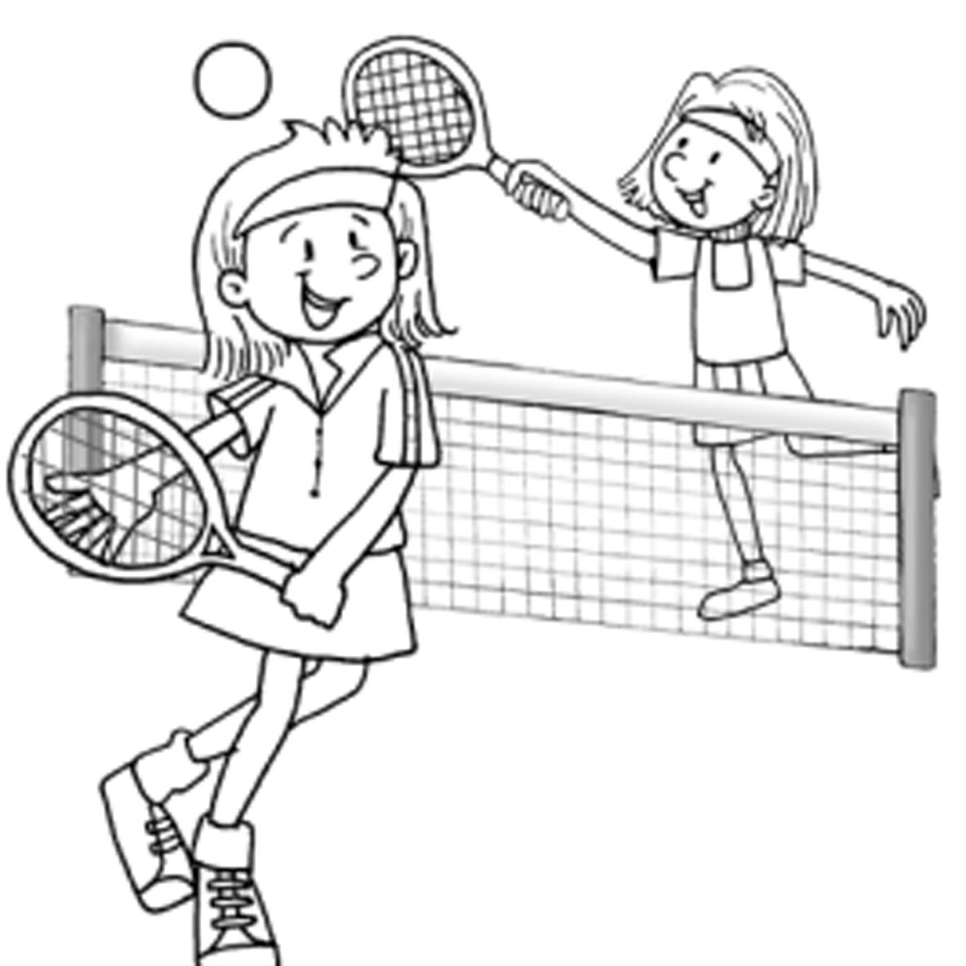
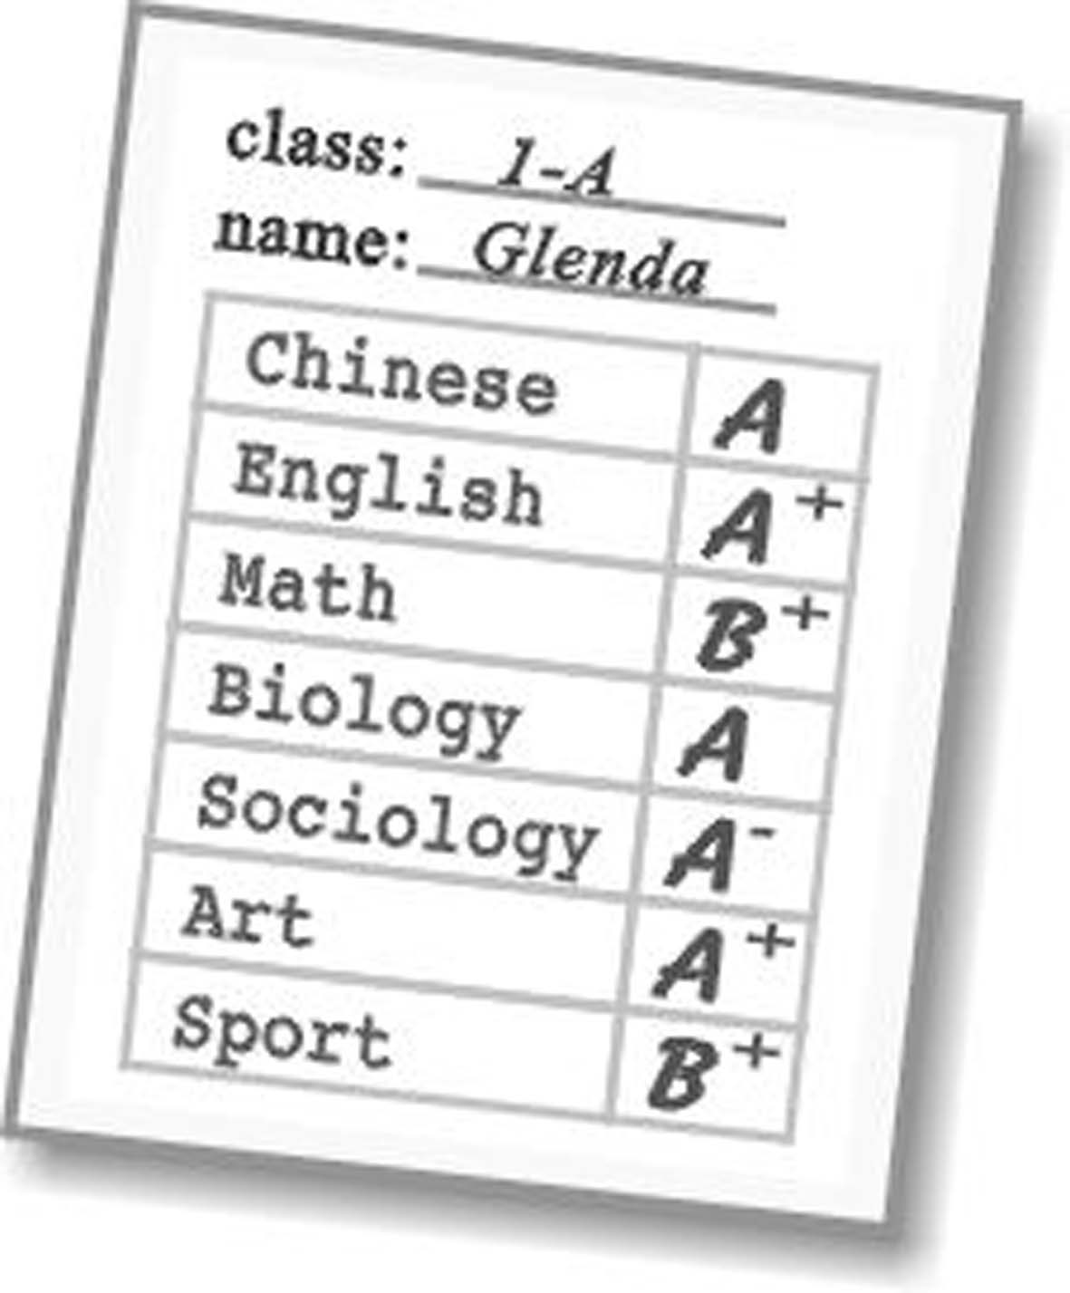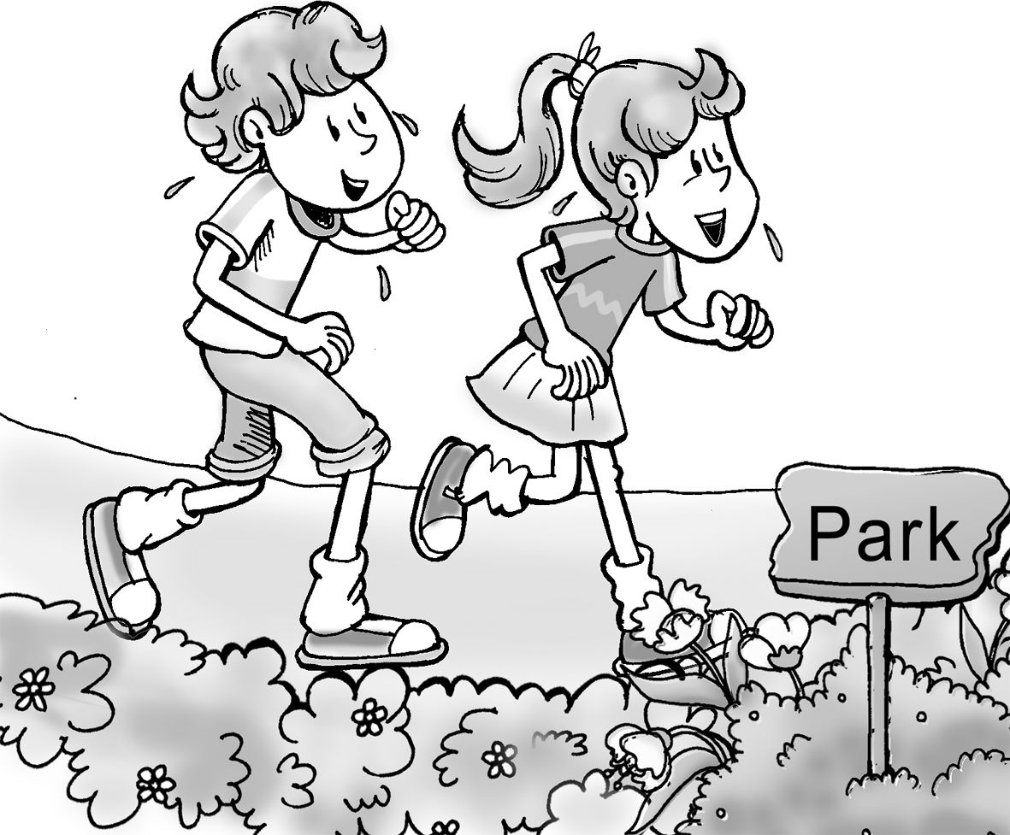
14. 15. 16.
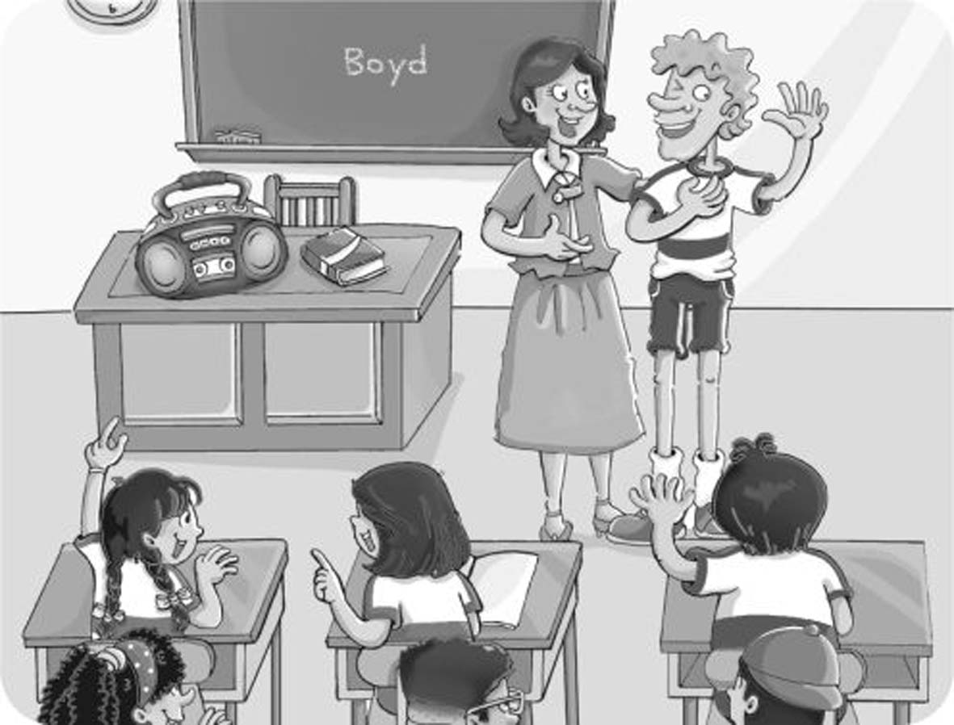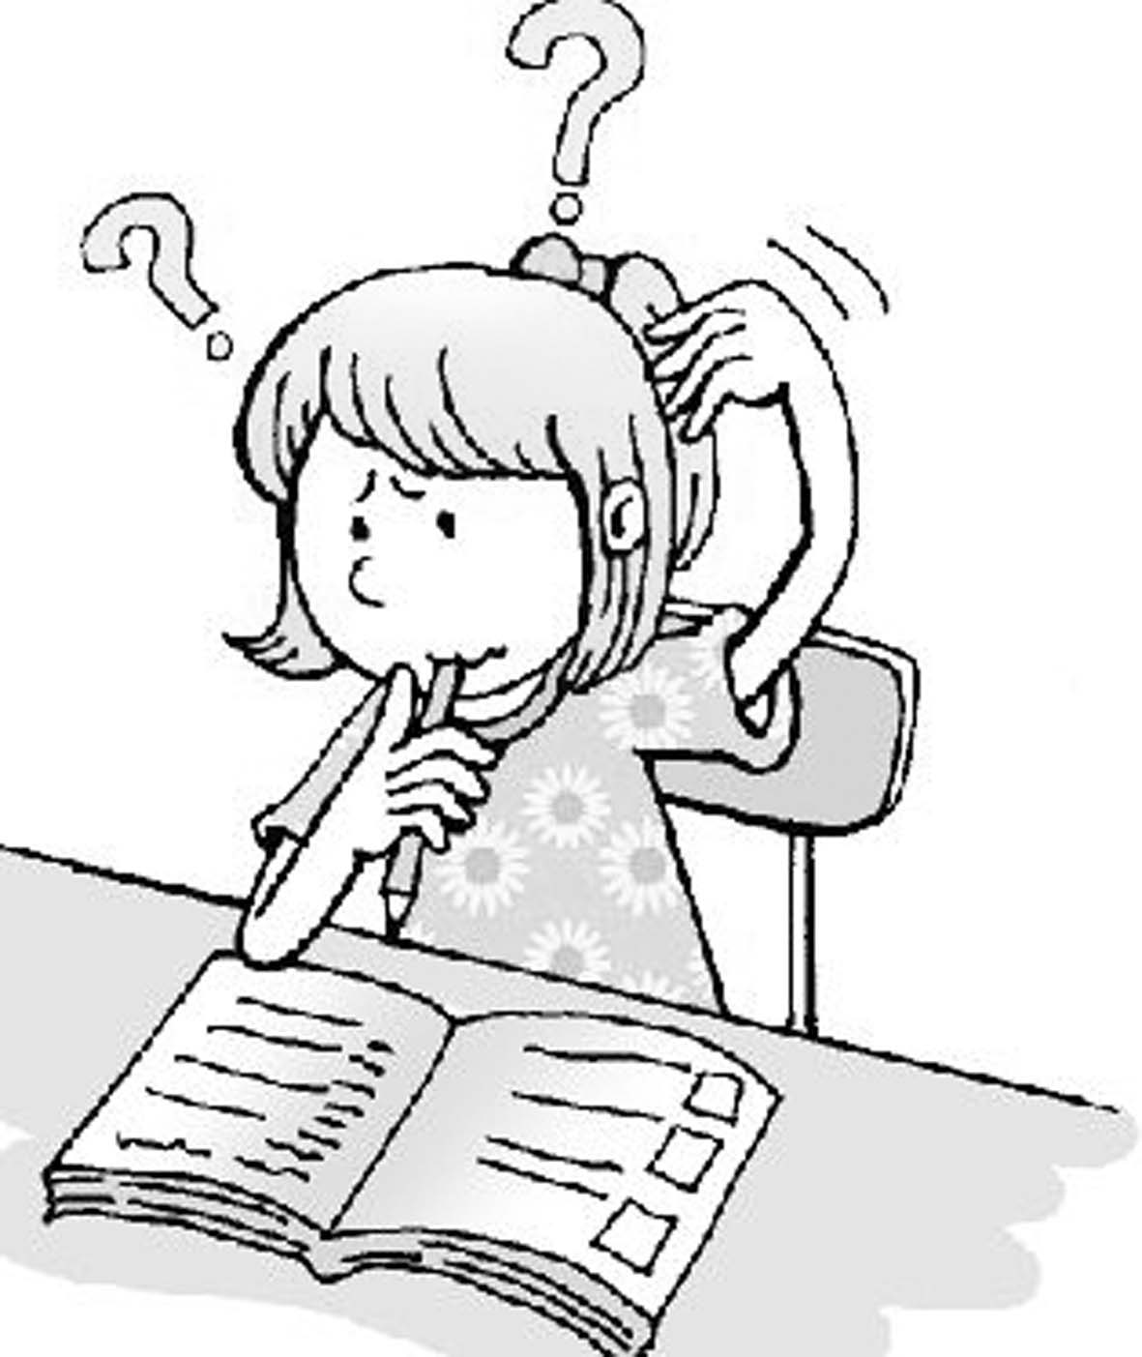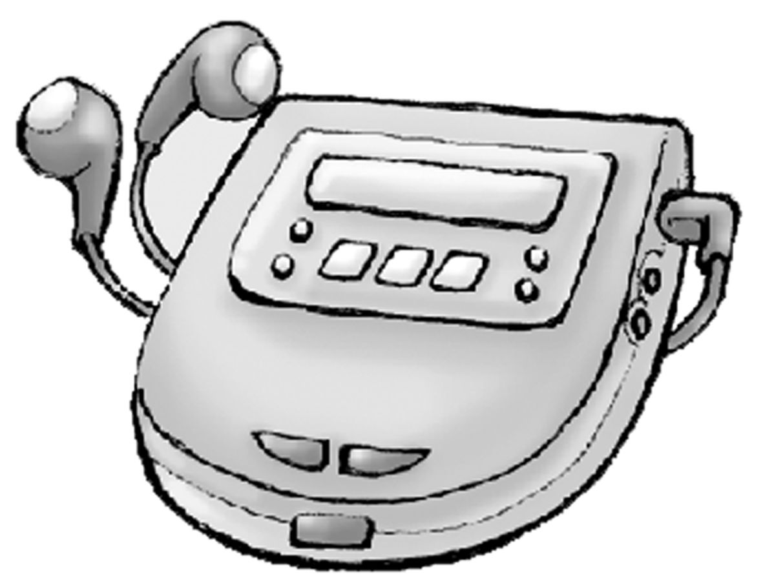
17. 1 8. 19. 20.
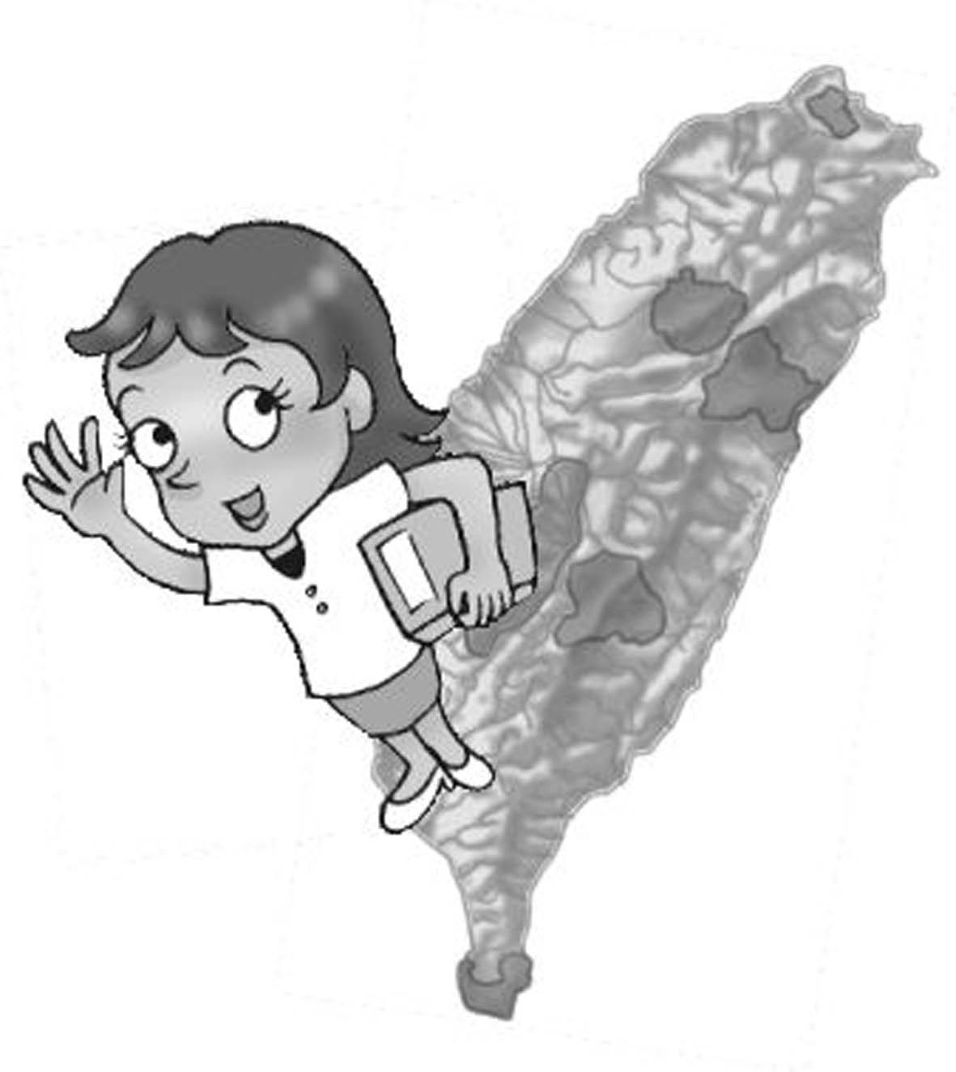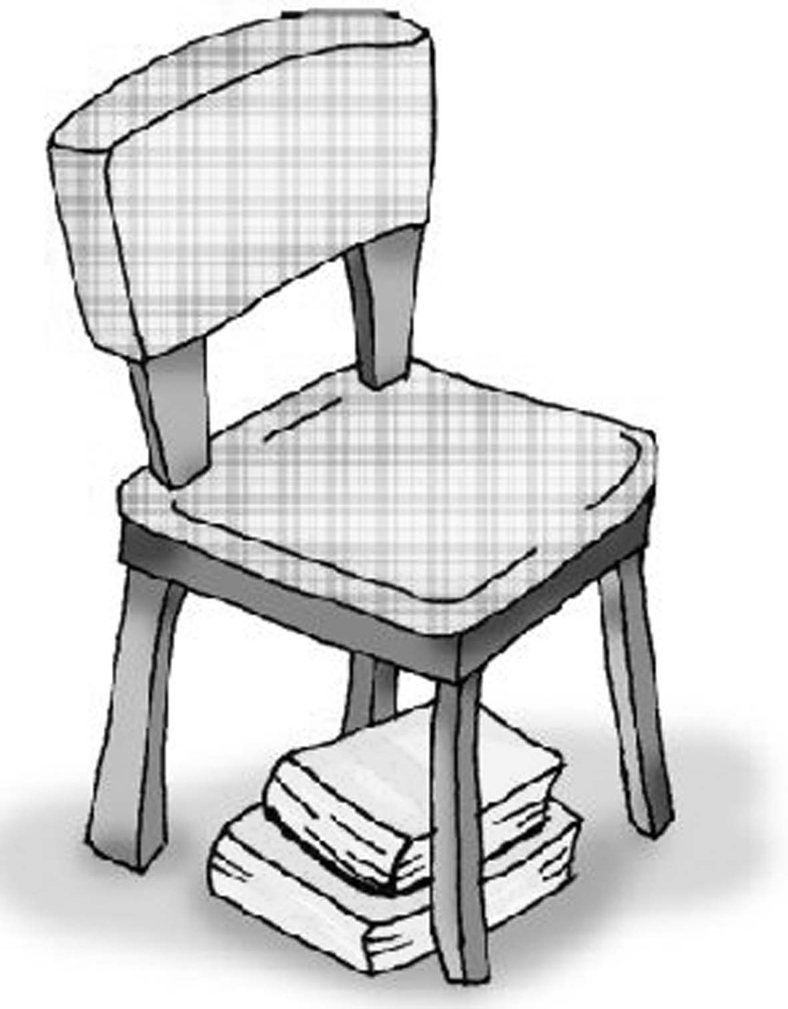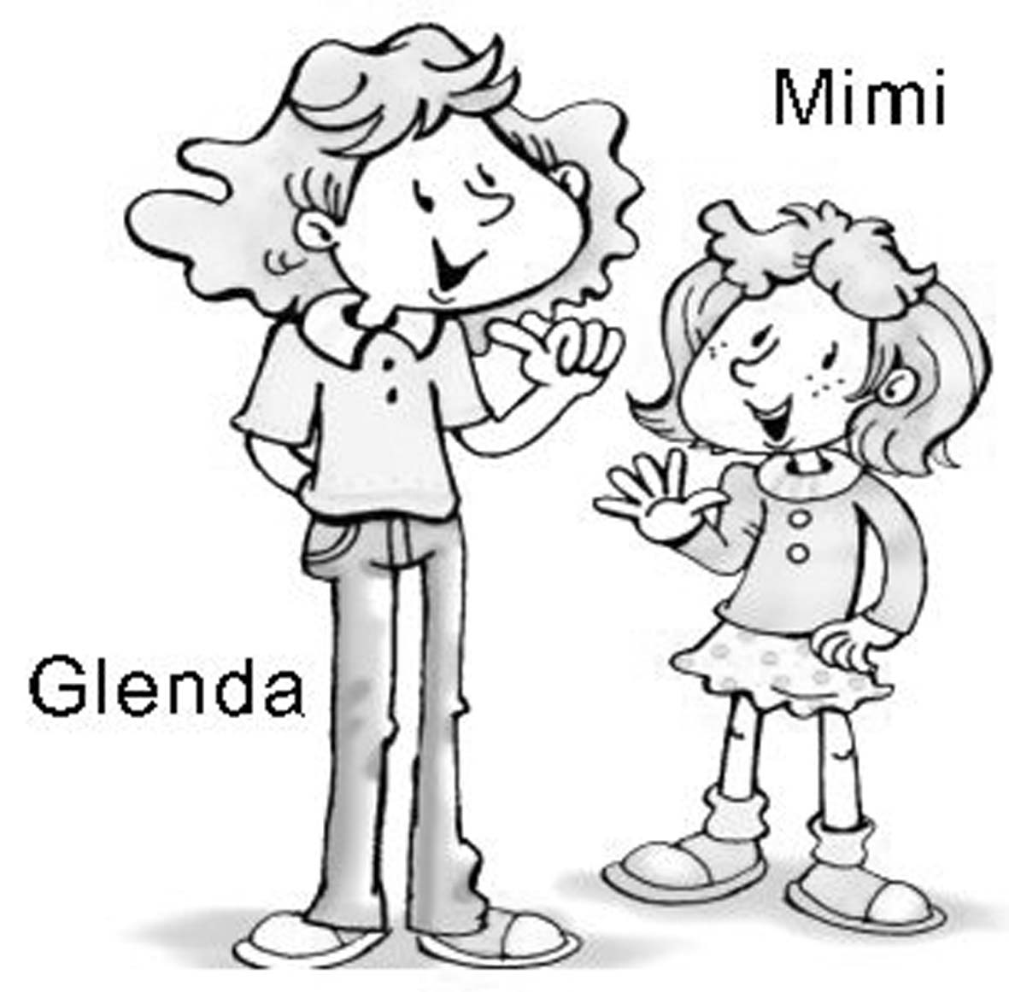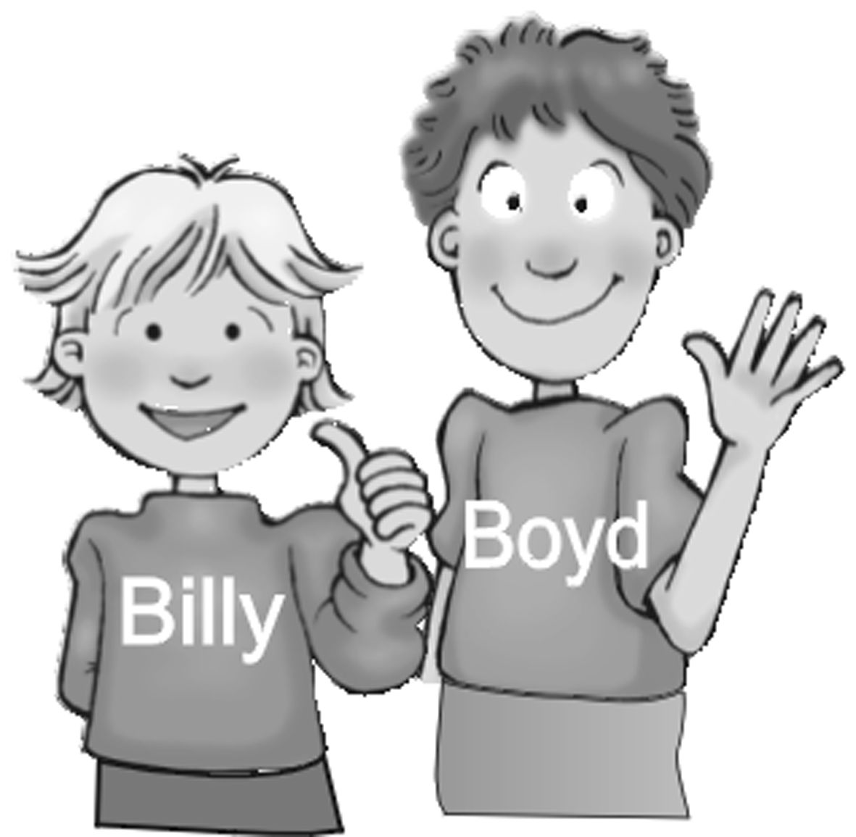

(D) 根據對話選出適當的答案
Dialogue 1.
( )21. The girl’s first name is_______. Betty Glenda Mimi Lisa
Dialogue 2
( )22. Who is in Mr. Lin’s class? Andy Lisa Miss Lin Joe
Dialogue 3
( )23. Who can’t swim? Kimi Benny Bobby Benny’s brother
( )24. Where is Bobby? At school At home In the swimming pool In his room
Dialogue 4
( )25. What is on Andy’s desk? His books His lunch Glenda’s books Glenda’s lunch

- 字彙、文法、閱讀(50%)
( )26. A: Is she ____ classmate? B: Yes, she is my classmate. her his your my
( )27. ______ your name Amy? Am Is Are Aren’t
( )28. A: ___ your friends hungry? B: I’m not sure. Am Is Are Isn’t
( )29. A: ____ your English teacher? B: She’s great. How’s Who’s What’s Where’s
( )30. A: Are Lisa and Mimi from Taiwan? B: No, _____ aren’t. she these they we
( )31. Glenda: How is Boyd? Andy: _____. Fine, thank you. He is not in class. He is not well.
He is my brother.
( )32. A: Where is Frank? B: He is ____. at home from the UK America not bad
( )33. Andy is in my class. He is my ____. teacher mother classroom classmate
( )34. My mother is ____ the telephone in the living room. on at in from
( )35. A: Can you _____? B: Yes, I can. to swim swimming swims swim
( )36. Please give _____ _____ report card. him; my your; me my; you her; me
( )37. I can read the story, ______ she can’t. and but about so
( )38. 選正確的句子Please, say your name. Please say your name Mark. Say your name, Mark, please. Mark, say your name.
( )39. Sylvia is ____ now. She can’t get the key for you. happy fine busy hungry
( )40. Are you busy ____ your homework? in with do on
This is Lisa. She is from America. She can swim and play basketball, but she
can’t play tennis.
Chris is Lisa’s friend. He is from Taiwan. He can play tennis and basketball, but
he can’t swim.
( )41. Where is Chris from? Taiwan America the US Taipei
( )42. Who can’t play tennis? Lisa Chris Lisa’s friend Chris and Lisa
Ted: Good morning, Andy.
Andy: 43 , Ted.
Ted: ___44__ that girl?
Andy: That’s Jessica.
Ted: 45 she your classmate?
Andy: Yes. She’s a new student in 46 class. She came to Taiwan last week.
Ted: She is tall, 47 she is pretty, too.
( )43. How are you? I’m fine. Good morning. Good afternoon.
( )44. How’s Who’s What’s Where’s
( )45. Are Am Don’t Isn’t
( )46. our his their me
( )47. so or and but
John: Hello, Sandy. How are you?
Sandy: Fine, John. It’s my birthday.
John: It’s your birthday? Happy birthday to you.
Sandy: Thank you, John.
John: Sandy, what’s that?
Sandy: That’s my birthday present(禮物).
John: What is it?
Sandy: What is it? It’s my new dog.
John: Dog? It looks like a pig.
( )48. Whose(誰的) birthday is it today? John John’s pig Sandy Sandy’s dog
( )49. What’s Sandy’s birthday present? A dog. A pig. A doll. A surprise.
( )50. What does the dog look like? A flower. A dog. A boy. A pig.

高雄縣立林園高級中學 國中部96學年度 第一學期一年級英文科單科評量 答案卷
範圍： 班級： 姓名： 座號：
- CAABD
- CBCAB
- ABABA
- AABBA
- DDACB
- CBCAC
- CADAD
- ABDCB
- AACBD
- ACCAD

