高雄縣立林園高級中學 國中部96學年度 第一學期 二年級 英文 科第一次段考考卷
範圍：Unit1~Review1 班級： 姓名： 座號：
第一部分，聽力測驗 (每小題2分，共30分)
一、根據圖片，請回答所聽到的問題答案。

1. | 2. | 3. | 4. | 5.
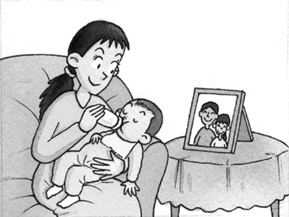 | 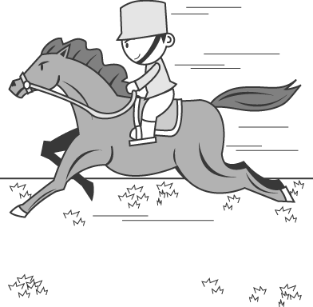 | 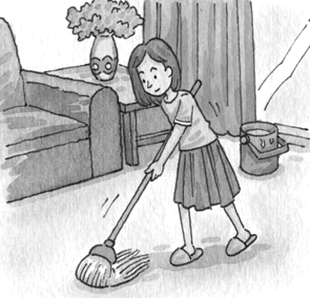 | 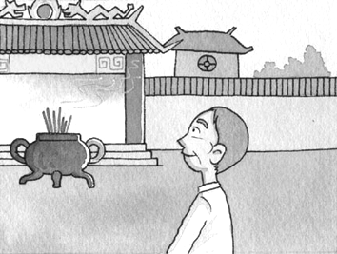 | 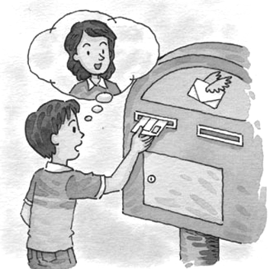
- ( )(A) She looked at her baby. (B) She was feeding her baby. (C) She was taking a picture. (D) She watched TV.
- ( )(A)A man ran after a horse. (B)A man rode a horse. (C)The man was with a hat. (D)The horse was running.
- ( )(A)She danced with a mop. (B)She wrote with a mop on the floor. (C)She carried flowers. (D)She mopped the floor.
- ( )(A) At a church. (B) At a gym. (C) At a temple. (D) At a museum.
- ( )(A) He was sending her mother a letter. (B)He was talking to her mother. (C)He was playing the mailbox. (D)He was cleaning the mailbox.

二、選出你所聽到的單字。
1. ( ) (A)Queen. (B)Quick (C)Question. (D)Quiet.
2. ( ) (A)Walk. (B) Fall. (C) Wall. (D)Word.
3. ( ) (A)Thank (B) Third.. (C)Salt. (D)Think.
4. ( ) (A)Flower. (B)Front. (C)Frank. (D)Floor.
5. ( ). (A)Concert. (B) Concern. (C)common. (D) Camp.

三、聆聽以下的問題，選出最佳的答案。
- ( )(A)Yes, I buy a sweater for you. (B) No, I bought nothing . (C)No, I don’t buy anything at all. (D)No. I buy nothing.
- ( )(A) I like it. (B) Let’s take him to the hospital. (C) I didn’t mean to. (D) I don’t mean to.

四、根據聽到對話內容及問句，選出正確的答案。
(１)（ ）(Ａ) Yes, it’s messy. (Ｂ) No, it’s not messy. (Ｃ) Yes, it was. (Ｄ) No, it wasn’t.
(２)（ ）(Ａ) She studied English. (Ｂ) She did her math homework. (Ｃ) She cleaned up the living room. (Ｄ) She played computer games.
(３)（ ）(Ａ) They don’t have anything to do. (Ｂ) They’re too tired. (Ｃ) Uncle Sam is visiting them. (Ｄ) They are happy to clean it up.

第二部分，紙筆測驗
  - 文意字彙 (每題1分，共10分)
1. The Lee family went to Japan on v n this summer.
2. James made a ship of s ls on the beach. The ship was beautiful.
3. I don’t like my skin white. I want to have a s n at the beach.
4. It’s cold outside. Put on your s r before you go fishing.
5. Shopping in a d t store is Denny’s favorite hobby.
6. S.H.E. are f s stars in Taiwan. They are popular with most students.
7. Many people worship(朝拜) in Confucian t e (孔廟) on September 28th.
8. Some Japanese plan to make a long s y in Taiwan.
9. S e sent a message to you on your cell phone.
10. I can’t b e it! Jolin is your new English teacher.

  - 綜合測驗 (每題2分，共20分)
( ) 1. The mother fed her little baby an hour . (Ａ) before (Ｂ) ago (Ｃ) after (Ｄ) later

接下一頁
( ) 2. James like rock music very much before, but now he . (Ａ) doesn’t; does (Ｂ) does; does (Ｃ) didn’t; did (Ｄ) didn’t; does
( ) 3. What Jenny last Sunday afternoon? (Ａ) did; do (Ｂ) did; did (Ｃ) does; do (Ｄ) do; do
( ) 4. What you at 10:30 the day before yesterday? (Ａ) do; do (Ｂ) did; do (Ｃ) were; doing (Ｄ) are; doing
( ) 5. Terry wrote Carol a birthday card. (Ａ) to (Ｂ) for (Ｃ) with (Ｄ) ╳
( ) 6. My sister the table at 6:00 the day before yesterday. (Ａ) wipes (Ｂ) wiped (Ｃ) was wiping (Ｄ)doesn’t wipe
( ) 7. Fruit is good for our health（健康）. The book so, right? (Ａ) says (Ｂ) talks (Ｃ) tells (Ｄ) speaks
( ) 8. I left my homework in teacher’s office. Can you it me? (A) Bring; at (B) bring; for (C) sent; to (D) show; to
( ) 9. Ada rode her motorcycle very fast and a tree. (A)showed (B)wiped (C)hit (D)ate
( )10.A: Who the floor? B: Jolin did. (A)mops (B)mop (C)moped (D)mopped

  - 寫出介系詞或適當的動詞形式 (每題1分，共10分)
1. What happened your Brother? He looked worried.
2. Kelly wrote a sweet letter Carol.
3. Nancy bought some beautiful flowers her mom on Mother’s Day.
4. Tina had four tickets the tennis game.
5. You can watch TV a while.
6. Don’t tell me about the plan again. I (change) my mind (主意) yesterday.
7. Daniel (study) all night last night.
8. Larry (see) some beautiful girls swimming at the beach in summer .
9. Stacy (fall) asleep in the sun, so she got a bad sunburn.
10. Anny (jog) at the park on Saturday morning last week.

  - 對話 (每題2分，共10分)
( ) 1. Ivy: Did you have fun on Uncle Jack’s farm?
Bill:
(Ａ) No, I had a good time there.
(Ｂ) No, I don’t have a good time there.
(Ｃ) No, I had a terrible time there.
(Ｄ) No, I have a terrible time there.
( ) 2. Mary: You didn’t tell me the truth（實情）. You broke my heart.
Tony: I am so sorry.
(Ａ) I had a terrible time.
(Ｂ) I didn’t mean to.
(Ｃ) I meant to say so.
(Ｄ) I meant it.
( ) 3. Tom: Mom, can I go to my friend’s house... Aachoo!
Mom: Bless you!
Tom: .
Mom: You can’t go out. Stay home and drink some hot water.
(Ａ) Did you eat anything?
(Ｂ) I have a great time.
(Ｃ) I catch a cold.
(Ｄ) I didn’t mean to.
( ) 4.Sam: Why was Ivan so excited yesterday?
Sue:
(Ａ) She had a question at work, and no one could answer it.
(Ｂ) She caught a terrible cold.
(Ｃ) She stayed in bed for many days.
(Ｄ) Her boyfriend visited her and gave her a beautiful present.
( ) 5. Dad: Why were you all wet?
Sue:
(Ａ) I drank a lot of water.
(Ｂ) A dog ran after me, and I fell into a river.
(Ｃ) I went shopping at a night market.
(Ｄ) I bought a new dress.

接下一頁

  - 閱讀 (每題2分，共10分)
1.
Last week, my family and I spent our vacation in Kaohsiung. We visited many interesting places. On the first day, we visited an old market and Kaohsiung Harbor. On the second day, we drove to see an exciting baseball game. On the third day, after we went swimming at the beach, we returned to Taichung. The next day, on Monday, my brother and I had to go to school.
All of my family had much fun during the vacation.

 harbor 海港 return 返回

( )1. What day did they visit Kaohsiung Harbor?
(A)On Sunday. (B)On Saturday. (C)On Friday. (D)On Thursday.
( )2. Where do they live?
(A)In Kaohsiung. (B)At Kaohsiung Harbor. (C)In Taichung. (D)We don’t know.
( )3. What are the writer and his brother?
(A)Travelers. (B)Students. (C)Office workers. (D)Baseball Players.
2.
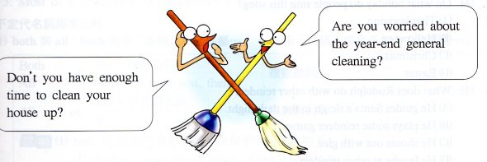
Then you need to call me, 766 Cleaning Company.
Service in no time! Clean first!
P.S. to add to keep in good repair.
Call (at) 03-5766-5766
 general 一般的 repair 修理 add 增加 in no time 立刻

( )1. What month may it be now?
(A)September. (B)December. (C)July. (D)March.
( )2. What CAN’T 766 Cleaning Company do for you?
(A)Cook dinner. (B)Fix the window. (C)Mop the floor. (D)Wipe the table.

  - 翻譯與造句 (每題2分，共10分)

- Vicky 上周日下午和誰去釣魚?

- 在廚房裡，Tom第一次下廚。他覺得很興奮。

- 昨天晚上我什麼都沒吃。

- She was washing her shoes at 10:00 on Monday morning. (造原問句)

- Did Sam and Judy have a good time at the party? (先否定簡答，再詳答)

恭喜你作答完畢，別忘了檢查喔！

高雄縣立林園高級中學 國中部96學年度 第一學期 二年級 英文 科第一次段考解答
範圍：Unit1~Review1 班級： 姓名： 座號：
第一部分，聽力測驗(每小題2分)
一、根據圖片，請回答所聽到的問題答案。
1. | 2. | 3. | 4. | 5.
B | A | D | C | A
二、選出你所聽到的單字。
1. | 2. | 3. | 4. | 5.
C | C | B | D | A
三、聆聽以下的問題，選出最佳的答案。
1. | 2.
B | C
四、根據聽到對話內容及問句，選出正確的答案。
1. | 2. | 3.
C | D | C

第二部分，紙筆測驗
  - 文意字彙 (每題1分，共10分)
1. | 2. | 3. | 4. | 5. | 6. | 7. | 8. | 9. | 10.
vacation | seashells | suntan | sweater | department | famous | temple | stay | Someone | believe

  - 綜合測驗 (每題2分，共20分)
1. | 2. | 3. | 4. | 5. | 6. | 7. | 8. | 9. | 10.
B | D | A | C | D | C | A | B | C | D

  - 填充 (每題1分，共10分)
1. | 2. | 3. | 4. | 5. | 6. | 7. | 8. | 9. | 10.
to | to | for | to | for | changed | Was studying | saw | fell | jogged

  - 對話 (每題2分，共10分)
1. | 2. | 3. | 4. | 5.
C | B | C | D | B

  - 閱讀 (每題2分，共10分)
1.
1. | 2. | 3.
C | C | B

2.
1. | 2.
B | A

  - 翻譯與造句 (每題2分，共10分)

- Vicky 上周日下午和誰去釣魚?
Who did Vicky go fishing with last Sunday afternoon?
- 在廚房裡，Tom第一次下廚。他覺得很興奮。
In the kitchen, Tom cooked for his first time, and he was excited.
- 昨天晚上我什麼都沒吃。
I didn’t have anything last night./I had nothing last night.
- She was washing her shoes at 10:00 on Monday morning. (造原問句)
What was she doing at 10:00 on Monday morning?
- Did Sam and Judy have a good time at the party? (先否定簡答，再詳答)
No, they didn’t. They didn’t have a good time at the party.

