高雄縣立林園高級中學 國中部96學年度第一學期 二年級 英文 科第二次段考考卷
範圍：L4－Review2 班級： 姓名： 座號：
第一部分，聽力測驗（每小題2分，共30分）
一、根據錄音內容選出適當的答句。
1、（A）I was on my way home.（B）Because it is late.（C）Because I have fever.（D）Because you didn’t tell the truth.
2、（A）There are too many. （B）It’s too expensive.（C）I miss the bus. （D）The MRT station is open.
3、（A）Yes, I forgot it. （B） No, I can do it. （C）Yes, I remember her.（D）No, you can not remember it.
4、（A）It’s my birthday. （B）Because today is special.（C）We don’t get together on Christmas.（D）I had a big dinner that day.
5、（A）It is a big tire. （B）I have a flat tire. （C）Let’s go get some money. （D）Four hundred dollars.

二、根據聽到的內容填入相符的題號。

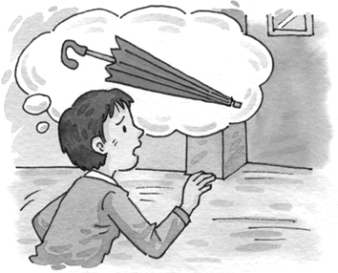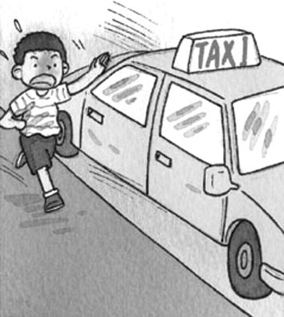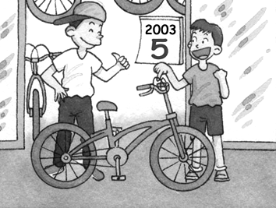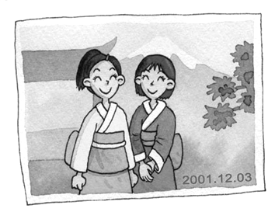

（A） （B） （C） （D）

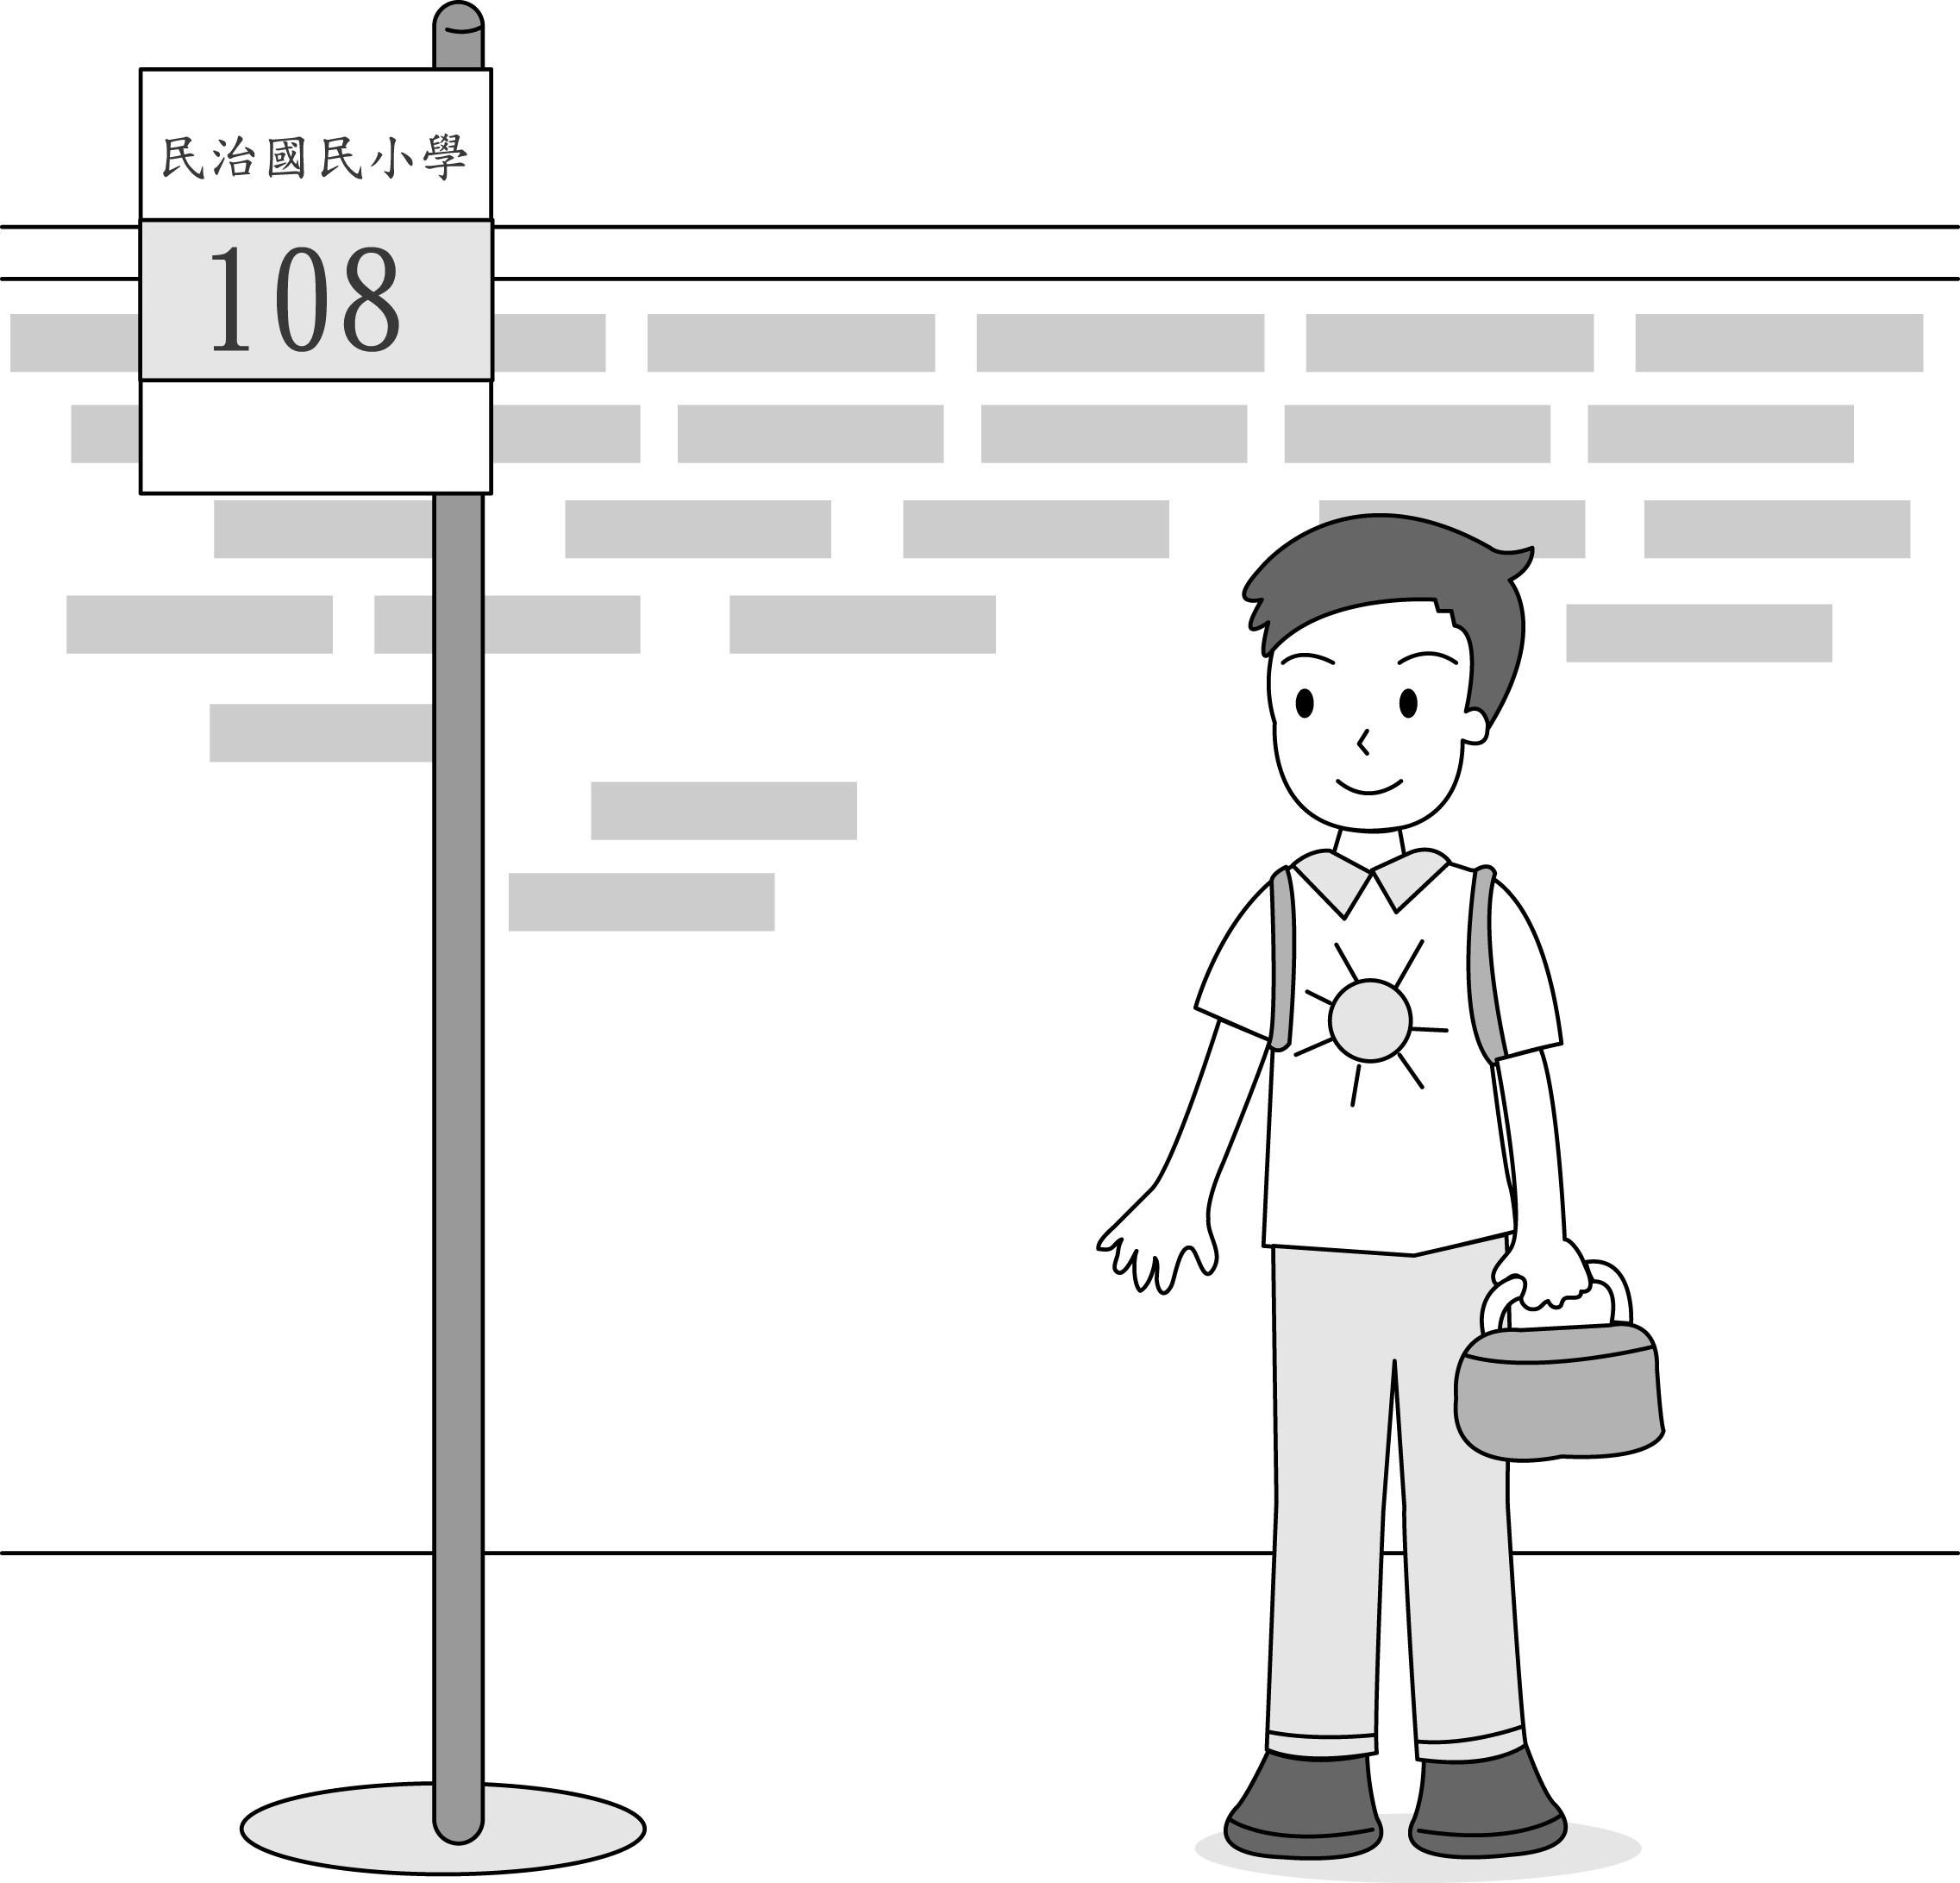

（E）

三、選出你所聽到的單字：
（1）（A）she （B）finally （C）please （D）true
（2）（A）straight （B）block （C）right （D）corner
（3）（A）Christmas （B）for （C）Tuesday （D）November
（4）（A）funny （B）sunny （C）favorite （D）fourth
（5）（A）is （B）sleeping （C）sleepy （D）asleep
第二部分，紙筆測驗（70分）
- 語法選擇（每題1分，共10分）
1. She is _____ to see a cat in her car.
(A)surprised (B)surprising (C)surprises (D)surprise
2. We have to help the poor(窮人) in our ______ .
(A)life (B)lifes (C)live (D)lives
3. The bakery is ______ the corner of Beach Road and Second Street.
(A)on (B)during (C)from (D)between
4. There’s a library _______ here.
(A)across (B)around (C)between (D)next
5. Why ______ you come to school yesterday? Were you sick?
(A)weren’t (B)didn’t (C)doesn’t (D)won’t
6. I don’t believe you. You’re not ______ the truth.
(A)talking (B)speaking (C)saying (D)telling
7. I want to keep fit (保持身材),so I never eat anything sweet ______ meals.
(A)behind (B)next (C) between (D)across
8. My classes begin _____ September.
(A)at (B)in (C)with (D)for
9. The Wang family usually goes camping ______ holidays.
(A)on (B)in (C)at (D)for
10. What did Ben’s mom make ______ him ______ the evening of April 22 ______ 2007?
(A)to;on;in (B)for;on;in (C)to;in;in (D)for;on;of
二、文意字彙(每題2分,共20分)
1. I can’t read Mr.Chen’s h g. It’s too messy.
2. Go straight for two b ks . The bank is there.
3. My f e food is salad. I eat it every day!
4. D g the Chinese New Year, everyone is very happy.
5. Mary m sed her parents very much, so she wrote them a letter.
6. Let’s get s g to drink. It’s hot and I’m so thirsty.
7. Some beautiful women enjoy looking at t s in the mirror(鏡子).
8. Who did you i e to your party tonight?
9. You can buy eggs at a c e store, too.
10. I take out the t h at 7:00 p.m.every day.
三、填充題（每格1分，10分）
1. I f you don’t have a key, you can’t _______ _______ the house.
2. He left Taipei _______ Tainan last night.
3. I bought the cat _______ 2004.
4. We had some turkey ______ dinner.
5. Helen didn’t go to school ________ she was sick.
6. Many people get _______ and _______ the bus at the station.
7. There is not anything wrong _______ your computer.
8. The answer _______ your question is “1,000.”

四、閱讀（每題2分，共8分）
1.
Brian comes from the U.S.A., but he’s now living and studying in Tainan. Christmas is his favorite holiday, but he doesn’t know much about Chinese New Year.
Today is February 2nd. Chinese New Year is two weeks away. Brian’s good friend, Georege, will invite Brian to his house for the New Year. On Chinese New Year’s Eve, George’s family will have a big dinner. They’ll have chicken, fish, dumplings, and many other delicious dishes. After dinner, they’ll watch TV, make some tea and talk more about the customs for Chinese New Year. George’s parents will also give Brian a red envelope with NT$3,600 inside. It will be Brain’s first time to get the “lucky money."
dmpling(s) 水餃 dish(es)菜肴
cstoms(s) 習俗 envelope 信封

1. When’s Chinese New Year this year?
- On February second. (B) On February ninth. (C) On February sixteenth.
(D) On February twelfth.
2. Which holiday does Brian like the best (最)?
(A) Chinese New Year. (B) Thanksgiving. (C) Christmas. (D) New Year’s Eve.
3. How much lucky money will Brian get at least (至少) this year?
(A) NT$1,200. (B) NT$3,600. (C) NT$2,400. (D) NT$7,200.
4. Which is NOT true?
(A) Brian is an American, but George isn’t. (B) George’s family like to drink tea aftrer dinner. (C) Brian will spend Chinese New Year in Taiwan (D) George and Brian are good friends and classmates.

五、翻譯（每題3分，共12分）
1.他用英文寫日記。
2.我對我生命中所有美好的事物表達感謝。
3.一年的第十個月份是十月。
4.John昨天自己煮晚餐。

六、課文填空（每格1分，共10分）
1、 Brian _______ _______ the U.S.A. Last week, Brian _______ a very _______ Thanksgiving ________ Taiwan. _______ dinner, Brian told Thanksgiving jokes _______ Mrs. Lin’s family.
2、______the way_______ Carol’s house, he bought beautiful flowers _______ her, but he could not find her house.

高雄縣立林園高級中學 國中部96學年度第一學期 二年級 英文 科第二次段考考卷
範圍： 班級： 姓名： 座號：
第一部分，聽力測驗（每小題2分，共30分）
一、
1. | 2. | 3. | 4. | 5.
D | B | C | A | D
二、
1. | 2. | 3. | 4. | 5.
C | D | B | A | E
三、
1. | 2. | 3. | 4. | 5.
B | A | D | A | C
第二部分，紙筆測驗（70分）
- 語法選擇（每題1分，共10分）
1. | 2. | 3. | 4. | 5. | 6. | 7. | 8. | 9. | 10.
A | D | A | B | B | D | C | B | A | B
二、文意字彙(每題2分,共20分)
1. | 2. | 3. | 4. | 5. | 6. | 7. | 8. | 9. | 10.
handwriting | blocks | favorite | During | missed | something | themselves | invite | convenience | trash
三、填充題（每格1分，10分）

1. | 2. | 3. | 4. | 5. | 6. | 7. | 8. | 9. | 10.
get | into | for | in | for | because | on | off | with | to
四、閱讀（每題2分，共8分）

1. | 2. | 3. | 4.
C | C | B | D

五、翻譯（每題3分，共12分）
1. He keeps a diary in English.
2. I show thanks for all the good things in my life.
3. The tenth month of the year is October.
4. John cooked dinner by himself yesterday.

六、課文填空（每格1分，共10分）
1. | 2. | 3. | 4. | 5. | 6. | 7. | 8. | 9. | 10.
comes | from | had | special | in | At | to | On | to | for

