高雄縣立林園高級中學 國中部 96 學年度 第一學期 第三次評量 二年級 英文科試題卷
範圍: Unit 7~ Review III
- 選出與錄音內容相符的圖片 6 %
1. (A) (B) (C) 2. (A) (B) (C)
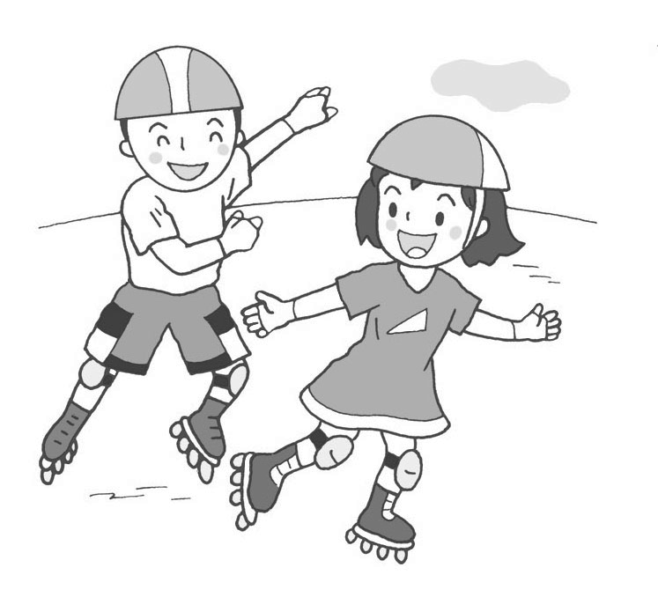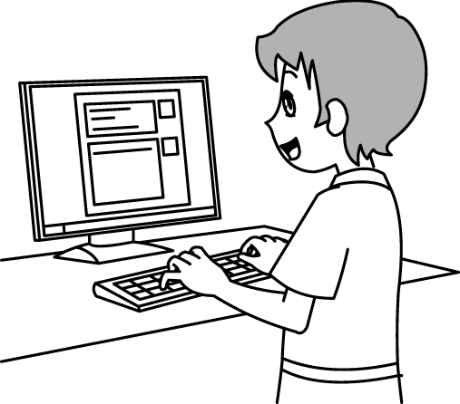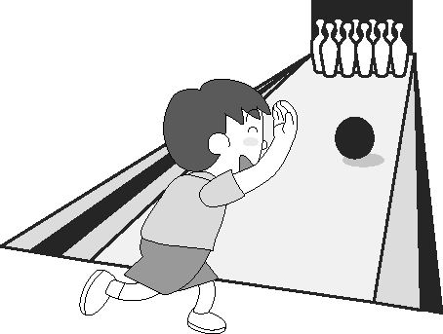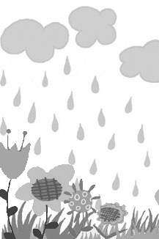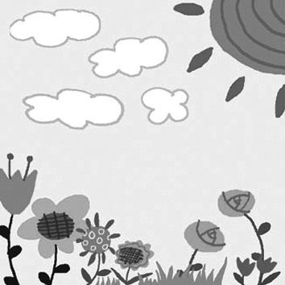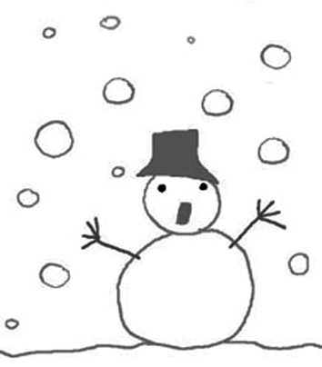
3. (A) (B) (C) 4. (A) (B) (C)
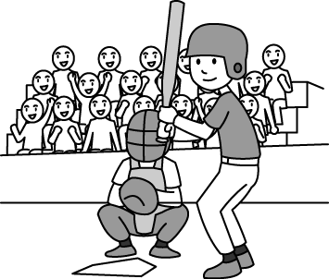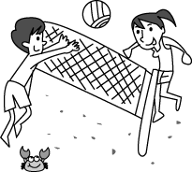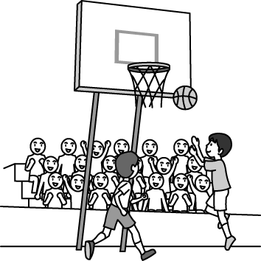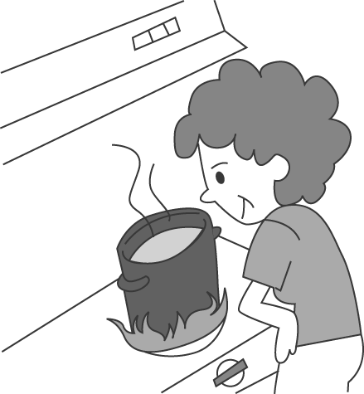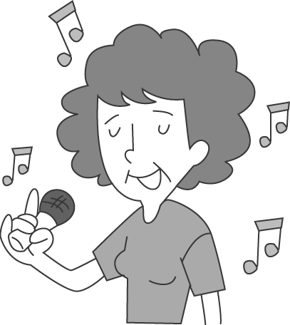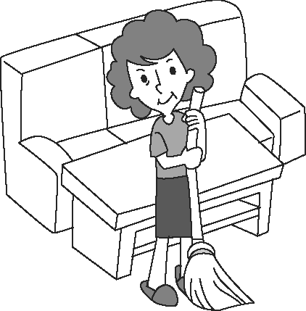
5. (A) (B) (C) 6. (A) (B) (C)
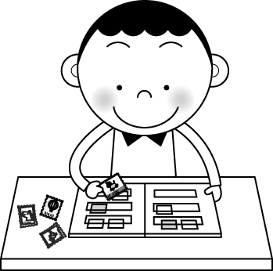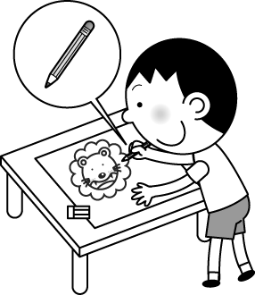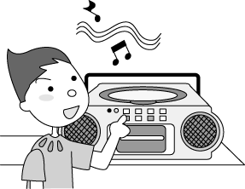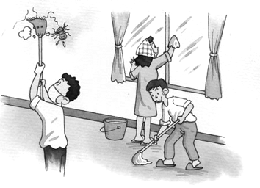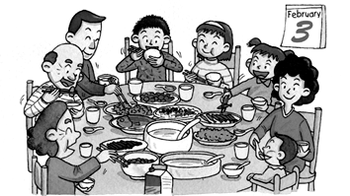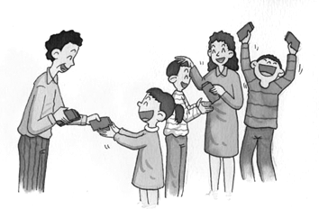

- (第七 ~ 十題 ) 選出與錄音內容相符的圖片 4 %
( A ) ( B ) ( C ) ( D )
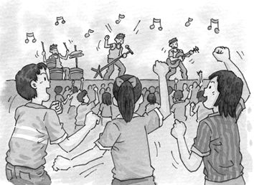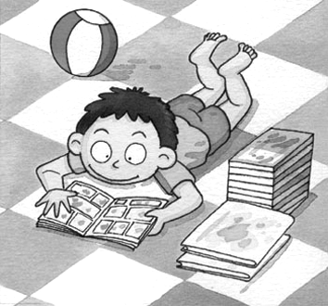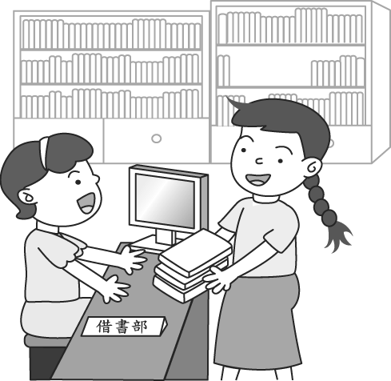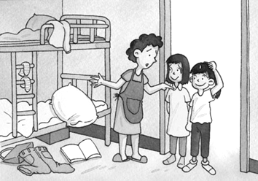

- 根據對話，敘述正確的劃 A，錯誤的劃 B 10 %
11. The man’s dog is missing.
12. The woman is reading a magazine.
13. They are going to the supermarket.
14. The woman thinks English is important.
15. The woman isn’t going to wear that dress because it’s too large.

- 根據錄音內容選出適當的答句 10 %
16. (Ａ) I enjoyed playing video games. (Ｂ) I hate to watch TV. (Ｃ) I enjoy doing housework. (Ｄ) I don’t like to do it alone.
17. (Ａ) No, it is raining. (Ｂ) No, it is sunny in Taipei. (Ｃ) No, it is cloudy in Tainan. (Ｄ) No, it is not raining in Taichung.
18. (Ａ) I like you very much. (Ｂ) I like to stay home. (Ｃ) I like snow. (Ｄ) I like summer the most.
19. (Ａ) Yes, I think so. (Ｂ) Yes, I am exciting. (Ｃ) I think surfing the Net is exciting. (Ｄ) I think reading is boring.
20. (Ａ) No, the dress is mine. (Ｂ) Yes, the dress is small. (Ｃ) I will try it on later. (Ｄ) I tried everything.
※ 聽力測驗結束 ※
五、文法測驗 20 %
21. Asking questions ____ Tina learn more and better.
( A ) helping ( B ) to help ( C ) help ( D ) helps
22. Shaun is going to study in the library, but Billy ______ .
(Ａ) won’t (Ｂ) aren’t (Ｃ) isn’t (Ｄ) doesn’t
23. Mike: there any novels in your room? Frank: Yes, there one.
(Ａ) Have; has (Ｂ) Are; are (Ｃ) Are; is (Ｄ) Is; are
24. Ken wants to win the basketball game, so he ________.
(Ａ) doesn’t need to practice more (Ｂ) needs to learn more skills (Ｃ) has terrible basketball skills (Ｄ) will try to lose it.
25. Vickey:Do you know the girl ______ a white skirt? Jean: It’s Terresa. The skirt looks really nice on her.
( A ) with ( B ) on ( C ) in ( D ) at
26. Can you wait me five more minutes?
( A ) for; for ( B ) for; to ( C ) x; for ( D ) to; for
27. English lessons .
(Ａ) is easy to learn (Ｂ) are not very difficult (Ｃ) has lots of fun (Ｄ) is a lot of fun
28. Elva doesn’t have enough money, so she’ll _____.
( A ) pay with credit card ( B ) pay by a credit card ( C ) pay with cash ( D ) use a credit card to pay.
29. Everyone in my family snacks between meals.
(Ａ) loves to eat (Ｂ) enjoys eat (Ｃ) want to eating (Ｄ) hate eating
30. Tom, don’t forget ________ the light before you go out ?
( A ) turning off ( B ) to turn off ( C ) turn off ( D ) turns off

六、對話 10 %
31. Jason: Do you like to play chess? James:
(Ａ) It is a little difficult. (Ｂ) No, it’s quite boring. (Ｃ) Yes, I like them very much. (Ｄ) Yes, I hate playing it.
32. Nancy: ________ Gloria: Just one.
( A ) How do you like it ? ( B ) Did you return the comic book yesterday ? ( C ) How much is it ?
( D ) How many magazines do you want to check out ?
33. Annie: When will the movie begin? Cindy:
( A ) Last year. ( B ) Maybe you should check the show time. ( C ) We should go to that restaurant. ( D ) I like it.
34. Jenny: Edward : It’s always like spring or fall. It doesn’t rain very much.
( A ) Do you like your hometown? ( B ) What’s the weather like in your hometown? ( C ) What are you thankful for?
( D ) Are there cloudy days in spring in your hometown?
35. Eric: It’s too bad. I can’t go to the movies with you this afternoon. Julia:
( A ) That’s too bad. Let’s go. ( B ) Really? Why not? ( C ) It sounded wonderful. ( D ) We are happy for that.

七、克漏字測驗 20 %
- Judy is good __36.__ music. She can play many kinds instruments ( 樂器 ), _ 37.__ piano, drums and guitar. She practices __38.__ the piano four hours a day. She even listens to the music played by famous people. She learns many skills from them. There’s a music _39._next month. Judy is going to join it, and she hopes to _40._first prize.
36. ( A ) to ( B ) at ( C ) on ( D ) for
37. ( A ) like ( B ) as ( C ) for ( D ) except
38. ( A ) plays ( B ) play ( C ) playing ( D ) to play
39. ( A ) costume ( B ) candy cane ( C ) coat ( D ) competition
40. ( A ) lose ( B ) win ( C ) play ( D ) miss

- Andy wants to be a great novelist ( 小說家 ). He keeps 41. and never quit ( 放棄 ). He improves ( 改善 ) his writing skills and 42. write a good novel. He finished ( 完成 ) his first novel and published ( 出版 ) it in a local bookstore last weekend. His friends cheered for him and were all proud of him. They celebrated Andy’s first novel with a big party.
Andy would like to write more novels and becomes a 43. writer. He hopes there 44. more and more people enjoy __45. his stories. He knows it won’t be easy, but he will do his best.
41. ( A ) wrote ( B ) writing ( C ) writes ( D ) to write
42. ( A ) wants to ( B ) likes ( C ) needs ( D ) were going to
43. ( A ) serious ( B ) crazy ( C ) famous ( D ) free
44. ( A ) has ( B ) will have ( C ) is going to be ( D ) will be
45. ( A ) read ( B ) reading ( C ) to read ( D ) will read

八、閱讀測驗 20 %
(一) Today is January 18, 2008. Dr. Wang’s is still very busy. His chart falls on the floor . He needs to match the charts with the
patients now . Please help him.
Name: Chester  Age: 12  Cavities : 15  Last appointment :  December 29, 2006 | Name: Johnson  Age: 15  Cavities: 6  Last appointment:  August 25, 2007 | Name: Emily  Age: 14  Cavities: 0  Last appointment:  December 18, 2007
chart病歷表 match符合 patient病人 cavity蛀牙 appointment約定 floss剔牙 dentist 牙醫
 | I brush and floss my teeth after meals.  I don’t have any cavities.  I visited the dentist every six months.
 | I should brush my teeth more often.  I care about having healthy teeth.  I want to have beautiful teeth.
 | I love to eat candy.  I hate going to the dentist’s office.  My parents tell me to brush my teeth every day, but I don’t.
46.Who likes to eat candy, and doesn’t like to see the dentist?
( A ) Johnson ( B ) Emily ( C ) Dr. Wang ( D ) Chester
47.Who wants to have beautiful teeth?
( A ) Johnson ( B ) Emily ( C ) Chester ( D ) Dr. Wang
48.Who has the most(最) healthy teeth?
( A ) Chester ( B ) Emily ( C ) Dr. Wang ( D ) Johnson
49.Who did’t go to the dentist last year?
( A ) Dr. Wang ( B ) Johnson ( C ) Chester ( D ) Emily
50.Which statement (敘述) is true?
( A ) Chester doesn’t like to eat candy. ( B )Emily doesn’t have any cavities. ( C )Johnson doesn’t care about having healthy teeth. ( D ) Chester keeps his mouth very clean.

- People used to (習慣) buy things in the stores. Owners and customers (顧客) were friends. They knew much about each
other. Many people are busy now, and they don’t have much time to stay in the stores and chat (閒聊) with clerks or owners.
Others don’t want to go to crowed stores. So they shop by phone or from mail-order catalogs (目錄). And now more young age
use the Internet to do shopping.
By these ways, people spend (花費) less time getting what they need. But many people still like to go to stores. They enjoy spending much time choosing what they want. They say that’s the most interesting part of shopping.

51. Where did people used to by things before?
( A ) On the Internet. ( B ) On TV ( C ) In the stores. ( D ) At home.
52. Many people don’t like to go to stores to buy things now. According to (根據) the article (文章), which may not be the reason?
( A ) They are busy. ( B ) They don’t have enough money. ( C ) They don’t want to go to crowed stores.
( D ) They don’t have much time.
53. What is the newest (最新的) way for young age to do shopping?
( A ) By Internet. ( B ) By mail. (C ) By phone. ( D ) Go to stores.
54. According to the article, which is correct?
( A ) No one buys things by the Internet now. ( B ) People used to buy things by phone. ( C ) People like to chat with clerks.
( D ) Some people don’t like to go to crowed stores.
55. According to the article, why do some people like to buy things at the stores?
( A )They can chat with handsome clerks. ( B ) They enjoy spending time choosing what they need.
( C ) They can spend less money. ( D ) They can get a computer there.

高雄縣立林園高級中學 國中部 96 學年度 第一學期 第三次評量 二年級 英文科 答案卷
範圍: Unit 7~ Review III
- CBACAA
- CDBA
- FFFTT
- CCDCC
- DCCBCABDAB
- BDBBB
- (一)BACDB (二)BACDB
- (一)DABCB (二)CBADB

高雄縣立林園高級中學 國中部 96 學年度 第一學期 第三次評量 二年級 英文科 答案卷
範圍: Unit 7~ Review III
一、CBACAA
二、CBDA
三、FFFTT
四、CCDCC
五、DCCBC ABDAB
六、BDBBB
七、(一)BACDB (二)BACDB
八、(一)DABCB (二)CBADB

