高雄縣立林園高級中學 國中部96學年度 第一學期 三年級 英文 科第一次段考考卷
範圍：Book5 Lesson1~Review1 班級： 姓名： 座號：
- Vocabulary / 字彙測驗18%
- I like to walk ____ the river bank(岸) after dinner.
(A) across (B) along (C) straight (D) besides
2. The price is too ____. I am afraid it’s just a fake(仿冒品).
(A) cheap (B) low (C) little (D) bad
3. I can’t ____ understand(明白) what you said. Can you explain(解釋) it again?
(A) certainly (B) wisely (C) fully (D) carefully
4. Wendy: How did you find this place? Sam: By reading a ____.
(A) map (B) comic book (C) dictionary (D) system
5. Ice, snow and steam(蒸氣) are different ____ of water.
(A) systems (B) products (C) effects (D) forms
6. Kine: You look ____. What’s wrong? Brady: A big dog ran after me just now. It may be still outside the door.
(A) amused (B) frightened (C) excited (D) touched
7. He lives five ____ away from our school, but he still walks to school.
(A) blocks (B) roads (C) exits (D) walls
8. Many people learned ____ knowledge(知識) when they studied in school.
(A) half (B) wisely (C) convenient (D) treasure
9. Do it as if(彷彿) you won’t have another ____ to do it again.
(A) change (B) form (C) treasure (D) chance
- Grammar / 文法選擇14%
- Wilson: ____ Ken hit by a car this morning? Steven: No! Who told you that?
(A) Did (B) Was (C) Is (D) Does
2. ____ is the price of this bag?
(A) How much (B) How many (C) What (D) How
3. Chinese ____ in more and more countries now.
(A) speak (B) is speaking (C) is spoke (D) is spoken
4. The players are made ____ every day.
(A) practice (B) practiced (C) practicing (D) to practice
5. If the MRT station ____ near my house next year, I won’t need to drive to work.
(A) builds (B) will build (C) will be built (D) can be built
6. The meatball soup ____ delicious.
(A) taste (B) is tasted (C) is tasting (D) tasted
7. Sam thinks working with his father is ____ . There are always so many things to do.
(A) tire (B) tiring (C) tired (D) tires

III. True or False / 以下的句子，正確的畫「○」，錯誤的畫「×」10%
  - If winter comes, can spring be far behind?
  - I got up late, therefore I missed the bus.
  - Though she is old, but she is still energetic.
  - How do you think about the fair?
  - Do you like to go bird watching?

IV. Translation / 引導式翻譯20%
- 到處都看得到便利商店。
Convenience stores can ______ ______ ______ every place.
- 戲院裡擠滿了看電影的人。
The theater ______ _______ ______ movie-goers.
- 每次都讀同一個故事容易膩。
It’s easy to get ______ _______ ______ the same story every time.
- 李安的電影總是很感人也容易引起人們的注意。
Ang Lee’s movies are always ______ and easy to ______ ______ ______.
- 善用空閒時間對臺灣的學生是重要的。
_______ good _______ _______ free time is important for students in Taiwan.
6. 這場雨不會持續很久。(4%)
V. Cloze / 克漏字選擇 20%
Chinese New Year is an important holiday for Chinese people. Before it comes, many things 1. in every family. The house 2. before New Year’s Day. After cleaning the house, people 3. red couplets on the wall near the door for luck. Kids are 4. on this special holiday because they can wear new clothes and enjoy much food. And the most important of all, they can get red envelopes 5. lucky money inside.
 couplets春聯 envelop信封
1. (A) have to do (B) must be done (C) will do (D) are doing
2. (A) needs to be cleaned (B) needs to clean (C) has to clean (D) are cleaned
3. (A) are put (B) are putting (C) puts (D) will put
4. (A) exciting (B) excited (C) surprising (D) surprised
5. (A) have (B) without (C) with (D) put
A book fair was held at the TWTC. Sam invited Peter to 6. it with him and his cousin, Wendy. They
7. the MRT and got off at the Taipei City Hall Station. In the fair, they found 8. for a book sale. It
9. most books were cheaper. Then they met Mr. Martin, a friend of Peter’s sister. What a 10. ! They bought a few books and met Wendy’s favorite writer. Finally, they all felt it was fun.
6. (A) go (B) get to (C) visit (D) read
7. (A) by (B) took (C) built (D) rode
8. (A) a bookstore (B) a good price (C) an advertisement (D) comic books
9. (A) said (B) wrote (C) told (D) sold
10. (A) surprising (B) small world (C) beautiful mistake (D) funny thing

VI. Reading Comprehension / 閱讀理解 18%
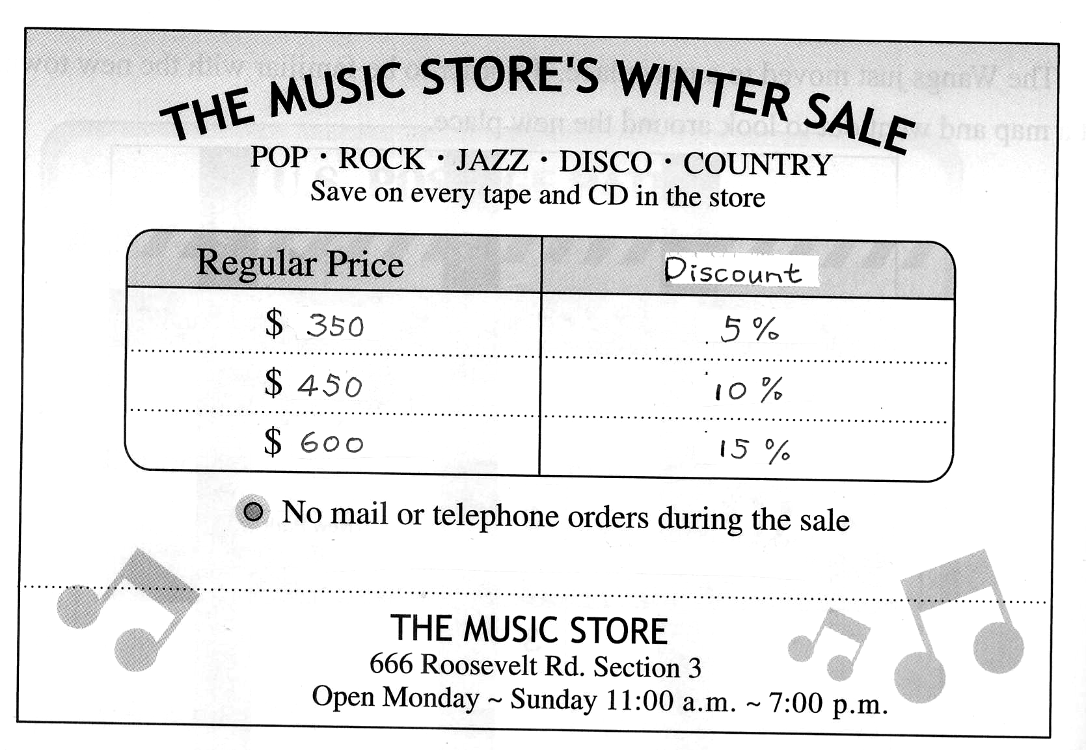
- The music store is _____.
 address 地址
(A) for sale (B) closing (C) having a sale (D) saving tapes and CDs
2. In which month might the sale be?
(A) June (B) January (C) September (D) April
3. Tapes or CDs that were $450 are sold for _____.
(A) $10 (B) $45 (C) $440 (D) $405
4. What can’t be found on this poster?
(A) The price. (B) The e-mail address. (C) The opening hours. (D) The form of the product in the store.
5. Which is NOT true?
(A) The store is on Roosevelt Road. (B) CDs are cheaper during the sale.
(C) You can’t visit the store at 10:00 a.m. (D) You may call to order a CD during the sale.
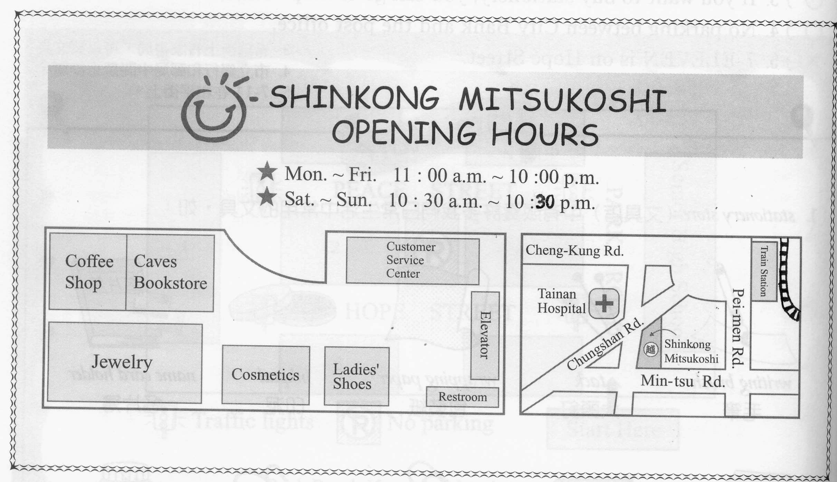
6. Rita is at the train station now. How can she get to Shinkong Mitsukoshi Department Store?
(A) Go along PEI-men Rd. and turn left on Mintsu Rd.
(B) Go straight on Cheng-kung Rd. and turn left on Chung-shan Rd. It’s on the right.
(C) Go straight on Chung-shan Rd. and it’s just across from Tainan Hospital.
(D) Go along Pei-men Rd. It’s on the corner of Pei-men RD. and Min-tus Rd.
7. Jason and Tim went to Shinkong Mitsukoshi Department Store on Sunday afternoon. They arrived there at 5 p.m., and they left right before the store was closed. How long did they stay in Shinkong?
(A) Five hours. (B) Five and a half hours. (C) Six and a half hours. (D) Twelve hours.
8. Jane needs to buy some cosmetics. The cosmetics department is .
(A) next to Caves Bookstore (B) across from the restroom
(C) between “Jewelry” and “Ladies’ Shops” (D) in front of the Customer Service Center
9. Which is true about Shinkong Mitsukoshi Department Store?
(A)It’s on Min-tsu Rd. (B)It is next to Tainan Hospital.
(C)You can’t get any drink in it. (D)It opens at 10:30 a.m. on Thursday.

班級： 姓名： 座號：
I. Vocabulary / 字彙測驗18% (每題2分)
1 |  | 2 |  | 3 |  | 4 |  | 5 |  | 6 |  | 7 |  | 8 |  | 9
II. Grammar / 文法選擇14% (每題2分)
1 |  | 2 |  | 3 |  | 4 |  | 5 |  | 6 |  | 7
III. True or False / 以下的句子，正確的畫「○」，錯誤的畫「×」10% (每題2分)
1 |  | 2 |  | 3 |  | 4 |  | 5
IV. Translation / 引導式翻譯20% (每格2分；第6題4分)
1.
2.
3.
4.
5.
6.
V. Cloze / 克漏字選擇 20% (每題2分)
1 |  | 2 |  | 3 |  | 4 |  | 5
6 |  | 7 |  | 8 |  | 9 |  | 10
VI. Reading Comprehension / 閱讀理解 18% (每題2分)
1 |  | 2 |  | 3 |  | 4 |  | 5
6 |  | 7 |  | 8 |  | 9
高雄縣立林園高級中學 國中部96學年度 第一學期三年級英文科第一次段考 答案卷
範圍： 班級： 姓名： 座號：
I. Vocabulary / 字彙測驗18% (每題2分)
1 | B | 2 | B | 3 | C | 4 | A | 5 | D | 6 | B | 7 | A | 8 | A | 9 | D
II. Grammar / 文法選擇14% (每題2分)
1 | B | 2 | C | 3 | D | 4 | D | 5 | D | 6 | D | 7 | B
III. True or False / 以下的句子，正確的畫「○」，錯誤的畫「×」10% (每題2分)
1 | ○ | 2 | × | 3 | × | 4 | × | 5 | ○
IV. Translation / 引導式翻譯20% (每格2分；第6題4分)
1. | be | seen | in
2. | is / was | filled / crowded | with
3. | tired / bored | of / with | reading
4. | touching | catch | people’s | eye
5. | Making | use | of
6. | The rain won’t last long.
V. Cloze / 克漏字選擇 20% (每題2分)
1 | B | 2 | A | 3 | D | 4 | B | 5 | C
6 | C | 7 | B | 8 | C | 9 | A | 10 | B
VI. Reading Comprehension / 閱讀理解 18% (每題2分)
1 | C | 2 | B | 3 | D | 4 | B | 5 | D
6 | C | 7 | B | 8 | C | 9 | A

