高雄縣立林園中學（國中部）九十六學年度第二學期一年級第二次月考英文科試題
一年 班 座號: 姓名:
第一部分 聽寫測驗30%
一、聽CD的三個敘述，選出符合圖片的句子（10％）
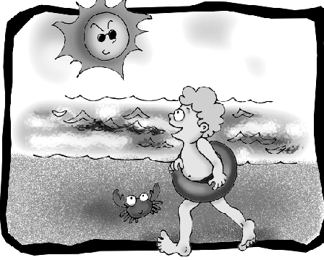
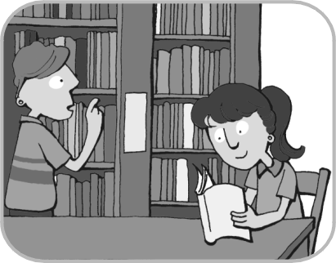
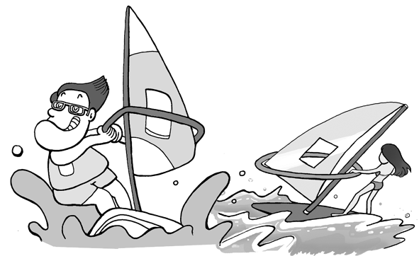
1. 2. 3.

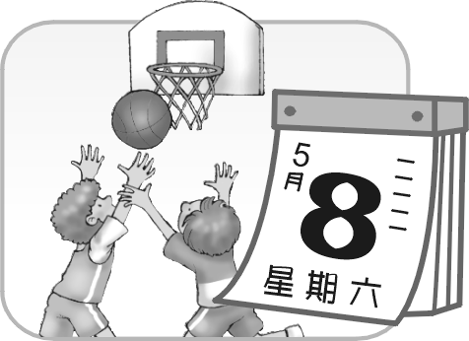
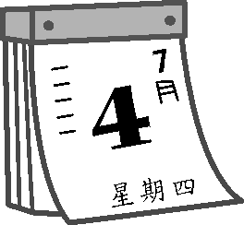
4. 5.

二、 聽CD，每題將唸出一個問題及四個選項，請看圖選出正確的答案（10％）
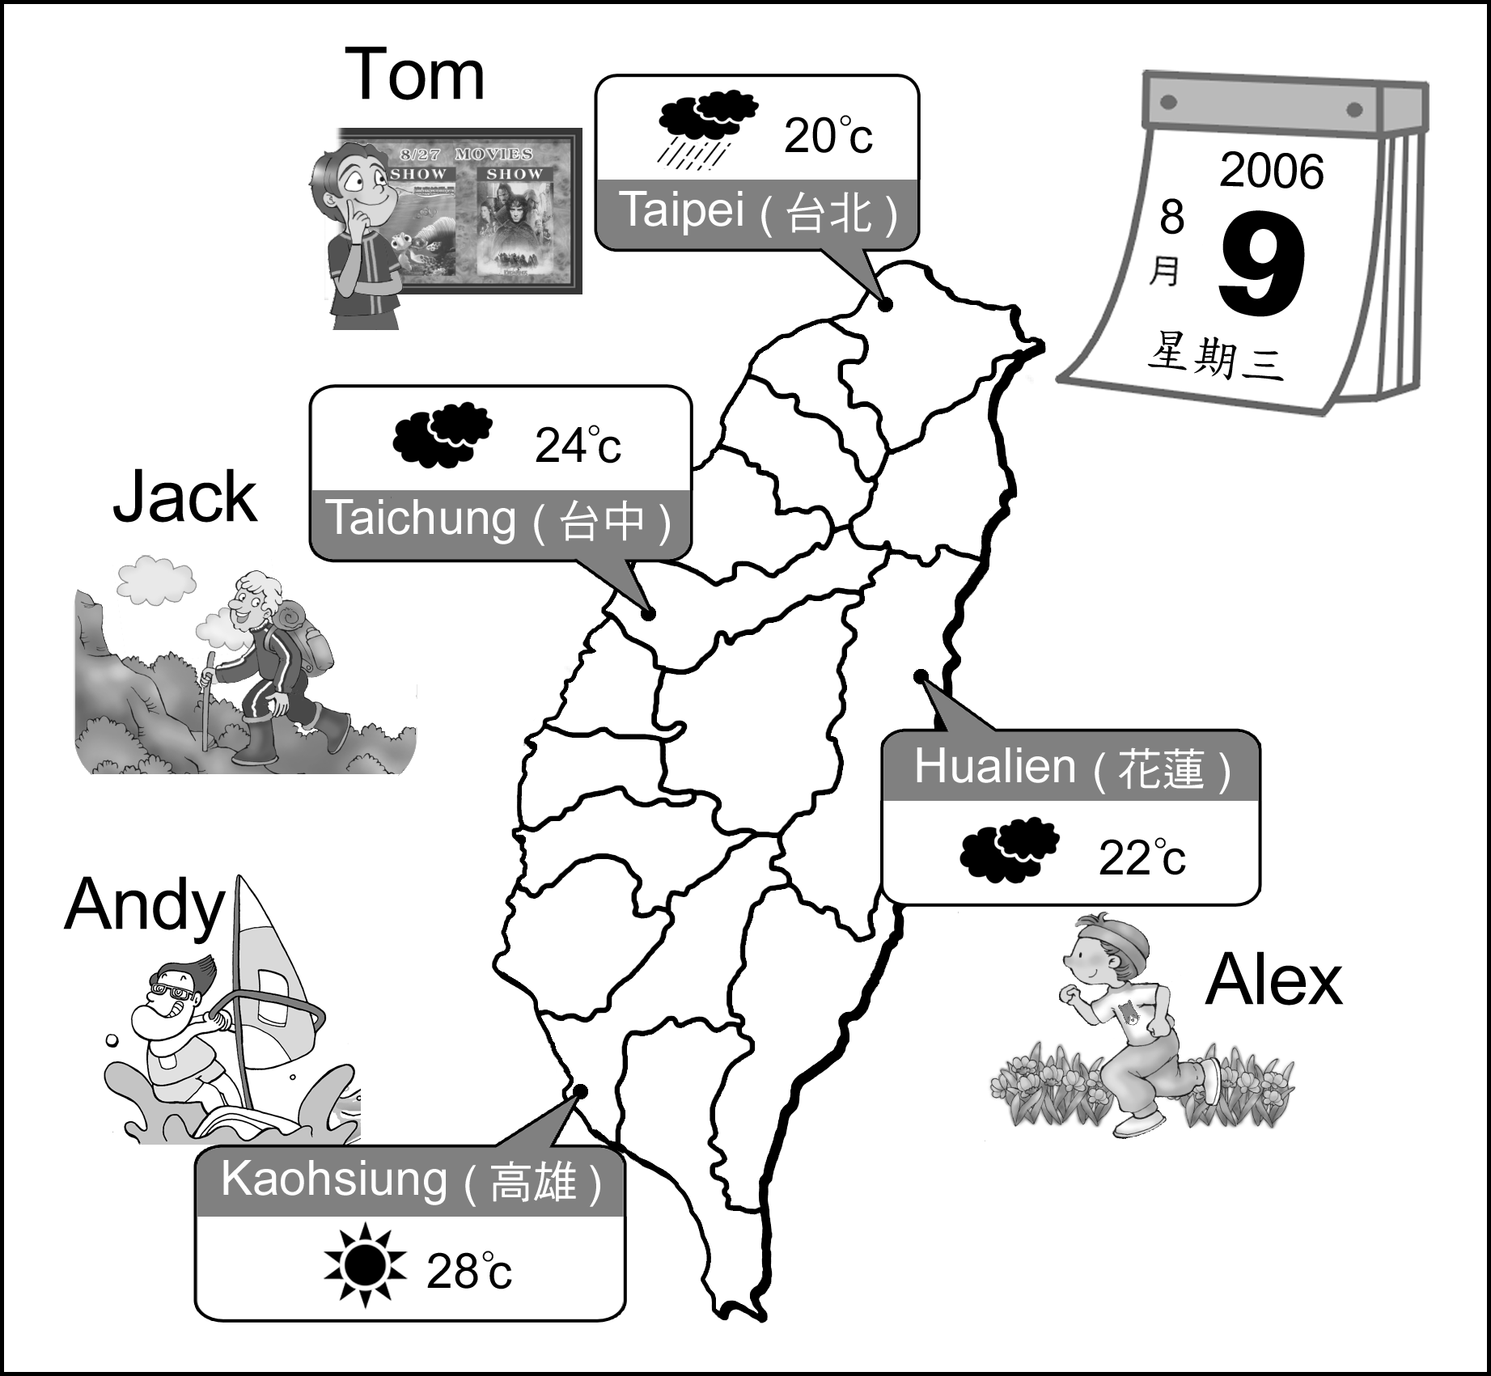

三、聽完CD的敘述與問題後，根據CD問題，選出正確答案或最適當的答案（10％）
1. (A) A watch. (B) A big card. (C) A big cake. (D) A digital camera.
2. (A) Boyd. (B) Andy. (C) Danny. (D)Sally.
3. (A) Blue. (B) Red. (C) Summer. (D) Fall.
4. (A) Go swimming. (B) Go surfing. (C) Go jogging. (D) Go mountain climbing.
5. (A) It was terrible. (B) It was beautiful. (C) It was cool. (D) It was nice.

第二部分 讀寫測驗70%
一、文意字彙（10﹪）
1. Be q______. Don’t talk in class again.
2. I’m putting sixty c______ on Alice’s birthday cake because she is sixty years old today.
3. Christmas is on D_____ 25.
4. There are four s______ in a year.
5. When p_____ talk, don’t cut in.
6. Helen is good at math, and she always gets good g_____ in math.
7. This m_____ Let’s talk in English comes out monthly.
8. The test was very d____ －half the students failed.
9. The grandchildren give their grandmother a b____. It can bake bread.
10. She was home the day before y_____.
 when當 cut in 插嘴 come out 出刊 failed 不及格 bake 烘焙
二、選擇題（20﹪）
1. The third month of a year is ______.
（A）January. （B）March. （C）May. （D）July.
2. I have an English test ____the afternoon___ May sixteenth.
（A）at, on （B）in, on （C）in, of （D）on, of
3. A：What’s the _____ today? B：It’s April first. It’s also Fool’s Day.
（A）day （B）date （C）month （D）weather
4. A：_____ is your birthday, Mary？
B：It’s September 28. You want to give me a birthday present？
（A）Why （B）What （C）When （D）Who
5. A： I want to read “ Harry Potter”, but I don’t have it. B：You can borrow it from the ______.
（A）bank （B） library （C） hospital （D） Mary’s home
6. A：Why do you like autumn? B：______.
（A）Because I like Taiwan hot pots.
（B）I can go swimming.
（C）So I can see my boyfriend again.
（D）Because it’s cool and nice.
7. A：_____ holiday is your favorite? B：Christmas.
（A）When （B）Who （C）Which （D）Why
8. A：Where____ you last night? B：I ____ in Hong Kong.
（A）are, am （B）was, were （C）were, was （D）are, is
9. A：When do you play tennis? B：_______.
（A）I like to play tennis.
（B）Yes, I play tennis on Sunday morning.
（C）No, I don’t play tennis. I like to play basketball.
（D）I play tennis on Friday evening.
10. A：Was Tinna late for school this morning? B：___.
（A）No, she wasn’t. She was there on time.
（B）Yes, she’s late for school this morning.
（C）I know Tinna was late for school this morning.
（D）She was late for school in the morning.
borrow借
三、閱讀測驗（20﹪）
I’m holding a party for my birthday, and you are invited！
Who：Gary
Where：123 Prince Avenue Los Angeles, CA 90031
When：Sat 11/25/08
What time：7：00 P.M.
Reply to me ASAP
Bring some food and a friend.

hold舉辦 invite 邀請
1. What date is the birthday party?
（A）It’s on November twenty-fifth.
（B）It’s on November eighth.
（C）It’s on August eleventh.
（D）We don’t know.
2. Which is true？
（A）The birthday party begins at 7：00 in the morning.
（B）You can bring some presents and a friend there .
（C）Gary’s birthday is in summer.
（D）Gary’s birthday party is on Saturday.

END OF THE YEAR SALE！！
Buy more！Save more！
LIST PRICE SALE PRICE
$260 $208
$350 $280
$430 $344 THE CD CITY
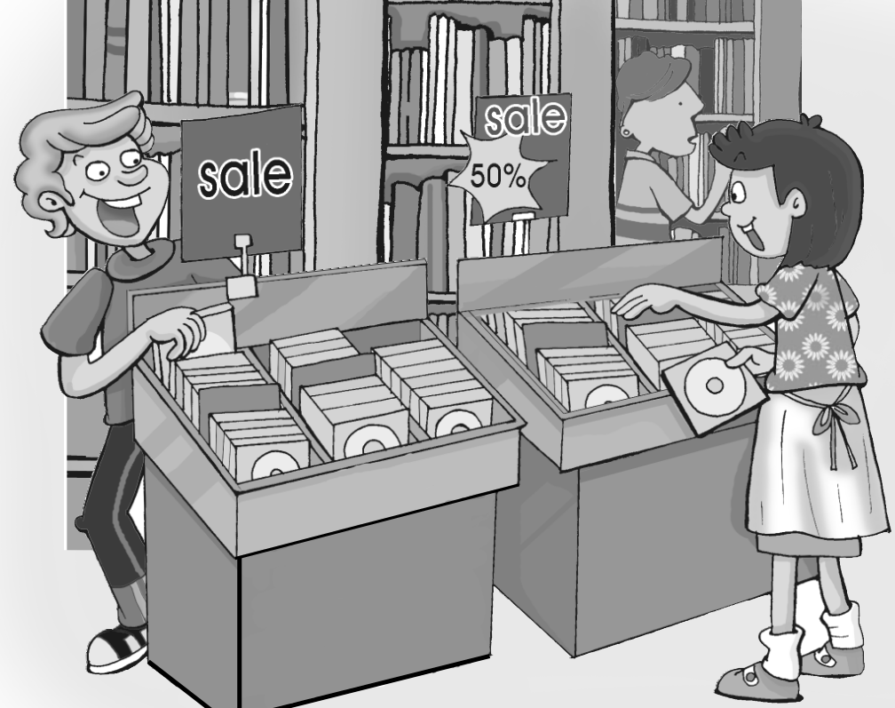
$100 50 % 0ff
Sale from March 1 to March 14
No telephone orders during sale.
THE CD CITY
66 West Street
Open everyday, 10 a.m. to 10 p.m.

3. You can’t buy CDs ______.
（A）on Sundays
（B）at 9：30 p.m.
（C）over the phone
（D）during the sale
4. Each CD that costs $350 is on sale for_____.
（A）$208
（B）$280
（C）$344
（D）$175
5. How long does the sale last?
（A）One month.
（B）Only in March.
（C）Fourteen days.
（D）Fifteen days.
6. What is on sale?
（A）Books
（B）Computers
（C）Pictures
（D）CDs

Two Kids Hurt Badly by a BMW
Han-lin Daily News

KAOHSIUNG, February 18－There was a serious traffic accident on Park Road at 7：00 in the morning. Two junior high school students walking across the street were bumped by a white BMW. Both students were hurt badly. And then they were sent to the hospital right away. According to the witness, the driver was driving quite fast, and he didn’t stop for the red light, either. The police said the driver’s breath test was also high, up to 2.4.
traffic accident車禍 across越過 bumped撞擊 hurt受傷 sent送到 witness證人 said 說 breath test呼吸測試 drunk driving 酒醉駕車 either也
7. Where did the traffic accident happen?
（A）In the junior high school.
（B）On Park Road
（C）In the hospital.
（D）In the BMW.
8. How many people were hurt in the traffic accident?
（A）Two children.
（B）One woman and her son.
（C）One man and two children.
（D）An old man or a child.
9. How did this traffic accident happen?
（A）The driver was drunk driving.
（B）The driver didn’t stop for the green light.
（C）The children played basketball on the road.
（D）The children didn’t see the BMW.
10. How was the traffic accident?
（A）It was terrible.
（B）It was boring.
（C）It was at 7：00a.m.
（D）It was in February.
四、造句（10﹪） （全對才給分）
1. spring（n.）
2. study（v.）
3. so（conj.）
4. fresh（adj.）
5. ago（adv.）
五、翻譯 （10﹪） （錯一字扣一分）
1. 今天天氣晴朗。我們可以一起去健行。
2. Harper先生正坐在椅子上打盹。
3. 在美國的暑假是三個月----從六月到八月。
4. 去年在書店裡有一間小咖啡店。
5. 那裏的咖啡很便宜，但書很貴。

高雄縣立林園國中九十六學年度第二學期一年級第二次月考英文科試題答案卷
一年____班 座號： 姓名：
第一部分 聽寫測驗30%
一、聽CD的三個敘述，選出符合圖片的句子（10％）
1.A | 2.B | 3.C | 4.B | 5.C
二、 聽CD，每題將唸出一個問題及四個選項，請看圖選出正確的答案（10％）
1.A | 2.B | 3.A | 4.D | 5.A
三、聽完CD的敘述與問題後，根據CD問題，選出正確答案或最適當的答案（10％）
1.B | 2.C | 3.B | 4.D | 5.A
第二部分 讀寫測驗70%
一、文意字彙（10﹪）
1.quiet | 2.candles | 3.December | 4.seasons | 5.people
6.grades | 7.magazine | 8.difficult | 9.bread machine | 10.yesterday
二、選擇題（20﹪）
1.B | 2.D | 3.B | 4.C | 5.B | 6.D | 7.C | 8.C | 9.D | 10.A
三、閱讀測驗（20﹪）
1.A | 2.D | 3.C | 4.B | 5.C | 6.D | 7.B | 8.A | 9.A | 10.A
四、造句（10﹪） （全對才給分）
五、翻譯 （10﹪） （錯一字扣一分）
1.It’s sunny today. We can go hiking together.
2.Mr. Harper is taking a nap in/on the chair.
3.The summer vacation in America is three months－from June to August.
4.There was a small coffee shop in the bookstore last year.
5.The coffee there is/was cheap, but the books are/were expensive.

