高雄縣立林園高級中學 國中部96學年度 第二學期 一 年級英語 科第三次段考考卷
範圍： L7-L9 班級： 姓名： 座號：
- 聽力部分: 30%
( 1) 根據圖片, 聽CD的 四個選項與問題選出正確的答案：10％
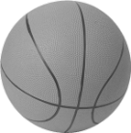  1. | 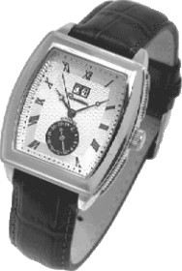  2. | 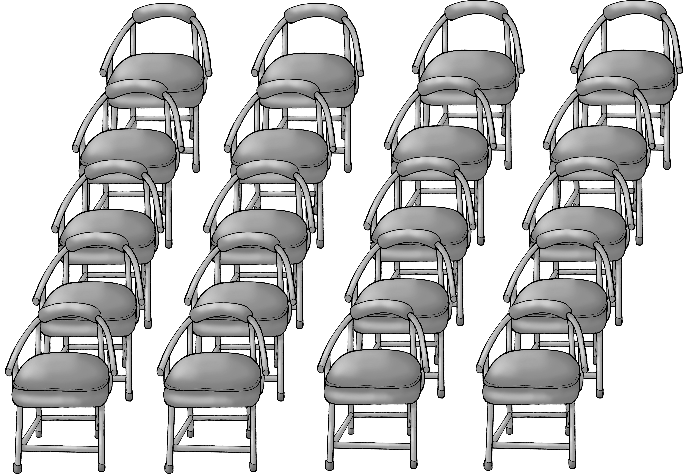  3. | 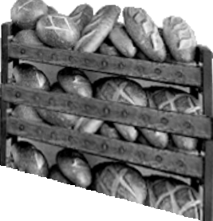  4. | 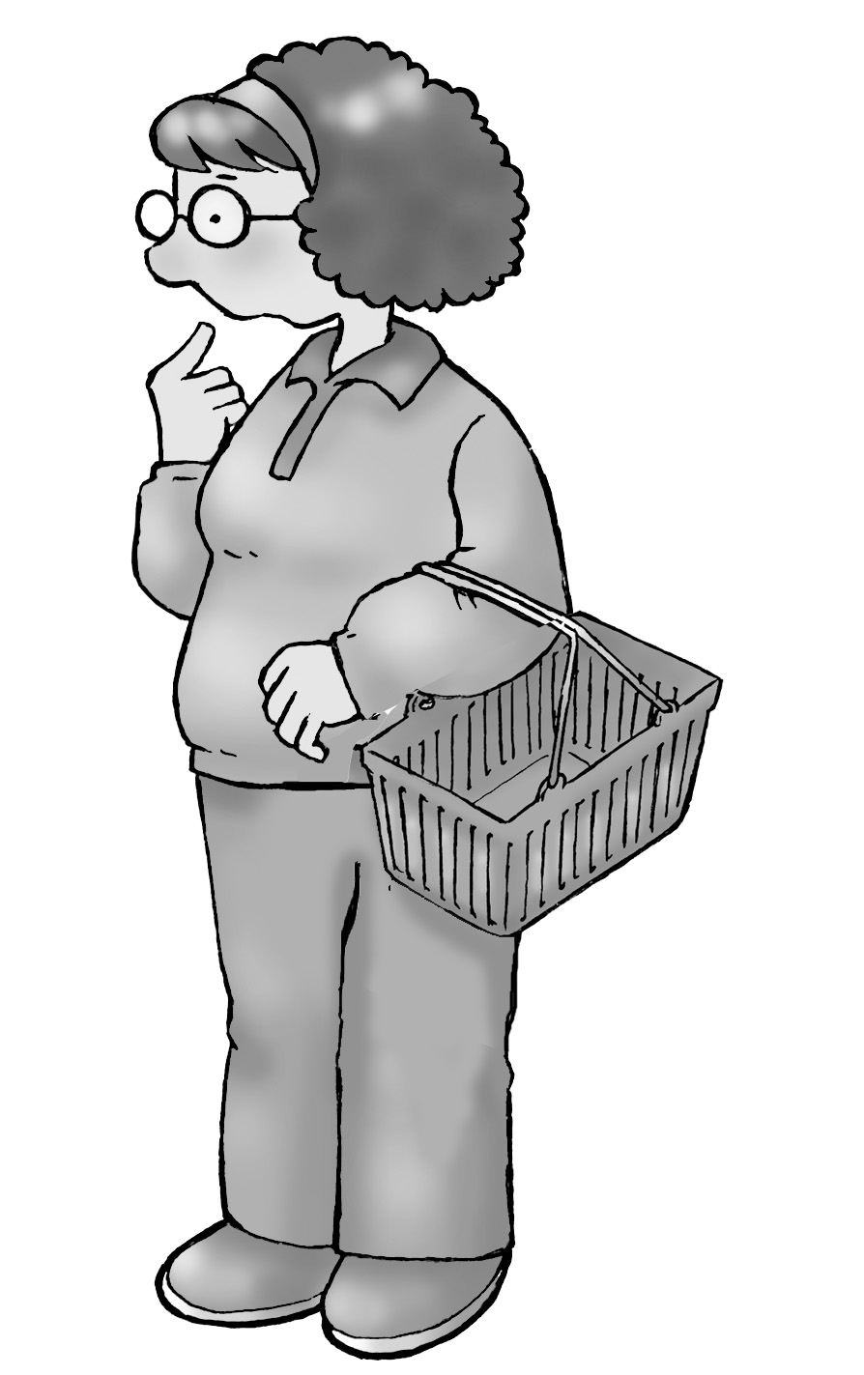  5.
(2)、聽完CD的對話後，選出與內容相符的句子：10％
__6. (A) They want to watch the dragon boat races on TV.
(B) The boy wants to see the dragon boat races on the river.
(C) There are many people on the river on the Dragon Boat Festival.
__7. (A) The boy had a terrible test today.
(B) They didn’t have an English test.
(C) There were a lot of tests yesterday.
__8. (A) The boy didn’t read any books last week.
(B) The boy read two books last week.
(C) The boy is reading two books.
__9. (A) Mother had some flowers for Tom.
(B) Tom gave his girlfriend a card.
(C) Tom gave his mother a card.
__10. (A) Jack said “Happy Birthday” to his mother.
(B) Yesterday was Jack’s birthday.
(C) Jack forgot Mother’s Day.
(3)、聽完CD的敘述，根據CD問題，選出正確答案：10％
__11. (A) A king.
(B) A baker.
(C) A teacher.
(D)A cook.
__12. (A) Bad.
(B) Beautiful.
(C) Kind.
(D) Boring.
__13. (A) He took a bus.
(B) He called a taxi.
(C) Mimi’s brother drove him there.
(D) He drove a car.
__14. (A) He made cakes.
(B) He slept.
(C) He ate food.
(D) He remembered the movie.
___15. (A) Candy.
(B) Jam.
(C) Ice cream.
(D) Vegetables.
(二) 筆試不部分: 70%
(1) 字彙文法選擇 (16-35 題) 每題1分

___16 Mrs. Lin didn’t buy bread, but Mrs. Wu bought .
(A) any ; some (B) some ; any (C) some ; some (D) any ; any
___17 Jack had food to eat, but Sally didn’t.
(A) many (B) any (C) not (D) much
___18. Do you still Andy? He lived next to us five years ago.
(A) forget (B) remember (C) tell (D) clean
___19 A: What did you give your dog for dinner? B:
(A) Did you remember? (B) The dog is sitting next to me.
(C) Oh, no. I forgot. (D) No, I didn’t buy any food.
___20 A: Mom, I went to a horror movie with my friends last night. B: How was it ?
A: It was _______.
(A) scary (B)full (C) delicious (D) poor
____21Do you know the answer ____ the question?
(A) of (B) to (C) for (D) with
____22 Remember to be ____ to others.
- poor (B) bad (C) smiling (D) polite
____23 A: Who ____ in the department store? B: Mark.
- did you saw (B) you saw (C) did you see (D) you did see
____24 How many students ____ in your class last year?
(A) there are (B) are there (C) there were (D) were there
____25 Why did the old man ____ into the river?
- jump (B) wash (C) swim (D) fell
____26. A: Did you have fun on the Dragon Boat Festival? B:
(A) No, I didn’t go mountain climbing. (B) Yes, I went to the post office this afternoon.
(C) No, I didn’t smile at him. (D) Yes, I ate a lot of delicious Chinese food.
___ 27 Students, do you have other questions?
(A) all (B) any (C) both (D) no
____28. A: How could you forget my birthday? B:
(A) I’m sorry. I was busy yesterday. (B) I didn’t do the dishes.
(C) The movie was boring and I fell asleep. (D) You could have vegetables for breakfast.
____29 A: What was the movie about? B: _______________
(A) Dogs and Cats. (B) It was very scary.
(C) No, I didn’t see it. (D) I had much food to eat.
____30 I like to help my mother ______the housework on the weekend.
(A) in (B) on (C) of (D) with

Miss Trouble was a good little girl. But she was also a lot of trouble for her family and friends. When her mother wanted her to get up, she slept. When her father wanted her to go to sleep, she stayed up. When her friends wanted to go out, she sat at home. When her family wanted to watch TV, she listened to the radio. When her family wanted to eat, she wasn’t hungry. When her parents wanted her to do homework, she talked on the phone. When her friends wanted to talk to her , she didn’t have time. When her mother wanted her to do the dishes , she wanted to play. When her teachers wanted her to play ball in school , she had a headache. But when her parents wanted to give her some money, she said,” OK!” Yes, Miss Trouble was a good little girl, but she was a lot of trouble

.

__31 What did Miss Trouble want to do when her friends wanted to go out?
(A) Watch TV. (B) Stay at home.
(C) Listen to the radio. (D) Stay up.
__32 What did Miss Trouble want to do when her parents wanted her to do homework?
(A) Talk on the phone. (B) Listen to the radio.
(C) Walk the dog. (D) watch TV.
__33 “Stay up” means_________.
(A) get up late (B) stay at home
(C) go to bed late (D) stay at the same place
__34 “Do the dishes” means _____________.
(A) makes dishes. (B)wash dishes.
(C) takes some dishes (D) borrow some dishes
__35 Did Miss Trouble take the money when her parents wanted to give her?
(A) Yes, she did. (B) No, she didn’t.
(C) Her parents didn’t want to give her money. (D) It doesn’t say.
(3) 克漏字選擇題 每題2分

( Kim and Ken are classmates. They come back to school from summer vacation. )
Kim: Hey, Ken. Long time no see. __36_ was your vacation?
Ken: It was awful!
Kim: Something wrong?
Ken: Nothing special.
Kim: Then _37___ did you say so?
Ken: OK, let me tell you. First, the people there didn’t talk to me in English. The next day, someone stole my bag on the trip.
Kim: Wow! _38__ was in your bag?
Ken: Yes, my train tickets, lucky coins and some money.
Kim: Too bad! _39_ did you do after that?
Ken: I asked the police for help and walked back to the hotel.
Kim: You must be very sad and tired.
Ken: You’re right. Also, everything there is very, very , very expensive. Look at this bag. Guess __40____?
Kim: Maybe three or four thousand dollars.
Ken: It cost me 10,000 dollars!
Kim: What? It cost too much. Why _41_ you buy such an expensive bag?
Ken: Because I needed a new one. Remember, I lost my old bag.
Kim: Poor you! Buy the way, one last question--- where __42_ you spend your vacation?
Ken: Paris.
awful:可怕的 special: 特別的 stole: 偷 coin: 硬幣 guess: 猜 lost: 丟 spend: 渡假 cost 值
( ) 36. (A) How (B) When (C) What (D) Where
( ) 37. (A) how (B) why (C) who (D) what
( ) 38. (A) What (B) Which (C) Were (D) Why
( ) 39. (A) How (B) What (C) Which (D) Where
( ) 40. (A) how (B) how old (C) how much (D) how many
( ) 41. (A) do (B) does (C) can (D) did
( ) 42. (A) can (B) does (C) did (D) do

A: Yesterday was my thirteenth 43 , and I got a new bike.
B: 44 ? Who 45 it to you?
A: My parents__46_. And they took me to a nice _47 . The steak was delicious. I 48 it very much.
B: You had a good time yesterday.
steak 牛排
( )43. (A) birthday (B) year (C) class (D) game
( )44. (A) Now (B) Really (C) And then (D) What for
( )45. (A) took (B) bought (C) gave (D) did
( )46 (A) do (B) does (c) did (4) can
( )47. (A) theater (B) bus stop (C) high school (D) restaurant
( )48. (A) enjoy (B) love (C) enjoyed (D) ate
(4) 選出句中有錯的句子 每題2分
__49 (A) Was the theater next to the restaurant?
(B) There aren’t any flower in the basket.
(C) They had so much food to eat in the party last week.
(D) There are no flowers in the basket.
__50 (A) There are two glasses of water on the table.
(B) There are two cups of coffee on the table.
(C) There is some hot dogs on the table.
(D) There is some cola in the glass.
__51 (A) How many CDs do you have at home?
(B) How many ice cream did you eat?
(C) How much money do you get from your parents every week?
(D) How much free time do you have this weekend?
(5) 選出正確的句子 每題2 分
__52 (A) I always smile at my customers.
(B) We had a exam last week.
(C) He felt asleep in class this morning.
(D) He ate a orange yesterday.
__53 (A) Qu Yuan was an important people in the kingdom of Chu.
(B) He ate too much candy last night.
(C) How many tooth does the old man have?
(D) How much vegetables did Mr. Wu need?
__54
- Remember doing the dishes before you play the computer games.
- Don’t forget to do the dishes before you watch TV.
- How could you forgot to see the movie?
- He got good grades in the exam.
(6) 閱讀測驗 每題2 分

( ) 55. What day did they visit Kaohsiung Harbor?
(A)On Sunday. (B)On Saturday. (C)On Friday. (D)On Thursday.
Last week, my family and I spent our vacation in Kaohsiung. We visited many interesting places. On the first day, we visited an old market and Kaohsiung Harbor. On the second day, we drove to see an exciting baseball game. On the third day, after we went swimming at the beach, we returned to Taichung. The next day, on Monday, my brother and I had to go to school.
All of my family had much fun during the vacation.

 harbor 海港 return 返回

( )56. Where do they live?
(A)In Kaohsiung. (B)At Kaohsiung Harbor. (C)In Taichung
Credit Cards
Credit cards are getting popular because they are convenient to use. However, they bring some people much trouble when they don’t use them wisely. Some people overspend money by using credit cards. When they use credit cards, they don’t feel they’re spending real money. They forget they still have to pay the credit card companies days later. So, they use all their money and sometimes they even borrow money from banks. At last, they can’t earn enough money to pay the banks back and bring problems to their family. People really need to be more careful when using credit cards.
wisely明智地 overspend超支 companies公司 earn賺 however 然而 bring 帶來 spend 花錢
credit card 信用卡 popular 受歡迎 convenient 便利 trouble 麻煩 borrow借 pay 付 earn 賺

__57 what is the passage(文章) mainly(主要) about?
(A) The problems that credit cards bring. (B) Credit cards are very convenient.
(C) How to use credit cards wisely. (D) Using real money is better than using credit cards
__58 Why do people like credit cards?
(A) They do not have to pay. (B) Credit card companies will pay for you.
(C) You can use them everywhere . (D) They are convenient.
__59 What problem do credit cards bring?
(A) Overspending. (B) Convenience to use them.
(C) Too many credit card companies. (D) More families have trouble.

__60 What might be the writer’s advice(建議) about credit cards?
(A) Don’t shop with credit cards. (B) Keep only one card.
(C) Get a card from a better bank. (D) Think twice before using the card.

高雄縣立林園高級中學 國中部96學年度 第二學期一年級 英語 科第三次段考 答案卷
範圍： 班級： 姓名： 座號：

1-5 BCDDC
6-10 BCBCC
11-15 BCCCD
16-20 ADBCA
21-25 BDCDA
26-30 DBAAD
31-35 BACBA
36-40 ABABC
41-45 DCABC
46-50 CDCBC
51-55 BABBC
56-60 CADAD

