高雄縣立林園高級中學 國中部96學年度 第二學期 二年級 英語科第一次段考考卷
範圍： Book 4- Unit 1~Review 1 班級： 姓名： 座號：
一、聽力測驗
A. 聽聽看，若題目與圖片相符者圈T，不符則圈F (每題1分)
1.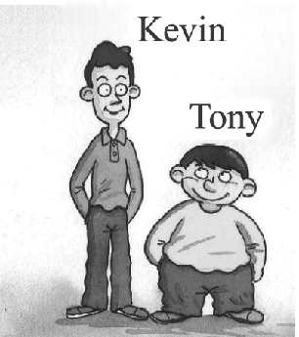 2.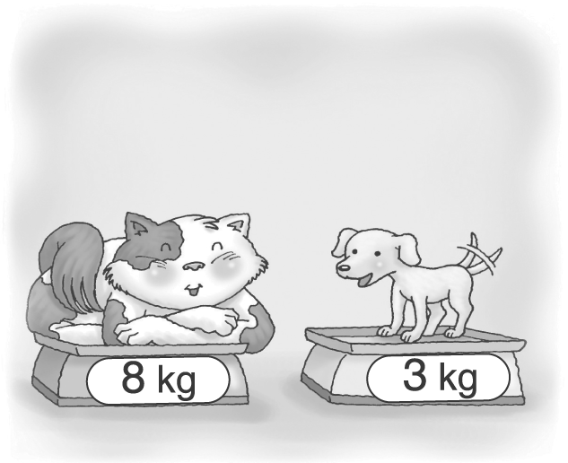 3.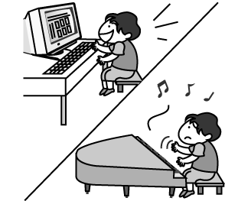 4.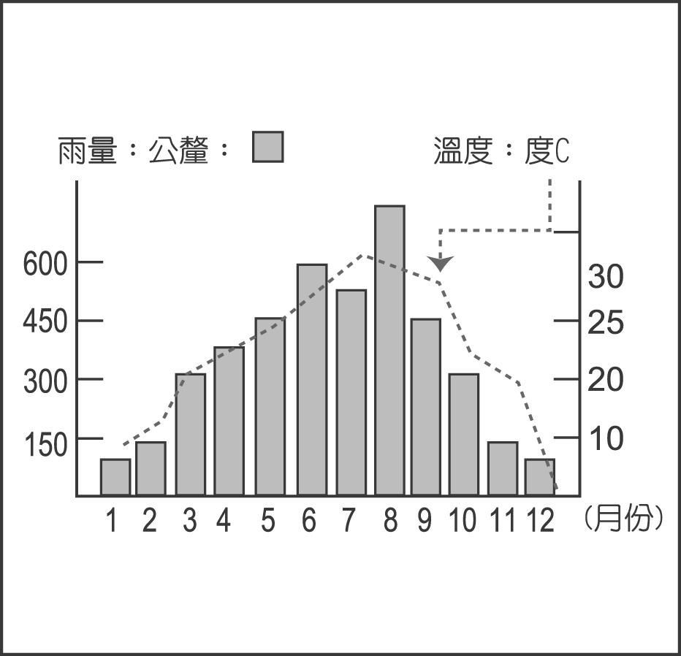 5. 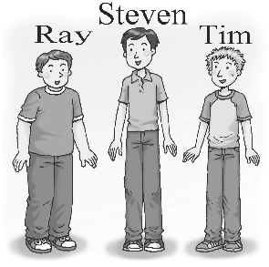
T F T F T F T F T F

6. 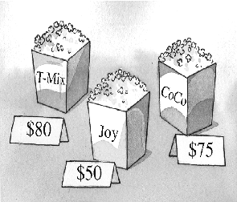 7. 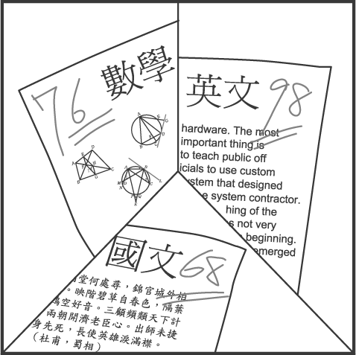 8. 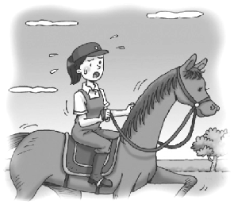 9. 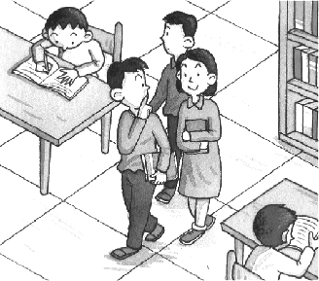 10. 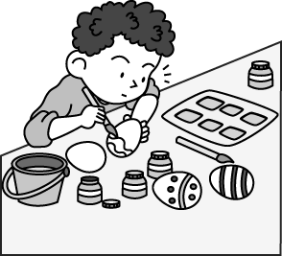
T F T F T F T F T F

B. 選出適當的答句 (每題2分)
1. (A) This is a model car. (B) This model car is better.
(C) That’s Jacky’s. (D) This is a red model.
2. (A) We have some chocolates. (B) No, we need to look for eggs.
(C) We have to go to church. (D) Yes, we have many activities.
3. (A) I don’t want to break them. (B) Yes, I’m holding them.
(C) I am looking for them. (D) Let me try!
4. (A) No, they went home very early. (B) Yes, they were late for school.
(C) No, they did it quickly. (D) Yes, they were better than us.
5. (A) He has to go swimming tomorrow. (B) He went swimming last Monday.
(C) He swims beautifully. (D) He swam the fastest of all.

C. 根據聽到的對話內容，選出正確的答案 (每題2分)
1. (A) The boy’s camera is lighter than the girl’s.
(B) The girl has a new camera.
(C) The design of the girl’s camera is worse.
2. (A) Math is difficult for the boy.
(B) The girl likes math because it’s easy.
(C) Math is the most interesting to the boy.
3. (A) Lucky only found two eggs at the egg hunt.
(B) Lucky is the winner of the egg hunt.
(C) Lucky found less than two eggs at the egg hunt.
4. (A) Sam sings and dances well.
(B) Sam sings and dances badly.
(C) Sam sings well but dances badly.
5. (A) Judy goes to a cell phone store with her mom.
(B) The red one is more expensive than the blue one.
(C) Judy doesn’t have enough money, so she’ll buy the blue one.
(請翻到背面繼續作答)
二、文意字彙(每題2分)
1. I have many movie p on the wall of my bedroom.
2. Buying things online is very c t. You don’t need to go out to buy things.
3. Kevin wants to be a great movie d r and make movies.
4. Jay is a p r singer. A lot of students like him.
5. A: How many c n do you have, Mr. Wang? B: Well, I have a son and a daughter.

三、語法選擇 (每題2分)
1. Bob is __________ of the two boys.
(A) tall (B) taller (C) the taller (D) the tallest
2. David is a careful driver and he always drives his car _________.
(A) fast (B) slow (C) quickly (D) slowly
3. Tony and Billy work together __________ a great player __________ the school baseball team.
(A) becoming ; in (B) becoming ; on (C) to become ; in (D) to become ; on
4. Susan’s hair is longer than __________. (A) I (B) me (C) my (D) mine
5. The big cars are more expensive than the small __________.
(A) car (B) one (C) ones (D) those
6. A: __________ laptop is this? B: It’s __________.
(A) Who ; hers (B) What ; our (C) Whose ; his (D) Which ; mine
7. Ben is 11, and Helen is 13. Ben is two years __________ than Helen.
(A) younger (B) older (C) thinner (D) shorter
8. I will __________ the tickets __________ my cell phone.
(A) lend ; to (B) book ; with (C) check ; by (D) hold ; on
9. Henry is holding an egg in one hand and an apple in ___________.
(A) the other (B) others (C) each other (D) any other
10. Jolin is a very ___________ singer. She sings very ___________.
(A) hard ; hardly (B) good ; well (C) hardly ; hard (D) well ; good

四、對話(每題2分)
1. A: I went to the movies with my friends yesterday. That was great! B: __________
(A) What’s the movie about? (B) Sure. Here you are.
(C) That’s sad. (D) OK. I’ll go with you this time.
2. A: Do you want to paint Easter eggs? B: Sure, ___________.
(A) here you are (B) let me try
(C) I got it (D) It’s time for egg hunt.
3. A: You’ll love this laptop. It’s light and beautiful.
B: I see. ___________
A: It’s 35000 dollars.
(A) Which do you like? (B) How much did you pay for it?
(C) Let’s take the white one. (D) What about the price?
4. A: I didn’t see this movie. What’s it about?
B: __________ Kate and Leo meet on a ship and fall in love.
(A) I have no idea. (B) It’s a little like Titanic.
(C) I can lend it to you. (D) I enjoy watching movies with my family.
5. A: Just click (按) here, and you can shop online.
B: ___________ Let me try.
(A) Can I have it? (B) How did you do it?
(C) Sounds easy. (D) Can I have a look at them?

五、克漏字選擇 (每題2分)
Robert is good at sports. When he was a little boy, he began to play baseball. After he studies in junior high school, he practices playing it harder than anyone. So he plays baseball
1. than all the other boys in his school. He is 2. player on the school team.
However, he had a very sad experience. Last year, he was seriously sick on the eve of an important game. He couldn’t play, so his school lost the game.
This year, Robert will have to play for his school again. He tells himself that he won’t make the same mistake. He eats 3. , and then he’ll be stronger and run 4.
than before. He practices more often than before, and then he can pass the ball 5. .
This time it will be possible to win the game.
however 然而 experience 經驗 eve 前夕 pass傳遞
1. (A) good (B) better (C) the best (D) very well
2. (A) good (B) better (C) the best (D) very well
3. (A) well (B) good (C) many (D) healthy
4. (A) fast (B) faster (C) quickly (D) quicker
5. (A) quick (B) quicker (C) the quicker (D) more quickly

六、閱讀測驗 (每題2分)
(FiFa Department Store is having a summer sale. Fiona and her cousin, Regina, are shopping there. )
Fiona: How about this blue skirt?
Regina: It looks great.
Fiona: Do you think so? Let me try it on.
(Several minutes later.)
Regina: Wow! It looks gorgeous on you.
Fiona: Really? But it’s too expensive.
Regina: How much?
Fiona: It costs $9000. In fact, it’s the most expensive skirt in this store.
Regina: It’s much cheaper because it’s 30% off now.
Fiona: But I only have 3000 dollars. I always spend most of my money at the end of every month. Could you lend me some?
Regina: Fiona! You really have to use your money well.
spend 花費

1. What does gorgeous mean?
(A) Great. (B) Famous. (C) Popular. (D) Successful.
2. How much is this blue skirt now?
(A) $9000. (B) $4500. (C) $6300. (D) $2700.
3. What does some refer to(指的是)?
(A) Skirts. (B) Money. (C) Time. (D) Clothes.
4. What date is today?
(A) August 1st. (B) August 10th. (C) August 15th. (D) August 28th.
5. Which is NOT true?
(A) FiFa Department Store is having a sale. (B) Fiona and Regina are shopping.
(C) Regina should use her money well. (D) Fiona doesn’t have enough money for this blue skirt.

(請翻到背面繼續作答)
七、翻譯句子(每題2分)
1. 要確定這支手機真的符合你的需求。

2. 它是城裡最新的戲院，而且它的螢幕是全台灣(Taiwan)最大的。

3. 鐵達尼號(Titanic)是歷年來最浪漫的電影。

4. 互相幫助比贏得比賽來得更重要。

5. 你必須小心拿著這顆蛋。

高雄縣立林園高級中學 國中部96學年度 第二學期二年級 英語科第一次段考 答案卷
範圍： Book 4- Unit 1~Review 1 班級： 姓名： 座號：
一、聽力測驗
A. 聽聽看，若題目與圖片相符者圈T，不符則圈F (每題1分)
1. | T F | 2. | T F | 3. | T F | 4. | T F | 5. | T F
6. | T F | 7. | T F | 8. | T F | 9. | T F | 10. | T F
B. 選出適當的答句 (每題2分)
1. |  | 2. |  | 3. |  | 4. |  | 5.
C. 根據聽到的對話內容，選出正確的答案 (每題2分)
1. |  | 2. |  | 3. |  | 4. |  | 5.
二、文意字彙(每題2分)
1. | 2. | 3. | 4. | 5.
三、語法選擇 (每題2分)
1. |  | 2. |  | 3. |  | 4. |  | 5.
6. |  | 7. |  | 8. |  | 9. |  | 10.
四、對話(每題2分)
1. |  | 2. |  | 3. |  | 4. |  | 5.
五、克漏字選擇 (每題2分)
1. |  | 2. |  | 3. |  | 4. |  | 5.
六、閱讀測驗 (每題2分)
1. |  | 2. |  | 3. |  | 4. |  | 5.
七、翻譯句子(每題2分)
1. ______________________________________________________________________________
2.
______________________________________________________________________________
3.
______________________________________________________________________________
4.
______________________________________________________________________________
5.
______________________________________________________________________________

高雄縣立林園高級中學 國中部96學年度 第二學期二年級 英語科第一次段考 解答
一、聽力測驗
A. 聽聽看，若題目與圖片相符者圈T，不符則圈F (每題1分)
1. | T F | 2. | T F | 3. | T F | 4. | T F | 5. | T F
6. | T F | 7. | T F | 8. | T F | 9. | T F | 10. | T F
B. 選出適當的答句 (每題2分)
1. | C | 2. | C | 3. | A | 4. | A | 5. | D
C. 根據聽到的對話內容，選出正確的答案 (每題2分)
1. | B | 2. | A | 3. | B | 4. | C | 5. | B
二、文意字彙(每題2分)
1. posters | 2. convenient | 3. director | 4. popular | 5. children
三、語法選擇 (每題2分)
1. | C | 2. | D | 3. | D | 4. | D | 5. | C
6. | C | 7. | A | 8. | B | 9. | A | 10. | B
四、對話(每題2分)
1. | A | 2. | B | 3. | D | 4. | B | 5. | C
五、克漏字選擇 (每題2分)
1. | B | 2. | C | 3. | A | 4. | B | 5. | D
六、閱讀測驗 (每題2分)
1. | A | 2. | C | 3. | B | 4. | D | 5. | C
七、翻譯句子(每題2分)
1. Make sure this cell phone really meets your needs.
2. It’s the newest theater in town, and its screen is the biggest in Taiwan.
3. Titanic is the most romantic movie of all time.
4. Helping each other is more important than winning the game.
5. You have to hold this egg carefully.

