高雄縣立林園高級中學 國中部96學年度 第二學期 二年級 英語科第二次段考考卷
範圍： 班級： 姓名： 座號：
一、聽力測驗
A.根據聽到的內容，依序標出圖片的代號。(每題2分)10%
(Ａ) (Ｂ) (Ｃ) (Ｄ) (Ｅ)
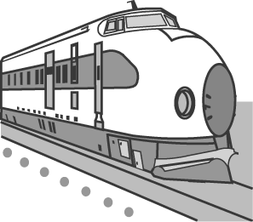 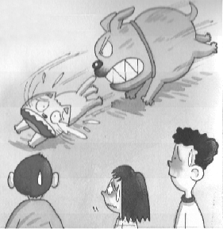 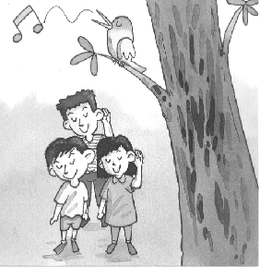 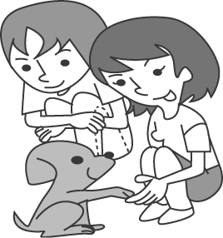 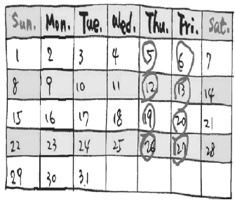
(1)＿＿＿＿ (2)＿＿＿＿ (3)＿＿＿＿ (4)＿＿＿＿ (5)＿＿＿＿
B.選出適當的答句。(每題2分)10%
1. (A) No, she’s good at playing baseball. (B) No, she’s poor at playing baseball. (C ) Yes, she should play well.
(D) She likes to play baseball.
2. (A ) No, he likes playing video games. (B) He’s afraid to cook. (C ) Yeah. And he’s good at cooking.
(D) Yes, he’s poor at cooking.
3. (A) Come on! Let’s start. (B) She must go out at 3 o’clock. (C) Yes, she’s active in learning.
(D) No, she has to prepare for the test.
4. (A) Yes, she likes to play baseball. (B) Because she always breaks the rules. (C) No, she doesn’t
(D) She should follow the rules.
5. (A) I’d love to. (B) I usually relax and go out to have fun. (C) I prepared for the test. (D) I don’t watch too much TV.
C.根據所聽到的問題，配對正確的答案。(每題2分)10%
(A) NO, she can do it by herself.
(B) I’ll check again.
(C) Let’s call the police.
(D) It looks clean.
(E) The factory is polluting it.
二、文法選擇(每題2分)20%
1. My dad makes me________ every day.
(A) studies (B) studied (C) studying (D) study
2. Tom needs to_______ and_______ fun.
(A) relaxes ; has (B) relaxes ; hare (C) relax ; have (D) relax ; has.
3. How did she do _______the test ?
(A) of (B) with (C) for (D) on
4. _______ attention in class, he gets better grades.
(A) By paying (B) Paying (C) To pay (D) Pay
5. My mom will give me a dog _______ my birthday present.
(A) for (B) about (C) to (D) as
6. Jim _______ the train moving and was very excited.
(A)feel (B) was feeling (C) felt (D) feels
7. They looked at the cat _______ after the mouse just now.
(A) run (B) ran (C)to run (D) was running
8. Give your pets lots of care and they can grow _______.
(A) in health (B) healthily (C) healthy (D) healthier
9. A vet is a doctor _______.
(A) for kids (B) to children (C) to adults (D) for dogs (請翻到背面繼續作答)

10. Besides _______ trash, we should also try not to produce too much waste.
(A) sorting (B) sort (C) sorted (D) sorts
三.文意字彙(每題2分)20%
1. He always eats with his own chopsticks. He never uses d e ones.
2. Meg’s g e was better than mine. She got 100, but I got 70.
3. My brother has a good h t . He gets up early every morning.
4. Helen is a very outgoing and f y girl.
5. Listen! This parrot can r t after me.
6. We should put some water in this b e.
7. Is this answer c t?
8. We have only one earth(地球). Please keep our e t clean.
9. Smoke from cars will p e the air.
10. Barking dogs seldom b e.
四、對話選擇(每題2分)10%
1. Ben: It’s getting hot. _______ Joe: Here , have some black tea.
(A) I get hungry easily. (B) I feel so thirsty. (C) I smell something burning. (D) I’m so sweet.
2. Cindy: Why does your dog look so strong and healthy? Kevin:_______
(A) Every three weeks. (B) Every two months. (C) Twice a day. (D) Once a week.
3. Jill: How can I be a good dog owner? Rose:_______
(A) Keep your dog at home all the time. (B) Give it a bath twice a day. (C) Give your dog a lot of love and care.
(D) Take it for a walk once or twice a year.
4. Peter: David, you look sad. ______ David: I am worried about showing my poor grades to my mom.
(A) What’s up? (B) Come on, David. (C) Do you have to? (D) You must be all right.
5. Leo: Everyone should follow the school rules, right? Meg: _______
(A) Should we push others? (B) Should we break the rules? (C) Should we follow the rules?
(D) Should we do some warm-ups first?
五、閱讀測驗(每題1分)5%
Rick: Tim. Why do you look unhappy? What’s up?
Tim: I did terribly on my tests. My parents must be very angry.
Rick: You are good at math , aren’t you?
Tim: Yes, but the math test was much more difficult this time. I didn’t get good grades in math.
And I’m poor at English and social studies.
Rick: Too bad. I didn’t do well on the math test, either. But I got high grades in the other subjects.
Study harder, and you’ll do a better job next time.
Tim: I don’t have a habit of previewing before class. And I seldom review after school.
I really have to change my study habits.
Rick: Let’s study together. We cam prepare for tests earlier.
Tim: Thanks a lot, Rick. I learned a lesson. I won’t make the same mistake next time.
Subject科目 decision決定
(1) Why does Tim look sad?
- His parents don’t care about his grades. (B) He is tired of taking tests.
- He’s active in learning. (D) He didn’t do well on the tests.
(2) Rick got bad grades in ______.
(A) science (B) social studies (C) math (D) English
(3) Tim isn’t good at _______.
(A) math (B) English (C) Chinese (D) science
(4) Tim _______ previews before class.
(A) always (B) never (C) seldom (D) often
(5) Why didn’t Tim do well on the math test this time?
(A) Because he didn’t do warm-ups. (B) Because he didn’t follow the rule.
(C) Because the test was much more difficult. (D) Because he was poor at math.
六、翻譯(每題3分)15%
1. 你必須給狗兒們許多的愛和關懷，牠們才能夠快樂地成長。
2. 資源回收幫助我們減少垃圾。
3. 好的學習者在學習上是積極主動的。
4. 藉由預習和複習她的功課，她常常得到好成續。
5. 每個人都應該聽老師的話。

高雄縣立林園高級中學 國中部96學年度 第二學期 二年級 英語科第二次段考考卷
範圍： 班級： 姓名： 座號：
一、聽力測驗
A.根據聽到的內容，依序標出圖片的代號。(每題2分)10%
1.  B | 2.  C | 3.  A | 4.  E | 5.  D
B.選出適當的答句。(每題2分)10%
1.  A | 2.  C | 3.  D | 4.  B | 5.  B
C.根據所聽到的問題，配對正確的答案。(每題2分)10%
1.  E | 2.  C | 3.  B | 4.  A | 5.  D
二、文法選擇(每題2分)20%

1.  D | 2.  C | 3.  D | 4.  A | 5.  D
6.  C | 7  A | 8.  B | 9  D | 10.  A

三.文意字彙(每題2分)20%

1.  disposable | 2.  grade | 3  habit | 4.  friendly | 5  repeat
6  bottle | 7  correct | 8  environment | 9  pollute | 10  bite
四、對話選擇(每題2分)10%

1.  B | 2.  送 | 3.  C | 4.  A | 5.  C
五、閱讀測驗(每題1分)5%

1.  D | 2.  C | 3.  B | 4.  B | 5.  C

六、翻譯(每題3分)15%

1. You need to give dogs a lot of love and care, and then they can grow healthily and happily.
2. Recycling helps us reduce trash.
3. Good learners are active in their learning.
4. By previewing and reviewing her lessons, she often gets good grades. (She often gets good grades by previewing and
reviewing her lessons.)
5. Everyone should listen to his/her teachers.

