高雄縣立林園高級中學 國中部97學年度 第一學期 一年級 英語科 第二次段考考卷
範圍：國中英語第一冊 (U3, U4, U5, & Review2) 班級： 姓名： 座號：

- 聽力測驗 30% (每題2分)
- 聽到的對話內容與圖片相符者打O，不符者打X：10%
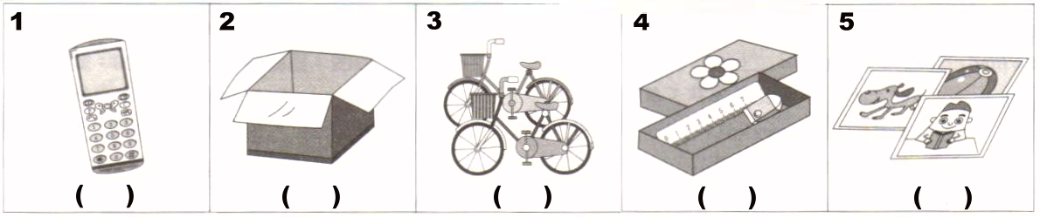
- 聽到的句子內容與題目相符者打O，不符者打X：10%
- The three birds are under the tree.
- The table is in front of the sofa.
- Four pens are behind the door.
- The two dogs are under the sofa.
- My brother is next to my mother.

- 聽到的句子或對話內容與圖片相符者打O，不符者打X：10%
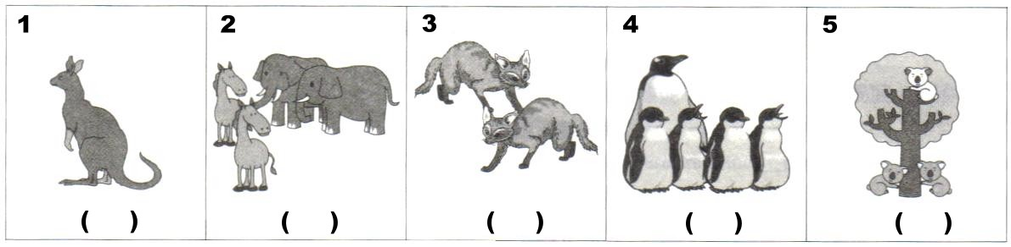
- 筆試 70%
- 文意字彙：10%
1. Please be q t in the library(圖書館).
2. My father and mother are my p s.
3. The notebook is a birthday g t from my uncle.
4. The dog is very s t. It can count(會數數) and dance(跳舞).
5. Jack and the Beanstalk(傑克與魔豆) is an i g story(故事).

- 文法選擇：20%
1. A: What those? B: a box and an orange.
(A) is; They’re (B) is; It’s (C) are; They’re (D) are; It’s
2. Amy’s and Meg’s mothers are _____.
(A) housewife (B) housewives (C) housewifes (D)house wife
3. A: “computer.” B: C-O-M-P-U-T-E-R, computer.
(A) Spell (B) Spelling (C) To spell (D) To spelling
4. A: Please a good girl, Patty. B: Yes, Mom.
(A) do (B) be (C) is (D) are
5. tigers are there in the zoo? B: Six.
(A) How much (B) How many (C) What (D) Where
6. A: Billy, play in the kitchen. It’s dangerous(危險的). B: All right(好的).
(A) isn’t (B) X (C) doesn’t (D) don’t

7. The beautiful park is Jean’s school.
(A) between (B) under (C) on (D) near
8.Patty sits Amy Peter.
(A) between; and (B) between; to (C) next; and (D) next; to
9.A: Where Peter? B: He in the bathroom.
(A) are; is (B) are; are (C) is; is; (D) is; are
10.A: Are there four penguins? B: Yes, .
(A) they are (B) it is (C) there are (D)there is

- 閱讀測驗：10%
Dec. 1, 2008
Dear Annie,
My family and I move to our new house in Taipei. Our house is near a big zoo. We love our house. I have a bedroom of my own. My brother’s bedroom is next to mine. He isn’t at home now. He is at Sue’s birthday party. Dad and Mom watch television in the living room. Our dog, Lucky, is also over there. He is not under the table. He sits on the sofa.
Yours,
Irene
*move to 搬去
*have 有
*of my own 屬於自己的
*mine 我的房間
*also 也
*yours 你的朋友

1. Where are Irene’s parents?
(A) In the new house. (B) In the zoo. (C) In the bedroom. (D) In the kitchen.
2. Who is the birthday girl?
(A)Irene. (B) Sue. (C) Annie. (D) Lucky.
3. Where is Irene’s new house？
(A) It’s near a zoo. (B) It’s big. (C) It’s near a park. (D)It’s in Kaohsiung.
4. What is next to Irene’s bedroom?
(A)Her dad and mom’s bedroom. (B)Her brother’s bedroom. (C) The living room (D) The kitchen.
5.Where is the dog?
(A) Under the table. (B) On the television. (C) In the living room. (D) In the bedroom.

- 依提示作答：10%
  - There are 35 students in the class. (依劃線部分造原問句)
  - Sherry is in the dinning room. (依劃線部分造原問句)
  - Are these red apples? (將複數句改為單數句)
  - What is it? (將單數句改為複數句)
  - Where is the bag? (以「在椅子之前」詳答)

- 翻譯：20%
  - 寫下你的名字。 (4分)
  - 彼得，請不要寫字在桌面上。 (7分)
  - 台北動物園有大象、斑馬和熊。 (9分)

高雄縣立林園高級中學 國中部97學年度 第一學期 一年級 英語科 第二次段考答案卷
範圍：國中英語第一冊 (U3, U4, U5, & Review2) 班級： 姓名： 座號：

- 聽力測驗 30% (每題2分)
- 聽到的對話內容與圖片相符者打O，不符者打X：10%
1. | 2. | 3. | 4. | 5.
- 聽到的句子內容與題目相符者打O，不符者打X：10%
1. | 2. | 3. | 4. | 5.
- 聽到的句子或對話內容與圖片相符者打O，不符者打X：10%
1. | 2. | 3. | 4. | 5.

- 筆試 70%
- 文意字彙：10%
1. | 2. | 3. | 4. | 5.
- 文法選擇：20%
1. | 2. | 3. | 4. | 5.
6. | 7. | 8. | 9. | 10.
- 閱讀測驗：10%
1. | 2. | 3. | 4. | 5.
- 依提示作答：10%
1.
2.
3.
4.
5.
- 翻譯：20%
1.
2.
3.

高雄縣立林園高級中學 國中部97學年度 第一學期 一年級 英語科
第二次段考解答
- 聽力測驗 30% (每題2分)
- O X X O X
- X O X X O
- X O X O X

- 筆試 70% (第一至第四大題每題2分)
- quiet / parents / gift / smart / interesting
- C B A B B D D A C C
- A B A B C
- 依提示作答：10% (每題2分，錯一字扣1分，不倒扣)
1. | How many students are there in the class?
2. | Where is Sherry?
3. | Is this a red apple?
4. | What are they?
5. | It is in front of the chair. (The bag is in front of the chair.)
- 翻譯：20% (每題分數如下，錯一字扣1分，不倒扣)
1. | Write down your name. (4分)
2. | Peter, please don’t write on the desk. (7分)
3. | There are elephants, zebras and bears in Taipei Zoo. (9分)

