高雄縣立林園高級中學 國中部97學年度 第一學期 二年級 英文科 第一次段考考卷(題目卷)
範圍： B3 L1~Review1 班級： 姓名： 座號：
A部份：聽力評量（30%）
一、聽CD的句子，寫出符合圖片的句子代號：10%
1.  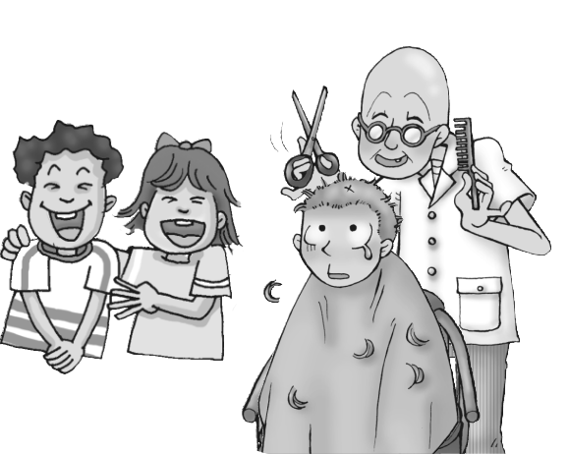 | 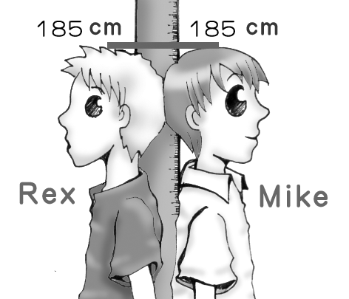  2. | 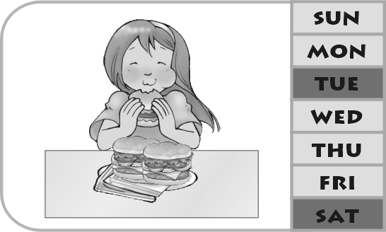  3. | 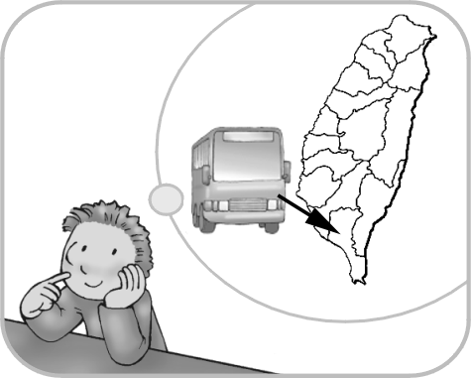  4. | 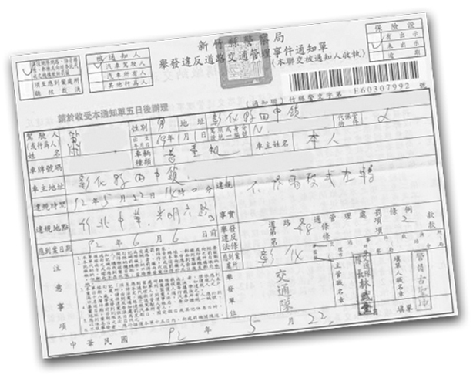  5.
( ) | ( ) | ( ) | ( ) | ( )
二、聽CD的敘述，選出正確的回應：10%
( ) 1. (A) I’m online with my friend in America now. (B) Don’t run in the classroom.
(C) I’ll visit old buildings in Tainan. (D) It’s time to go home and have dinner.
( ) 2. (A) He can use chopsticks. (B) That’s great. (C) No, he won’t. (D) He seldom cooks.
( ) 3. (A) You can ride your bicycle. (B) Sorry, you can’t. (C) Why not? (D) I go there twice a week.
( ) 4. (A) Twice a month. (B) I sometimes get on the Internet.
(C) I’m waiting for my friend. (D) I like to join chat rooms.
( ) 5. (A) No, he often rides his bicycle to school. (B) No, he won’t come.
(C) Yes, he has a lot of fun every day. (D) Yes, he always gets up early.
三、聽CD的問題，根據下列的表格，選出正確的答案：10%
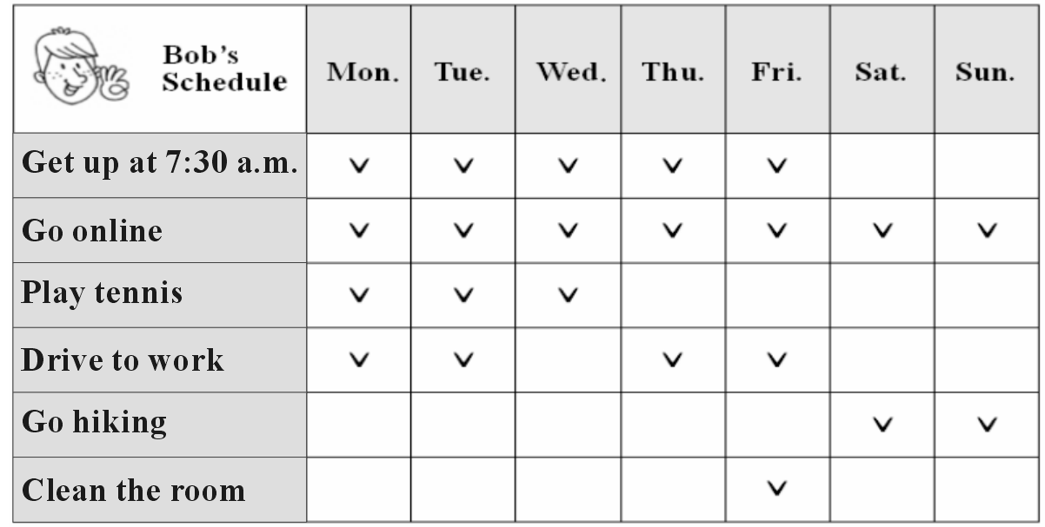

( ) 1. (A) Go online. (B) Go hiking. (C) Play tennis. (D) Clean the room.
( ) 2. (A) By car. (B) By train. (C) By bus. (D) By bicycle.
( ) 3. (A) He sometimes goes online. (B) He never goes online. (C) He always goes online. (D) He seldom goes online.
( ) 4. (A) No, seldom. (B) Yes, he often does. (C) Yes, sometimes. (D) No, he never cleans the room.
( ) 5. (A) Twice a month. (B) Three times a week. (C) Once a month. (D) Four times a week.

B部份：讀寫評量（70%）
- 字彙:10%
( ) 1. It’s really a gift. Mom will like it. (A) full (B) angry (C) special (D) smart
( ) 2. That American boy can’t use . (A) bicycles (B) words (C) chopsticks (D) tickets
( ) 3. Don’t worry. Sam will help you your homework. (A) correct (B) join (C) enjoy (D) ask
( ) 4. In the , all students will have computers in the classroom. (A) future (B) e-mail (C) fax (D) letter
( ) 5. A: Do you near Lisa's bakery? B: Yes, I do, so I often buy some bread there.
(A) like (B) live (C) miss (D) use
6. My uncle’s son is my c . uncle 伯父；叔父
7. My mother is going to f dinner tonight.
8. Do you like to read c c books?
9. My sister is 8 years old. She studies in an e y school.
10. The new s r begins in September.
- 文意填充:10%
1. Don’t laugh my mistakes.
2. Sally is worried her homework.
3. We can do many things the Internet.
4. Where do they want to sit? the door.
5. I often go to Tainan train.
6. He has to go home two days.
7. A: Who are you waiting ? B: Debbie.
8. John, it’s dinner time. Come home once.
9. She wrote the letter English.
10. Aren’t you going to have dinner your wife tonight?
- 文法及對話選擇:20%
( ) 1. Bob always gets bad grades because he studies hard. (A) always (B) sometimes (C) never (D) usually
( ) 2. Danny often studies at home, but Betty .
(A) seldom does (B) doesn’t seldom (C) does seldom (D) seldom doesn’t
( ) 3. We are going to a party this Sunday. ________ you join us?
(A) had ; Do (B) have ; Are (C) have ; Will (D) had ; Did
( ) 4. That's to me. I didn't know that. (A) a news (B) news (C) no news (D) not a news
( ) 5. A: Do both of your brothers like the comic books? B: No, only one of them the comic books.
(A) like (B) will like (C) likes (D) liked
( ) 6. __________ each of the enjoy the delicious food here?
(A) Do ; customer (B) Do ; customers (C) Does ; customer (D) Does ; customers
( ) 7. There a game here on Friday afternoon. (A) will have (B) will be (C) will is (D) is going to
( ) 8. Can you ? It’s rainy today. (A) hang up (B) pick me up (C) look at me (D) get up
( ) 9. A: I’m going to take a trip to America. B:
(A) Don’t worry about it. (B) That’s too cheap. (C) That’s wonderful. (D) I’m off work tomorrow.
( ) 10. A: I can't go with you. B: (A) Are you OK? (B) Of course. (C) Sorry, I can't. (D) Why not?
- 閱讀測驗:10%
(一)
In 2004, the car company Toyota in Japan made a car with feelings. The car will soon be on the road. The car with feelings will talk to cars in traffic. The two lights on the front of the machine are its eyes. When you are on the road and a driver is not nice to you, the car’s eyes will go red. When you want to say “thank you,” you can make the car’s eyes smile a happy yellow. When you are sitting in a long line of traffic, your car can cry. How? Little white lights come on under its eyes. The horn makes different noises for different feelings, too. Drivers can hear when you are happy, sorry, angry or bored. horn 喇叭
( ) 1. Why do the car lights go red?
(A) To show you’re unhappy. (B) To let people know you’re lonely.
(C) To show you’re afraid (D) To tell other drivers to be careful.
( ) 2. Which of the following is NOT true?
(A) The word “machine” means the car itself. (B) The car is made in Japan.
(C) The two lights can see what’s going on outside. (D) The car can show feelings by its sound and lights.
(二)
Many people like to buy a lot of food, clothes and fashionable things in night markets in Taiwan because most of the things there are very cheap. People can also play games there like fishing and many kinds of ball games. They also can find a lot of delicious food there from all over the world. People can have fun at night markets. Don’t miss it! I believe you will love it.
( ) 1. Who likes to go to night markets?
(A)Weathermen. (B) Visitors. (C) Policemen. (D) Nobody.
( ) 2. What does the word “fashionable” mean?
(A) New and modern. (B) Expensive and big. (C)Clean and small. (D) Old and bad.
( ) 3. What can’t you do in a night market?
(A) To buy clothes. (B) To eat food from foreign countries. (C) To drive a car. (D) To play games.
- 依提示作答及翻譯:20% (1~4題每題2分，全對才給分；5~8題每題3分，錯一字扣一分)
- Mary goes shopping twice a month. (依劃線部份造原問句)
- I had a math test last Thursday. (劃線部份改為next Thursday)
- Helen plays computer games on the weekend. ( 加入 sometimes )
- Two of the men were policemen. (劃線部份改為each)
- (中翻英) 你將來要做什麼?
- (中翻英) 今天沒有任何新鮮事。
- (中翻英) 他常常在學校犯錯。
- (中翻英) Bill的雙親都很高。（Both…）

高雄縣立林園高級中學 國中部97學年度 第一學期 二年級 英文科 第一次段考考卷(答案卷)
範圍： B3 L1~Review1 班級： 姓名： 座號：
A部份：聽力評量（30%）
一、聽CD的句子，寫出符合圖片的句子代號：10%
1. | 2. | 3. | 4. | 5.
二、聽CD的敘述，選出正確的回應：10%
1. | 2. | 3. | 4. | 5.
三、聽CD的問題，根據下列的表格，選出正確的答案：10%
1. | 2. | 3. | 4. | 5.
B部份：讀寫評量（70%）
- 字彙:10%
1. | 2. | 3. | 4. | 5.
6. | 7. | 8. | 9. | 10.
- 文意填充:10%
1. | 2. | 3. | 4. | 5.
6. | 7. | 8. | 9. | 10.
- 文法及對話選擇:20%
1. | 2. | 3. | 4. | 5.
6. | 7. | 8. | 9. | 10.
- 閱讀測驗:10%
(一)  1. | 2. | (二)  1. | 2. | 3.
- 依提示作答及翻譯:20% (1~4題每題2分，全對才給分；5~8題每題3分，錯一字扣一分)
1.
2.
3.
4.
5.
6.
7.
8.
高雄縣立林園高級中學 國中部97學年度 第一學期 二年級 英文科 第一次段考考卷(解答)
A部份：聽力評量（30%）
一、聽CD的句子，寫出符合圖片的句子代號：10%(每題2分)
1. C | 2. E | 3. D | 4. A | 5. B
二、聽CD的敘述，選出正確的回應：10%(每題2分)
1. C | 2. B | 3. C | 4. A | 5. D
三、聽CD的問題，根據下列的表格，選出正確的答案：10%(每題2分)
1. A | 2. A | 3. C | 4. A | 5. B
B部份：讀寫評量（70%）
- 字彙:10% (每題1分)
1. C | 2. C | 3. A | 4. A | 5. B
6. cousin | 7. fix | 8. comic | 9. elementary | 10. semester
- 文意填充:10% (每題1分)
1. at | 2. about | 3. on | 4. By | 5. by
6. in | 7. for | 8. at | 9. in | 10. with
- 文法及對話選擇:20% (每題2分)
1. C | 2. A | 3. C | 4. B | 5. C
6. D | 7. B | 8. B | 9. C | 10. D
- 閱讀測驗:10% (每題2分)
(一)  1. A | 2. C | (二)  1. B | 2. A | 3. C
- 依提示作答及翻譯:20% (1~4題每題2分，全對才給分；5~8題每題3分，錯一字扣一分)
1. How often does Mary go shopping?
2. I will have a math test next Thursday.
3. Helen sometimes plays computer games on the weekend.
4. Each of the men was a policeman.
5. What will you be / do in the future?
6. There is nothing new / special today.
7. He often makes mistakes at school.
8. Both of Bill’s parents are tall.

