高雄縣立林園高級中學 國中部97學年度 第一學期 二年級 英文科 第二次段考考卷(題目卷)
範圍： B3 L4~Review2 班級： 姓名： 座號：
A部份：聽力評量（30%）
一、聽CD的句子，與圖片相符者寫T，不符合者寫F：10％
  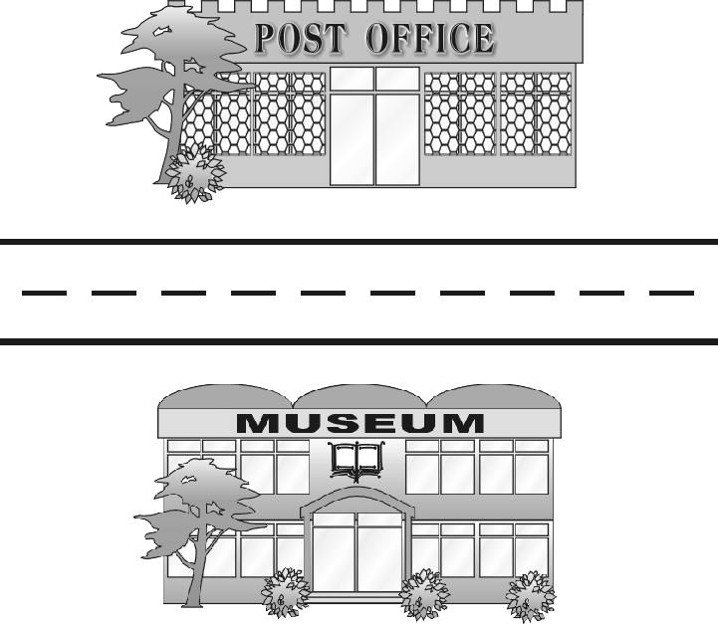  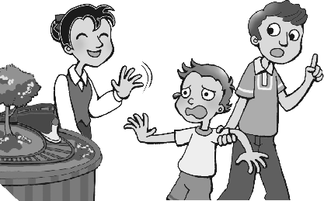  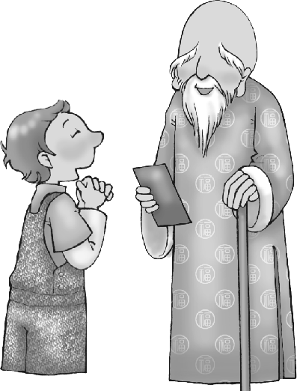  1. | 2. | 3. | 4. | 5.
( ) | ( ) | ( ) | ( ) | ( )
二、聽CD，選出正確的回應：10％
( ) 1. (A) It sounds fun. (B) This special offer ends on May 5th.
(C) They saw this advertisement in the newspaper. (D) Because it is broken.
( ) 2. (A) What? I have to buy them? (B) They are hers.
(C) I am standing in front of them. (D) Wow! They’re very cool.
( ) 3. (A) Behind the police we could see the accident. (B) The car ran through a red light.
(C) We hope no one is hurt. (D) That’s good news.
( ) 4. (A) Nothing is really free in life. (B) There are many strange things.
(C) Don’t worry. I can fix it. (D) Aren’t you lucky?
( ) 5. (A) The truck hit him yesterday. (B) Lucky guy. He’s on TV right now.
(C) That’s terrible. (D) His father bought him a new computer.
三、聽CD的句子，參考下列的圖示，將建築物的代號填入圖中正確的位置，1-5為題目編號：10％
A. gas station B. bookstore C. museum D. restaurant E. post office
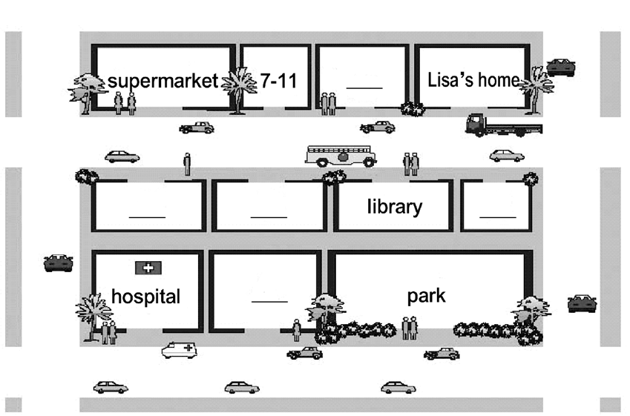
1
2
3
4
5

B部份：讀寫評量（70%）
一、請將下列的形容詞改為副詞，副詞改為形容詞：10％
1. fast 2. hungry 3. quiet 4. easily 5. hard
6. late 7. lucky 8. sad 9. noisily 10. well
二、將所有格改為所有格代名詞：5％
1. the Huangs’ 2. their 3. her 4. his 5.my
三、文意字彙：24％(請依照句意及文法結構作出適當變化)
1. These s l o r in department stores end on November 30!
2. There are a lot of p r on the bus.
3. How did the car accident h n last night?
4. Andy is James’ c e friend. He knows everything about him.
5. Don’t eat too many s ts. They’re bad for your teeth.  teeth牙齒
6. He gives each of us a c e to ask one question.
7. Peter always likes to kid. No one b e him.
8. H y! The movie will begin soon.
9. Boyd: Ron loves Mary? Is the news t e? Tina: Yes, I’m sure.
10. A: Do you s l cameras in this store? B: Yes, we do.
11. We need a Chinese teacher. Please p t a want ad in the newspaper.
12. Mary’s home is very near her school. It only t k Mary 5 minutes to walk to school.
四、文法選擇：10％
( ) 1. Mary is a worker. She always works .
(A) well ; hard (B) well ; hardly (C) good ; hard (D) good ; hardly
( ) 2. Jenny spent three hours with me on the phone about her future last night.
(A) talk (B) talking (C) to talk (D) talked
( ) 3. My grandfather last night.
(A) told us a funny story (B) told a funny story us
(C) told us to a funny story (D) told a funny story of us
( ) 4. A: Is this bag? B: No, it’s .
(A) Lisa ; me (B) Lisa ; I (C) Lisa’s ; mine (D) Lisa’s ; my
( ) 5. It the police two months the bad guy.
(A) took ; catch (B) takes ; catches (C) took ; to catch (D) took ; catching五、閱讀測驗:一題2分，共6分
Math Teachers wanted
- We are looking for math teachers for junior high school students. 2. Must live in Kaohsiung City.
- Interested in teaching math. 4. At least 2 year experience(經驗) 5. Age: 20~30. 6. Sex: female(女性).
Please call Mr. Li at 07-7894561 or fax 07-7896543 or e-mail to wanted@wewantyou.com.tw
( ) 1.According to this ad, which of the following is true?
(A)This want ad needs a Chinese teacher. (B) The payment in this ad is NT$30,000 a month.
(C) Teachers must have at least 2 year experience. (D) Teachers must have interviews(面試) in Taipei.
( ) 2. Which way can’t you contact(連絡) Mr. Li?
(A)By mail (B) By phone (C)By fax (D) By e-mail
( ) 3. Who is the best candidate(應徵者) for this job?
(A) Mr. Lin is a 25 years old teacher with 3 year experience and loves to teach math.
(B) Mrs. Kuo is a 40 years old teacher with 10 year experience.
(C) Miss Chang is a 20 years old student without any experience in teaching math.
(D) Mrs. Liou is a 28 years old teacher with 5 year experience and really loves kids.
五、整句翻譯：每題3分，共15分
1. David總是在加油站後面等我。

2. A: 這輛卡車是誰的？ B: 它是Hardy的。(限用所有代名詞)

3. 不要大聲地敲門。
.
4. 昨天David給Tina一個新穎的手機。

5. Jean花很多錢買一台新的電腦。

高雄縣立林園高級中學 國中部97學年度 第一學期 二年級 英文科 第二次段考考卷(答案卷)
範圍： B3 L4~Review2 班級： 姓名： 座號：
A部份：聽力評量（30%）
一、聽CD的句子，與圖片相符者寫T，不符合者寫F：10％
1. | 2. | 3. | 4. | 5.
二、聽CD的敘述，選出正確的回應：10%
1. | 2. | 3. | 4. | 5.
三、聽CD的句子，參考下列的圖示，將建築物的代號填入圖中正確的位置，1-5為題目編號：10％
1. | 2. | 3. | 4. | 5.
B部份：讀寫評量（70%）
一、請將下列的形容詞改為副詞，副詞改為形容詞：10％
1. | 2. | 3. | 4. | 5.
6. | 7. | 8. | 9. | 10.
二、將所有格改為所有格代名詞：5％
1. | 2. | 3. | 4. | 5.
三、文意字彙：24％(請依照句意及文法結構作出適當變化)
1. | 2. | 3. | 4. | 5. | 6.
7. | 8. | 9. | 10. | 11. | 12.
四、文法選擇：10％
1. | 2. | 3. | 4. | 5.
五、閱讀測驗:一題2分，共6分
1. | 2. | 3.
六、整句翻譯：每題3分，共15分
1.
2.
3.
4.
5.

高雄縣立林園高級中學 國中部97學年度 第一學期 二年級 英文科 第二次段考考卷(答案卷)
範圍： B3 L4~Review2 班級： 姓名： 座號：
A部份：聽力評量（30%）
一、聽CD的句子，與圖片相符者寫T，不符合者寫F：10％
1.T | 2. F | 3.T | 4.F | 5.T
二、聽CD的敘述，選出正確的回應：10%
1.D | 2.B | 3.B | 4.C | 5.D
三、聽CD的句子，參考下列的圖示，將建築物的代號填入圖中正確的位置，1-5為題目編號：10％
1.E | 2.C | 3.B | 4.A | 5.D
B部份：讀寫評量（70%）
一、請將下列的形容詞改為副詞，副詞改為形容詞：10％
1.fast | 2.hungrily | 3.quietly | 4.easy | 5.hard
6.late | 7.luckily | 8.sadly | 9.noisy | 10.good
二、將所有格改為所有格代名詞：5％
1.the Hunag’s | 2.theirs | 3.hers | 4.his | 5.mine
三、文意字彙：24％(請依照句意及文法結構作出適當變化)
1.special offers | 2.passengers | 3.happen | 4.close | 5.sweets | 6.chance
7.believes | 8.Hurry | 9.true | 10.sell | 11. put | 12. takes
四、文法選擇：10％
1.C | 2.B | 3.A | 4.C | 5.C
五、閱讀測驗:一題2分，共6分
1.C | 2.A | 3.D
六、整句翻譯：每題3分，共15分
1.David always waits for me behind/ in back of the gas station.
2. A: Whose truck is this? B: It’s Hardy’s.
3. Don’t knock on the door loudly.
4. David gave Tina a modern cell phone yesterday. (David gave a modern cell phone to Tina yesterday.)
5. Jean spent a lot of money (on) buying a new computer.

