高雄縣立林園高中國中部97學年度第一學期二年級英語科第三次段考
範圍：L7-Review III 班級： 姓名： 座號：
A部份：聽力評量（30%）
一、聽CD的三個敘述，選出與圖片相符者，並填入其英文代號：10％
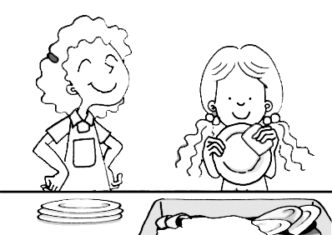  1. | 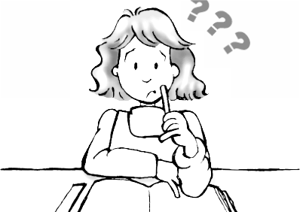  2. | 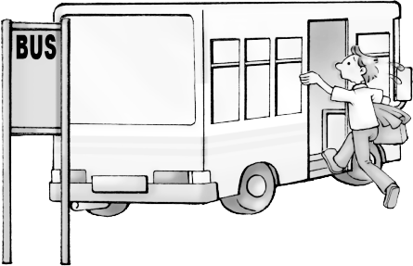  3. | 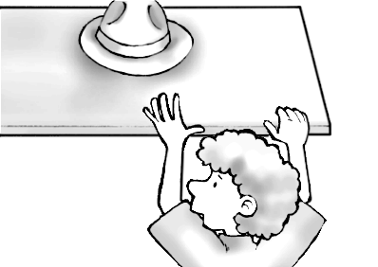  4. | 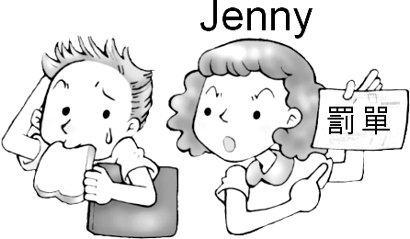  5.
( ) | ( ) | ( ) | ( ) | ( )

二、聽CD的敍述，選出最適當的回應：10％
( ) 1. (A) I was too busy to go there. (B) I’m sorry to tell you the bad news.
(C) I decided to have a party. (D) It was very easy.
( ) 2. (A) She finished cleaning her room. (B) Yes, she practiced swimming with us.
(C) Yes, we hoped to see her then. (D) It is not much fun.
( ) 3. (A) Oh, no. He forgot! (B) Yes, he remembered to write Mary a letter.
(C) He really needs to talk to our teacher. (D) He forgot to do his homework.
( ) 4. (A) He doesn’t like to exercise. (B) His hobby is very different from ours.
(C) Swimming. (D) He hates to go jogging on Sunday.
( ) 5. (A) That’s good. Children always give pets to their parents.
(B) Yes, a book is cheap enough.
(C) Thank you for the new book.
(D) He is very happy to have you in our family.

三、聽CD的敍述，請在表格內選出下列五人喜愛做的活動並填入其英文代號：10％

A. getting on the Internet B. watching movies C. cooking D. talking on the phone E. playing tennis
Danny | John | Lisa | Robert | Mary
 |  |  | _

B部份：書寫評量（70%）
- 文意字彙：10％
  - People should at least do ten minutes’ e________e every day. It’s good for health.
  - My first camping trip was an exciting e_________e.
  - Collecting（收集）baseball cards is a common h______y.
  - She got an i_______n to the party.
  - Can you put coffee on your shopping l_____t?
  - Their new house is large and c_______e.
  - The computer is very u_______l in our life.
  - If you don’t understand the word, look it up in the d_______y.
  - He can speak three l_______es－Chinese, Taiwanese, and a little English.
  - We spent a lot of time picking up a p_______e gift for our friend.

- 介詞填充：10％
1. They are talking about their plans ________ the winter vacation.
2. People will come home and get ________ with their family during the Chinese New Year.
3. Don’t get too close ______ the fire（火）.
4. My bicycle is different ________ yours in color.
5. Taking care _______ your parents is important.
6. He is writing ________ his friend’s new phone number.
7. Do I have to dress up _____ an elf?
8. Thank you ______ giving me a wonderful present.
9. Can you pick me ______ at the airport?
10. We can’t wait _____ enjoy our winter vacation.

三、文法選擇及對話：20％
1. After school, they _______ to go home early.
（A）decide （B）finish （C）enjoy （D）practice
2. Playing computer games _____ a lot of fun.
（A）are （B）is （C）does （D）did
3. I will help the old man ______ across the street.
（A）walk （B）walking （C）walked （D）walks
4. My father is too busy ______ you.
（A）not to see （B）seeing （C）not seeing （D）to see
5. All teachers would like their students _______ well.
（A）learn （B）learning （C）to learn （D）learned
6. May is ______ to play basketball.
（A）tall enough （B）enough tall （C）so tall （D）very tall
7. Why don’t we go shopping on the weekend?
（A）I’m sorry to tell you the bad news.
（B）It isn’t much fun.
（C）It will be a great experience.
（D）That’s a good idea.

8. What did he want you to buy?
（A）Something special.
（B）To the beach.
（C）By letter.
（D）By tomorrow.
9. Do you think my hobby is interesting?
（A）Great.
（B）Yes, I will.
（C）Yes, I think so.
（D）Who takes care of it?
10. Sign me up.
（A）Do you? （B）No problem. （C）Yes, please. （D）No, thanks.

四、閱讀測驗：20％
（一）
Hello, my dear students!
I’m very glad （1） you some good news. The Chinese New Year is coming.
And I’m planning （2） a small party at the school on Friday evening. You don’t （3）
bring anything. There will be a lot of delicious snacks at the party. The party will begin
at 7 o’clock, so you can （4） around that time. I hope you can come.

P.S. Sarah will bring lots of DVDs. We can enjoy （5） some good movies.

Question: 1. （A）tell （B）to tell （C）telling （D）told
2. （A）to give （B）to make （C）giving （D）making
3. （A）want to （B）love to （C）forget to （D）have to
4. （A）arrive （B）visit （C）prepare （D）borrow
5. （A）in watching （B）to watch （C）watching （D）watch

（二）
Do you love panda bears? They’re big, cute and shy. Two new visitors, Tuan-tuan and Yuan-yuan, just came from Szu-chuan last December. But remember not to get too close. There was an interesting story about a man and a panda.
This man had too much wine and went alone to Beijing Zoo. He would climb in and said hello to the pandas. He found one panda and tried to shake its hand. But
instead, the panda took the man, turned him over and started to bite his leg! The man
wasn’t happy and tried to bite the panda on the back.
The panda’s keeper saw what was happening and got the man out. Luckily the
man was not hurt. It is a good thing he tried to hug a panda not a tiger!

1.wine 酒 2. alone 單獨 3. instead 代替 4. bite 咬 5. hug 擁抱

Question: 1. Where did the two pandas---Tuan-tuan and Yuan-yuan come from?
（A）Taiwan （B）America （C）England （D）China
2. Why did the man try to shake the panda’s hand?
（A）He was too happy. （B）He was too tired to do it.
（C）He was drunk. （D）He got angry.
3. Who saw the accident?
（A）A policeman. （B）A keeper. （C）A mailman. （D）A taxi driver.
4. Did the man get hurt?
（A）Yes, he did. （B）Sure. （C）No, I don’t think so. （D）Of course.
5. Which is true?
（A）Tuan-tuan and Yuan-yuan are cats.
（B）The man tried to bite one panda’s leg.
（C）The keeper made the man safe.
（D）We should get close to the cute pandas.

- 引導式翻譯：10%

  - 活到老學到老。
We are never （1） old to （2）.

  - 我媽媽會帶一些三明治及爆米花給我們。
My mom will bring us some （3） and （4）.

  - 我將下決心努力讀書。
I’ll （5） up my（6） to study hard.

  - 光想著我的新腳踏車就使我快樂。
Just （7） about my new bike （8） me happy.

  - 你人真好還幫我做家事。
It’s （9） （10） you to help me with the housework.

Happy the Chinese New Year！

高雄縣立林園高中國中部97學年度第一學期英語科二年級第三次段考標準答案卷
班級： 姓名： 座號：
A部份：聽力評量（30%）
一、聽CD的三個敘述，選出與圖片相符者，並填入其英文代號：10％
1 C | 2 C | 3 B | 4 C | 5 C
二、聽CD的敍述，選出最適當的回應：10％
1 A | 2 B | 3 D | 4 C | 5 B
三、聽CD的敍述，請在表格內選出下列五人喜愛做的活動並填入其英文代號：10％
1 C | 2 A | 3 D | 4 B | 5 E
B部份：書寫評量（70%）
- 文意字彙：10％
1 exercise | 2 experience | 3 hobby | 4 invitation | 5 list
6 comfortable | 7 useful | 8 dictionary | 9 languages | 10 possible
- 介詞填充：10％
1 for | 2 together | 3 to | 4 from | 5 of
6 down | 7 as | 8 for | 9 up | 10 to
三、文法選擇：20％
1 A | 2 B | 3 A | 4 D | 5 C
6 A | 7 D | 8 A | 9 C | 10 B
四、閱讀測驗：20％
（一）
1 B | 2 A | 3 D | 4 A | 5 C
（二）
1 D | 2 C | 3 B | 4 C | 5 C
- 引導式翻譯：10%
1 too | 2 sandwiches | 3 make | 4 thinking | 5 kind
learn | popcorn | mind | makes | of

