高雄縣立林園高級中學國中部97學年度 第二學期 一年級 英語科 第三次段考考卷
範圍： Book2 U7~U9 班級： 姓名： 座號：
【此份試題卷共有4頁，本測驗為電腦讀卡，請依題號在答案卡上畫記】
第一部分：聽力測驗（題號1~15），每題2分，共30分。
一、 選出聽到的單字或句子
（ ）1. （A）October （B）November （C）September （D）December
（ ）2. （A）eighth （B）eighteenth （C）eighty （D）eightieth
（ ）3. （A）It’s on the second Sunday of May. （B）It’s on the third Sunday of June.
（C）It’s on the fourth Thursday of November. （D）It’s on the first Monday of May.
（ ）4. （A）What is the date today? （B）What day is it? （C）What day is today? （D）What date is today?
（ ）5. （A）She loves to work at night. （B）She plans to work tonight. （C）She hates to work late at night.
（D）She wants to work every night.

二、選出與錄音內容相符的圖片（左圖請畫A，右圖請畫B）
(6) | 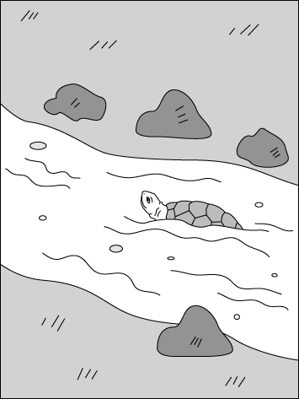 | 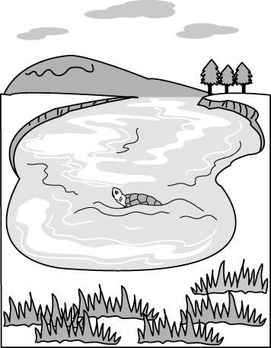 |  | (7) | 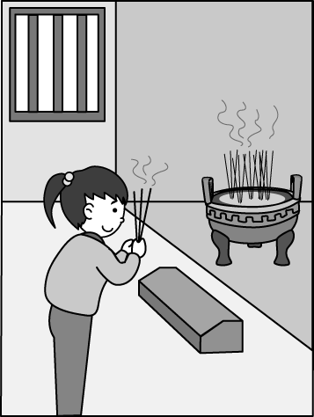 | 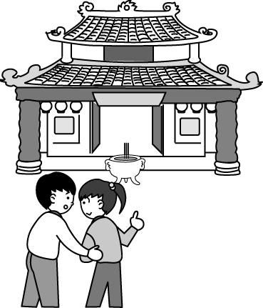
 | A（ ） | B（ ） |  |  | A（ ） | B（ ）
(8) |  | 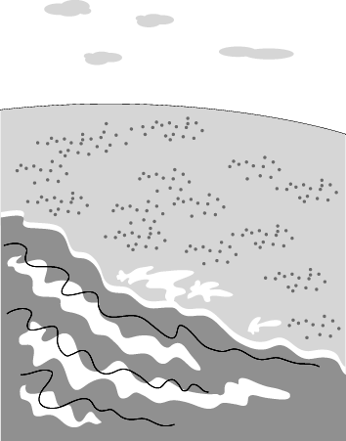 |  | (9) | 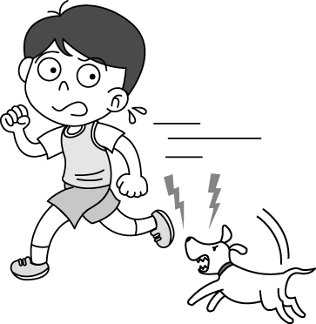 | 
(10) | 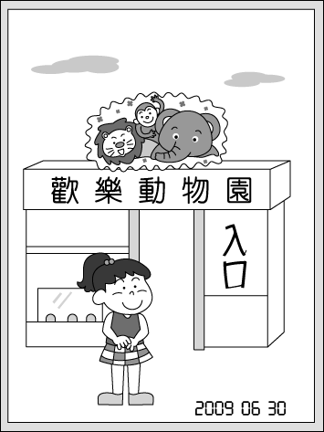  A（ ） | B（ ） |  |  | A（ ） | B（ ）
(10) | 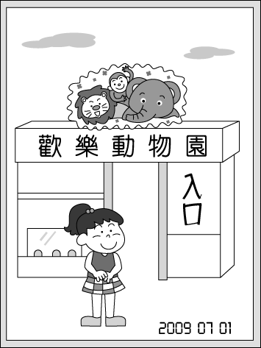
 | A（ ） |  | B（ ）
三、 根據錄音內容選出適當的答句
（ ）11. （A）I enjoy playing tennis. （B）I hate to exercise. （C）Yes, I enjoy the meal a lot.
（D）No, I don’t like to play tennis with my partner.
（ ）12. （A）They are playing with mud. （B）They work together and never give up. （C）They join the race.
（D）They hate running and swimming.
（ ）13. （A）Yes, winter is the rainy season here. （B）No, I don’t like rainy days. （C）No, I don’t have an umbrella with
me. （D）Yes, the weather in winter is fine.
（ ）14. （A）Yes, I need to do something interesting. （B）Yes, it’s an interesting story book. （C）I enjoy surfing the Net.
（D）I hate reading.
（ ）15. （A）I like to. （B）TV is not good for eyes. （C）Yes, she loves to. （D）Yes, she does.
第二部分：下列各題（題號16~27）為介系詞測驗，每題1分，共12分。
I. 請選出適當的介系詞，16~20題選項為（A）in （B）on （C）at （D）×
（ ）16. What do you love to do your free time？
（ ）17. Our guitar class is Friday evenings.
（ ）18. Chinese New Year is usually January or February.
（ ）19. They were in Taipei last Christmas.
（ ）20. She often drinks a glass of hot milk night.
II. 請選出適當的介系詞，21~27題選項為（A）for（B）about （C）with （D）of
（ ）21. Thanksgiving(感恩節) is on the fourth Thursday November.
（ ）22. My birthday is coming. My friend, Lisa, buys Cheer’s CDs me.
（ ）23. How going to the library with me today？
（ ）24. After raining, the road is full mud.
（ ）25. The little girl likes to play badminton her brother.
（ ）26. Is her cousin afraid rats？
（ ）27. The English test is coming. We are nervous it.

第三部分：下列各題（題號28~41），請依據題意選出一個正確或最佳的答案，每題2分，共28分。
（ ）28. Why are there so many cookies in your room？（A）everything （B）everywhere （C）pond （D）temple
（ ）29. Today is a very day for my parents. It is their twentieth wedding anniversary (結婚紀念日).
（A）expensive （B）enjoy （C）special （D）same
（ ）30. A：Do you like our new ？ B：Yes, it’s clean and big. Who lives in it with you？
（A）place （B）road （C）river （D）museum
（ ）31. A： the movie？ B：It was a lot of fun.（A）How’s （B）What’s （C）How was （D）What was
（ ）32. Sometimes snows here in winter.＝Sometimes is snow here in winter.
（A）it；there （B）the weather；it （C）we；the weather （D）there；it
（ ）33. The players keep basketball, and they win the game in the end.（A）practice；play
（B）practicing；playing （C）practice；playing （D）practicing；play
（ ）34. A： do they go biking？ B：On Wednesdays and Saturdays.（A）What date （B）What day
（C）What time （D）How
（ ）35. Everyone in our class very happy at that time.（A）is （B）are （C）was （D）were
（ ）36. the weather like in Taipei two months ago？（A）How is （B）How was （C）What is （D）What was
（ ）37. A：Doesn’t your cousin know you and me？ B：Yes, knows .
（A）he；us （B）he；you （C）she；we （D）she；them
（ ）38. A：What does Chien-Ming Wang do the team？ B：He the ball.
（A）in；pitches （B）on；pitches （C）in；catches （D）on；catches
（ ）39. A：How long were you and your family in the mountains？ B： （A）Two days ago. （B）For three days.
（C）The day before yesterday. （D）In a week.
（ ）40. A：Can you help me wash the bike？ B： It’s a piece of cake.
（A）No way！ （B）Give up. （C）That’s OK. （D）No problem.
（ ）41. A： B：What’s up？ A：I was late for school again. Miss Chen was angry.
（A）How late！ （B）Poor you！ （C）Are you afraid of me？ （D）Today really wasn’t my day.
第四部分：題組測驗（題號42~56），請依據選文或所附圖表資料，選出一個正確或最佳的答案，每題
2分，共30分。
（一）

Rabbit wants to (42) the Spring Race. He needs a (43) , and Turtle says yes to him. Rabbit likes running but he hates swimming. Turtle enjoys (44) , but he doesn’t like to run. Here’s their plan：Rabbit runs and Turtle swims. Rabbit carries Turtle (45) land, and
Turtle carries Rabbit on his back in the water. They practice (46) the race every day. In the end, they win the race.

（ ）42. （A）work （B）climb （C）know （D）join
（ ）43. （A）beach （B）team （C）partner （D）photo
（ ）44. （A）swim （B）swimming （C）to swim （D）swims
（ ）45. （A）in （B）at （C）on （D）for
（ ）46. （A）for （B）in （C）about （D）ago

（二）
Dragon Boat Race！
When：May 28, 2009
Where：Love River
Who：Anyone above 15 years old
Sign up：Starts on May 2
What：The 2009 Kaohsiung Dragon Boat Race！

Join and be a team of the boat race. It’s FREE and FUN!
Call 0800-500-5660 or visit our website at www.kh-dragonboat.gov.tw for more information.

dragon boat 龍舟／above 在…之上 ／sign up報名／start開始／Kaohsiung 高雄／website 網站／information 資訊
（ ） 47. Tony wants to know more about the boat race. What can he do？（A）Go to Love River. （B）Call 0800-500-5666. （C）Watch TV. （D）Go to www.kh-dragonboat.gov.tw.
（ ）48. Does the race cost money？（A）Yes, it costs a lot. （B）No, it doesn’t. （C）No, it is cheap. （D）We don’t know.

（三）
My First Halloween
My family moved to America from Taiwan two months ago. And last week, on October 31st, was Halloween. Halloween is a very fun day for everyone. Parents go to the department stores or toy stores to buy scary or funny masks and costumes for their children. In the evening, the children dress up in their costumes and ask people for candy.
I went trick-or-treating with my new friend, Tom. He brought his little sister, Sarah, with us, too. Tom dressed like a ghost and Sarah dressed like a cute pumpkin. I dressed like a scary monster. It was so much fun, and we got a lot of candy!

Halloween 萬聖節、moved 搬家
Department store 百貨公司
scary 可怕的、funny 滑稽的
mask 面具、costume戲服
dress up 打扮、candy糖果
went (go的過去式)
trick-or-treating不給糖就搗蛋
brought (bring的過去式)
ghost鬼、monster怪獸
got (get的過去式)

（ ）49. What month is it now？（A）October （B）November （C）December （D）February
（ ） 50. When did the author (作者) move to America？（A）In January. （B）In November. （C）In September. （D）In February.
（ ）51. According to (根據) the reading, who did NOT dress in a scary costume？（A）Tony. （B）the author.
（C）The author’s sister. （D）Sarah.

（四）

knowledge知識／machine 機器／health健康／friendship友誼／last持續／be bought被買／by藉由／heart心
It can buy a Bed,
But not Sleep.
It can buy a Clock,
But not (52) .
It can buy you a Book,
But not Knowledge.
It can buy a House,
But not a (53) .

It can buy you Machine,
But not Health.
It can buy some Friends,
But not Friendship.
Buying things is (54) ,
But it can’t last long.
Things cannot be bought,
But you can win (55) by your heart!

（ ）52. （A）a Watch（B）Time （C）Food （D）Meal
（ ）53. （A）Hotel （B）Computer （C）Home （D）Blender
（ ）54. （A）hard （B）easy （C）expensive （D）poor
（ ）55. （A）it （B）its （C）they （D）them
（ ）56. What is the best(最好的) title(標題) of this poem(詩)？ （A）Time. （B）Water. （C）Money. （D）Body.

高雄縣立林園高級中學國中部97學年度 第二學期 一年級 英語科 第三次段考答案
範圍： Book2 U7~U9 班級： 姓名： 座號：
【此份試題卷共有4頁，本測驗為電腦讀卡，請依題號在答案卡上畫記】
第一部分：聽力測驗（題號1~15），每題2分，共30分。
一、 選出聽到的單字或句子（1-5）
CDCAC
二、選出與錄音內容相符的圖片（左圖請畫A，右圖請畫B）（6-10）
BBBAB
三、 根據錄音內容選出適當的答句（11-15）
ABACD

第二部分：下列各題（題號16~27）為介係詞測驗，每題1分，共12分。
I. 請選出適當的介系詞，16~20題選項為（A）in （B）on （C）at （D）×
ABADC
II. 請選出適當的介系詞，21~27題選項為（A）for（B）about （C）with （D）of
DABDC DB

第三部分：下列各題（題號28~41），請依據題意選出一個正確或最佳的答案，每題2分，共28分。
28-32 BCACA 33-37 BBCDA 38-41 BBDD

第四部分：題組測驗（題號42~56），請依據選文或所附圖表資料，選出一個正確或最佳的答案，每題
2分，共30分。
（一）42-46 DCBCA
（二）47-48 DB
（三） 49-51 BCD
（四） 52-56 BCBDC

