高雄縣立林園高級中學 國中部97學年度 第二學期 二年級 英文科第一次段考考卷
範圍：L1~Review I 班級： 姓名： 座號：
壹：聽力評量（30%）
一、聽CD的三個敘述，選出符合圖片的句子10％
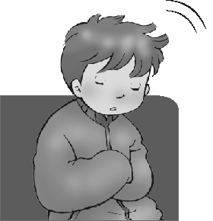  1. | 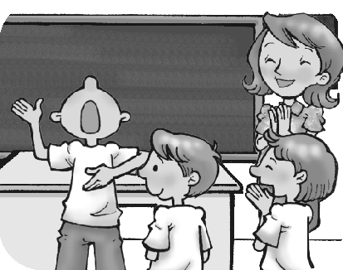  2. | 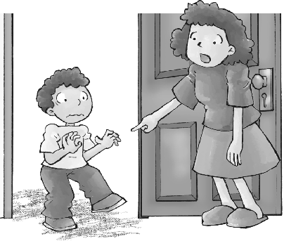  3. | 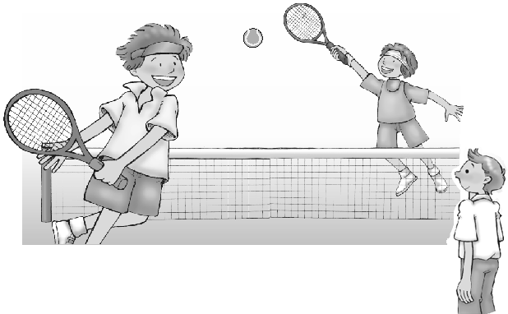  4. |   5.
( ) | ( ) | ( ) | ( ) | ( )
二、選出出現在CD句中的單字10％
( ) 1. (A) table (B) seat (C) order (D) burning
( ) 2. (A) cheer (B) tryout (C) helpful (D) menu
( ) 3. (A) pizza (B) moment (C) smells (D) let
( ) 4. (A) art (B) pay (C) fan (D) MRT
( ) 5. (A) ground (B) turn (C) road (D) pretty
三、聽CD的問題，選出最適當的回應10％
( ) 1. (A) So what? (B) A sandwich.
(C) The snack bar is near our school. (D) The ham tastes like fish.
( ) 2. (A) He made us do a lot of homework in class.
(B) My teacher made English sound interesting.
(C) I had a terrible experience. (D) She made us some tea.
( ) 3. (A) I guess it was great. (B) The bus has many passengers on it.
(C) Taipei is really a beautiful city. (D) He took a trip to Kaohsiung by train.
( ) 4. (A) The MRT is very fast. (B) Sure, that’s fine.
(C) Sorry, I missed the stop again. (D) Can I take your order?
( ) 5. (A) The cake is delicious. (B) I have to buy another cake.
(C) I don’t have a dog. (D) No, thanks. I want to lose weight.
貳：書寫評量（70%）
一、文意字彙10%
1. I saw Jim s g hands with his favorite singer yesterday.
2. Mr. Smith is e t at telling stories, so all of his students enjoy story time in his class.
3. Cindy likes wearing strange hats because she wants her classmates to n e her.
4. There is a p c telephone over there. You can use it to call your father right now.
5. Andy spends four hours studying every night. He is a h g student.
6. That store is full of people today. It’s so c d.
7. Students have to wear their u s to school.
8. Don’t park your car or motorcycle on the s k. It’s dangerous for passers-by（行人）.
9. My sister works as a w s at a seafood restaurant.
10. I caught a cold. The doctor told me to take the m e three times a day.

二、依前後文填入適當的片語10%
- It’s very cold outside. P____________ your coat before you go out.
- Suddenly, the lights in the room w and I couldn’t see anything.
- I’m going to use this table. Please p_____________ all your toys on the table.
- The machine is o . I need someone to fix it.
- Sally got angry because her brother t the TV when she was still watching her favorite program.
- He worked hard all summer i buy that new cell phone.
- A：Sorry, I’m late. I had an accident.
B：Stop m stories. I won’t believe you.
8. Cindy has to leave now because she needs to p her daughter after school.
9. Our English teacher asks us to l the new words in the dictionary.
10. T your shoes before you enter the room.

三、文法選擇20%
1. After he _________ his homework, he went to bed.
(A) finishes (B) finished (C) finishing (D) will finish
2. The teacher _______ his students mop the floor of the classroom after the party.
(A) asked (B) ordered (C) got (D) had
3. A：Let’s take a trip to Japan this summer vacation. B：That __________ a good idea.
(A) hears like (B) sounds (C) sounds like (D) listens to be
4. My mom asked me several times to pay the light bill, but I still forgot _______ it.
(A) pay (B) to do (C) doing (D) to doing
5. Sue heard her cell phone ________ in her school bag.
(A) ringing (B) rang (C) rings (D) to ring
6. The boy fell asleep quickly. His mother couldn’t ____________.
(A) wake up him (B) wake him up (C) pick up him (D) give up him
7. You can lead a horse to water, but you can’t _________ him drink.
(A) order (B) call (C) make (D) get
8. The teacher looked _________ at the careless（粗心的）student because he made a big mistake again.
(A) angrily (B) angry (C) friendly (D) like
- The bus stopped in front of the hospital. And the old man got ________ slowly.
(A) the bus off (B) it off (C) off the bus (D) it out of
10. I still feel __________because I didn’t __________ last night.
- asleep; sleep well (B) sleepy; sleep well (C) asleep; have a good sleep
(D) sleepy; sleep good

四、克漏字選擇 10%
Bob saw a car 1 a man on his way to school yesterday. The driver got away after he hit the man and
he didn’t stop 2 the man. Bob was very terrified. But later, he realized that he had to call the police with his cell phone. When the police got there, Bob told the police about the traffic accident. The police thanked Bob 3 his help. 4 , the man was not seriously hurt.
When Bob got to school, it was almost noon. The teacher didn’t blame Bob 5 the police told him about the car accident. He told Bob that he was a very brave boy.
terrified 嚇壞的 realize 了解 blame 責怪 brave 勇敢的
- (A) to hitting (B) to hit (C) hitting (D) hitted
- (A) saw (B) seeing (C) sees (D) to see
3. (A) from (B) with (C) for (D) over
4. (A) Luckily (B) Slowly (C) Suddenly (D) Quietly
5. (A) after (B) so (C) moment (D) maybe

五、閱讀測驗10%
(一)
Read Tom’s diary and answer the questions.
March 16, 2009
Today I met an American on my way home. He asked me some questions in English. I knew his words, but I was nervous and couldn’t say anything. But my friend, David, talked to him happily. I
felt so depressed.
I study English very hard and get the best grades on English tests. But I just can’t speak. However,
David is not good at taking tests, but he listens to English radio programs and sometimes calls in to talk to the DJs in English. I think I have to practice speaking English more.
nervous 緊張的 however 然而
- What does depressed mean?
  - proud (B) sad (C) free (D) terrible
- What can we learn from Tom’s diary?
  - Talking to an American doesn’t help Tom.
  - Getting good grades on English tests is good for Tom.
  - Practicing speaking English is as important as studying it.（as….as 和…一樣）
  - Keeping a diary in English helps Tom to speak English well.
- How does David practice his English?
  - Talking to Tom in English.
  - Listening to English songs.
  - Answering Americans’ questions.
  - Talking to the DJs of the radio.

(二)
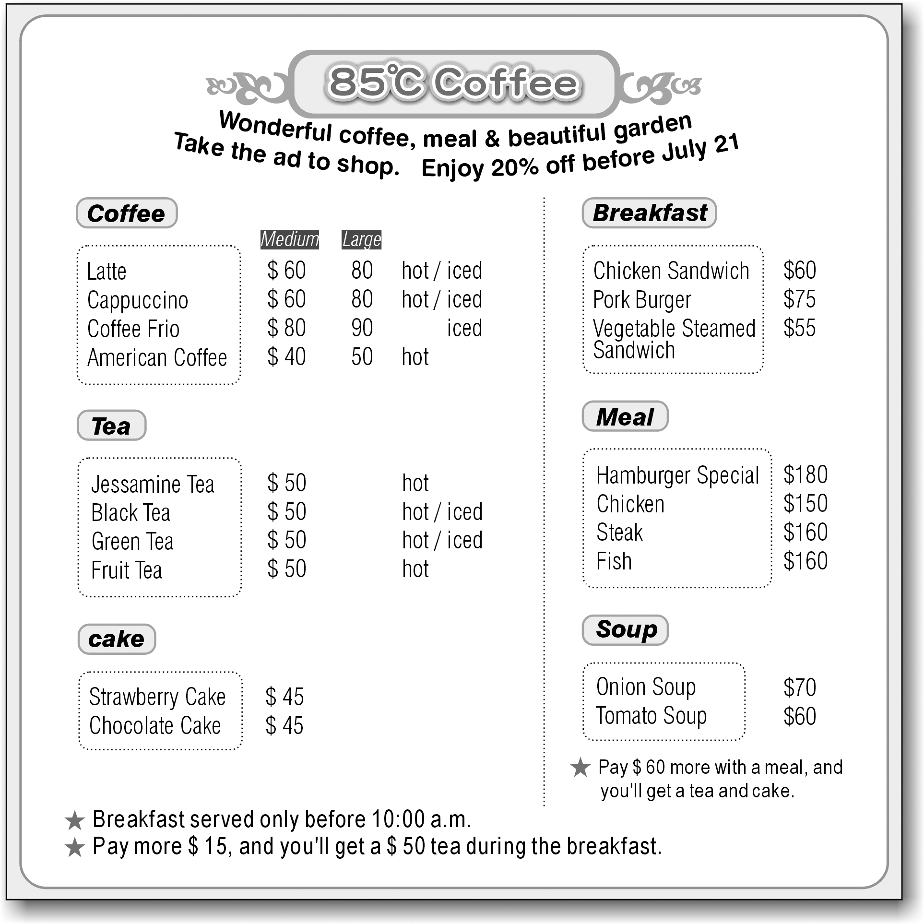
- Today is July 18. Johnny takes the ad to 85℃ Coffee. He wants to order the chicken, a tomato soup, and a large Cappuccino. He paid 500 dollars. How much change did he get?
(A) $210 (B) $268 (C) $290 (D) $232
- After playing basketball, Tony and three teammates came to 85℃ coffee without (沒有) the ad. They ordered three meals-chicken, steak, and fish, three teas and cakes. How much should they pay?
(A) NT$ 755 (B) NT$ 520 (C) NT$ 650 (D) NT$ 700
六、翻譯10%
- 當我今天早上醒來時，我聞到奇怪的味道。
2、Jane對於學習新事物有興趣。
3、Chien-Ming Wang是一位很棒的棒球選手。我們以他為榮。
4、在許多地鐵車站，你可以看到大大小小的公共藝術品。
5、我的父母已經決定放學後帶我出去吃晚餐。

高雄縣立林園高級中學 國中部97學年度 第二學期 二年級 英文科第一次段考答案卷
範圍：L1~Review I 班級： 姓名： 座號：
- 聽力評量30%
一、聽CD的三個敘述，選出符合圖片的句子10％
1. | 2. | 3. | 4. | 5.
二、選出出現在CD句中的單字10％
1. | 2. | 3. | 4. | 5.
三、聽CD的問題，選出最適當的回應10%
1. | 2. | 3. | 4. | 5.
- 書寫評量70%
一、文意字彙10%
1. | 2. | 3. | 4. | 5.
6. | 7. | 8. | 9. | 10.
二、依前後文填入適當的片語10%
1. | 2. | 3. | 4. | 5.
6. | 7. | 8. | 9. | 10.
三、文法選擇20%
1. | 2. | 3. | 4. | 5.
6. | 7. | 8. | 9. | 10.
四、克漏字選擇 10%
1. | 2. | 3. | 4. | 5.
五、閱讀測驗10%
1. | 2. | 3. | 4. | 5.
六、翻譯10%
1.

2.

3.

4.

5.

高雄縣立林園高級中學 國中部97學年度 第二學期 二年級 英文科第一次段考答案卷
範圍：L1~Review I 班級： 姓名： 座號：
壹、聽力評量30%
一、聽CD的三個敘述，選出符合圖片的句子10％
1.  A | 2.  C | 3.  C | 4.  A | 5.  B
二、選出出現在CD句中的單字10％
1.  D | 2.  B | 3.  C | 4.  A | 5.  D
三、聽CD的問題，選出最適當的回應10%
1.  B | 2.  A | 3.  A | 4.  C | 5.  D
貳、紙筆測驗70%
一、文意字彙10%
1.  shaking | 2.  excellent | 3.  notice | 4.  public | 5.  hard-working
6.  crowded | 7.  uniforms | 8.  sidewalk | 9.  waitress | 10.  medicine
二、依前後文填入適當的片語10%
1.  Put on | 2.  went out | 3.  put away | 4.  out of order | 5.  turned off
6.  in order to | 7.  making up | 8.  pick up | 9.  look up | 10.  Take off
三、文法選擇20%
1.  B | 2.  D | 3.  C | 4.  B | 5.  A
6.  B | 7.  C | 8.  A | 9.  C | 10.  B
四、克漏字選擇 10%
1.  C | 2.  D | 3.  C | 4.  A | 5.  A
五、閱讀測驗10%
1.  B | 2.  C | 3.  D | 4.  B | 5.  C
六、翻譯10%
1. When I woke up this morning, I smelled something strange.

2. Jane is interested in learning new things.

3. Chien-Ming Wang is a great baseball player. We are proud of him.

4. In many subway stations, you can see small and large public works of art.

5. My parents decided to take me out for dinner after school.

