高雄縣林園中學（國中部）九十七學年度第二學期二年級英語科第三次月考題目
班級： 姓名： 座號：
壹、聽力選擇（30％）
一、聽CD的句子，與圖片相符合者寫A，不符合者寫B：10％
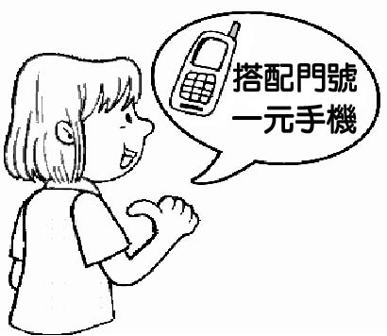 | 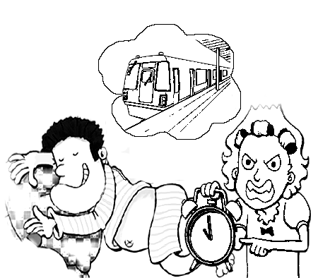 | 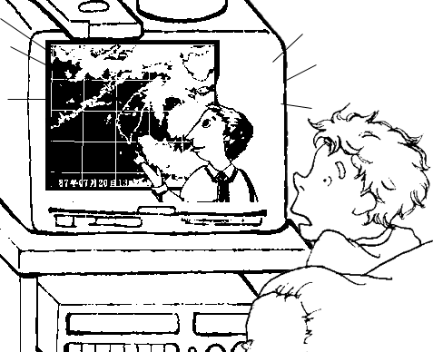 | 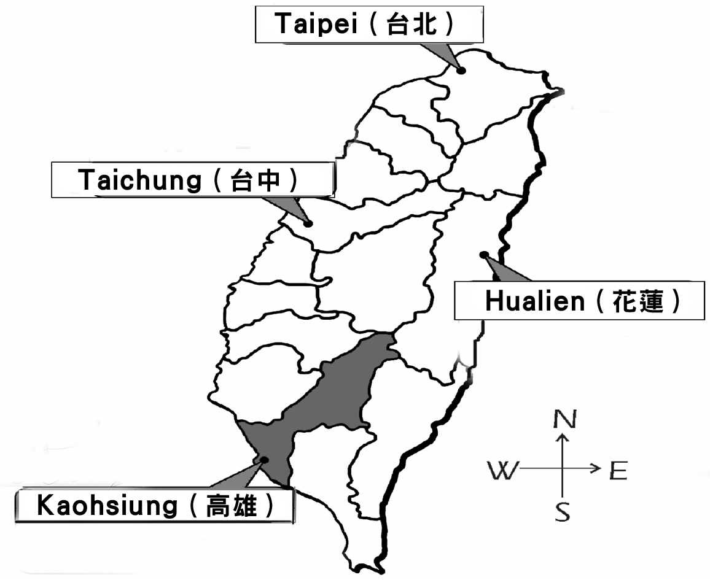 | 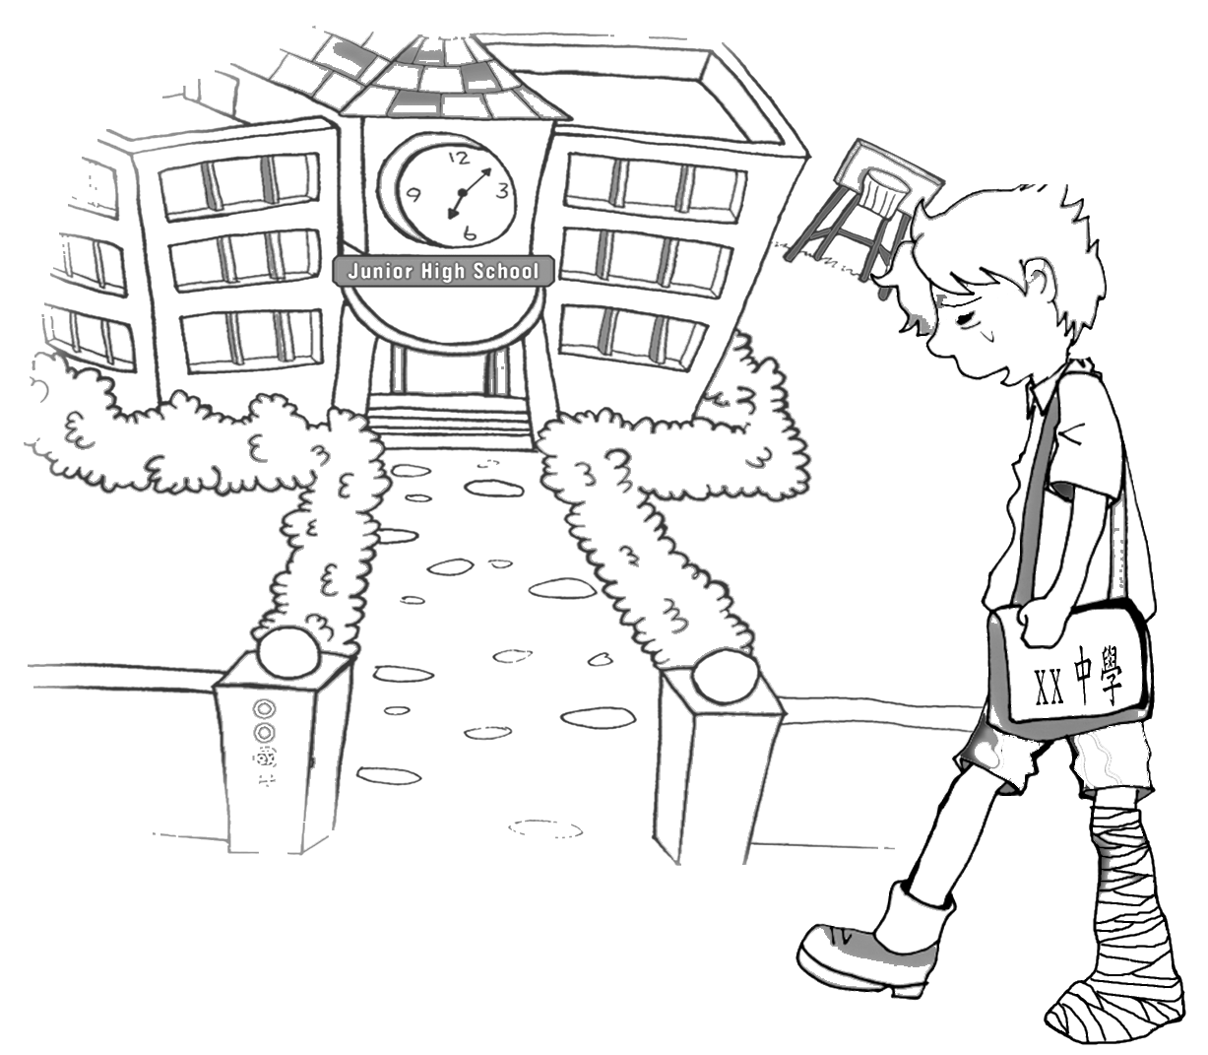
1. ( ) | 2. ( ) | 3. ( ) | 4. ( ) | 5. ( )
二、聽CD的三個敘述，將符合圖片的句子代號填入空格中：10％
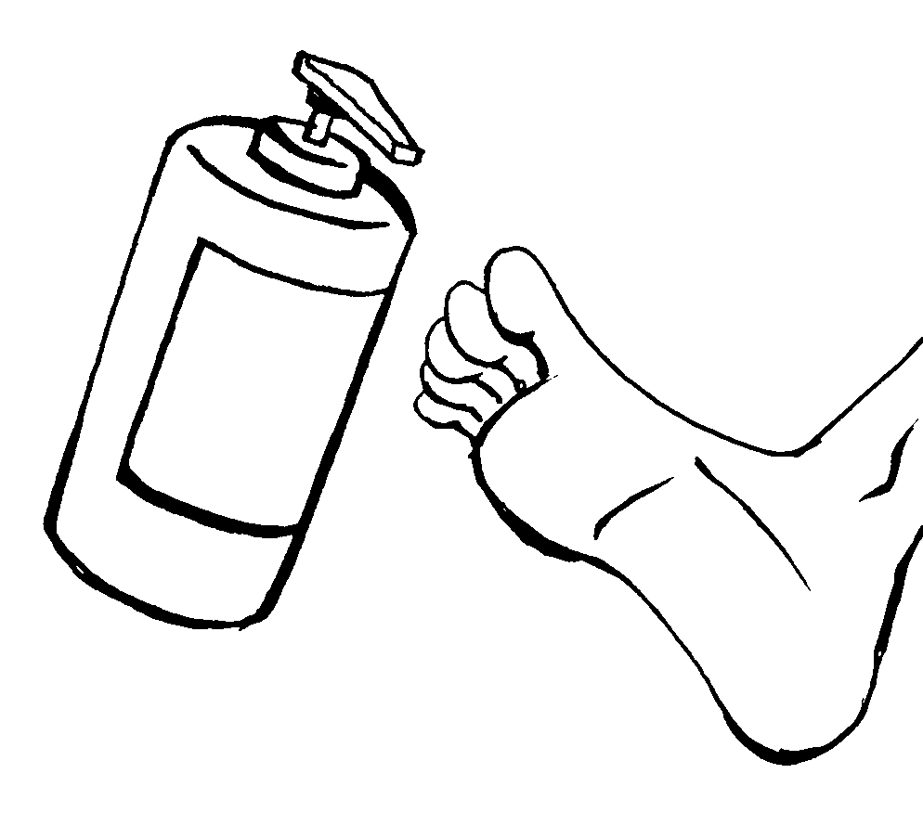 | 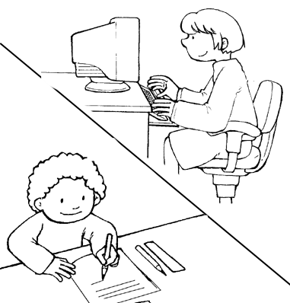 | 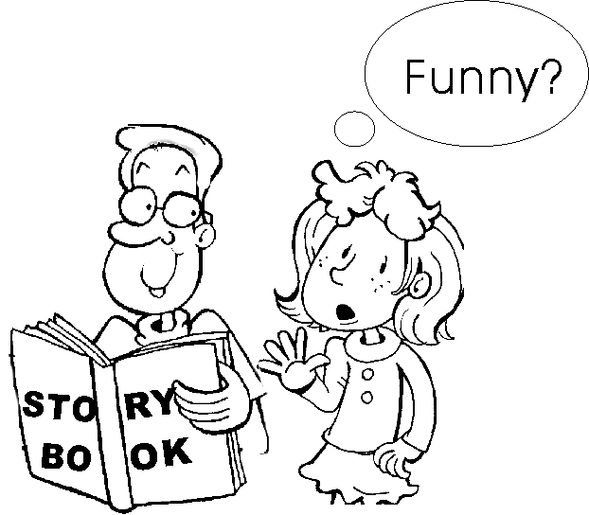 | 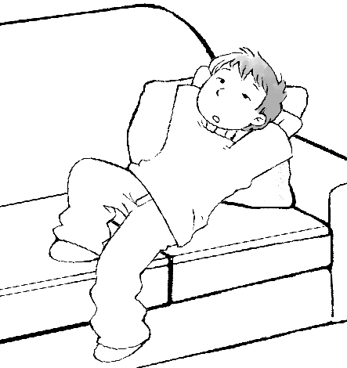 | 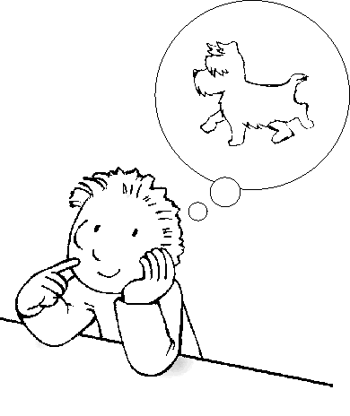
6. ( ) | 7. ( ) | 8. ( ) | 9. ( ) | 10. ( )
三、聽完CD的問題，選出正確的回答：10％
( ) 11. （A）No, we wouldn’t.

（B）I have some magazines about food.
（C）Of course, we could.
（D）Of course, you would.
( ) 12. （A）I don’t want to buy that, either.
（B）Maybe I can borrow your clothes.
（C）Perhaps you can lend me some.
（D）Perhaps I can lend you some.
( ) 13. （A）You should try it on.
（B）Yes, it’s too small for you.
（C）You shouldn’t wear the jacket.
（D）I didn’t like the sweater, either.
( ) 14. （A）And I am, either.
（B）And neither do I.
（C）And I do, either.
（D）And neither am I.
( ) 15. （A）I don’t think so.
（B）You’re welcome.
（C）Give it up.
（D）Yes, he talked to his classmates.
貳、閱讀理解選擇（70％）
一、字彙選擇（18%）
（ ）16. There’s no way to play basketball well – only practice very often.
（A）healthy （B）friendly （C）type （D）magic
（ ）17. It may rain later, so take a(n) with you.
（A）umbrella （B）toothpaste （C）mouthwash （D）sweater
（ ）18. A big typhoon is dangerous. It will cause ____. Which is NOT true?
（A）hills （B）landslides（C）mudslides （D）flooding
（ ）19. After it rains, we sometimes can see beautiful ____ in the blue sky.
（A）rainbows （B）fingers （C）fingertips （D）queens
（ ）20. Don’t lose ___. Study harder, and you can get a high grade.
（A）heart （B）hear （C）heard （D）earth
（ ）21. We stayed at a great ______ when we took a trip to Hong Kong last month.
（A）history （B）hobby （C）husband （D）hotel
（ ）22. Sam exercises four times a week to keep his beautiful ________.
（A）painting （B）shape （C）beauty （D）daydream
（ ）23. He the comic books with the newspaper when his father came in.
（A）covered （B）checks （C）clicked （D）searches
（ ）24. Tony ___ two thousand dollars to Nancy, because she lost the money.
（A）borrow （B）care （C）post （D）lent
二、文法及對話選擇（22%）
（ ）25. Welcome to my party. I hope you will enjoy .
（A）ourselves （B）themselves （C）herself （D）yourselves
（ ）26. The Internet is like _____ the world’s biggest library in your house.
（A）has （B）have （C）having （D）to have
（ ）27. If it _________tomorrow, I will not go mountain climbing.
（A）rained （B）is raining （C）will rain （D）rains
（ ）28. Schools use the Internet, and ___________everyday people.
（A）either does （B）so do （C）so are （D）either is
（ ）29. Your shoes are too dirty. You take them off before getting into the house.
（A）should （B）would （C）has to （D）want dirty髒的
（ ）30. Father washed not only the dishes .
（A）but also washed his car
（B）but cleaned the kitchen
（C）but his car
（D）also his car
（ ）31. Over there ___ the latest CDs and DVDs.
（A）are （B）is （C）has （D）have
（ ）32. They never go to school late, and their teacher.
（A）so does （B）neither does （C）either does （D）so didn’t
（ ）33. My mother was very tired last night. _____ , she still had to do the housework.
（A） However （B）If （C）So （D）Though
（ ）34. Andy：I am hungry and thirsty.
Mimi：Let’s go get ______.
（A）something to eat.
（B）anything to drink.
（C）anywhere to see.
（D）somewhere to go.
（ ）35. Ted: I had a bad day today.
Mary: Cheer up. I have something interesting ________ you happy.
（A）making （B）to make （C）will make （D）makes

三、克漏字（10%）
Ted: I feel 36.
Alice: Hey! Look at the skirt. It’ s pink. Don’t you think it’s beautiful?
Ted: I am thirsty. I need 37. .
Alice: Wow! This is wonderful 38. . With it, you will never have tooth decay.
Ted: I am hungry. I really need to eat something.
Alice: Perhaps we could 39. some of the latest tapes, CDs and videos. I love music.
Ted: I can’t walk anymore because I am becoming 40. .
Alice: All right. You stay here, and I will go to the next store myself.
pink 粉紅色 tooth decay蛀牙 anymore再也不
（ ）36.（A）boring （B）bored （C）warm （D）healthy
（ ）37.（A）drink something（B）some drink thing（C）something drink（D）something to drink
（ ）38.（A）mouthwash （B）make-up case （C）stomach （D）soap
（ ）39.（A）look up （B）look at （C）look in （D）look like
（ ）40.（A）ready （B）worst （C）weak （D）strong
四、閱讀測驗（20%）
Is a computer smarter than I am? The answer to this question is “No.” People can create new ideas, but computers can’t do that. Who creates the computers? Human beings do. Of course we are smarter than computers. Computers may be able to do more things and do them better than human beings. With the Internet, people can go shopping, make new friends, and even sell things online. As we know, computers are super calculators. They can calculate very fast and seldom give wrong answers. However, they may bring some problems to our lives. Most people spend too much time playing games and less time exercising.
That will cause some health problems. We should take advantage of this technology, but don’t spend too much time using them.
create創造 human being 人類 calculator 計算機 calculate 計算 take advantage of 利用 technology科技
（ ）41. What can create more new ideas?
（A）Computers. （B）Make-up cases. （C）Villages. （D）Human beings.
（ ）42. What can’t people do with computers?
（A）Selling things online.
（B）Shopping.
（C）Making new friends.
（D）Creating new ideas.
（ ）43. In the article, what do “they” mean?
（A）Computers. article文章
（B）E-mails.
（C）Cameras.
（D）Human beings.
（ ）44. According to the article, how can you shop if you cannot go out?
（A）Call someone. according to根據
（B）Watch TV.
（C）Use the Internet.
（D）Write mails.
（ ）45. Which is NOT true?
（A）Computers can do more things than human beings.
（B）Computers always give wrong answers.
（C）Today, people can make new friends by using the Internet.
（D）Most people spend more time sitting in front of computers.

Dear students:
It is important for you all to understand how important it is to drink enough water. Even if you exercise and eat healthy foods, you won’t be healthy. What’s missing? That’s right: you need to drink enough water. If you don’t drink enough water, you may get sick very easily, and your body won’t work as well as it should.
How much water is enough water? Well, everyone should drink at least eight glasses of water a day. But for students who are growing, like you, more water is needed. If you are taller or bigger than most of your classmates, you should also drink more water. The bigger you are, the more water you need. Someone in junior high should drink at least ten glasses of water a day. And if you are bigger than most of your classmates, try to drink at least twelve glasses of water a day. Drinking enough water will ensure that you grow healthy and strong. So what are you waiting for? Drink it up!
Miss Lee
even if 即使 as well as 和~一樣 ensure確保
（ ）46. Why is it important for people to drink enough water?
（A）To be bigger than your classmates.
（B）To be healthy and strong.
（C）Because water is bad for you.
（D）To be young and pretty.
（ ）47. If you are a bigger or taller person, what should you do?
（A）Drink more water than other people.
（B）Drink the same amount of water as other people. amount 數量
（C）Drink less water than other people
（D）You shouldn’t drink any water.
（ ）48. How much water should most people drink?
（A）8 or more glasses of water every day.
（B）5 or more glasses of water every day.
（C）100 or more glasses of water every day.
（D）Never drink any water.
（ ）49. If we don’t drink enough water, what may happen?
（A）Nothing will happen.
（B）We may become taller and bigger.
（C）We may be healthier.
（D）We may get sick easily.
（ ）50. Which is NOT true?
（A）If you are bigger than most other people, you should drink more water.
（B）If you are taller than most other people, you should drink more water.
（C）It is healthy to drink only a little water.
（D）It is good for you to drink a lot of water every day.

林園國中第二年級第三次月考英語科答案
1 | B | 2 | A | 3 | D | 4 | B | 5 | C | 6 | C | 7 | A | 8 | B | 9 | A | 10 | C
11 | C | 12 | D | 13 | A | 14 | B | 15 | A | 16 | D | 17 | A | 18 | A | 19 | A | 20 | A
21 | D | 22 | B | 23 | A | 24 | D | 25 | D | 26 | C | 27 | D | 28 | B | 29 | A | 30 | C
31 | A | 32 | B | 33 | A | 34 | A | 35 | B | 36 | B | 37 | D | 38 | A | 39 | B | 40 | C
41 | D | 42 | D | 43 | A | 44 | C | 45 | B | 46 | B | 47 | A | 48 | A | 49 | D | 50 | C

