高雄縣立林園高級中學 國中部97學年度 第二學期三年級英語科 第一次段考考卷
範圍：Lesson1~Review1 班級： 姓名： 座號：
一、單題54%(每題2分)
( )1.There are books in the library. (A) million (B) millions (C) million of (D) millions of
( )2.A: Did you see my cell phone? B: I think I saw it in your room. (A) somewhere (B) who (C) which (D) happen
( )3.The cell phone is not mine. It to my cousin. (A) becomes (Ｂ) prevents (C) happens (D) belongs
( )4.You can’t judge people by their . (Ａ) appearance (Ｂ) apartments (Ｃ) houses (Ｄ) relationships  judge 判斷
( )5.The ship “Titanic” finally sank (下沉) to the of the sea. (A) bread (B) bottom (C) butter (D) board
( )6.Ella didn’t get your e-mail because she had trouble online this week. (A) getting (B) to get (C) got (D) get
( )7.Emily wears a pair of sunglasses to protect her eyes the sun.(A) from (B) to (C) with (D) of
( )8.My father taught me . (A) what I should do it (B) how to do (C) how to do it (D) what should I do
( )9.Although he is very handsome, nobody likes him. (A) but (B) ╳ (C) and (D) however
( )10.Can you spend less money cell phones? (A) to buy (B) talking (C) on (D) with
( )11.For your safety, you should wear a helmet when a bicycle. (A) you riding (B) riding (C) you rode (D) ride
( )12.The boy who is a good student. (A) I like him (B) in glasses (C) Mr. Lin is talking (D) sits under the tree
( )13.The food not only smells good but also . (A) delicious (B) looked well (C) tastes delicious (D) famous
( )14.Either you or my brother and I right. (A) am (B) is (C) be (D) are
( )15.They for you until you agree to go with them. (A) wait (B) will wait (C) were waiting (D) waited
( )16.All that he used to think about sports. (A) is that (B) are (C) were (D) was
( )17.If you want to buy clothes, you had better try .(A) them on (B) it on (C) on it (D) on them
( )18.I will call you when I there tomorrow. (A) arrives (B) arrived (C) arrive (D) will arrive
( )19.They since last year. (A) have been married (B) got married (C) married (D) were married
( )20.She a teacher. Now she is a firefighter. (A) used to (B) was used to be (C) used to be (D) used be
( )21.Sara didn’t tell me .
(A) where she is going to(B) how she celebrated Christmas (C) if will she go to Taipei (D) when will she leave
( )22.We all believe our team the game. (A) that; win (B) when; win (C) ; will win (D) why; win
( )23.You made Amy so . What did you do to her? (A) angry (B) angrily (C) crying (D) sadly
( )24. A: Jolin Jay studied hard this time. B: That’s right. Both of them got bad grades.
(A) Not only; but also (B) Either; or (C) Both; and (D) Neither; nor
( )25.A: I have decided to marry a girl. She likes drawing and she is my best friend. B: .
(A) I wonder who your best friend wanted to get married with.
(B) I see. That’s why you don’t like your friend so much.
(C) So, you decided to marry someone who loves drawing.
(D)OK. She must be very pretty and rich.
( )26.A:Wow, you bought a new laptop. Does it have many new functions(功能)? B: .
(A) No, it can be used both at home and in the office.
(B)Yes, I can not only talk with friends but also see their faces.
(C)Yes, I can neither receive mails nor surf the Net.
(D)No, either playing games or watching movies is possible.

( )27.Choose the wrong one.
(A) Mom wakes me up every morning. (B) He has finished his homework, but he forgot to hand in it.
(C) We laughed at the girl when she put her funny coat on. (D) The cat saw the mice, and then it ran after them.
二、題組46%(每題2分)
( I ) 28.~33.
George and Mary 28. husband and wife 29. ten years. Since they 30. married, George has 31.
celebrated Valentine’s Day or Mary’s birthday. Mary often complains about it. Yesterday was Mary’s birthday. When Mary
32. the house, George 33. the lights. And then he took out a big cake. At that moment, Mary was moved to tears.
 complain 抱怨  be moved to tears 感動得掉淚
( )28.(A) will be (B) were (C) are (D) has been
( )29.(A) for (B) since (C) from (D) until
( )30.(A) were got (B) have got (C) got (D) have been got
( )31.(A) always (B) never (C) remembered (D) forgot
( )32.(A) entered (B) will enter (C) is entering (D) enters
( )33.(A) opened (B) opening (C) turned on (D) turning on
( II ) 34.~38.
(1) 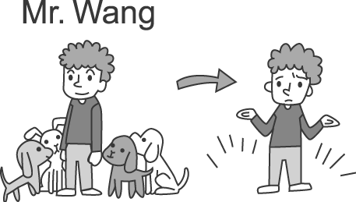 (2) 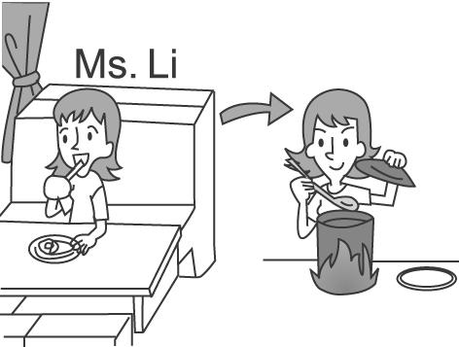 (3) 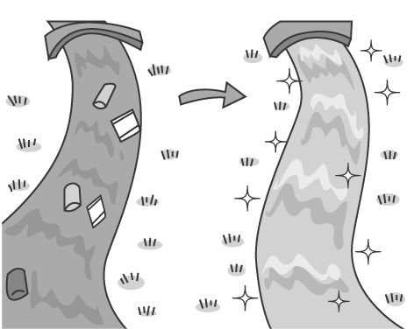 (4) 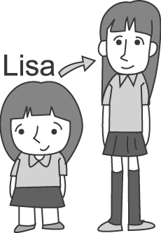 (5) 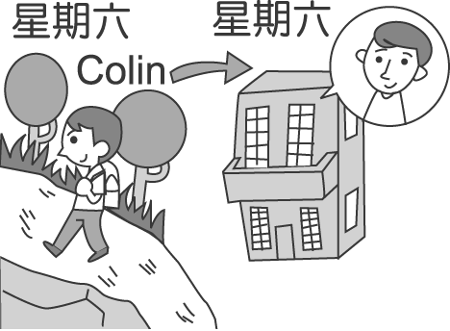
( )34.Someone used to eat at a restaurant, but now the person likes to cook at home. The person is .
(A) Colin (B) Lisa (C) Ms. Li (D) Mr. Wang
( )35.There used to be many cute dogs at . (A) the restaurant (B) Mr. Wang’s house (C) Ms. Li’s house(D) the river
( )36.Who used to go mountain climbing on Saturday, but now often stays at home? (A) Lisa (B) Tom (C) Colin (D) Ms. Li
( )37.From picture 3 , we know there used to be in the river.
(A) a lot of fish (B) a lot of trash (C) a lot of trees (D) a lot of water
( )38. looks taller and has longer hair. (A) Tom (B) Colin (C) Mr. Wang (D) Lisa
( III ) 39.~43.
How do people go to work in Taipei?
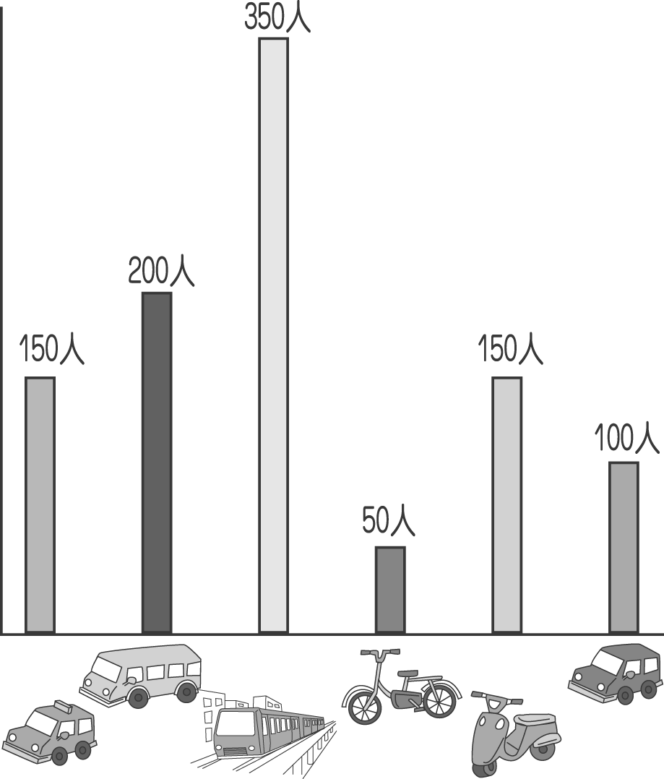
( )39.There are people in the survey(調查).
(A) 900 (B) 1000 (C) 950 (D) 1050
( )40.The number(數量) of people who go to work by is the most .
(A) MRT (B) bus (C) bicycle (D) car
( )41.The number of people who go to work by and that of people who go to work by are the same.
(A) bus; MRT (B) taxi; motorcycle (C) bus; car (D) car; taxi
( )42.The percentage(百分比)of people who take a taxi to work is .
(A) 10% (B) 5% (C) 20% (D) 15%
( )43.The percentage of people who take a bus to work is higher than that of people who go to work by bicycle.
- 20% (B) 5% (C) 15% (D) 10%
( IV ) 44.~47.
Waiter: May I help you?
Woman A: I’d like an iced coffee, please.
Woman B: I want a piece of cheese cake and a cup of hot coffee. Thanks.
Waiter: OK.
Woman A: We haven’t seen each other since you got married in 1994.
Woman B: You’re right. I can’t believe it’s already 2009!
Woman A: How’s everything?
Woman B: OK. I’m working at Taipei 101 as a clerk, and I have a daughter who is a teenager.
Woman A: It’s hard to deal with teenagers, isn’t it? My daughter is also a teenager, and I have a lot of trouble communicating with her.
Woman B: Well, I used to think that way, but after I read a book about teenagers, the relationship between my daughter and I got better.
Woman A: Really? Can you give me some advice?
Woman B: Sure. Just try to understand them in their ways. Don’t hesitate to give them encouragement. Listen to what they think, and most important, you should always try to spend time with them every day.
Woman A: Thanks for the advice. That’s really helpful.
Woman B: No problem.
 deal with 相處  communicate 溝通  hesitate 遲疑  encouragement 鼓勵
( )44. Where could the two women be?
(A) At a library. (B) At school. (C) At an office. (D) At a restaurant.
( )45. How long has woman B got married?
(A) Ten years. (B) Fifteen years. (C) Twenty years. (D) Thirteen years.
( )46.Which advice is good for keeping a good relationship between teenagers and parents?
(A) Don’t give teenagers any encouragement.
(B) Parents should spend less time with their teenagers.
(C) Parents don’t need to understand teenagers too much .
(D) Parents should spend more time listening to what teenagers think.
( )47.Which is not true?
(A) Woman B used to think that teenagers are hard to deal with.
(B) Woman B is a clerk at Taipei 101.
(C) Both of the women ordered coffee.
(D) Woman A has no problem communicating with her daughter.
( V ) 48.~50.
It’s important to have a smoke alarm in different rooms of the house because fires can sometimes happen at home. You should also know what to do when a fire starts.
Most fires at home begin in the kitchen. This usually happens when grease catches fire during cooking. If it happens, using water will make the fire worse. Most fires can be put out by covering it. If your pan catches fire, cover it with a lid and turn off the gas.
It’s also important to have a fire extinguisher at home. Before you buy a fire extinguisher, remember that different fires are put out in different ways. This would help you decide which fire extinguisher is best for you.
 alarm 警報  grease 油脂  catch 點著(火)  put out 撲滅  pan平底鍋
 lid 蓋子  fire extinguisher 滅火器
( )48. Where do most fires in the house begin?
(A) In the bathroom. (B) In the bedroom. (C) In the living room. (D) In the kitchen.
( )49. If a fire is caused by grease, what should you do?
(A) Turn on the gas. (B) Turn off the smoke alarm. (C) Cover the fire with a lid. (D) Use water to put it out.
( )50. Why should you choose the correct fire extinguisher?
(A) We can’t put out all fires in the same way.
(B) Some fire extinguishers are too expensive.
(C) We can’t spend too much money on fire extinguishers.
(D) Some fire extinguishers have no water.

高雄縣立林園高級中學 國中部97學年度 第二學期三年級英語科 第一次段考解答
1~10 | D | A | D | A | B | A | A | C | B | C
11~20 | B | D | C | D | B | D | A | C | A | C
21~30 | B | C | A | D | C | B | B | D | A | C
31~40 | B | A | C | C | B | C | B | D | B | A
41~50 | B | D | C | D | B | D | D | D | C | A

