高雄縣立林園高級中學 國中部98學年度 第一學期 一年級 英語科 第一次段考考卷
範圍：國中英語第一冊 (Starter, L1, L2 L3, & Review1) 班級： 姓名： 座號：

- 聽力測驗 30% (每題2分)
- 看圖辨義：根據聽到的內容，敍述符合圖片者寫T，不符者寫F：10%
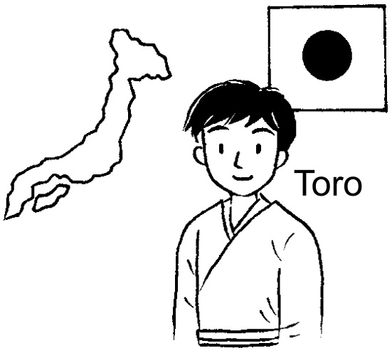

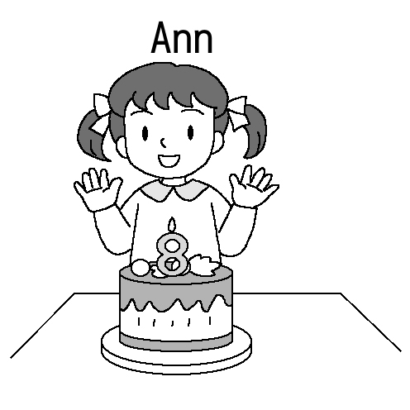
1. 2. 3.

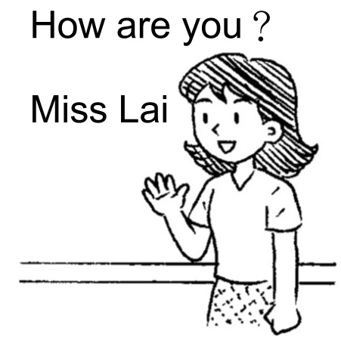

4. 5.

- 聽句辨義：根據聽到的短文內容，敍述正確者寫T，不正確者寫F：10%
1. Jimmy’s sister is only four years old.
2. Jimmy’s aunt is on vacation now.
3. Jenny and Ben are Jimmy’s teachers.
4. Emma’s favorite subject is English.
5. Jimmy and Emma are thirteen years old.

- 對話選擇：根據聽到的句子內容，選出合適的回應：10%
1. (Ａ) She is my English teacher. (Ｂ) She is from Japan.
( Ｃ) She is twenty years old. (Ｄ) She is Nora’s aunt.
2. (Ａ) He is Susan’s brother. (Ｂ) He is a junior high school student.
(Ｃ) He is fourteen years old. (Ｄ) She is thirteen years old.
3. (Ａ) Yes, she is a nurse. (Ｂ) I don’t know.
(Ｃ) No, she isn’t. She is a teacher. (Ｄ) Yes, she is. She is an English teacher.
4. (Ａ) She is twenty six years old. (Ｂ) She is my favorite teacher, too.
(Ｃ) Is she a good teacher? (Ｄ) Miss Lin is a teacher.
5. (Ａ) They are Sam and Josh. (Ｂ) They are thirteen years old.
(Ｃ) They are from Korea . (Ｄ) They are on vacation.
- 筆試 70%
- 文意字彙：10%
1. I like(喜歡) English. It is my f te subject.
2. Our teacher is p y and young.
3. Nancy and Alice are in the same class. They are c tes.
4. My brother-in-law is a r er. He works(工作) for China Times(中國郵報).
5. Is he a t le cook? Yes. He isn’t good at cooking.

- 文法選擇：20%
1. It is my dog. name is lucky.
(A) It’s (B) Its (C)it’s (D) its
2. Nora and Tina _____ smart(聰明).
(A) is (B) are (C) am (D)and
3. It’s orange.
(A) an (B) a (C) two (D) three.
4. They are my parents. I’m _____ daughter.
(A) her (B) his (C) their (D) they
5. She’s my mother’s sister, Aunt _____.
(A) Lin (B) lin (C) Judy (D) Sam
6. Welcome _____ home.
(A) X (B) to (C) is (D) are
7. Father is busy _____ in the kitchen.
(A) cooking (B) cook (C) to cook (D) a cook
8.She is a _____ girl.
(A) one (B) one year old (C) one-year-old (D) eleven-year-old
9.A: George from? B: He’s from Canada.
(A) Who (B) Who’s (C) Where (D)Where’s
10.A: Is she a student? B: ___________ .
(A) No, she is. (B) No, he isn’t (C) Yes, he is. (D)Yes, she is.

- 克漏字對話選擇：10%
A: 1. the handsome man?
B: He is my uncle.
A: What’s 2. name?
B:Eric.
A:3. is he from?
B: He is from the US. And he is 4. vacation 5. our family now.
1. (A) Who’s (B) What’s (C) Where’s (D) Is
2. (A) her (B) his (C) your (D) their
3. (A) Where (B) Who (C) What (D) When
4. (A) in (B) on (C) from (D) at
5. (A) and (B) but (C) with (D) on

- 閱讀測驗：10%
Ella is fifteen years old. She comes from Japan. Her father is a lawyer, and her mother is a cook. Her grandmother is an English teacher. She has one brother and one sister, Tony and Jennifer. Tony is seven years old. Jennifer is three years old. They are smart and cute kids. She loves them. come來 has有 smart聰明 kid 小孩 them他們
1. Where is Ella from?
(A) Kaohsiung. (B) Japan (C) Taiwan (D) Korea.
2. There are(有) _____ people(人) in Ella’s family.
(A) three (B) four (C) five (D) six
3. Tony is Ella’s ______.
(A) father (B) mother (C) brother (D)sister
4. How old is Ella’s sister?
(A) fifteen (B) seven (C) three (D) two.
5. Is Ella’s brother a junior high school student?
(A) No,he isn’t. (B) No, she isn’t. (C) Yes, he is. (D) Yes, she is.

- 翻譯：20%
  - 她在廚房。 (5分)
  - 他是一個報社記者。 (5分)
  - 他是我姑姑的丈夫。 (5分)
  - 他的弟弟叫什麼名字？ (5分)

高雄縣立林園高級中學 國中部98學年度 第一學期 一年級 英語科
第一次段考解答
- 聽力測驗 30% (每題2分)
- T F F T T
- F T F T F
- B C D B A

- 筆試 70% (第一至第四大題每題2分)
- favorite / pretty / classmates / reporter / terrible
- B B A C C A A C D D
- A B A B C
- B C C C A
- 翻譯 (20分):每題5分。錯一字或標點符號扣1分，每題至多扣5分。
1. | She is in the kitchen .
2. | He is a newspaper reporter.
3. | He is my aunt’s husband.
4. | What’s his brother’s name?

