高雄縣立林園高級中學 國中部 98學年度 第一學期 一 年級 英文科 第二次段考考卷 （A）
範圍：Book One L3—Review2 班級： 姓名： 座號：
I聽力測驗30%
一、字彙選擇：每題2分，共10分
選出句子中出現的單字。
( ) 1. (Ａ) Your (Ｂ) Yours (Ｃ) You’re
( ) 2. (Ａ) word (Ｂ) work (Ｃ) walk
( ) 3. (Ａ) fourteen (Ｂ) forty (Ｃ) four
( ) 4. (Ａ) pass (Ｂ) past (Ｃ) party
( ) 5. (Ａ) on (Ｂ) of (Ｃ) off

二、看圖回答：每題2分，共10分
根據圖片，聽完問題後勾選出正確的答案。
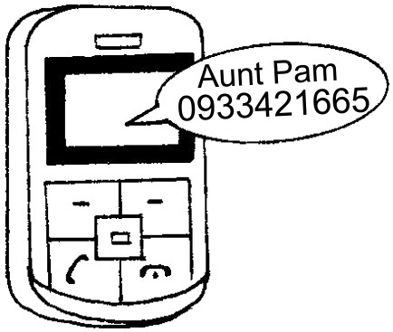
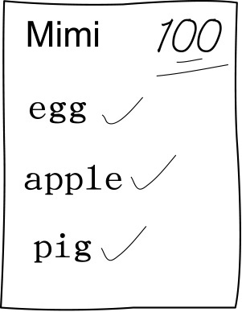
1. 2. 3.
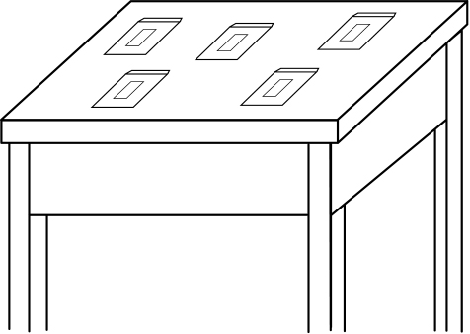


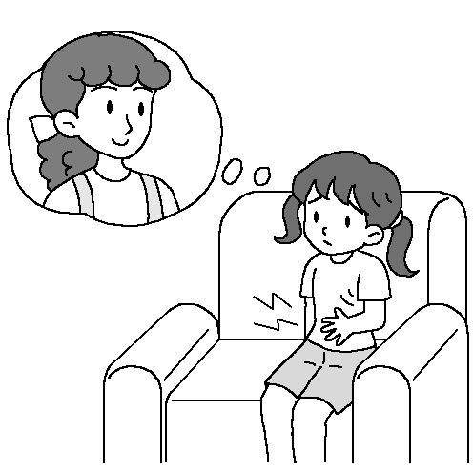
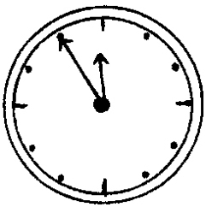
4. 5. It is ten ten

三、簡短對話：每題2分，共10分
根據聽到的對話內容與問題，選出正確的答案。
( ) 1. (Ａ) She is a cook. (Ｂ) She is Tom’s teacher.
(Ｃ) She is a newspaper reporter. (Ｄ) She is Tom’s classmate.
( ) 2. (Ａ) It’s a clock. (Ｂ) It’s a desk. (Ｃ) It’s a box. (Ｄ) It’s a cake.
( ) 3. (Ａ) It’s six fifty. (Ｂ) It’s six ten. (Ｃ) It’s seven fifty. (Ｄ) It’s seven ten.
( ) 4. (Ａ) It’s ten twenty. (Ｂ) It’s nine forty-five. (Ｃ) It’s nine ten. (Ｄ) It’s ten fifteen.
( ) 5. (Ａ) It’s Peter’s favorite program. (Ｂ) It’s about English. (Ｃ) It’s about animals.(Ｄ) It’s about math.

II筆試 70%
一、 文意字彙: 10%
1.Please look at the p _________e . They are my family.
2.My lucky n________r is eight, but my brother’s is seven.
3.It’s not a pen. It’s s_______g else.
4.My wife is a h________e, not a teacher.
5. You watch TV for a m_______e Then(然後) turn it off to do your homework.

二、文法選擇: 20%
1. An (A)envelop (B)envelope(C)elope(D) frisbee is in the box.
2. 選出錯誤的句子 (A) Tom, be a good student. (B)Tom is a good student.
(C) Be a good student , Tom.(D)Tom be a good student.
3. 選出正確的句子(A)The o’clock is my present for Tom. (B) It’s seven o’clocks now.
(C) It’s ten. (D)The oclock is on the wall.
4. 選出正確的句子(A)Don’t close his book. (B)It’s time to home
(C)It’s time to eat dinner .(D) Don’t to close his book.
5. It’s ten forty-five 等於(A) It’s a quarter to eleven.(B) It’s a quarter past eleven.
(C) It’s fifteen to ten.(D) It’s fifteen past ten.
6. I am hungry, _____ Mom is still busy in the kitchen. (A) and (B) but (C)or (D)in
7 .Let’s _____ out(外食).(A) to eat(B) go (C) eat(D)to go
8. 選出正確的句子(A)Not talk in class.(B)Please don’t talk in class.
(C) Don’t please talk in class. (D)Please not talk in class.
9. Is that boy Tom or Tim? (A) He is Tom. (B) Yes, he is Tom. (C) No, he is Tim. (D)She is Tom.
10.A:Are those pens? B: ________.(A)Yes, those are.(B) No, those aren’t.
(C) Yes, they’re (D) No. They are pencils.
三、將下列各字改為複數,並註明發何種音,填入答案欄中,但只填代號。
A代表發[s]音B代表發[Z]音.,C代表發[IZ]音。(10%,每格1分)
複數 發音代號 複數 發音代號
如: book → books → A
1,party → _________ → ______ 2,leaf → ____________ → ____
3.play (戲劇) → _______ →________ 4.ruler → _________ → _____
5.watch →_________ → ______
四、閲讀測驗12%每題2分
It’s 8:10 in the morning. It’s time for the first (第一) class, English. John is late for the first class. A sign “Be quiet “ is on the wall. There are two English sentences on the blackboard. (黑板) The students are still noisy, not quiet, in the classroom. Their English teacher Mr. Wang is still busy in the office. He is ready to go to the classroom. He isn't happy.
(1)What time does John walk (走) in the classroom ? (A)7:30 (B) 8:00 (C) 8:05(D) 8:20
(2)What time is the English class? (A)7:30 (B) 8:00 (C) 8:10 (D) 8:20
(3) Why(為什麼) isn’t Mr. Wang happy?
(A)The students are too (太) noisy. (B) The students are too quiet.
(C) John isn’t late for the first class. (D)Mr. Wang is hungry.
(4)What does the sign say ?
(A) Don’t worry. (憂慮) Be happy. (B)Keep quiet. (C) Be noisy. (D) Sit down.
(5) Where (地方) is the English teacher at 8:09?
(A) At home (B) In the classroom (C)In Canada. (D) In the office.
(6)What’s on the blackboard?
(A) Two workbooks (B) Two English sentences (C) Two pictures (D) Two pens.

五、依提示作答9%(每題3分,1字錯扣1分)
1. It’s six forty-five now (用…..to…..改寫句子)
2.Those apples are for your brothers(改為單數)
3 My sister is tall. My sister is pretty.(用連接詞併為一句且要精簡,否則不給分)

六、翻譯9%(每題3分,1字錯扣1分)
1.Lisa的新手機號碼是幾號?
2.請翻到第40頁。(40用英文否則扣1分)
3.這些紅蠟蠋很漂亮。

第二次段考考卷 範圍：Book One L3—Review2 （A卷） 班級： 姓名： 座號：

I聽力測驗30%
一、字彙選擇：每題2分，共10分
1. C | 2. A | 3. B | 4. B | 5. C
二、看圖回答：每題2分，共10分

1. C | 2. A | 3. A | 4. B | 5. B
三、簡短對話：每題2分，共10分

1. B | 2. A | 3. D | 4. D | 5. C

II. 筆試70%
一、文意字彙: 10%
1. picture | 2. number | 3. something | 4. housewife | 5. minute
二、文法選擇20%

1. B | 2. D | 3. C | 4. C | 5. A
6. B | 7. C | 8. B | 9. A | 10. D
三、複數與發音10%(每格1分)
1 |  | 2 |  | 3 |  | 4 |  | 5
parties | C | leaves | C | plays | B | rulers | B | watches | C
四、閲讀測驗12%每題2分
1. D | 2. C | 3. A | 4 B. | 5 D. | 6. B
五、依提示作答9%(每題3分,1字錯扣1分)
1. | It’s a quarter( fifteen) to seven
2. | That apple is for your brother
3. | My sister is tall and pretty
六、翻譯9%(每題3分,1字錯扣1分)
1. | What’s Lisa new cellphone number ?
2. | Please turn to page forty
3. | Those red candles are beautiful

