高雄縣立林園高級中學 國中部 98學年度 第一學期 一 年級 英文 科 第三次段考考卷 （A卷）
範圍： 班級： 姓名： 座號：
一、 Listening Comprehension 聽力測驗 （３０%）
（一） 看圖選擇：每題2分，共10分
 根據聽到的內容，選出正確的圖片代碼。 ※（若聽到的圖片代碼答案為E，劃卡請劃D）
1.  2. 3. 4. 5.
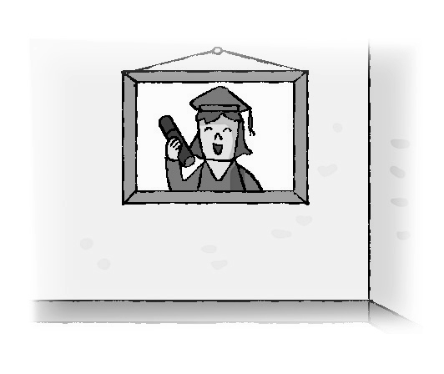
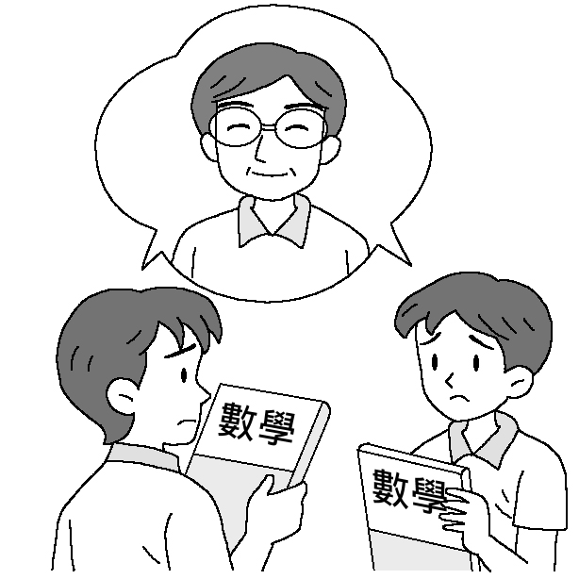
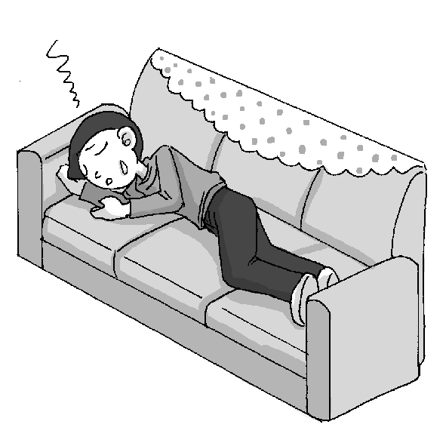
A. B. C.

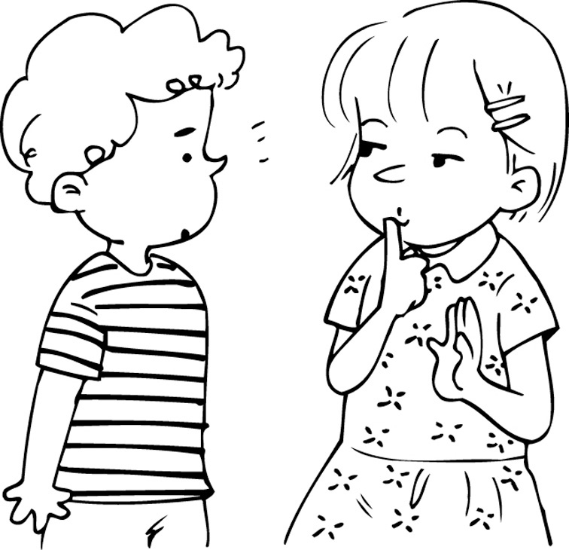
D. E.
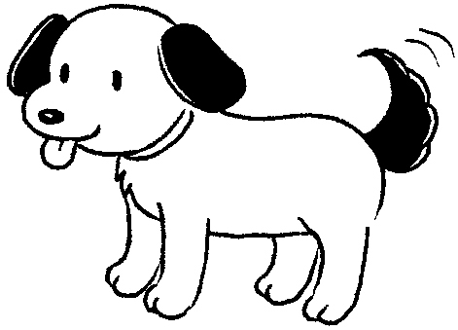

（二） 對話選擇：每題2分，共10分
根據聽到的內容，選出合適的回應。
( ) 6. (Ａ) He is watching TV. (Ｂ) He is cooking. (Ｃ) He is jogging. (Ｄ) He is doing homework.
( ) 7. (Ａ) Eric is a science teacher. (Ｂ) Eric is good at math. (Ｃ) Eric is good at English. (Ｄ) Eric is not good at math.
( ) 8. (Ａ) His name is Peter. (Ｂ) He is thirteen years old. (Ｃ) He is sleeping. (Ｄ) He is in the living room.
( ) 9. (Ａ) No. It’s on the bed. (Ｂ) Yes, it’s on the chair. (Ｃ) Yes, it’s on the bed. (Ｄ) Yes, it’s on the desk.
( ) 10. (Ａ) It’s so scary. (Ｂ) It’s so young. (Ｃ) It’s so kind. (Ｄ) It’s in the box.

（三） 字彙選擇：每題2分，共10分
選出句子中出現的單字。
( ) 11. (Ａ) whale (Ｂ) spider (Ｃ) scary
( ) 12. (Ａ) swing (Ｂ) swinging (Ｃ) turtle
( ) 13. (Ａ) bathroom (Ｂ) bedroom (Ｃ) dining room
( ) 14. (Ａ) look for (Ｂ) looking for (Ｃ) looking at
( ) 15. (Ａ) dogs (Ｂ) some (Ｃ) frogs

二、Reading Comprehension 閱讀理解測驗 （70%）
（一）文法選擇（40%） 每題2分 （請根據題意選出最適當答案）
16.Monica is watching TV, _______ the newspaper.
(A) isn’t reading (B) isn’t seeing (C) not seeing (D) not reading
17.Mom loves to buy .
(A) good something (B) something good (C) good some thing (D) some good thing
18.They are not good at .
(A) writeing (B) swiming (C) jogging (D) runing
19.Rober, ________ to the park right now. Sally and Nora are waiting you there.
(A) go；for (B) go；with (C) is going；with (D) goes；for
20. Look! The girls in the classroom ________ the books.
(A) are looking (B) are looking for (C) study (D) is studying
21.Let’s Tom his homework.
(A) to help；to do (B) help；doing (C) help；to do (D) helping；do
22.There are many students in the playground（操場）.
(A) to walk around (B) walk around (C) are walking around (D) walking around
23.Mr. and Mrs. Wang a son and two daughters now.
(A) have (B) are having (C) is having (D) has
24.There ________ any books in my desk. (A) is (B) isn’t (C) are (D) aren’t
25.下列句子何者錯誤？
(A) Please don’t be hard on me.(B) Maybe you are right.(C) The insects are from nature.(D) In the pond has two frogs.
26. My younger brother, Johnny, now.
(A) is eatting and talking (B) is eating and sleeping (C) are clerks in the museum (D) is eating and talking
27. are talking to them.(A) Our all teachers (B) All our teachers (C) All the teacher (D) Our teacher
28.Don’t shout me. I am looking (找) my mask. It is a present my good friend.
（A）at；for；from （B）to；at；from （C）at；for；in （D）at；at；from
29. A: Is there ________ ruler in your pencil box? B: Yes, there are three.
(A) some (B) no (C) any (D) many
30. A: Are these wallets good? B: _______ they are.
（A）And you, （B）Of course, （C）Don’t shout （D）Not again
31. A: Who ________ homework in the library? B: Amy and Jack are.
(A) do (B) is doing (C) are doing (D) does
32. Andy: Mom, where are my comic books? Mom: ________.
(A) Aren’t they on your desk? (B) They are good. (C) They are from your uncle. (D) His comic books are under the desk.
33. A: ? B: He is studying for tomorrow’s test.
(A) Where is he (B) What is he (C) Is he studying (D) What is he doing
34. Kelly:You are my favorite friend. Help me,please. Selina:
(A) Thank you very much. (B) Of course. What’s the trouble? (C) Come on. (D) Wow！You are very good.
35. Rose: Are there four pictures on the wall? Peter: Yes, ________.
(A) there is (B) there’s (C) there are (D) there’re

（二）克漏字測驗（20%） 每題2分

It’s a beautiful day. Let’s have a picnic.
A: (36) there in the basket?
B: There are some sandwiches.
A: Is there any fruit in it?
B: Yes, there (37) some apples, bananas, and watermelons.
A: (38) there any water or juice?
B: Yes, there’s some orange juice and soda.
A: Are there any hot dogs?
B: No, we don’t have (39) hot dogs.
A: Can I buy some? I like hot dogs.
B: (40) , we can get some hot dogs in the supermarket.

（ ）36. (A) What (B) Is (C) What’s (D) Are
（ ）37. (A) is (B) has (C) are (D) have
（ ）38. (A)Is (B) Are (C) What’s (D) What are
（ ）39. (A) some (B) a (C) the (D) any
（ ）40. (A) Of course not (B) Sure (C) Come on (D) Are you kidding

Amy: (41) , Mom?
Mom: Yes, I’m in the kitchen. I’m making dinner for you.
Amy: (42) our cat, Kitty, there, too?
Mom: No, she (43) here.
Amy: Where is she (44) ?
Mom: How about looking (45) the bed in your bedroom? She likes staying there sometimes.
Amy: I got it!
make 製作 stay 停留

（ ）41. (A) Are you in the kitchen (B) Where are you (C) Where is she (D) Is she in the kitchen
（ ）42. (A) Are (B) Aren’t (C) Is (D) Isn’t
（ ）43. (A) is (B) are (C isn’t (D) aren’t
（ ）44. (A) then (B) really (C) so (D) at
（ ）45. (A) in (B) between (C) next (D) under
（三）閱讀測驗（10%） 每題2分
＊
This is a big kitchen. I smell something good. Oh, there is some coffee and there are also some cakes on the table. Under the table, there is a dog sleeping. Next to it, there’s a cat drinking milk. Mom is coming into the kitchen. And then she will sit at the table and drink the cup of coffee on the table.
smell 聞 will 將
（ ）46. Are there a dog and a cat in the kitchen?
(A)Yes, they are. (B) No, there is a dog. (C) Yes, there are. (D) No, they aren’t.
（ ）47. Which picture is right?
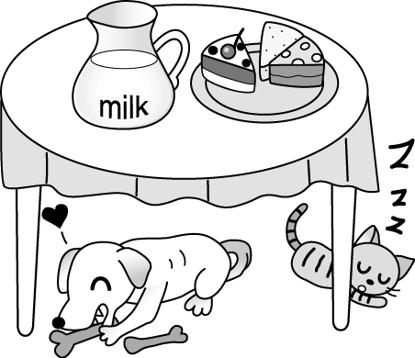
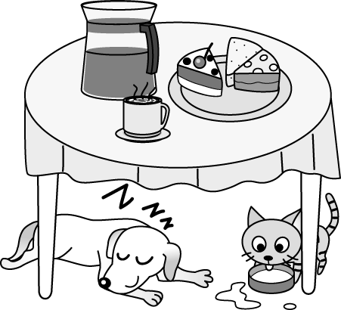
(A) (B)

(C) (D)
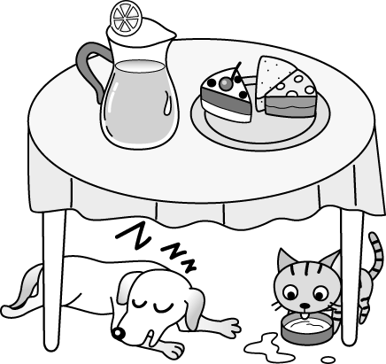
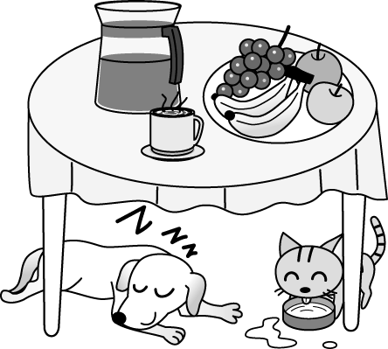

＊ Movie Date（電影之約）
Lucy: Mom, where are my new shoes?
Mother: Under your bed.
Lucy: Where’s my new hat?
Mother: Where are you going?
Lucy: I’m going to the movies.
Mother: Can I go, too?
Lucy: Mom…
Mother: OK, OK, I’m just kidding.
Lucy: Thanks, Mom. I’m leaving.(離開) Bye!
（ ）48. Is Mom going to the movies, too? (A) Yes. (B) No, she isn’t. (C) We don’t know. (D) In the morning.
（ ）49. Where are Lucy’s new shoes? (A) Under her bed. (B) Under her desk. (C) In the box. (D) In the living room.
（ ）50. What does “ I’m just kidding.” mean（意義）?
- I’m just joking.（開玩笑） (B) I’m angry.（生氣） (C) I want to go. (D) I am happy to hear that.1

一年級 英文 科 答案欄 （A卷專用）
1-10 DADCB CBDCA
11-20 CBABC DBCAB
21-30 CDADD DBACB
31-40 BADBC CCADB
41-50 ACCAD CBBAA

