高雄縣立林園高級中學 國中部98學年度 第一學期 二年級 英語科 第一次段考考卷
範圍：Unit 1~Review 1 班級： 座號： 姓名：
B卷
第一部份 聽力測驗 30％
一、根據錄音內容，將題號寫入正確的圖片中：10％ (每題2分)
(Ａ)  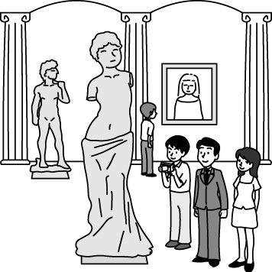 | (Ｂ)  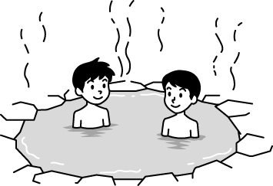 | (Ｃ)  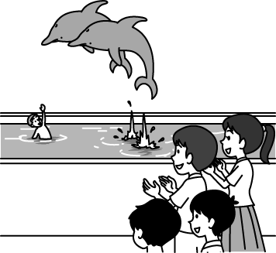 | (Ｄ)  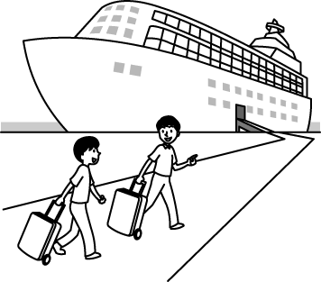 | (Ｅ)  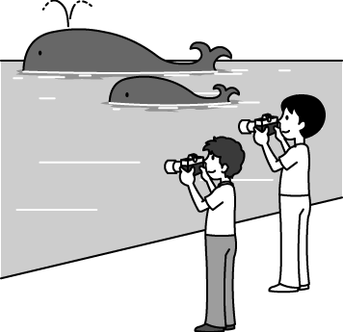
（ ） | （ ） | （ ） | （ ） | （ ）
二、選出適當的回應句：10％ (每題2分)
（ ）1. (Ａ) You really did a wonderful job. (Ｂ) It’s so nice of you to do all these for me. (Ｃ) That’s all right.
（ ）2. (Ａ) It’s a quarter to twelve. (Ｂ) I don’t have time to take those tests. (Ｃ) It’s at half past eight.
（ ）3. (Ａ) I took a trip to America. (Ｂ) I did my homework and then watched some TV.
(Ｃ) I usually surfed the Net in the evening.
（ ）4. (Ａ) Yes, I just did it before dinner. (Ｂ) No, I didn’t jog after lunch.
(Ｃ) Yes, I often exercised in the morning.
（ ）5. (Ａ) That’s too bad. We need to clean it up today. (Ｂ) No, there weren’t any pictures on them.
(Ｃ) That’s right. The students decorated them yesterday.
三、根據對話內容，正確的寫○，錯誤的寫×：10％ (每題2分)
（ ）1. The boy didn’t study for the test because he was sick.
（ ）2. The boy has a sore throat.
（ ）3. The boy’s math teacher wasn’t interesting, so he didn’t like the subject.
（ ）4. There are many red bikes in the park.
（ ）5. Every student likes the story of the Moon Rabbit.

第二部份 紙筆測驗 70％
一、文法選擇：20％ (每題2分)
（ ）1. Did you eat yesterday? (Ａ) a lot of (Ｂ) medicine (Ｃ) pomelo (Ｄ) a lot
（ ）2. I a lot of fun swimming in the river. (Ａ) have (Ｂ) having (Ｃ) am (Ｄ) was
（ ）3. A: ____ did Joe go to school late? B: He was late last Thursday. (Ａ) Where (Ｂ) When (Ｃ) How (Ｄ) Why
（ ）4. Jacky didn’t go to the movies last night. He math all night. (Ａ) study (Ｂ) studies (Ｃ) studied (Ｄ) studying
（ ）5. It is five to five. ＝_____ (Ａ) It is five five. (Ｂ) It is five after five. (Ｃ) It is four fifty-five. (Ｄ) It is five fifty-five.
（ ）6. Miss Yamato: Who the book? Max: I did. (Ａ) used (Ｂ) wash (Ｃ) write (Ｄ) looked
（ ）7. Mary homework yesterday morning, but George .
(Ａ) does; doesn’t (Ｂ) wrote; did (Ｃ) didn’t do; didn’t (Ｄ) did; didn’t
（ ）8. Jolin has tests every day, so she can’t watch TV. (Ａ) many (Ｂ) little (Ｃ) no (Ｄ) Math
（ ）9. Tony is in bed with a bad . He needs to see a doctor. (Ａ) sick (Ｂ) headache (Ｃ) stomache (Ｄ) vacation
（ ）10. A: Where are the kids? B: There are three the third floor and one here. (Ａ) kid (Ｂ) kids (Ｃ) on (Ｄ) in
二、對話：10％ (每題2分)
（ ）1. A: B: He just ran away. (Ａ) Does he always say hello to you? (Ｂ) What did he do after he saw you?
(Ｃ) What does he do after school? (Ｄ) How was he when you saw him?
（ ）2. A: . B: Thanks. But I ate ten yesterday.
(Ａ) How about having some moon cakes? (Ｂ) How much rice did you eat yesterday?
(Ｃ) Why not come to my party? (Ｄ) Do you want to take some medicine?
（ ）3. A: B: Of course.
(Ａ) Who else did you see? (Ｂ) How was it? (Ｃ) Did you visit anywhere interesting? (Ｄ) What did you eat?

（ ）4. A: B: We usually sing songs and eat cakes. A: It’s so nice of you!
(Ａ) What did you usually read? (Ｂ) Why did you celebrate Father’s Day?
(Ｃ) I have a high fever. (Ｄ) How do you usually celebrate Father’s Day?
（ ）5. A: When did you wash the car? B:
(Ａ) Because the car was dirty. (Ｂ) I started an hour before. (Ｃ) I washed it . (Ｄ) At noon.
三、閱讀測驗：8％ (每題2分)
Kim is a young man from Taipei and he had a great time in Green Island during summer vacation. He didn’t take a trip but a part-time job at a drink store there for two months. He worked there from half past eight in the morning to ten at night every day. He stayed with his shopkeeper’s family and ate three meals for free. Kim enjoyed everything and worked hard all the time.
Sometimes the shopkeeper wanted him to look around the beautiful island. He went to hot springs, saw animals, and swam in the sea. Kim lived a different life from the life in a big city during his stay in the island. So he plans to go back to the island again next year. part-time 兼職 shopkeeper 店長 around 四處

（ ）1. What didn’t Kim do during his stay in Green Island?
(A) paid for his meals (B) saw animals (C) swam in the sea (D) went to hot springs
（ ）2. Which is NOT true? (A) Kim enjoyed his stay in Green island. (B) Kim got up at nine every day.
(C) Kim ate breakfast with the shopkeeper’s family. (D) Kim sold drinks well when he worked there.
（ ）3. When did Kim stay in Green Island ?
(A) In January and February. (B) In March and April. (C) In May and June. (D) In July and August.
（ ）4. Why does Kim plan to go back to Green Island? (A) Because his family live there.
(B) Because he had a great time there. (C) Because he enjoyed drinking. (D) Because he doesn’t like Taipei.
四、文意字彙：5％ (每題1分)
______________ 1. Ants and butterflies are my favorite i ts.
______________ 2. Ms. Lin went to the hospital because she h t her legs.
______________ 3. I had a t e day today. I took the wrong bus and didn’t do well on the test.
______________ 4. We didn’t have time to go to the art museum today. We plan to go there t w.
______________ 5. Most Chinese come home and get t r during Chinese New Year.
五、填入正確的動詞或be動詞：5％ (每題1分，一題一字)
1. Mr. Chen is ______________________ (go) on a trip to Taipei later.
2. The Brown family ______________________ (jog) every morning last month.
3. Who ______________________ (sleep) in his room yesterday evening?
4. We had a good time ______________________ (watch) the monkey show.
5. Those boys already ______________________ (carry) the heavy bags to the mountains.
六、填空：7％ (每格1分，一格一字)
Mom: What 1. to you? You come home late today.
Hilton: My math teacher 2. angry in class today because I didn’t do well on the test.
After school, he 3. me a lesson and asked me to study 4. the test.
Mom: I 5. you so, and you didn’t listen to me but (k) 6. playing computers games last night!
Hilton: I am so sorry. I really need to 7. the math exercise.
Mom: That’s right!
七、翻譯：15％ (每題5分)
1. 一小時前我才剛到這裡！（數字必須寫成英文）
2. 他們在中秋節那天開始聽故事。（過去式）
3. 因為Tom忙著做卡片給他媽媽，所以他昨天沒有來。（Because...）

