高雄縣立林園高中國中部九十八學年度第一學期第二次段考二年級英語科（A）
範圍：Book 3 Unit4~Review2 命題教師：潘如庸

I. Listening Comprehension 聽力測驗 （３０%）

（I）根據圖片內容，選出正確的答案。
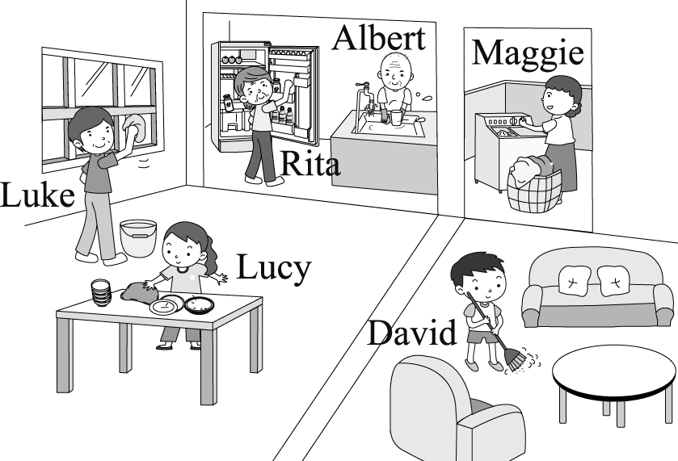
(１)（A）Yes, she was.
（B）No, she wasn’t.
(２)（A）Yes, he was.
（B）No, she wasn’t.
(３)（A）She was cleaning the table.
（B）She was doing the dishes.
(４)（A）Rita was.
（B）Albert was.
(５)（A）He was wiping the windows.
（B）He was wiping the table.

（II）若聽到的內容與題目相符畫○；不符則畫×。(寫T / F不給分)
（ ）(１) The boy went to the show by bus yesterday.
（ ）(２) The boy’s uncle lived in Penghu.
（ ）(３) They can’t take an airplane to the town.
（ ）(４) The boy wants to have a lot of roses on his farm.
（ ）(５) They plan to go hiking and camping this weekend.

（III）寫出下列地點在地圖中的代號。
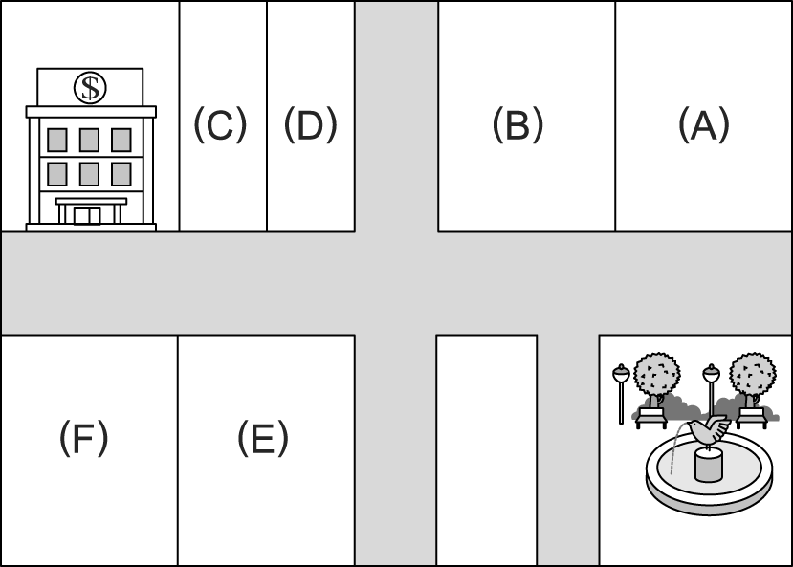
（ ）(１) movie theater
（ ）(２) bookstore
（ ）(３) department store
（ ）(４) bus station
（ ）(５) gym

II. Reading Comprehension 閱讀測驗 （54%）
(I) Vocabulary Test（10%）
（請根據題意選出最適當答案）
1. This train goes from Kaohsiung to Taipei with only four ____. It’s fast.
(A) stops (B) stations (C) streets (D) yards
2. The milk went bad because you didn’t put it in the ____.
(A) police station (B) restaurant (C) refrigerator (D) foreigner
3. John ____ his grandparents to his birthday party.
(A) visited (B) invited (C) found (D) sent
4. Amy loves movies. She often goes to the ____.
(A) station (B) theater (C) library (D) bank
5. He already ____ to New York from Taiwan this morning.
(A) took (B) rode (C) drove (D) flew

(II) Grammar Test（10%）
（請根據題意選出最適當答案）
- “ Look at ___. Why are you so dirty?” Jack and Bob’s mom said to them.
(A) yourself (B) himself (C) yourselves (D) themselves
- How did Nicole go to the market? ___ a taxi.
(A) By (B) On (C) In (D) Drive
- I gave ___ my good friend a present on her birthday.
(A) for (B) to (C) with (D) ×
4. Lily ___ me last night. At that time, I ___ my favorite TV show.
(A) called; watched (B) called; was watching (C) was calling; watched (D) was calling; was watching
5. I’m tired. Let’s stop ___ a break.
(A) take (B) to take (C) taking (D) ,then take

(III) Cloze（18%）
（請根據文意選出最適當答案）
Jim lives in Chijn 1 himself. He is a sales clerk in a 2 . Every day, he has to 3 a ferry across Kaohsiung Harbor to his work. That’s an interesting 4 ride. He 5 on the ferry with his scooter. It takes about 10 minutes. Jim can have his breakfast and enjoy the view.
*Chijn旗津 / sales clerk店員 / ferry渡輪 / harbor港 / view景色

1. (A) by (B) on (C) with (D) for
2. (A) bank (B) theater (C) restaurant (D) department store
3. (A) take (B) ride (C) drive (D) fly
4. (A) plane (B) train (C) bus (D) boat
5. (A) gets (B) sits (C) turns (D) goes

One day, a man 6. . He saw an old farmer and a dog sitting in front of a house, so he decided to stop
and 7. directions(方向). But 8. the man got out of his car, he asked, “ 9. , sir. Does your dog bite?” The farmer said, “NO!” Then the man got out of his car, and the dog ran and bit him. The man said, “ I thought you said your dog didn’t bite.” “ That’s not my dog,” the old farmer answered.

6. (A) is lost (B) was getting lost (C) got lost (D) lost something
7.( A) looked at (B) asked for (C) drove to (D) thought of
8. (A) when (B) after (C) before (D) then
9. (A) Sorry (B) Excuse me (C) What’s wrong (D) Come on

(IV) Reading Skills Test（16%）（請根據文意選出最適當答案）
(i)
A Camping trip
My family lives in a small town. We go camping twice a year. Last weekend, we went camping again and I enjoyed it very much. It was so beautiful in the country. We went jogging in the morning and watched the sunset in the evening.
At night, we sat around the campfire under the moon and made pizza and hot dogs. We even took turns telling scary stories! Richard told a lot of really scary stories.
Late at night, we went to sleep in a log cabin by a river. The cabin was small but very comfortable. We all had a nice sleep.
*the country鄉下 / sunset日落 / scary可怕的 / log cabin小木屋 / by在…旁邊

- When did they go camping?
(A) On Monday. (B) On Tuesday. (C) On Wednesday. (D) On Saturday.
- Where did they go camping?
(A) In a small town. (B) In the mountains. (C) In the country. (D) On a farm.
- What did they have for dinner?
(A) Pizza. (B) Moon cakes. (C) Dogs. . (D) Fish.
- Where did they sleep?
(A) Outside under the moon. (B) Around the campfire. (C) In the cabin. (D) In the river.
- Which is TRUE?
(A) They go to the cabin twice a year. (B) They went jogging before noon.
(C) They told scary stories in the cabin. (D) They slept well by the campfire.

(ii) Angel studies in Yuanlin High School. Here’s the street map around the school.

 |  | Four Seasons Road
City Library |  | Nemo Movie Theater |  |  |  |  |  | Park | Railway Station
 |  | Garden Road
Good Buy  Supermarket | Rose Street | Bookstore |  | Burger  Queen |  | Lily Street | SOGOOD  Department Store
Great Chinese  Restaurant | Rose Street | Yuanlin High School |  |  |  | Lily Street
 |  | Rainbow Road
Police Station |  | Gift Shop | Bank |  | Café  86℃ |  | Hospital

building 建築物 beside 在…旁邊 around 在…周圍 death 死亡

- Where can Angel go to borrow books?
(A) The building next to the supermarket. (B) The building beside the fast food restaurant.
(C) The building across from the theater. (D) The building between a gift shop and coffee shop.
- Angel needs to buy some vegetables. She is in the park now. Where can she go?
(A) Go down Lily St. and turn right on Garden Rd. Walk across Rose St. It’s on the left.
(B) Turn left and go down Four Season Rd. Then turn left on Rose St. and turn right on Rainbow Rd. It’s on the left.
(C) Take Garden Rd. and walk for one block. Turn left on Rose St. It’s on the left.
(D) Go up Rose St. and turn right on Garden Rd. Then walk down and turn left on Lily St. It’s on the right.
- What can’t Angel do around the school?
(A) To buy some clothes. (B) To take a train.
(C) To see a doctor. (D) To send a letter.

III. Translation翻譯填充 （１6 %）
（配合中文，在每個空格中填入一個英文字，以完成整篇文章。）
Tiffany和Jessie是林中的學生。它是ㄧ所位於林園北路和王公路轉角的學校。這兩個女孩有很多共同點。他們倆個都喜歡英文和自拍。在學校，他們總是互相幫忙。昨天，它們一起去高雄逛街。Tiffney爲她媽媽買了一個錶。Jessie什麼都沒買，但她還是玩得很開心。大約7點，他們就搭公車回家了。
Tiffany and Jessie are students from Linyuan High School. It’s a school on the _____________ ____________ Linyuan N. Road. and Wanggong Road. The two girls have a lot ____________ ____________. They both like English and taking pictures ____________ _____________. They always ____________ _____________ _____________ in school. Yesterday, they ____________ _____________ _____________ Kaohsiung. Tiffany bought a watch _____________ her mother. Jessie didn’t buy anything, but she still ____________ _____________ very much. At about seven o’clock, they ____________ a bus home.

高雄縣立林園高中國中部九十八學年度第一學期第二次段考二年級英語科
【答案卷】 Class No. Name
- Listening Comprehension 聽力測驗 （３０%）

(I) | 1. | 2. | 3. | 4. | 5.
(II) | 1. | 2. | 3. | 4. | 5.
(III) | 1. | 2. | 3. | 4. | 5.
- Reading Comprehension 閱讀測驗 （54%）
(I) Vocabulary Test（10%）
1. | 2. | 3. | 4. | 5.
(II) Grammar Test（10%）
1. | 2. | 3. | 4. | 5.
(III) Cloze（18%）
1. | 2. | 3. | 4. | 5.
6. | 7. | 8. | 9.
(IV) Reading Skills Test（16%）
1. | 2. | 3. | 4. | 5.
6. | 7. | 8.

III. Translation翻譯填充（１6 %）(一字一分)
Tiffany and Jessie are students from Linyuan High School. It’s a school on the _____________ ____________ Linyuan N. Road. and Wanggong Road. The two girls have a lot ____________ ____________. They both like English and taking pictures ____________ _____________. They always ____________ _____________ _____________ in school. Yesterday, they ____________ _____________ _____________ Kaohsiung. Tiffany bought a watch _____________ her mother. Jessie didn’t buy anything, but she still ____________ _____________ very much. At about seven o’clock, they ____________ a bus home.

高雄縣立林園高中國中部九十八學年度第一學期第二次段考二年級英語科
【解答】
- Listening Comprehension 聽力測驗 （３０%）
- BAAAA
- XOOXO
- CBEAD
- Reading Comprehension 閱讀測驗 （54%）
(I) ACBBD （第五題C亦可）
(II) CCDBB
(III) ADADA CBCB
(IV) DCACB CAD
III. Translation翻譯填充（１6 %）(一字一分)
Tiffany and Jessie are students from Linyuan High School. It’s a school on the corner of Linyuan N. Road. and Wanggong Road. The two girls have a lot in common. They both like English and taking pictures of themselves. They always help each other in school. Yesterday, they went shopping in Kaohsiung. Tiffany bought a watch for her mother. Jessie didn’t buy anything, but she still enjoyed herself very much. At about seven o’clock, they took a bus home.

