高雄縣立林園高中國中部九十八學年度第一學期第二次段考二年級英語科（B）
範圍：Book 3 Unit4~Review2 命題教師：潘如庸

I. Listening Comprehension 聽力測驗 （３０%）

(I)聽到的內容與圖片相符者打○，不符者打×。
(１)  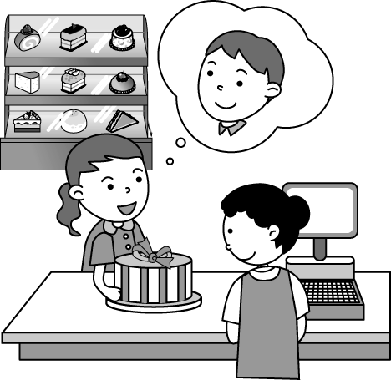 | (２)  
（ ） | （ ）
(３)  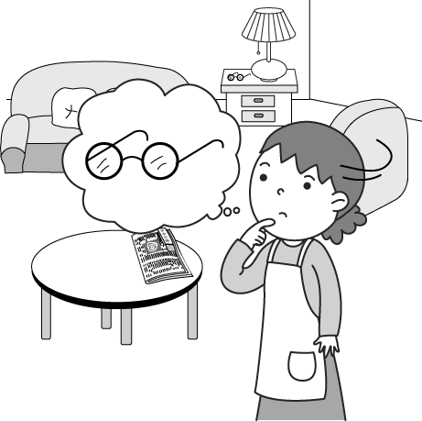 | (４)  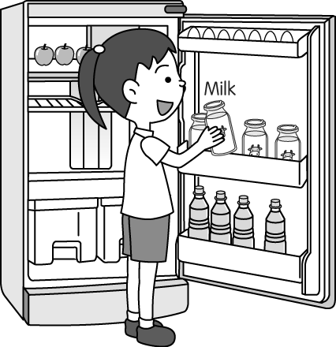
（ ） | （ ）
(５)
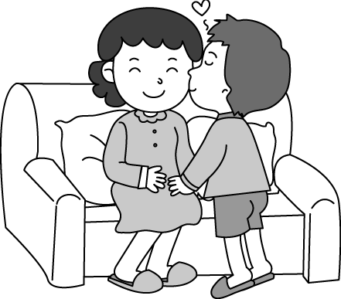
（ ）

(II)圈出與聽到的內容不同的地方。
(１) They lived in a small fishing town.
(２) A few foreigners went biking there.
(３) Mom drives a car to work every morning.
(４) Ryan went to the hospital by taxi.
(５) We went on a picnic last Sunday.

(III)根據對話內容，正確的寫 T，錯誤的寫 F。
（ ）(１) The woman’s house is near the bus station.
（ ）(２) They are going together.
（ ）(３) The bookstore is next to the bank, not across from it.
（ ）(４) The woman knows the way to Carol’s house.
（ ）(５) The museum is next to the MRT station.

II. Reading Comprehension 閱讀測驗 （48%）
(I) Vocabulary Test（10%）
（請根據題意選出最適當答案）
1. They are from different countries(國家), but they speak the same ____.
(A) foreigner (B) language (C) refrigerator (D) department
2. I ____ the trash every night.
(A) get off (B) take out (C) right away (D) look for
3. John ____ his grandparents and went fishing with them in Penghu.
(A) visited (B) invited (C) lost (D) sent
4. Where is the ____? I need to take the train.
(A) railway station (B) movie theater (C) bus station (D) police station
5. You can’t make a U- ____ here. Please keep going.
(A) turn (B) right (C) block (D) stop

(II) Grammar Test（10%）
（請根據題意選出最適當答案）
- Let’s ask the police ___ help us.
(A) for (B) to (C) x (D) with
- ___ do you go home from school? On my mom’s scooter.
(A) How (B) What (C) Where (D) When
- Be quiet! Stop ___ so much noise! The teacher is coming.
(A) make (B) to make (C) making (D) and make
4. Lily made her mom a beautiful card. Can you also make me ___ ?
(A) it (B) them (C) one (D) card
5. Many people go ___ in Hualien.
(A) watching whales (B) whales watching (C) to watch whale (D) whale watching

(III) Cloze（10%）（請根據文意選出最適當答案）
- Kate: Honey, are you 1. something?
John: Yes. I lost my ring.
Kate: 2. did you last see it?
John: I still wore it this morning before I went out.
Kate: Where did you go?
John: I 3. with our daughter at Sogo Department Store. Then we 4. dinner at McDonald’s. After that, we took a taxi 5. . But now I just can’t find it.
Kate: Maybe we should(應該) call the police.
1. (A) looking for (B) looking at (C) finding (D) finding out
2. (A) when (B) what (C) how (D) which
3. (A) had a picnic (B) went surfing (C) went shopping (D) went sailing
4. (A) were having (B) had (C) have (D) are having
5. (A) to home (B) back to home (C) home (D) went home

(IV) Reading Skills Test（18%）
（請根據文意選出最適當答案）
(i)
Bob worked in an office in a small town. One day his boss said to him,” Bob, I want you to go to Taipei, to an office there, to see Mr. Lin. Here’s the address.”
Bob took the train to Taipei. He left the station, and thought, “The office isn’t far from here. It’s easy to find it.” But an hour later, he was still looking for it, so he stopped and asked an old woman. She said,” Go down the street two blocks, turn left on the corner, and it’s the second building on the right.” Bob went and found it.
A few days later, he went to the same office, but again he couldn’t find it, so he asked someone the way. It was the same old woman! She was very surprised and said,” Are you still looking for that place?”

*office辦公室 / boss老闆 / address地址 / left離開 / far遠 / building建築物 / surprised驚訝
- What did Bob’s boss want him to do?
(A) To go to Taipei. (B) To buy a train ticket for him. (C) To work in the new office. (D) To visit an old woman.
- How did Bob go to Taipei?
(A) By train. (B) In his car. (C) He took a plane. (D) On a motorcycle.
- Who did Bob ask the way to the office?
(A) Mr. Lin. (B) His boss. (C) An old woman. . (D) No one.
- Where did Bob go a few days later?
(A) The station. (B) Mr. Lin’s office. (C) The small town. (D) The street corner.
- Which is NOT true?
(A) Bob asked the same old woman the way again. (B) Bob worked in an office in Taipei.
(C) The old woman was surprised to see Bob again. (D) Bob thought the office was near the station.

(ii)
Dear Tony,
Last weekend, I stayed at a wonderful hotel on the corner of Mountain Road and Fifth Street. It was in the mountains, but it was convenient because I got everything I needed from the convenience store in front of it.
In the morning, you can see the sunrise on the balcony. At noon, you can take a walk and see beautiful flowers and trees. Later in the afternoon, you can go to the hot spring beside the gift shop. Then, at night, have a great dinner in the Chinese food restaurant. It’s on Fourth Street, across from the hot spring.
Call me if you want the number of the hotel.
Jacky

convenient 便利的 / sunrise 日出 / beside 在…旁邊

 | Mountain Road | Convenience  Store | Forest Road
A | Mountain Road | Convenience  Store | Forest Road
 | Mountain Road | 5th Street | Forest Road
B | Mountain Road | Gift Shop | Forest Road
B | Mountain Road | C | Forest Road
 | Mountain Road | 4th Street | Forest Road
D | Mountain Road | E | Forest Road
- Where is the hotel?
(A) A (B) B (C) C (D) D
- Where is the hot spring?
(A) A (B) B (C) C (D) E
- Where is the restaurant?
(A) A (B) B (C) C (D) E
9. Which is true?
(A) Tony stayed at the hotel.
(B) You don’t need to get out of the hotel to see the sunrise.
(C) There is a wonderful fast food restaurant near the hotel.
(D) People can’t buy presents for their friends near the hotel.

III. Writing 寫作測驗 （22 %）

( I ) 依提示作答 (6%)
1. Gina and Rita swept the floor this morning. ( 加入at 7:30 )
2. Emma sent John a letter. ( 將畫線部分改為代名詞 )
3. Go straight for one block, and you can see the bank on the left. ( 造原問句 )

( II ) 連貫式翻譯 (16%)
- Carol的叔叔自己一人住在山上。
- 他時常騎腳踏車兜風。
- 昨天Carol全家人去找他玩。
- 大家都玩得很開心。(…enjoy…)

高雄縣立林園高中國中部九十八學年度第一學期第二次段考二年級英語科（B）
【答案卷】 Class No. Name
- Listening Comprehension 聽力測驗 （３０%）

(I) | 1. | 2. | 3. | 4. | 5.
(II) | 1. They lived in a small fishing town.
(II) | 2. A few foreigners went biking there.
(II) | 3. Mom drives a car to work every morning.
(II) | 4. Ryan went to the hospital by taxi.
(II) | 5. We went on a picnic last Sunday.
(III) | 1. | 2. | 3. | 4. | 5.
- Reading Comprehension 閱讀測驗 （54%）
(I) Vocabulary Test（10%）
1. | 2. | 3. | 4. | 5.
(II) Grammar Test（10%）
1. | 2. | 3. | 4. | 5.
(III) Cloze（10%）
1. | 2. | 3. | 4. | 5.
(IV) Reading Skills Test（18%）
1. | 2. | 3. | 4. | 5.
6. | 7. | 8. | 9.
III. Writing 寫作測驗 （22 %）
( I ) 依提示作答 (6%)
1
2.
3.
( II ) 連貫式翻譯 (16%)
1.
2.
3.
4.

高雄縣立林園高中國中部九十八學年度第一學期第二次段考二年級英語科（B）
【解答】(B)
- Listening Comprehension 聽力測驗 （３０%）
- XXOOX
- (１) They lived in a small fishing town.
(２) A few foreigners went biking there.
(３) Mom drives a car to work every morning.
(４) Ryan went to the hospital by taxi.
(５) We went on a picnic last Sunday.
- T F T F T
- Reading Comprehension 閱讀測驗 （54%）
(I) BBAAA
(II) BACCD
(III) AACBC
(IV) AACBB ACDB
III. Writing 寫作測驗 （22 %）
( I ) 依提示作答 (6%)
1. Gina and Rita was sweeping the floor at 7:30 this morning.
2. Emma sent it to John.
3. How do I get to the bank?
( II ) 連貫式翻譯 (16%)
- Carol’s uncle lives in the mountains by himself.
- He often goes biking.
- Carol’s family visited him yesterday.
- Everyone enjoyed themselves very much.

