高雄縣立林園高級中學 國中部 98學年度 第二學期 一 年級 英語 科 第一次段考考卷
範圍：第二冊Lesson One~ Review I 班級： 姓名： 座號：
第一部分: 聽力測驗
一、看圖選擇: 根據聽到的內容，選出正確的圖片代碼 (每題二分)
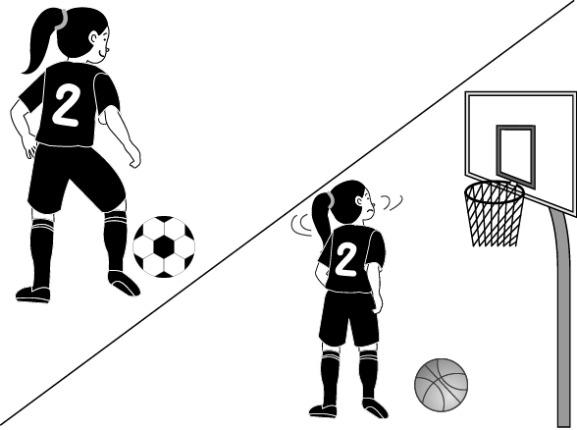
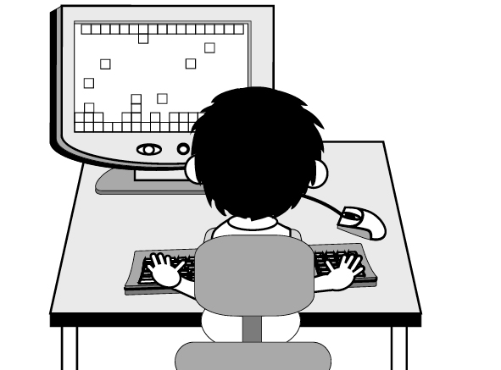
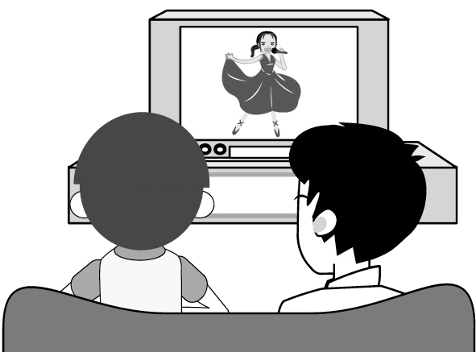
A. B. C.

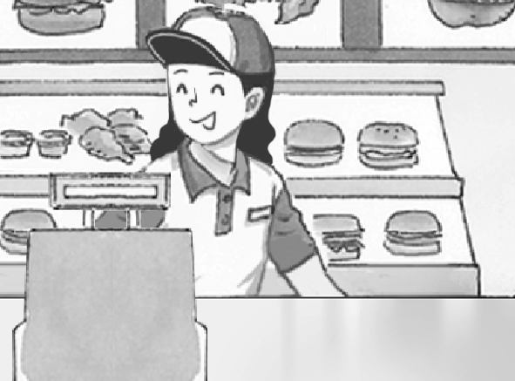
D. E.
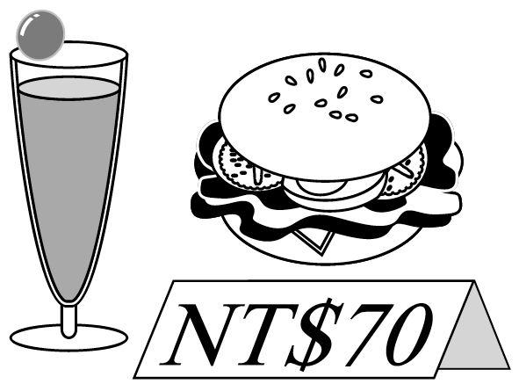

二、對話選擇: 根據聽到的內容，選出合適的回應 (每題二分)
1. (Ａ) Fried chicken, please. (Ｂ) Action movies. (Ｃ) Tea, please.
2. (Ａ) Cool! I can’t wait! (Ｂ) Sure. Just a minute. (Ｃ) She is good at it.
3. (Ａ) I like soccer. (Ｂ) I don’t like baseball. (Ｃ) I swim very well.
4. (Ａ) For here or to go? (Ｂ) No, that’s all. (Ｃ) May I help you?
5. (Ａ) They are NT$200. (Ｂ) A large coffee for here. (Ｃ) They are all cartoons.

三、簡短對話: 根據聽到的對話內容與問題，選出正確的答案 (每題二分)
1. (Ａ) At a bookstore. (Ｂ) At a fast food restaurant. (Ｃ) In the classroom.
2. (Ａ) Basketball. (Ｂ) Soccer. (Ｃ) Baseball.
3. (Ａ) They are talking on the phone. (Ｂ) They are singing a song. (Ｃ) They are watching TV.
4. (Ａ) Watch TV. (Ｂ) Play basketball. (Ｃ) Do his homework.
5. (Ａ) Coke. (Ｂ) Orange juice. (Ｃ) Water.

第二部分: 綜合測驗
一、文意字彙 (每題一分)
1. A: This is for you. B: Is it my birthday present? What a s se!
2. L n! The birds are singing in the trees.
3. A: Where is Billy? B: Maybe he is taking a sh r in the bathroom.
4. The boys like d t things, but they are good friends.
5. A: Don’t you want some water? B: No, thanks. I’m not th y.
6. The students are running on the p d.
7. I d k a cup of coffee every day.
8. I want a ham s ch and a milk tea, please.
9. A: Do you like the movie Rush Hour? B: Of course I do. It’s very f y.
10. My sister is a c k in a fast food restaurant.

二、填入正確的動詞或助動詞形式：每格不限一字 (每格一分)
1. Judy likes reading and ________________ (swim) in her free time.
2. Little Johnny can _______________ (read) English books now.
3. Lisa and Nina _______________ (do) their homework together every day.
4. Look! Every boy and girl ______________ (play) over there.
5. My brother ______________ (have) a new car now.
6. Alex, ______________ (open) your book.
7. I _______________ (watch) the movies on TV, but my sister does.
8. Tony (1) (want) a hamburger, and I (2) , too.
9. A: What does the boy like? B: He _______________ (like) apple pie.

三、文法與對話選擇 (每題二分)
1. There’s some ___________ on the table.
(A) fries (B) salad (C) grape (D) hamburger
2. I ___________ swim. What about you?
(A) likes (B) like to (C) want (D) wants to
3. A: Doesn’t your son ____________ cartoons on TV? B: Yes, he ___________.
(A) to watch; does (B) watching; doesn’t (C) watches; watches (D) watch; does
4. Joe can play ___________ basketball, and he can play ___________ piano, too.
(A) ×; × (B) the; × (C) ×; the (D) the; the
5. Rita’s sister is good at ___________ English songs.
(A) sing (B) sings (C) to sing (D) singing
6. A: ___________ your sister spell her name? B: No, she ____________.
(A) Can; can’t (B) Doesn’t; isn’t (C) Cannot; can’t (D) Is; isn’t
7. I like _____________, and I have ____________.
(A) soccer; a soccer (B) soccer; soccer (C) the soccer; a soccer (D) the soccer; soccer
8. ______________ all like the Rush Hour series.
(A) I and my sisters (B) My sisters and you (C) My parents and I (D) I and you
9. A: What’s the movie about? B: _____________
(A) I like it very much. (B) The movie is great. (C) It’s an action movie. (D) It’s about 2 p.m.
10. A: ______________ B: Yes, please. I want a fried chicken.
(A) What do you want? (B) May I help you? (C) Can I have some fast food? (D) How much is it?

四、克漏字選擇 (每題二分)
(On the phone)
Peter: Hello. 1. Peter. May I 2. to Harry?
Sally: 3.
Harry: Hi, Peter. 4.
Peter: Are you free today? Can you come over?
Harry: Sure. What can we do?
Peter: 5. playing computer games?
Harry: Cool! I can’t wait!

1. (A) I am (B) This is (C) You are (D) That is
2. (A) talk (B) wait (C) call (D) speak
3. (A) Speaking. (B) Hold on, please. (C) Who is this? (D) Sorry. You have the wrong number.
4. (A) He’s not here. (B) Just a minute. (C) What’s up? (D) What about you?
5. (A) Are you (B) Can we (C) Do you want (D) What about

五、閱讀測驗 (每題二分)
A.
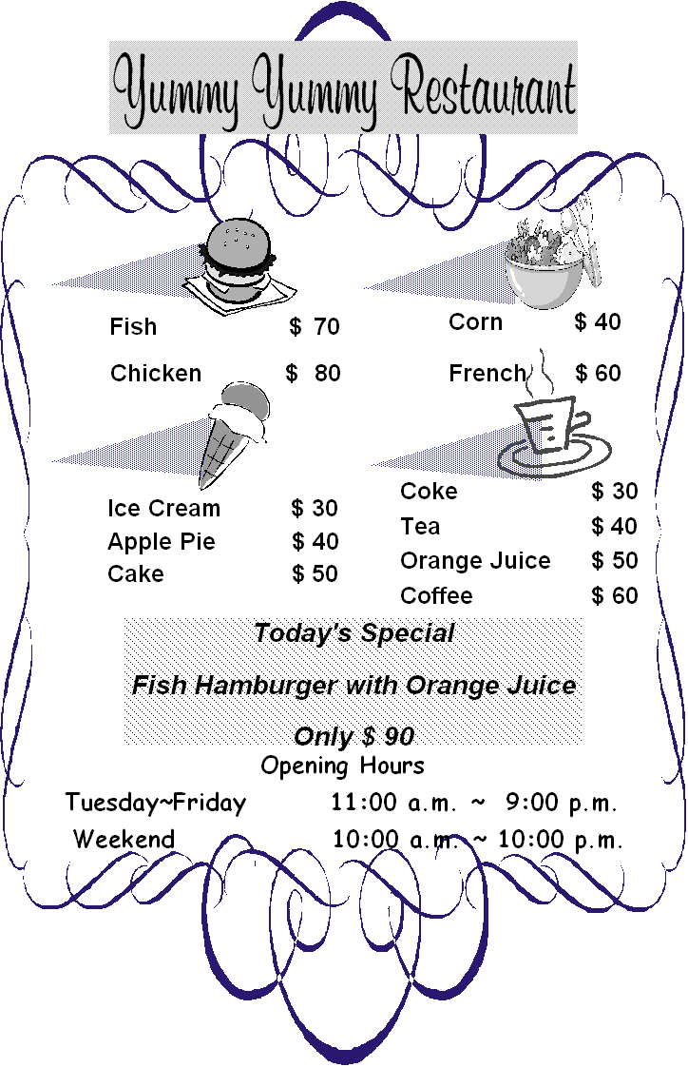 | 1. Mr. Wang has a chicken hamburger, a French salad, an ice cream and a coffee at the restaurant. How much are they?  (A) Two hundred dollars.  (B) Two hundred and twenty dollars.  (C) Two hundred and thirty dollars.  (D) Two hundred and fifty dollars.  2. Which is true（真的）?  (A) If (如果) you order (點) a fish hamburger, a corn salad and an orange juice, you have to pay (付費) $ 130.  (B) If you have $ 100, you can order a cake, an apple pie and a Coke.  (C) You can go to the restaurant for dinner every night.  (D) The restaurant is open for 10 hours (小時) on the weekend.
B.
Every year on the second Sunday of May, sons and daughters around the world come back home to celebrate Mother’s Day with their mothers. Some children buy presents for their mothers on this day and some celebrate it with big dinners at some really good restaurants. However, mothers do not expect any presents or big dinners from their children. They just hope their children can come home and visit them often. The really important thing on Mother’s Day is our love for mothers. Don’t just buy some presents or good food for your mother on the day. Spend more time with your mother.
3. According to（根據）the article（文章）, what do children usually do on Mother’s Day?
(Ａ) They give (給) some money to their mothers. (Ｂ) They take (帶) their mothers to some really good restaurants.
(Ｃ) They cook dinner for their mothers. (Ｄ) They go to the movies with their mothers.
4. What does“it”mean?
(Ａ) Mother. (Ｂ) Dinner. (Ｃ) Mother’s Day. (Ｄ) Children.
5. Which is true about the reading?
(Ａ) Mothers just want a family reunion（團聚）on Mother’s Day.
(Ｂ) Mothers should（應該）spend more time with their children.
(Ｃ) Mothers always want to eat in good restaurants.
(Ｄ) Mothers always like presents.

六、翻譯 (每題二分)
1. 他們現在正玩得很開心。
2. 你媽媽允許家中有不含酒精的清涼飲料嗎?
3. 他每個週末在學校打桌球。
4. 她擅長打籃球而且每次都投進很多球。
5. A: 要喝點什麼嗎？ B: 給我一杯奶昔。
高雄縣立林園高級中學 國中部 98學年度 第二學期 一年級 英語科 第一次段考 答案卷
範圍：第二冊Lesson One~ Review I 班級： 姓名： 座號：
第一部分: 聽力測驗
一、看圖選擇: 根據聽到的內容，選出正確的圖片代碼 (每題二分)
1. |  | 2. |  | 3. |  | 4. |  | 5.
二、對話選擇: 根據聽到的內容，選出合適的回應 (每題二分)
1. |  | 2. |  | 3. |  | 4. |  | 5.
三、簡短對話: 根據聽到的對話內容與問題，選出正確的答案 (每題二分)
1. |  | 2. |  | 3. |  | 4. |  | 5.

第二部分: 綜合測驗
一、文意字彙 (每題一分)
1. |  | 2. |  | 3. |  | 4. |  | 5.
6. |  | 7. |  | 8. |  | 9. |  | 10.

二、填入正確的動詞形式：每格不限一字 (每格一分)
1. |  | 2. |  | 3. |  | 4. |  | 5.
6. |  | 7. |  | 8.  (1) |  | 8.  (2) |  | 9.

三、文法與對話選擇 (每題二分)
1. |  | 2. |  | 3. |  | 4. |  | 5.
6. |  | 7. |  | 8. |  | 9. |  | 10.

四、克漏字選擇 (每題二分)
1. |  | 2. |  | 3. |  | 4. |  | 5.

五、閱讀測驗 (每題二分)
1. |  | 2. |  | 3. |  | 4. |  | 5.

六、翻譯 (每題二分)
1. _______________________________________________________________________________________
2. _______________________________________________________________________________________
3. _______________________________________________________________________________________
4. _______________________________________________________________________________________
5. _______________________________________________________________________________________
高雄縣立林園國中 98學年度第二學期 一年級第一次段考 英語科聽力稿
一、看圖選擇
1. My sister is a clerk at a fast food restaurant.
2. Jerry plays computer games every day.
3. Linda can play soccer very well, but she can’t play basketball.
4. A small grape juice and a hamburger are NT$70.
5. They are watching One Million Star together.

二、對話選擇
1. Anything to drink?
2. Hello. This is Nora. Can I speak to Lisa?
3. I like basketball. What about you?
4. Anything else?
5. You have so many DVDs. What are they about?

三、簡短對話
1. Girl: Good morning. May I help you?
Boy: Yes, please. I want a fish sandwich, and my sister wants a chicken hamburger.
Question: Where are the boy and his sister?
2. Girl: Mike is a great player. He makes many baskets.
Boy: Yes, he is. He plays it almost every day.
Question: What sport does Mike play almost every day?
3. Boy: Hello. This is Andy. May I speak to Lily?
Girl: Speaking.
Question: What are the boy and the girl doing?
4. Girl: What do you do every day?
Boy: Well, I play basketball in the morning, do my homework in the afternoon, and watch TV with my family in the evening.
Question: What does the boy do in the afternoon?
5. Boy: I’m thirsty. Can I have some Coke?
Girl: Sorry. My mom doesn’t like soft drinks, but there is some orange juice.
Boy: Well, I don’t like orange juice. Just water, please.
Question: What does the boy have?

高雄縣立林園高級中學 國中部 98學年度 第二學期 一年級 英語科 第一次段考 解答
範圍：第二冊Lesson One~ Review I
第一部分: 聽力測驗
一、看圖選擇: 根據聽到的內容，選出正確的圖片代碼 (每題二分)
1. | D | 2. | B | 3. | A | 4. | E | 5. | C
二、對話選擇: 根據聽到的內容，選出合適的回應 (每題二分)
1. | C | 2. | B | 3. | A | 4. | B | 5. | C
三、簡短對話: 根據聽到的對話內容與問題，選出正確的答案 (每題二分)
1. | B | 2. | A | 3. | A | 4. | C | 5. | C

第二部分: 綜合測驗
一、文意字彙 (每題一分)
1. | surprise | 2. | Listen | 3. | shower | 4. | different | 5. | thirsty
6. | playground | 7. | drink | 8. | sandwich | 9. | funny | 10. | clerk

二、填入正確的動詞形式：每格不限一字 (每格一分)
1. | swimming | 2. | read | 3. | do | 4. | is playing | 5. | has
6. | open | 7. | don’t watch | 8.  (1) | wants | 8.  (2) | do | 9. | likes

三、文法與對話選擇 (每題二分)
1. | B | 2. | B | 3. | D | 4. | C | 5. | D
6. | A | 7. | A | 8. | C | 9. | C | 10. | B

四、克漏字選擇 (每題二分)
1. | B | 2. | D | 3. | B | 4. | C | 5. | D

五、閱讀測驗 (每題二分)
1. | C | 2. | A | 3. | B | 4. | C | 5. | A

六、翻譯 (每題二分)
1. They are having a good time (now).
1% 1%
2. Does your mother allow soft drinks at home?
1% 1%
3. He plays table tennis at school every weekend / on weekends.
1% 1%
4. She is good at playing basketball and makes many baskets every time.
1% 1%
5. Anything to drink? A milk shake for me.
1% 1%

