高雄縣立林園高級中學 國中部 98學年度 第二學期 一 年級 英文 科 第二次段考考卷
範圍：Book 2 Lesson 4 ~ Review II 班級： 姓名： 座號：

【第一部分 聽力測驗 30％】
一、字彙選擇：選出句子中出現的單字（每題2分，共10分）
1. (Ａ) Internet (Ｂ) green (Ｃ) idea (Ｄ) ticket
2. (Ａ) garden (Ｂ) understand (Ｃ) once (Ｄ) theater
3. (Ａ) bunny (Ｂ) actress (Ｃ) rabbit (Ｄ) people
4. (Ａ) bookstore (Ｂ) supermarket (Ｃ) chocolate (Ｄ) altogether
5. (Ａ) Tuesday (Ｂ) Wednesday (Ｃ) Friday (Ｄ) Monday

二、看圖選擇：勾選出符合該圖片的句子代碼（每題2分，共10分）
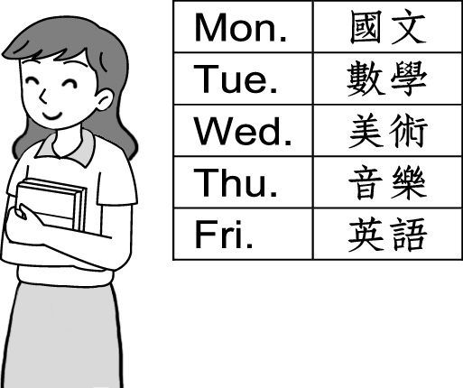
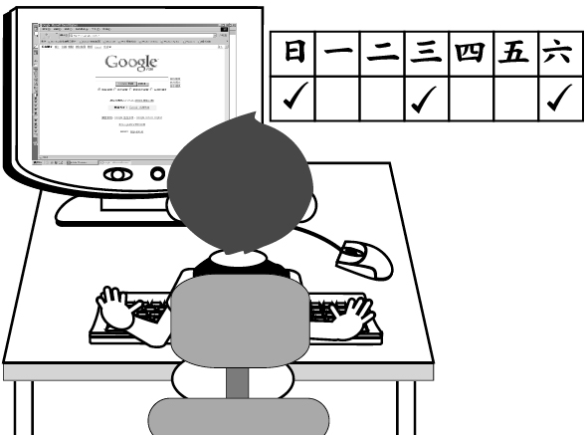
1. 2. 3.
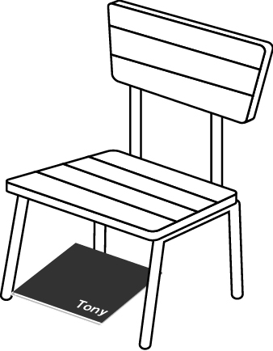

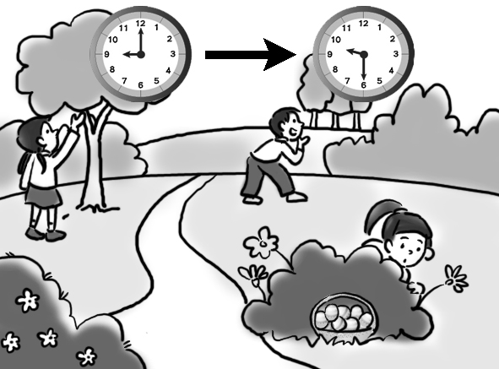
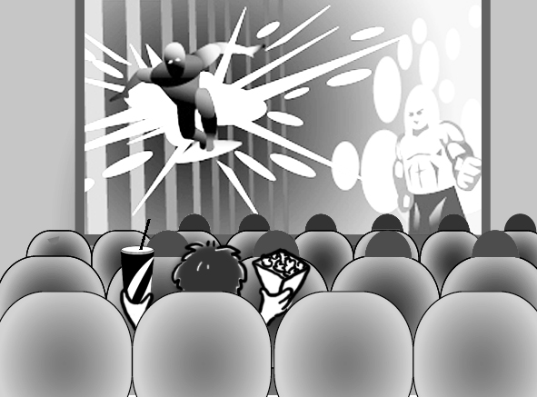
４. 5.

三、看圖回答：根據圖表內容，聽完問題後選出正確的答案（每題2分，共10分）
Mandy’s Evening Schedule for This Week
day  time | Mon. | Tues. | Wed. | Thur. | Fri. | Sat. | Sun.
17:00~  19:00 | music class | English class | art class | music class | English class | art class | watch TV
19:00~  20:00 | dinner at home | dinner with Alice | dinner at Joy’s | dinner at home | dinner at home | eat out with Dad & Mom
20:00~  22:30 | homework  & study | homework  & study | homework  & study | homework  & study | homework | watch a movie on TV | study for tests
22:30 | bedtime | bedtime | bedtime | bedtime | bedtime | bedtime | bedtime

( ) 1. (Ａ) Once a week. (Ｂ) Twice a week. (Ｃ) Three times a week.
( ) 2. (Ａ) Three times. (Ｂ) Four times. (Ｃ) Five times.
( ) 3. (Ａ) Tuesday. (Ｂ) Wednesday. (Ｃ) Thursday.
( ) 4. (Ａ) At 8 p.m. (Ｂ) At 10 p.m. (Ｃ) At 10:30 p.m.
( ) 5. (Ａ) Studying for tests. (Ｂ) Having dinner with Alice. (Ｃ) Watching a movie on TV.
請翻頁繼續做答！

【第二部份 綜合測驗 70％】
一、書寫體辨認：請將以下書寫體單字改為印刷體（大小寫須一致），每題全對才給分（每題1分，共5分）
1.bowling 2.Question 3.found 4.Single 5.YOUTUBE

二、文意字彙（每題1分，共7分）
1. My son likes Jolin very much. He c ts Jolin’s pictures and DVDs.
2. Sunday is the f t day of the week.
3. Don’t you know we have a different s e today?
4. To say is one thing; to do is a r.
5. Helen is so s e. She never talks to people.
6. Wow, the car is 5 million dollars. It’s e e.
7. Many students s f the Internet on holidays very often.

三、填充（第1~4題每格限填一字，每格1分，全對才給分，共5分）
1. It’s time the test. Students, please put away your books.
2. A: How English words can Ted spell? B: He can spell thirty English words.
3. You don’t have art class on Friday afternoon, and I don’t, .
4. They are almost ready the chess game.
5. There is no class this Friday. Students don’t (h) go to school.

四、文法與對話選擇（每題2分，共18分）
1. Mike to school on time. (A) go usually (B) goes usually (C) usually go (D) usually goes
2. A: Does Flora have to paint the room? B: Yes, she . (A) have to.(B) paints. (C) does. (D) is.
3. A: How juice do you need now? B: I don’t need .
(A) many; some (B)much; some (C) many; any (D) much; any
4. Susan always goes to school by bike, but I . (A) seldom go (B) usually go (C) seldom do (D) usually do
5. Tony and I need your help the art homework. (A) to (B) with (C) for (D) about
6. He buys food in the supermarket. (選錯的) (A) many (B) much (C) a lot of (D) some
7. A: B: No, that’s my number. (A) Can you call me this evening? (B) Is his number 0915-333888?
(C) What’s Robert’s phone number? (D) Do you have a cellphone?
8. A: Is next week OK you? B: No problem. (A) in (B) on (C) at (D) with
9. A: Do you usually play the guitar on weekdays? B: .
(A) Yes, I do usually. (B) Yes, I usually play. (C) No, I never don’t. (D) No, I never do.

五、克漏字（每題1分，共7分）

Wendy: It's Friday.

Linda: Yes. 1 you have math class tonight?
Wendy: No, I don't. What's up?
Linda: There is a concert in the theater. 2 you coming with me?
Wendy: Sure. Let's 3 to the concert together.
(During the concert)
Linda: Do you like the concert?
Wendy: Yes. It's great. The 4 are good.
Linda: You're right. And 5 do you go to a concert?
Wendy: Once a month. And you?
Linda: About twice a month. I'm not good 6 singing, but I like music.
Wendy: Really? 7 we can go to a concert together more often.
Linda: No problem.

1. (A) Are (B) Can (C) Do (D) Does
2. (A) Are (B) Is (C) Has (D) Have
3. (A) go (B) going (C) goes (D) went
4. (A) singers (B) nurses (C) doctors (D) bunnies
5. (A) how many (B) how old (C) how often (D) how about
6. (A) at (B) for (C) about (D) on
7. (A) Not yet (B) But (C) Then (D) Or

六、閱讀測驗（每題2分，共14分）

A.
Lots of people make friends on the Internet. Amy does, too. But she is careful about that. She uses a different name on the Internet. She doesn’t tell her Internet friends about her home. She doesn’t give them her home phone number, either. She gives a few Internet friends her cellphone number. Some people on the Internet are not nice. Amy knows that, too. She doesn’t talk to those people at all.
Amy gets together with a few Internet friends. She meets them at restaurants and coffee shops. Those places are OK. There are lots of other people around.

careful 小心的
a few 一些


1. What does Amy use to make friends?
(A) Fun toys. (B) Some music. (C) Her family. (D) A computer.
2. What does Amy change（改變） on the Internet?
(A) Her number. (B) Her home. (C) Her name. (D) Her friend.
3. What can a few of Amy’s Internet friends do?
(A) They can call her. (B) They can drive her home. (C) They can meet her parents. (D) They can visit her home.
4. What does Amy probably（可能）do with a few Internet friends? (A) Work. (B) Practice. (C) Eat. (D) Teach.
請翻頁繼續做答！

B.
CINEMARK Movie Theater
Date Night
Rated（分級）(R（限制級）) | Length（片長）: 1 hr. 40 mins
1:35 p.m., 6:40 p.m., 8:40 p.m.
Iron Man 2
Rated (PG-13（輔導級）) | Length: 1 hr. 58 mins
1:45 p.m., 4:00p.m., 6:15p.m., 8:30 p.m.
Toy Story 1&2 (3D)
Rated (G（普遍級）) | Length: 1 hr. 33 mins
2:05 p.m., 4:25 p.m., 6:55 p.m., 9:25 p.m.
Little Nicholas
Rated: (PG（保護級）) | Length: 2 hrs. 3 mins
9:00 a.m., 5:45 p.m., 8:10 p.m.

1. Lisa is in her third year of junior high school. Which movie CAN’T she see now?
(A) Date Night. (B) Iron Man 2. (C) Toy Story 1&2. (D) Little Nicholas.
2. It’s 7:00 p.m., and Cathy is seeing Iron Man 2. When will the movie be over（結束）?
(A) At about 11:00 p.m. (B) At about 10:00 p.m. (C) At about 8:20 p.m. (D) At about 9:20 p.m.
3. Romeo is going to have lunch with his girlfriend at 12:00 a.m. Which movie can he see before he meets her?
(A) Date Night. (B) Iron Man 2. (C) Toy Story 1&2. (D) Little Nicholas.

七、依提示作答（每題1分，全對才給分，共4分）

1. Doris has ten dollars in her pocket. (依畫線部分造原問句)
2. Today is Saturday. (依畫線部分造原問句)
3. A: Is he hungry after school? B: Yes, he is. (兩句皆加入「有時候」改寫)
4. Victor helps his mother cook every day. (加入have to)

八、翻譯（每題2~3分，共10分）

1. 一起到餐廳吃飯吧。我請客。(2分)
2. 我們必須快點。音樂會總是很準時演出。(2分)
3. A:你哥哥何時有空呢? B:他星期四有空。你可以回電給他。(3分)
4. 在Jill的生日派對上，總共有15個人。(3分)

高雄縣立林園高級中學 國中部 98學年度 第二學期 一 年級 英文 科 第二次段考答案卷
範圍：Book 2 Lesson 4 ~ Review II 班級： 姓名： 座號：
【第一部分 聽力測驗 30％】
一、字彙選擇：選出句子中出現的單字（每題2分，共10分）
1. |  | 2. |  | 3. |  | 4. |  | 5.

二、看圖選擇：勾選出符合該圖片的句子代碼（每題2分，共10分）
1. A( ) B( ) C( ) | 2. A( ) B( ) C( ) | 3. A( ) B( ) C( )
4. A( ) B( ) C( ) | 5. A( ) B( ) C( )

三、看圖回答：根據圖表內容，聽完問題後選出正確的答案（每題2分，共10分）
1. |  | 2. |  | 3. |  | 4. |  | 5.

【第二部份 綜合測驗 70％】
一、書寫體辨認：請將以下書寫體單字改為印刷體（大小寫須一致），每題全對才給分（每題1分，共5分）
1. |  | 2. |  | 3. |  | 4. |  | 5.

二、文意字彙（每題1分，共7分）
1. |  | 2. |  | 3. |  | 4. |  | 5.
6. |  | 7.

三、填充（第1~4題每格限填一字，每格1分，全對才給分，共5分）
1. |  | 2. |  | 3. |  | 4. |  | 5.

四、文法與對話選擇（每題2分，共18分）
1. |  | 2. |  | 3. |  | 4. |  | 5. |  | 6. |  | 7. |  | 8. |  | 9.

五、克漏字（每題1分，共7分）
1. |  | 2. |  | 3. |  | 4. |  | 5. |  | 6. |  | 7.

六、閱讀測驗（每題2分，共14分）
A.1. |  | 2. |  | 3. |  | 4. |  | B.1. |  | 2. |  | 3.
請翻頁繼續做答！
七、依提示作答（每題1分，全對才給分，共4分）

1. ____________________________________________________________ ___________________________

2. ____________________________________________________________ ___________________________

3. ____________________________________________________________ ___________________________

4. ____________________________________________________________ ___________________________

八、翻譯（每題2~3分，共10分）

1. ____________________________________________________________ ___________________________

2. ____________________________________________________________ ___________________________

3. ____________________________________________________________ ___________________________

____________________________________________________________ ___________________________

4. ____________________________________________________________ ___________________________

高雄縣立林園高級中學 國中部 98學年度 第二學期 一 年級 英文 科 第二次段考答案卷
範圍：Book 2 Lesson 4 ~ Review II 班級： 姓名： 座號：
【第一部分 聽力測驗 30％】
一、字彙選擇：選出句子中出現的單字（每題2分，共10分）
1. | C | 2. | D | 3. | C | 4. | A | 5. | B

二、看圖選擇：勾選出符合該圖片的句子代碼（每題2分，共10分）
1. A( ) B( ) C( ˇ ) | 2. A( ˇ ) B( ) C( ) | 3. A( ˇ ) B( ) C( )
4. A( ) B( ˇ ) C( ) | 5. A( ) B( ) C( ˇ )

三、看圖回答：根據圖表內容，聽完問題後選出正確的答案（每題2分，共10分）
1. | B | 2. | A | 3. | C | 4. | C | 5. | C

【第二部份 綜合測驗 70％】
一、書寫體辨認：請將以下書寫體單字改為印刷體（大小寫須一致），每題全對才給分（每題1分，共5分）
1. | bowling | 2. | Question | 3. | found | 4. | Single | 5. | YOUTUBE

二、文意字彙（每題1分，共7分）
1. | collects | 2. | first | 3. | schedule | 4. | another | 5. | strange
6. | expensive | 7. | surf

三、填充（第1~4題每格限填一字，每格1分，全對才給分，共5分）
1. | for | 2. | many | 3. | either | 4. | for | 5. | have to

四、文法與對話選擇（每題2分，共18分）
1. | D | 2. | C | 3. | D | 4. | C | 5. | B | 6. | A | 7. | B | 8. | D | 9. | D

五、克漏字（每題1分，共7分）
1. | C | 2. | A | 3. | A | 4. | A | 5. | C | 6. | A | 7. | C

六、閱讀測驗（每題2分，共14分）
A.1. | D | 2. | C | 3. | A | 4. | C | B.1. | A | 2. | C | 3. | D
請翻頁繼續做答！
七、依提示作答（每題1分，全對才給分，共4分）

1. What does Doris have in her pocket?
2. What day is today? （What day is it?）（What’s it today?）
3. A：Is he sometimes hungry after school？ B：Yes, he sometimes is.
4. Victor has to help his mother cook every day.

八、翻譯（每題2~3分，共10分）

1. Let’s eat in the restaurant. My treat.
（1分） （1分）
2. We have to hurry. Concerts always begin on time.
（1分） （1分）
3. A：When does your brother have (free) time？（When is your brother free？）
（1分）
B：He has (free) time on Thursday.（He is free on Thursday.） （1分）
You can call him back. （1分）
4. There are fifteen people altogether in（at）Jill’s birthday party.
（1分） （1分） （1分）

