高雄縣立林園高級中學 國中部 98學年度 第二學期 二年級 英文科 第一次段考考卷
範圍：L1~Review I 班級： 姓名： 座號：

Part A 聽力評量(共計30分/每格2分)
一、發音題：請寫出聽到單字的音節數。(共10分/每格2分)
Example: swim（1）
(１)（ ）
(２)（ ）
(３)（ ）
(４)（ ）
(５)（ ）

二、圖片題：勾選正確的圖片。(共10分/每格2分)
(１)
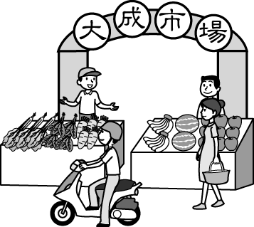 |  |  | 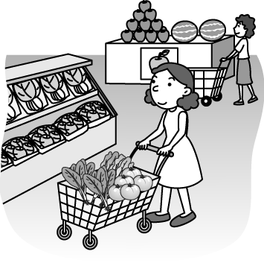
(２)
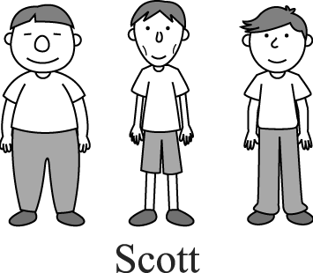 |  |  | 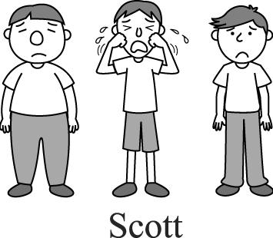

(３)
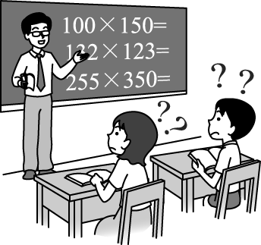 |  |  | 
(４)
 |  |  | 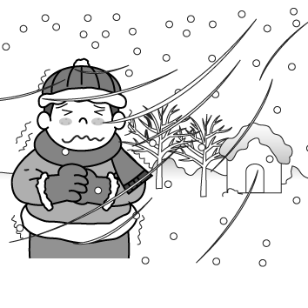
(５)
 |  |  | 

三、對話選擇題：請依對話內容選出最適當的答案(共10分/每格2分)
1. ( )
  - No. We want some computer games.
  - Can I see that CD player, please?
  - The MP3 player over there is NT$1,200.
- ( )
A: It’s NT$350. Which one do you want to buy?
B: Here’s your change, sir. It’s NT$650.
C: It’s NT$600. How would you like to pay, sir?
- ( )
A: Lisa went to the Christmas party.
B: Lisa had to stay at home on Christmas Day.
C: The Christmas party was fun for Lisa.
- ( )
A: The Bunny Game is an interesting activity.
B: Anna wants to join the Bunny Game.
C: Alex has to give away all the chocolate bunnies.
- ( )
A: Ben can join the Easter egg hunt with Linda tomorrow.
B: Ben will be on the playgound with his grandma tomorrow.
C: Ben has to visit his grandma tomorrow.

Part B 綜合題型
- 請寫出下列形容詞比較級與最高級 ( 請將答案寫在答案卷上 ) (每一格1分，共計10分)
形容詞原級 | 形容詞比較級 | 形容詞最高級
Example : big | bigger | biggest
1. happy
2. early
3. bad
4. good
5. wet
- 單字填空：請依提示之單字敘述填入最適當的答案。(每一格1分，共計10分)
_________ 1. Clerk : The total is NT$150. How would you like to pay?
Jason: In c______h.
_________ 2. Don’t play with k_______es, Joan. It’s very dangerous(危險的).
_________ 3. In Taiwan, the most c__________t way to see this beautiful island is taking the THSR.
_________ 4. I’m so cold. Could you turn off the f__________n for me?
_________ 5. Jack: Look,Vicky! There’s a cellphone on the ground.
Vicky : W________e cellphone is it?
_________ 6. Baseball is the most p__________r sport in Taiwan.
_________ 7. The story is the most i_____________g in this book.
_________ 8. Be c________l. Don’t drop the eggs. We’re going to paint them in beautiful colors on Easter.
_________ 9. Look! There are some kids r_________g eggs with spoons in the playground.
_________ 10. Wow, the baby is sleeping c_________ly in bed.

- 文法選擇：選一個最適當的答案。(每一格1分，共計15分)
( ) 1. My brother is hardworking at work. He is always as busy as a __________.
(A) pig (B)turtle (C)bear (D) bee
( ) 2. Michelle looks ________ in pants than in a dress.
(A) pretty (B)the prettiest (C)more prettier (D) prettier
( ) 3. Dick likes English. He thinks it is ________than math.
(A) more easier (B)much easier (C) most easier (D) the most easy
( ) 4. The new washing machine is ___________ of the three.
- the most biggest (B)more bigger (C) the biggest (D) much biggest
( ) 5. The new TVs are lighter than the old __________.
(A) one (B)ones (C) the one (D) it
( ) 6. Young boys really grow fast. Both my sons are already _________than I am.
- taller (B) tallest (C) more taller (D) the tallest
( ) 7. ___________ the book(it is).
- How a interesting (B) What the interesting (C) How interesting (D)what interesting
( ) 8. Why not ________ to go on the Internet? You’ll find lots of useful information(資訊).
- try (B)to try (C) trying (D) tried
( ) 9. The vegetables ______ Meg’s stand are the best of all.
- on (B)in (C) at (D) of
( ) 10. Donna didn’t show up (出現) at the party because she _________ do her homework.
(A)has to (B) had to (C) have to (D) will have to
( ) 11. All the food is delicious, but the beef noodles are ____________.
- most delicious (B) the most delicious (C) the delicious (D) more delicious
( ) 12. Rick: Do you know which movie is __________ of all in 2010? Linda: Yes, It’s the 3D movie “Avadar”
- good (B) the better (C) the good (D) the best
( ) 13. Rita: What are you going to do on this weekend? Betty: Well, I will go jogging with a friend of _______.
(A) my (B) mine (C) me (D) I
( ) 14. My Grandma can’t see __________ without wearing glasses.
(A) clear (B) clearly (C) carefully (D) careful
( ) 15. If students want to get higher scores(分數), they should study ____________.
(A) hardly (B) hard (C) fastly (D) lately

- 克漏字選擇：依內容選擇適當的答案。(每一格1分，共計5分)
- Chien-Ming Wang(王建民) , the most popular baseball player in Taiwan, moved ___(1)____ the U.S.A. last Christmas because he signed(簽署) a new contract(合約) there. ___(2)_______, he held a sale on the ____(3)___ of two streets near his house because he couldn’t bring too many things ___(4)_____ him to the U.S.A. He ____(5)____ most of his things. It was a successful sale.

( ) 1. (A) in (B) to (C) for (D) out
( ) 2. (A) By the way (B) After that (C) Before that (D) Two weeks ago
( ) 3. (A) way (B) corner (C) top (D) right
( ) 4. (A) for (B) in (C) to (D) with
( ) 5. (A) brought (B) bought (C) sold (D) threw

- 對話與完成句子：(每一格2分，共計10分)
( ) 1. Hobby: Can I use your cellphone?
Annie: Sure. ____________.
(A) Let’s go. (B) Be careful not to break it. (C) How wonderful! (D) Go ahead.
( ) 2. May: _____________________ .
James: It was successful.

    - What can I do for you ?
    - Why did James have a yard sale?
    - How’s everything? Are you all right?
    - How was the yard sale?

( ) 3. Clerk: Good morning, sir. ______________________?
Allan: Can we take a look at those two CD players?
Clerk: Sure!

- The total is NT$1500.
- How would you like to pay?
- How may I help you?
- What about the price?

( ) 4. Rita: Did you buy these fresh fruit at the supermarket?
Emily: No, I bought them at traditonal (傳統的) market. You can go with me next time.
Rita: Thanks ! __________________________________.

- That would be nice.
- That’s too bad.
- Don’t listen to him.
- You are welcome.

( ) 5. Duncan: Miya, do you want to join the egg toss with me this weekend?
Miya: _________________! I’m in!

- What time do I have to get up?
- How interesting!
- What’s the matter?
- Let me try again.

- 閱讀測驗(每一格2分，共計8分)


1.

（ ）(１) Who may need the service of Last Moment most?
(A) John. He wants to buy a gift for his wife on the Internet. (B) Ian. He plans to buy a new house in the future.
(C) Amy. She enjoys going shopping in department stores. (Ｄ) Elsa. She is looking for a computer store near her house. service 服務
（ ）(２) Allen enjoys the service of Last Moment. Which may be the main reason?
(Ａ) It is old and famous. (B) He will have a chance to meet new friends.
(C) He will get a surprise package on his birthday. (D) It is fast and convenient. main reason 主要原因
2.
Mrs. Jones was an eighty-year-old woman. She liked driving and she had a small car. She always drove her small car to go shopping. She drove her car slowly and carefully and she never hit anything.
Last Sunday, she stopped her car at a traffic light, and then the car did not start again. The light turned green, then yellow, then red, then green again, her car did not move.
“What am I going to do now?” said Mrs. Jones. Then a policeman came to her and said kindly, “Good afternoon. Don’t you like any of our colors today?”
（ ）(１) Which is true?
(Ａ) Mrs. Jones stopped her car because there was an accident.(B) There was something wrong with the traffic lights.(C) There was something wrong with Mrs. Jones’ car. (Ｄ) A policeman came to Mrs. Jones because she drove too fast.
（ ）(２) Why did a policeman come to Mrs. Jones?
(A) Mrs. Jones’ car didn’t move when the green light was on. (B) Mrs. Jones got lost and needed the policeman’s help. (C) Mrs. Jones’ car hit the policeman. (D) The policeman wanted to know Mrs. Jones’ favorite color.
- 長句式翻譯。(每一題4分，共計12分)
- 這些腳踏車太貴了! 你有便宜點的嗎?

___________________________________________________________________________________________.
- 這個市場的小販賣的草莓最大又最便宜!

___________________________________________________________________________________________.
- 這些學生們正小心的滾著蛋。

___________________________________________________________________________________________.
.
高雄縣立林園高級中學 國中部98學年度 第二學期 二年級 英文科 第一次段考考卷
範圍： Unit1 ~ Review I 班級： 姓名： 座號：

Part I 聽力測驗
一、 發音題：請寫出聽到單字的音節數。(共10分/每格2分)
(1) | (2) | (3) | (4) | (5)

二、 勾選正確圖片(共10分/每格2分)
題號 | 左 | 右
1.
2.
3.
4.
5.

三、對話選擇(共10分/每格2分)

1 | 2 | 3 | 4 | 5

Part II 綜合題型
一、 請寫出下列形容詞比較級與最高級(每一格1分，共計10分)
形容詞原級 | 形容詞比較級 | 形容詞最高級
1. happy
2. early
3. bad
4. good
5. wet
二、單字填空：請依提示填入最適當的答案。(每一格1分，共計10分)
1 | 2 | 3 | 4 | 5 | 6 | 7 | 8 | 9 | 10
三、文法選擇：選一個最適當的答案。(每一格1分，共計15分)
6 | 7 | 8 | 9 | 10
11 | 12 | 13 | 14 | 15
1 | 2 | 3 | 4 | 5

四、克漏字選擇(每一格1分，共計5分)
1 | 2 | 3 | 4 | 5

五、對話與完成句子(每一格2分，共計10分)
1 | 2 | 3 | 4 | 5

六、閱讀測驗 (每一格2分，共計8分)
1 | 2 | 3 | 4

七、長句式翻譯 (每一題4分，共計12分)

1._______

2.

3.
高雄縣立林園高級中學 國中部98學年度 第二學期 二年級 英文科 第一次段考考卷
範圍： Unit1 ~ Review I 班級： 姓名： 座號：

Part I 聽力測驗
一、 發音題：請寫出聽到單字的音節數。(共10分/每格2分)
(1) | (2) | (3) | (4) | (5)
3 | 2 | 2 | 1 | 5

二、 勾選正確圖片(共10分/每格2分)
題號 | 左 | 右
1. |  | V
2. |  | V
3. |  | V
4. | V
5. |  | V

三、對話選擇(共10分/每格2分)

1 | 2 | 3 | 4 | 5
B | C | B | A | C

Part II 綜合題型
一、 請寫出下列形容詞比較級與最高級(每一格1分，共計10分)
形容詞原級 | 形容詞比較級 | 形容詞最高級
1. happy | happier | happiest
2. early | earlier | earliest
3. bad | worse | worst
4. good | better | best
5. wet | wetter | wettest
二、單字填空：請依提示填入最適當的答案。(每一格1分，共計10分)
1 | 2 | 3 | 4 | 5 | 6 | 7 | 8 | 9 | 10
cash | knives | convenient | fan | Whose | popular | interesting | careful | rolling | comfortably
三、文法選擇：選一個最適當的答案。(每一格1分，共計15分)
6 | 7 | 8 | 9 | 10
A | C | A | C | B
11 | 12 | 13 | 14 | 15
B | D | B | B | B
1 | 2 | 3 | 4 | 5
D | D | B | C | A,B

四、克漏字選擇(每一格1分，共計5分)
1 | 2 | 3 | 4 | 5
B | C | B | D | C

五、對話與完成句子(每一格2分，共計10分)
1 | 2 | 3 | 4 | 5
B,D | D | C | A | B

六、閱讀測驗 (每一格2分，共計8分)
1 | 2 | 3 | 4
A | D | C | A

七、長句式翻譯 (每一題4分，共計12分)

1._(These bicycles)( are too expensive.) ( Do you have)( cheaper ones?)

2. (The/This vendor)( sells the biggest) (and the cheapest strawberry)( in this market.)

3. (These students)( are rolling)( the eggs )(carefully.)

聽力測驗解析
一、發音題型(共10分/每格2分)
1.寫出聽到單字的音節數。
Example: swim（1）

(１)（3 ）
(２)（2 ）
(３)（2 ）
(４)（1 ）
(５)（5 ）
答案：(１) 3；(２) 2；(３) 2；(４) 1；(５) 5

音軌：請參考 Unit 1 Track 3
錄音稿：(１) ex．pen．sive；(２) ba．by；(３) spe．cial；(４) knife；(５) re．fri．ge．ra．tor
能力指標：1-2-1
難易度：中
編號：278503

二、圖片題型(共10分/每格2分)
1.勾選正確的圖片。
(１)
V
(２)
V
(３)
V
(４)
V
(５)
V
答案：(１)右圖；(２)右圖；(３)右圖；(４)左圖；(５)右圖

音軌：請參考 Unit 2 Track 40
錄音稿：(１) Grandma buys fruit and vegetables at the supermarket.
(２) Scott is the saddest boy of the three.
(３) The students had the funniest lesson today.
(４) The hottest season is also the boy’s favorite season.
(５) The camera is hers.
能力指標：3-2-8
難易度：中
編號：278540

- Q: (Good morning, miss. How may I help you?)
  - No. We want some computer games.
  - Can I see that CD player, please?
  - The MP3 player over there is NT$1,200.
- Q: (What’s the total for all the batteries?)
A: It’s NT$350. Which one do you want to buy?
B: Here’s your change, sir. It’s NT$650.
C: It’s NT$600. How would you like to pay, sir?
- Q: Jacob: Did you go to the party on Christmas Day, Lisa?
Lisa: No, I didn’t. I had a fever, so I couldn’t go anywhere.
Jocob: That’s too bad!
A: Lisa went to the Christmas party.
B: Lisa had to stay at home on Christmas Day.
C: The Christmas party was fun for Lisa.
- Q: Alex: Anna, what’s “ the Bunny game”?
Anna: It’s an interesting activity. People hide some chocolate bunnies, and you have to find them.
Alex: Cool! Can I join it?
Anna: Sure, Alex. Go ahead.
A: The Bunny Game is an interesting activity.
B: Anna wants to join the Bunny Game.
C: Alex has to give away all the chocolate bunnies.
- Q: Linda: Ben, let’s look for Easter eggs on the playground tomorrow.
Ben: Sorry, Linda, I can’t go with you. I have to go to my grandma’s home tomorrow.
A: Ben can join the Easter egg hunt with Linda tomorrow.
B: Ben will be on the playgound with his grandma tomorrow.
C: Ben has to visit his grandma tomorrow.

