高雄縣立林園高級中學 國中部 98學年度 第二學期 二 年級 英語 科 第二次段考考卷
範圍： Unit4—Review2 班級： 姓名： 座號：

Part A 聽力評量(每題2分，共30分)
ㄧ、在圖片下方寫出聽到的題號。

二. 若聽到的對話內容與敘述相符寫 T；不符寫 F。
（ ）(１) The woman has the boy do his homework.
（ ）(２) The man makes the woman turn on the light for him.
（ ）(３) The woman helps the man f ix his CD player.
（ ）(４) The girl lets the boy play the video game.
（ ）(５) The boy and the girl are on the bus.

三.若敘述與圖片相符寫 T，不符寫 F。
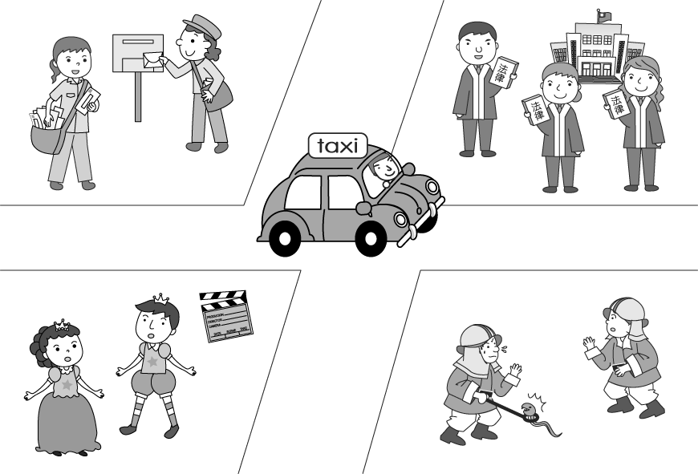
(１)（ ）
(２)（ ）
(３)（ ）
(４)（ ）
(５)（ ）

Part B 紙筆測驗
一、文意字彙 (每題1分，共10分)
1. Teddy put pears, peaches, lemons, guavas, and papayas in the milk, and it tasted t e.
2. A: What’s that on the packaging? B: It’s a recycling s l s lls l.
3. Yesterday’s birthday was my happiest m t.
4. There are six c es on the cake. Michael is six years old.
5. My mom doesn’t like Jay. I don’t like him, e r.
6. Miss Lin is a s y in the company. She helps her boss a lot.
7. Going to bed early and getting up early are good for our h h h hhh h.
8. My sister will g e from junior high school next year.
9.__________ The reporter i wed the famous actor. They talked a lot.
10._________ A f r can put out fires and save many people.

二、文法選擇 (每題2分，共30分)
( ) 1. A: did Tina feel? B: She felt .
(Ａ) How, sadly (Ｂ) What, sad (Ｃ) How, lonely (Ｄ) What, friendly
( ) 2. I am so tired. Let’s stop and take a break.
(Ａ) work (Ｂ) worked (Ｃ) working (Ｄ) to work
( ) 3. Here .
(Ａ) your books are (Ｂ) are your books (Ｃ) is it (Ｄ) the bus comes
( ) 4. John’s math is better than ______.
(Ａ) I (Ｂ) me (Ｃ) mine (Ｄ) my
( ) 5. Ken felt because he did in the show.
(Ａ) sad, bad (Ｂ) sadly, badly (Ｃ) sad, badly (Ｄ) sadly, well
( ) 6. Helen had Tom the door.
(Ａ) to open (Ｂ) opening (Ｃ) open (Ｄ) opened
( ) 7. Steve his son to wash the car.
(Ａ) asked (Ｂ) made (Ｃ)had (Ｄ)let
( ) 8. It was very hot last night. The girl __.
(Ａ) turned the fan on (Ｂ) turned on it (Ｃ) turned off the fan (Ｄ) turned the fan off
( ) 9. of the students is sick.
(Ａ) Some (Ｂ) Many (Ｃ) One (Ｄ) Most
( )10. All of the books on the table cheap.
(Ａ) are (Ｂ) is (Ｃ) am (Ｄ) be
( )11. Some of my friends to go swimming.
(Ａ) want (Ｂ) enjoy (Ｃ) wants (Ｄ) enjoys
( )12. Mrs. Wang has two sons. of them go to junior high school.
(Ａ) One (Ｂ) Both (Ｃ) Some (Ｄ) Many
( )13.A: Must you go back home right after school today?
B: No, I _______.
(Ａ) must (Ｂ) mustn’t (Ｃ) have to (Ｄ) don’t have to
( )14. Selina looked _____ at the zoo. And her father looked _____ at her. They had a good time today.
( A )happy, happy ( B )happily, happily ( C )happy, happily ( D )happily, happy
( )15. There ____ a lot of people _____ the THSR now.
( A )is, by ( B )are, taking ( C )was , take ( D )were, by

三、閱讀測驗 (每題2分，共18分)

Mr. Wang lived in Taipei, but he worked in Keelung. He usually went to work by bus, but sometimes he went by train or by taxi. It rained a lot in Keelung, and Mr. Wang usually took an umbrella with him to work, but he often lost umbrellas. He lost them in buses, in trains, and in the stores. His wife was angry about this, and three of his children laughed at him, too.
One morning Mrs. Wang said to him, “Umbrellas are expensive, and don’t lose this one. Bring it home tonight!” In the evening, Mr. Wang saw an umbrella in his bus. He took the umbrella, got off the bus and brought it home. “Honey, I’m home with my umbrella.” “But you forgot to take an umbrella with you this morning,” said his wife. “That one isn’t yours.”
( ) ( 1 ) How many children may Mr. Wang have?
(A)One. (B)Two. (C)Three. (D)Four.
（ ）(2) What was Mrs. Wang angry about?
(Ａ)Mr. Wang went to work by bus. (Ｂ)Umbrellas are expensive. (Ｃ) Her husband often lost umbrellas. (Ｄ) It rained a lot in Keelung.
（ ）(3) Which is not true?
(Ａ) Mr. Wang didn’t go to work by MRT. (Ｂ) Mr. Wang often forgot to bring his umbrella home so his wife was angry about it. (Ｃ) Mr. Wang took his umbrella home this time. (Ｄ) Mr. Wang lived in one city and worked in the other.

Helen is a junior high school student. One day when she was walking through the park on her way home from school, she found a very young dog . It was very cute. She played with the dog for a moment and decided to take it home. In the beginning, Helen was very happy to have a new friend. But she found it was a difficult job to take care of a dog.
Many people like to keep pets like cats and dogs. But like Helen, most people don’t know that keeping pets takes a lot of work to do. Pets need food and water. Sometimes they feel sick. Maybe they are noisy. And there is always excreta here and there.
It is not easy to keep a pet. A good pet keeper must have a passion for pets. He must be patient with pets. Pets can feel lonely. If we don’t take good care of them, they won’t be happy and they won’t live. After all, pets need not only food and water but love.
（ ）( 4 )Is Hellen a good keeper?
(Ａ)Yes, she was happy to have a new friend. (Ｂ)Yes,she decided to take the dog home. (Ｃ)Yes,the dog is very cute. (Ｄ)No, she felt it was difficult job to take care of a dog.
（ ）( 5 )A good pet keeper should ________.
(A)buy a lot of food for his pets (Ｂ)be a junior high school student (Ｃ)be patient with pets (Ｄ)be very rich
（ ）( 6 ) ”Passion” may mean _______.
(Ａ)love (Ｂ)spoon (Ｃ)neighbor (Ｄ)cash

Allen is tired of being a junior high school student. Every morning ,he has to get up early, or he will be late for school. After school, his mother asks him to go to cram school. He goes back home very late every day. After taking a bath, he does his homework for several hours. Every time he goes to bed, it’s always over twelve o’clock. He really has little time for fun.
Selina is different from Allen. She doesn’t have to get up early in the morning. There is an MRT station near her home. She listens to teachers carefully in class. She never goes to a cram school after school. She does her homework carefully but quickly. She does well on all the tests. She has a lot of free time to go to the movies, play basketball, and go shopping .
Are you like Allen or Selina?
（ ）( 7 ) Allen’s mother asks him to ______ after school.
(A)go shopping (B)play basketball (C)go to a cram school (D)go to the movies
（ ）( 8 ) Why is Selina never late for school?
(A)She runs to school every morning. (B)She goes to bed early every morning. (C)She takes the MRT to school every morning. (D)She gets up early every morning.
（ ）( 9 ) Selina doesn’t _______ after school.
- go shopping (B)go to a cram school (C)go to the movies (D)play basketball

四、翻譯 (每題4分，共12分)
1.那裡的空氣越來越糟。
2.快ㄧ點。妳上班要遲到了。
3.為了選擇正確的職業，你應該先了解自己。
_______________________________________________________________________________________________________________________
高雄縣立林園高級中學國中部98學年度 第二學期 二年級英語科 第二次段考作答卷
班級： 姓名： 座號：
Part A 聽力評量(每題2分，共30分)
ㄧ、在圖片下方寫出聽到的題號。

( A )  _______ | ( B )  ________ | ( C )  ________ | ( D )  ________ | ( E )  ________

二. 若聽到的對話內容與敘述相符寫 T；不符寫 F。
1.( ) | 2. ( ) | 3. ( ) | 4. ( ) | 5. ( )

三. 若敘述與圖片相符寫 T，不符寫 F。
1. ( ) | 2. ( ) | 3. ( ) | 4. ( ) | 5. ( )

Part B 紙筆測驗
一、文意字彙(每題1分，共10分)
1 | 2 | 3 | 4 | 5
6 | 7 | 8 | 9 | 10
二、文法選擇(每題2分，共30分)
1 | 2 | 3 | 4 | 5
6 | 7 | 8 | 9 | 10
11 | 12 | 13 | 14 | 15

三、閱讀測驗(每題2分，共18分)
1 | 2 | 3 | 4 | 5
6 | 7 | 8 | 9

四、翻譯(每題4分，共12分)
1.
____________________________________________________________

2.
____________________________________________________________

3.
____________________________________________________________
高雄縣立林園高級中學國中部98學年度 第二學期 二年級英語科 第二次段考作答卷
班級： 姓名： 座號：

Part A 聽力評量(每題2分，共30分)
ㄧ、在圖片下方寫出聽到的題號。

( A )  4 | ( B )  2 | ( C )  1 | ( D )  5 | ( E )  3

二. 若聽到的對話內容與敘述相符寫 T；不符寫 F。
1.( T ) | 2. ( F ) | 3. ( T ) | 4. ( F ) | 5. ( T )

三. 若敘述與圖片相符寫 T，不符寫 F。
1. ( T ) | 2. ( T ) | 3. ( F ) | 4. ( T ) | 5. ( F )

Part B 紙筆測驗
一、文意字彙(每題1分，共10分)
1 terrible | 2 symbol | 3 moment | 4 candles | 5 either
6 secretary | 7 health | 8 graduate | 9 interview | 10 firefighter
二、文法選擇(每題2分，共30分)
1 C | 2 C | 3 B | 4 C | 5 C
6 C | 7 A | 8 A | 9 C | 10 A
11 A | 12 B | 13 D | 14 C | 15 B

三、閱讀測驗(每題2分，共18分)
1 D | 2 C | 3 C | 4 D | 5 C
6 A | 7 C | 8 C | 9 B

四、翻譯(每題4分，共12分)
1.The air over there is getting(becoming) worse (and worse).
1 1 1 1
2.Hurry up! You are going to(will) be late for work.
1 1 1 1
3.To choose the right career, you should understand yourself first.
1 1 1 1

