林園高中國中部九十八學年度第二學期 三年級第二次段考 英語科試卷 ___年 ___班 座號：___ 姓名：__________
範圍：一至六冊
一、字彙選擇：根據題意選出正確或最適當之答案，每題二分。
1. Look at the picture. What is Jay doing? He is . (Ａ) singing (Ｂ)playing in the water (Ｃ) feeding fish (Ｄ) taking a picture
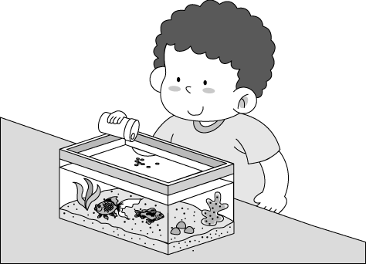

2. Ben: Is that Mr. and Mrs. Lee’s car? Meg: Yes, it’s car. (Ａ) his (Ｂ) her (Ｃ) our (Ｄ) their
3. These grapes are three hundred dollars for a . (Ａ) pound (Ｂ) foot (Ｃ) kilometer (Ｄ) bottle
4. There has been no rain for a long time, so the is very dry. (Ａ) hair (Ｂ) land (lＣ) album (Ｄ) plate
5. There used to _______a fruit farm near my school, but there are many stores now. (Ａ)have (Ｂ)having (Ｃ)be (Ｄ)being
6. I write down everything about work in my pink notebook; it, I’d forget the things I should do.
(Ａ)after (Ｂ) without (Ｃ) outside (Ｄ)before
7. David is ______ than all the other boys in his class. (Ａ)taller (Ｂ)tall (Ｃ)tallest (Ｄ) as tall as
8. Mike the doorbell, but no one answered. (Ａ)opened (Ｂ) called (Ｃ) took (Ｄ)rang
9. Lots of old people are killed in traffic every year. (Ａ)accidents (Ｂ)activities (Ｃ)business (Ｄ)lights
10. A terrible earthquake Haiti (海地) several months ago, and more than ten thousand people were killed.
(Ａ)happened (Ｂ) hit (Ｃ) sent (Ｄ) checked
11. It is dangerous to ride your motorcycle on the . You might hit someone. (Ａ)land (Ｂ)sidewalk (Ｃ) Frisbee (Ｄ)water
12. There is little on the menu, and I do not know what to eat. (Ａ)dish (Ｂ)chancee (Ｃ) choose (Ｄ) choice
13. the department store is the supermarket. (Ａ)Enter (Ｂ) In front (Ｃ) In back (Ｄ) Below
14. You should think before taking the job; don’t do it just for fun. (Ａ) happily (Ｂ) seriously (Ｃ) quickly (Ｄ)heavily
15. Joining clubs may help you learn something in a(n) way. (Ａ)interesting (Ｂ)tiring (Ｃ)interested (Ｄ)excited
16. Lucas has been in the hospital ______ he was five years old. I am sorry for him. (Ａ)when (Ｂ)since (Ｃ)after (Ｄ)if
17. Ms. Brown is at telling stories, so all of her students enjoy story time in her class very much.
(Ａ)excellent (Ｂ) fast (Ｃ) lucky (Ｄ) ready
18. it was raining, we kept playing basketball and did not call off（取消）the game.
(Ａ) Because (Ｂ) Although (Ｃ) If (Ｄ) When
19.The boy, who broke up with his girlfriend yesterday, _____ in his room right now. (Ａ)cried (Ｂ)cry (Ｃ)was crying (Ｄ)is crying
20.Lily had to finish doing her homework by Friday, and _____ I. (A)too (B)so do (C)so am (D)so did

二、克漏字測驗：根據題意選出正確或最適當之答案，每題二分。
A.
21.(A)plan (B)cake (C)a card (D) tea
22.(A)Solve (B)Look at (C)Make (D)Ask
23.(A)did (B)can (C)say (D)talk
24.(A)bad books (B)stories (C)habits (D)lies
25.(A)take (B)bring (C)make (D)draw
They keep telling me;
Make the correct 21 ;
Think the correct way;
22 the right question;
Follow the right way.

Are things as simple as black or white?
Can we really find in life any clear line?
I’m not happy with what they 23 ;
I believe there is another way.

Listen to me!
Listen to me!
Can I have my own voice?
Can’t I tell my own 24 ?

I’ll know what I feel.
I’ll say what I think.
I’ll start my own trip.
Then I’ll 25 my own history.

By Harley M.
B.
26. (Ａ) hot (Ｂ) cold (Ｃ) sun (Ｄ) rain
27.(Ａ) What’s (Ｂ) What (Ｃ) How’s (Ｄ) How
28. (Ａ) shopper (Ｂ) shops (Ｃ) shop (Ｄ) shopping
29. (Ａ) after eating (Ｂ) after eat (Ｃ) after I eating (Ｄ) after to eat
30. (Ａ) David (Ｂ) Lin (Ｃ)Jolin (Ｄ) Hotmail

三、閱讀測驗：根據題意選出正確或最適當之答案，每題二分。
A
There are some popular singers these days. Many of their fans enjoy getting together to share their love for the stars. My younger sister, Judy, is one of these fans.
Judy is crazy for Rich Smith. She has been in one of his fan clubs since last year. Judy did not have any close(親近的） friends before, and she always felt lost and lonely. But she has made many friends with the same interests since she joined the club. Now Judy and her friends are planning a big party for Rich’s birthday. Judy is happy, but my dad is not. In fact, he is very worried. Rich Smith is a total(完全的）stranger to him, and he cannot understand why a man who sings crazy songs can be so important to his daughter. He really hopes that Judy can love her family as much as she loves Rich Smith.
31. Who is Rich Smith? (Ａ) A doctor. (Ｂ) A singer. (Ｃ)Judy’s father. (Ｄ)A fan of a movie star.
32. Which is true about Judy? (Ａ) She is proud of her beautiful voice. (Ｂ) She always wants to be a movie star.
(Ｃ) She has changed a lot since she joined a fan club. (Ｄ) She is going to have a party on her birthday
33.Why is Judy’s father NOT happy? (Ａ)Judy does not do well on the test. (Ｂ)Judy does not have any friends at school.
(Ｃ)Judy is spending too much time on a stranger. (Ｄ)Judy is crazy about playing computer games.

B.
Read the poster and answer the questions.
Stay at May Flower
Comfortable rooms / beautiful garden
TV, refrigerator and Internet in every room
parking, breakfast, coffee and tea
Only one minute’s walk to the beach
Five minutes’ drive to the Sun Lake
Enjoy a wonderful vacation at the beach
swimming fishing boating
100 Maple Road
Sky Town
TEL:7777-6565
34. What is May Flower? (Ａ) A hotel. (Ｂ) A park. (Ｃ) A library. (Ｄ) A department store.
35. Look at the map. Where is May Flower? (Ａ) A. (Ｂ) B. (Ｃ) C. (Ｄ) D.
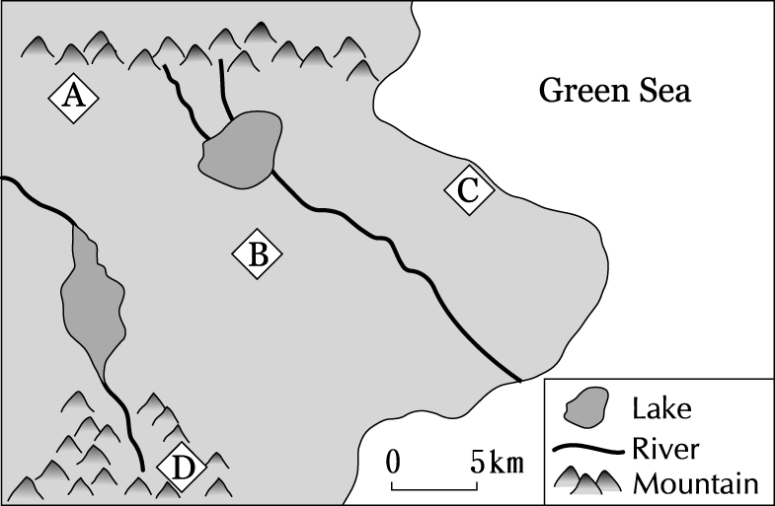

C.
Welcome 2010
All Rich’s Fans Invited!
Date: December 31, 2010
Time: 11:00 p.m.
Place: Dream Mall
Join us at “Welcome 2010.” Come and listen to Rich’s new songs when we count down for the New Year. His magic voice will give you a wonderful night. Free CDs, pictures, and posters will be given to those who can answer some questions about Rich. Come and see if you are one of the lucky ones! You can even sing a song with him if you are one of the first ten to come.
Call Jenny at 0800688216
36. What may Welcome 2010 be? (Ａ) A TV game. (Ｂ) A movie. (Ｃ) A song. (Ｄ) A party.
37. What can we learn from the poster? (Ａ)Jenny is a singer. (Ｂ)Rich is good at singing.
(Ｃ)Those who want to join the club need to bring pictures. (Ｄ) CDs and posters will be given to the first ten people to come.
D. Look at the pie chart and find out what women get on their birthdays.
38. If we ask three hundred women this question, women get roses from their love on their birthdays.
(Ａ)twenty (Ｂ)thirty (Ｃ)sixty (Ｄ)one hundred
39.Women who get watches on their birthdays are as many as those who get . (Ａ)diamond (Ｂ)cars (Ｃ)roses (Ｄ) cards
40. The percentage（百分比）of women who get cards is more than that of people who get watches and those who get diamond.
(Ａ)10 ％ (Ｂ) 15 ％ (Ｃ)20 ％ (Ｄ) 5 ％

E..
Look at the map. Cindy and Jim are in front of Da Da Theater. Read their dialogue and answer the questions.
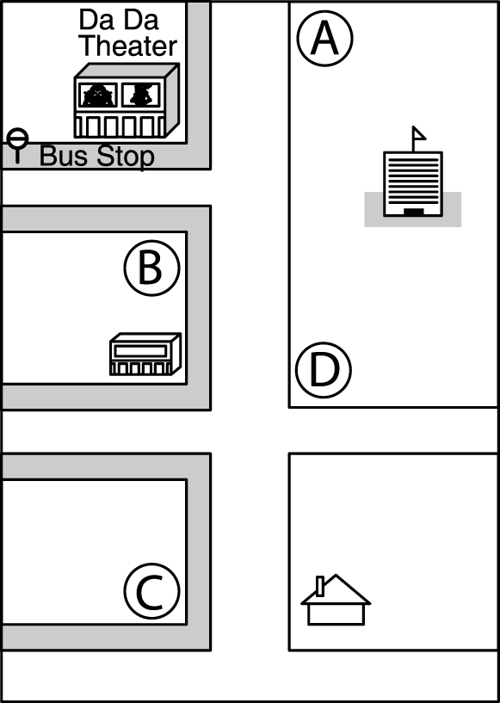
Cindy: Excuse me, how can I get to Ocean Park?
Jim: Well, if you want to take a bus, there’s a bus stop over there. But it’s faster if you take the subway. The subway station is two blocks away from here.
Cindy: I think I’ll take the subway. How much is a student ticket?
Jim: Twelve dollars from here to Ocean Park.
Cindy: Thanks. By the way, any supermarket near here? I need to buy a drink.
Jim: Yes, there’s one on the way to the subway station. It’s just down the street.
41. What can we learn from the dialogue?
(Ａ) Cindy will pay twelve dollars for the subway ticket. (Ｂ)Cindy will take a bus to the subway station. (Ｃ)Cindy will buy a coke at the bus stop. (Ｄ) Cindy will go to Ocean Park with Jim.

42. What does “one” mean in the dialogue? (Ａ) A bus stop. (Ｂ) A drink. (Ｃ) A bus station. (Ｄ) A supermarket.
43. Where is the subway station? (Ａ) At ○. (Ｂ) At. ○ (Ｃ) At ○. (Ｄ) At. ○
F.
Jolin and her mother are shopping in a supermarket now. They need some food and drinks for the barbecue.
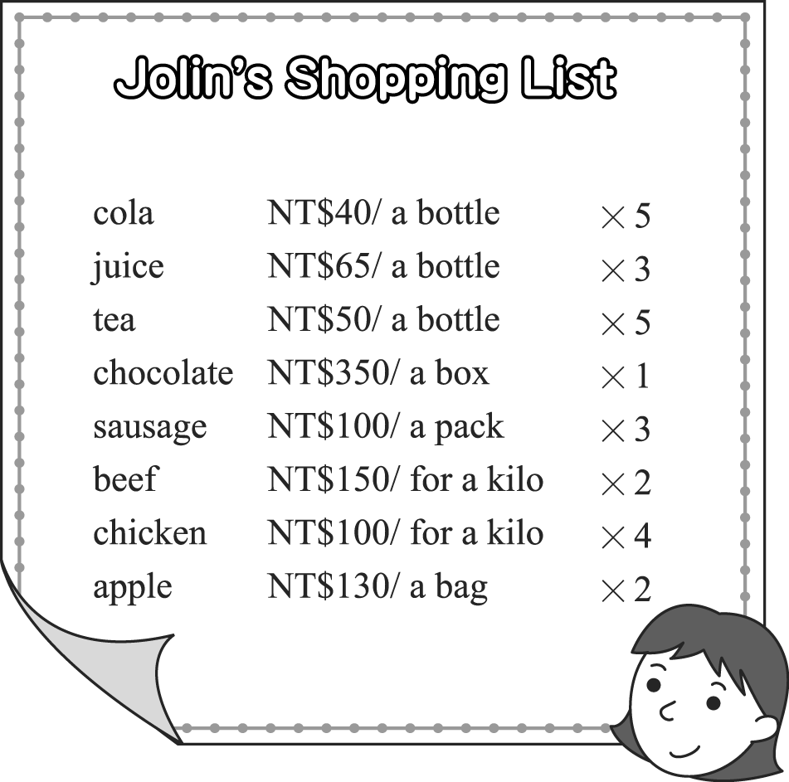
44. How much money does Jolin pay for fruit? (Ａ) NT$120. (Ｂ) NT$160. (Ｃ) NT$260. (Ｄ) NT$440.
G. Look at the ad, and answer the questions.

Things to remember:
1. For Puket: Remember to bring your swimsuit.
2. For Amazing Hualien: You had better take seasickness medicine.
3. For Tokyo & Yokohama: Be sure to bring some warm clothes.

45. Mandy is a busy businesswoman. Her doctor told her to take a trip. Visting many places is tiring for her. All she wants is to stay in one place and relax. Which trip will she like and how much will it cost?
(Ａ)Puket;$4200. (Ｂ) Tokyo & Yokohama;$45,000 (Ｃ) Tokyo & Yokohama;$40,.000. (Ｄ)Puket;$18.000.
H.
A Cheese Cake for Four People
Ingredients:
One stick of butter, one cup of sugar, three eggs,
one teaspoon of vanilla, two pieces of cheese,
three cups of flour, one cup of milk, a little salt
Steps:
1. Melt the cheese.
2. Mix the eggs with butter and sugar in a mixing bowl.
3. Put vanilla, milk and salt in the bowl.
4. Pour the flour and cheese and mix them up.
5. Put the paste into the oven.
6. Bake it at 200℃ for fifty minutes.
46. If you want to make a cake for 8 people, you need .
(Ａ) one teaspoon of butter and three eggs (Ｂ)two sticks of butter, two cups of sugar and four pieces of cheese (Ｃ) nine eggs, three cups of salt and nine cups of flour (Ｄ) nine eggs, six pieces of cheese and three cups of milk
I.
When Kelly was seven, she could take her computer apart (拆卸) and then put them back together. Her parents were very surprised at her. Although she kept reading a lot of novels, she was slow at writing and couldn’t pay much attention to what she was doing then. This made her parents very worried, so they took her to the doctor. She got ADHD and that was why she could not stop making trouble. She was always late for school, kicked and hit her classmates, ran around the classroom, and talked loudly in class. After she graduated from high school, she worked in a computer company. But she only worked for nine months. She said that she always forgot what she was doing when she was stopped by someone. Now she takes medicine three times a day and it makes her cool down and do things better.
47.Which is true about the reading?
(A) Kelly was sick. (B)Kelly’s parents were happy about her making trouble. (C)The doctor was proud of Kelly. (D)A lot of Kelly’s classmates loved her.
J.
Dear Ann,
My boyfriend left me behind, and I really want to kill myself. I can’t live without him, but the trouble is that I will have a baby this June. Even worse, if my parents know the truth, they will kill me. Last Sunday night, I told my boyfriend that I would bear a child this June, three months from now. He got reallly mad and told me that he was too young to have a child. He could do nothing about it, so he ran away from me. I tried very hard to call him and waited for him at his door tilll midnight every day but he just didn’t show up. I felt so sad and angry that I want to kill myself to make him feel sorry, but I am only seventeen. Please help me out.

Sad Girl

Dear Sad Girl,
I am sorry that your boyfriend was mean to you; therefore, you will be more stupid if you kill yourself and your baby because of him. The first thing you can do is ask someone, such as, your parents or teachers, to help you. You can decide to take care of the child by yourself or look for a good couple to bring it up. Stop hunting for your boyfriend or even being a friend with him. Never make the same mistake again. You have to know that if you live more happily than before, your boyfriend will feel worse. It’s not all your fault, so why do you want to kill yourself? Believe me, as long as you live, you will meet someone who really loves you someday.
Yours truly,
Ann
P.S. You can call Lifeline at 1995 or Teacher Chang at 0800-788-995 or at 1980 for advice.
48. Who do you think Ann is? (A) The girl’s doctor. (B) The Sad Girl’s parent. (C)The one that the Sad Girl asked for help.(D)The Sad Girl’s sister.
49. According to the reading, what can the Sad Girl do now?
(A)She can ask her mother or father to help her out first. (B)Her boyfriend is so bad that she can kill him. (C) She has to ask someone to help her boyfriend. (D)She had better kill herself at last.
According to根據 therefore因此 couple夫婦 advice忠告

K.
Chen Shu-Chu is the oldest of the children in her family, so after her parents died, she had to take care of her younger brothers and sisters. She has sold vegetables in Taitung County’s Central Market for 48 years. After her brothers and sisters got married and left home, she gave away about $32,000 to help poor children around Taiwan. Last year, she gave$144,000 to her old school to build a library. She is not a rich person. She seldom buys clothes for herself and spends less than one hundred dollars a day. She wakes up at 4 a.m., and works for ten hours every day. Furthermore, she has never gone traveling before. Although she made little money, she gave away all that she had to the people who were in need. “Money serves its purpose only when it is used for those who need it,” she said.
50Which is true about Ms. Chen Shu-Chu?
- She liked to help others because a lot of people helped her. (B)She helped many children because she was born with money.(C)She was kind to the poor children. (D)She saved a lot of money for herself.
Taitung County’s Central Market 台東中央市場 serve purpose 達到目的

國三英文第二次段考解答
1.C | D | A | B | C
6.B | A | D | A | B
11.B | D | D | B | A
16.B | A | B | D | D
21.A | D | C | B | C
26.B | A | D | A | C
31.B | C | C | A | C
36.D | B | C | A | C
41.A | D | B | C | D
46.B | A | C | A | C

