高雄縣立林園高級中學 國中部 99學年度 第一學期 一 年級 英文 科 第一次段考考卷
範圍：Starter~Review1 班級： 姓名： 座號：
【請將答案寫在答案欄內，交卷時只須繳交答案卷】
- 聽力測驗30%
一、聽CD的兩個敘述，勾選（✓）出符合圖片的句子10%
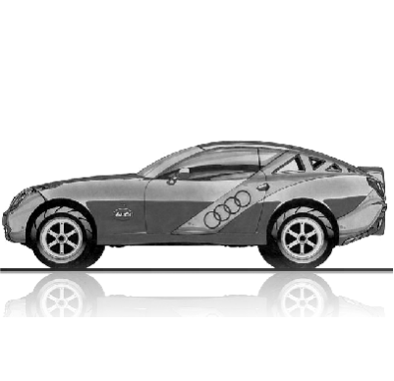  1. | 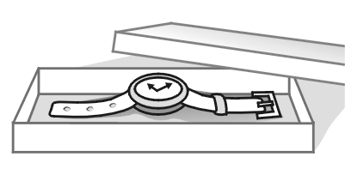  2. | 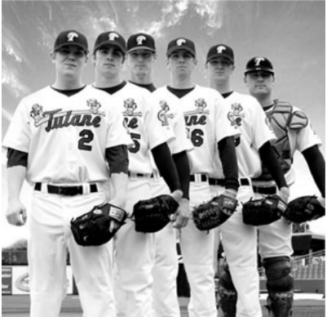  3. |   4. | 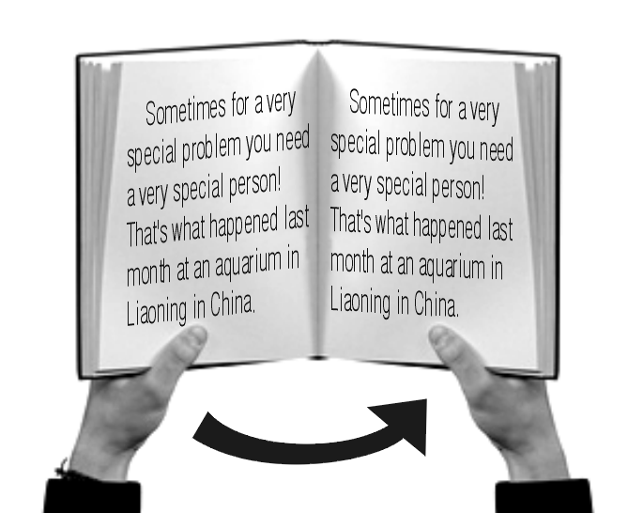  5.
A( ) B( ) | A( ) B( ) | A( ) B( ) | A( ) B( ) | A( ) B( )

二、選出出現在CD句中的單字10%
( ) 1. (A) class (B) school (C) classroom (D) new
( ) 2. (A) father (B) American (C) is (D) from
( ) 3. (A) pets (B) in (C) pencils (D) table
( ) 4. (A) watch (B) That’s (C) This (D) Those
( ) 5. (A) today (B) prizes (C) please (D) books

三、聽CD的問題，選出最適當的答句10%
( ) 1. (A) It’s room 301. (B) She is six years old.
(C) I’m fifteen. (D) It’s 631-2222.
( ) 2. (A) Yes, she is in her bedroom. (B) Yes, he is.
(C) Yes, he is in the park. (D) No, he is at home.
( ) 3. (A) She is my good friend. (B) She is from Taiwan.
(C) She is ten years old. (D) She is in the park.
( ) 4. (A) It’s on the desk. (B) It isn’t new. It’s old.
(C) It’s from China. (D) It’s my sister’s camera.
( ) 5. (A) See you tomorrow. (B) Good-bye.
(C) Good morning, Ms. Li. (D) Fine, thank you.
- 紙筆測驗70%
四、字母測驗6%（每題1分，全對才給分）
(一)依序寫出字母 1.大寫 D ___HI 2.小寫 p ____st
(二) 將大寫字母改小寫，小寫字母改大寫
3. INFORMATION 4. BROKEN 5. circle 6. fast
五、文意字彙20%
1. I’m Susan Wells. Susan is my f t name.
2. That’s not a real dog. That’s a r t dog.
3. That is my online p o album. It’s on my blog.
4. Mimi and Jenny are in my class. They are my c es.
5. A: Who’s your favorite s r? B: Celine Dion. I like all her songs.
6. We go to the b y to buy(買) bread(麵包). The bread there is great.
7. Hello, everyone. W e to my school. It is very big and beautiful(漂亮).
8. Chien-ming Wang is a b l player. He is from Taiwan.
9. My brother is 13 years old. He is a student in j r high school.
10. The book is u r the desk, not on the desk.
六、語法選擇20%
( ) 1. A: ________ are these? B: They’re David’s books.
(A) How (B) What (C) Where (D) Who
( ) 2. That tall man is ______ father. He is a teacher.
(A) Lisa and Sally’s (B) Lisa’s and Sally’s (C) this girls’ (D) those girl’s
( ) 3. Sally: Isn’t that cool? May: _______.
(A) Yes, it isn’t. (B) No, it isn’t. (C) Yes, it’s. (D) It’s not cool.
( ) 4. This is my pet. name is Lucky.
(A) It’s (B) Its (C) It (D) He
( ) 5. David is a _________ boy.
(A) ten-years-old (B) ten years old (C) eight-year-olds (D) twelve-year-old
( ) 6. A: That’s _______ new house. It’s big and nice.
- you (B) my teacher (C) our (D) Mr. Lin
( ) 7. Andy: _____________ Tina: Great, thanks.
- What’s your name? (B) How are you? (C) What’s this? (D) Who’s your father?
( ) 8. 選出正確的句子。 (A) This is a MP3 player. (B) These are my watchs.
(C) Good morning, miss Wang. (D) Dan’s and Bill’s cell phones are new.
( ) 9. Judy: _______ is Alex? Lisa: He’s in the park.
(A) Where (B) Who (C) How (D) What
( ) 10. Dan: Are you and Tim good friends? Bill: Yes, ________.
(A) I am (B) we are (C) they are (D) you are

七、克漏字選擇＆閱讀測驗14%
(一)
Jane and David have two daughters, Sally and Sara. Sally’s husband 1 Ken. Sally is a teacher. 2 Ken is a doctor. Sara married Steve. Sara has one daughter. Her name is Susan. She is 3 . Today is Steve’s birthday. They all come back to celebrate 4 birthday. They are a happy family.

have(有) daughter(女兒) husband(丈夫) married(嫁) has(有)
birthday(生日) come back(回來) celebrate(慶祝) family(家庭)

( ) 1. (A) are (B) am (C) is (D) be
( ) 2. (A) But (B) All (C) About (D) Too
( ) 3. (A) five year old (B) one year old (C) three-years old (D) two year olds
( ) 4. (A) their (B) his (C) her (D) David’s

(二)
Mr. Farmer: Good morning, everyone. I’m Andy Farmer, your English teacher. Let’s talk about your favorite sports star. Jeff, who is your favorite sports star?
Jeff: Well, my favorite sports star is a swimmer. His name is Michael Phelps.
Mr. Farmer: Is he from Canada?
Jeff: No, he and I are Americans.
Mr. Farmer: OK. How about you, Peter?
Peter: My favorite sports star is a basketball player. He is Kosuke Kitajima.
Mr. Farmer: Kosuke Kitajima? Is he from Korea?
Peter: No. He is from Japan, not Korea.
 let’s... 我們…吧 talk about談論 swimmer游泳選手

( ) 5. Where is Michael Phelps from?
(A) Canada. (B) Japan. (C) Taiwan. (D) The USA.
( ) 6. Who is Kosuke Kitajima ?

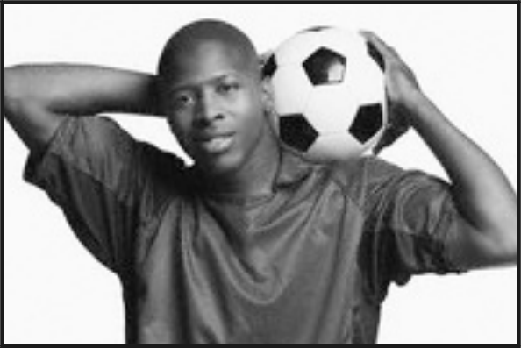
(A) (B)

(C) (D)



( ) 7. Which is true?（何者為真？）
(A) Jeff and Peter’s teacher is Andy. (B) Michael is Peter’s favorite sports star.
(C) Michael and Kitajima are English teachers. (D) Andy is Jeff’s student.

八、依提示作答（錯一字扣一分；標準符號錯誤扣一分）10%
1、I’m fifteen years old. （依劃線部份造原問句）
2、These are old cars. （改為單數句）
3、我媽媽在工作。
4、我們的英文老師是從哪裡來的呢?
5、那些是我的橡皮擦。

高雄縣立林園高級中學國中部 一 年級 英語 科第一次段考答案卷
範圍：範圍：Starter~Review1 班級： 姓名： 座號：

- 聽力測驗30%
一、聽CD的兩個敘述，勾選（✓）出符合圖片的句子10%
1.  A( ) B( ) | 2.  A( ) B( ) | 3.  A( ) B( ) | 4.  A( ) B( ) | 5.  A( ) B( )
二、選出出現在CD句中的單字10%
1. | 2. | 3. | 4. | 5.
三、聽CD的問題，選出最適當的答句10%
1. | 2. | 3. | 4. | 5.

貳、紙筆測驗70%
四、字母測驗6%（每題1分，全對才給分）
(一)依序寫出字母(1~2) (二) 將大寫字母改小寫，小寫字母改大寫(3~6)
1. | D ___HI | 2. | p ____st | 3.
4. |  | 5. |  | 6.

五、文意字彙20%
1. | 2. | 3. | 4. | 5.
6. | 7. | 8. | 9. | 10.
六、語法選擇20%
1. | 2. | 3. | 4. | 5.
6. | 7. | 8. | 9. | 10.
七、克漏字選擇＆閱讀測驗14%
1. | 2. | 3. | 4. | 5.
6. | 7.
八、依提示作答（錯一字扣一分；標準符號錯誤扣一分）10%

1.

2.

3.

4.

5.

高雄縣立林園高級中學國中部 一 年級 英語 科第一次段考答案
範圍：範圍：Starter~Review1 班級： 姓名： 座號：

- 聽力測驗30%
一、聽CD的兩個敘述，勾選（✓）出符合圖片的句子10%
1.  A( ✓ ) B( ) | 2.  A( ) B( ✓ ) | 3.  A( ) B( ✓ ) | 4.  A( ✓ ) B( ) | 5.  A( ) B( ✓ )
二、選出出現在CD句中的單字10%
1.  D | 2.  D | 3.  C | 4.  D | 5.  B
三、聽CD的問題，選出最適當的答句10%
1.  D | 2.  B | 3.  A | 4.  A | 5.  D

貳、紙筆測驗70%
四、字母測驗6%（每題1分，全對才給分）
(一)依序寫出字母(1~2) (二) 將大寫字母改小寫，小寫字母改大寫(3~6)
1. | D E F G HI | 2. | o p q r st | 3. | information
4. | broken | 5. | CIRCLE | 6. | FAST

五、文意字彙20%
1.  first | 2.  robot | 3.  photo | 4.  classmates | 5.  singer
6.  bakery | 7.  Welcome | 8.  baseball | 9.  junior | 10.  under
六、語法選擇20%
1.  B | 2.  A | 3.  B | 4.  B | 5.  D
6.  C | 7.  B | 8.  D | 9.  A | 10.  B
七、克漏字選擇＆閱讀測驗14%
1.  C | 2.  A | 3.  B | 4.  B | 5.  D
6.  C | 7.  A
八、依提示作答（錯一字扣一分；標準符號錯誤扣一分）10%

1. How old are you?

2. This is an old car.

3. My mother is at work.

4. Where is our English teacher from?

5. Those are my erasers.

聽力原稿：
- 聽CD的兩個敘述，勾選出符合圖片的句子10%
  - A: It is a car.
B: It is a cat.
  - A: My watch is on the box.
B: My watch is in the box.
  - A: They are basketball players.
B: They are baseball players.
  - A: She is from Canada.
B: She is from America.
  - A: Close your English book.
B: Open your English book.

- 選出出現在CD句中的單字10%
  - She is my new classmate.
  - Tim and his brother are from America.
  - My pencils are on the desk.
  - Those watches are great.
  - These cell phones are your prizes tonight.

- 聽CD的問題，選出最適當的答句10%
  - What’s your telephone number?
  - Is your father at home?
  - Who is the girl?
  - Where is your camera?
  - How are you, Andy?

高雄縣立林園高級中學 國中部 99學年度 第一學期 一 年級 英文 科 第一次段考解答
範圍：範圍：Starter~Review1 班級： 姓名： 座號：

- 聽力測驗30%
一、聽CD的兩個敘述，勾選（✓）出符合圖片的句子10%
1.  A( ✓ ) B( ) | 2.  A( ) B( ✓ ) | 3.  A( ) B( ✓ ) | 4.  A( ✓ ) B( ) | 5.  A( ) B( ✓ )
二、選出出現在CD句中的單字10%
1.  D | 2.  D | 3.  C | 4.  D | 5.  B
三、聽CD的問題，選出最適當的答句10%
1.  D | 2.  B | 3.  A | 4.  A | 5.  D

貳、紙筆測驗70%
四、字母測驗6%（每題1分，全對才給分）
(一)依序寫出字母(1~2) (二) 將大寫字母改小寫，小寫字母改大寫(3~6)
1. | D E F G HI | 2. | o p q r st | 3. | information
4. | broken | 5. | CIRCLE | 6. | FAST

五、文意字彙20%
1.  first | 2.  robot | 3.  photo | 4.  classmates | 5.  singer
6.  bakery | 7.  Welcome | 8.  baseball | 9.  junior | 10.  under
六、語法選擇20%
1.  B | 2.  A | 3.  B | 4.  B | 5.  D
6.  C | 7.  B | 8.  D | 9.  A | 10.  B
七、克漏字選擇＆閱讀測驗14%
1.  C | 2.  A | 3.  B | 4.  B | 5.  D
6.  C | 7.  A
八、依提示作答（錯一字扣一分；標準符號錯誤扣一分）10%

1. How old are you?

2. This is an old car.

3. My mother is at work.

4. Where is our English teacher from?

5. Those are my erasers.

聽力原稿：
- 聽CD的兩個敘述，勾選出符合圖片的句子10%
  - A: It is a car.
B: It is a cat.
  - A: My watch is on the box.
B: My watch is in the box.
  - A: They are basketball players.
B: They are baseball players.
  - A: She is from Canada.
B: She is from America.
  - A: Close your English book.
B: Open your English book.

- 選出出現在CD句中的單字10%
  - She is my new classmate.
  - Tim and his brother are from America.
  - My pencils are on the desk.
  - Those watches are great.
  - These cell phones are your prizes tonight.

- 聽CD的問題，選出最適當的答句10%
  - What’s your telephone number?
  - Is your father at home?
  - Who is the girl?
  - Where is your camera?
  - How are you, Andy?

