高雄縣立林園高級中學 國中部 99學年度 第一學期 一年級 英語科 第二次段考考卷
範圍：Lesson4~ReviewII 班級： 姓名： 座號：
【聽力測驗】
一、選出出現在CD句中的單字：10％
( C ) 1. (A) for (B) work (C) isn’t (D) your
( D ) 2. (A) me (B) her (C) them (D) us
( A ) 3. (A) let’s (B) getting (C) tomorrow (D) baseball
( D ) 4. (A) men (B) bathroom (C) dining (D) women
( B ) 5. (A) any (B) many (C) home (D) house

二、聽CD的二個敘述，勾選出符合圖片的句子： 10％

1.   | 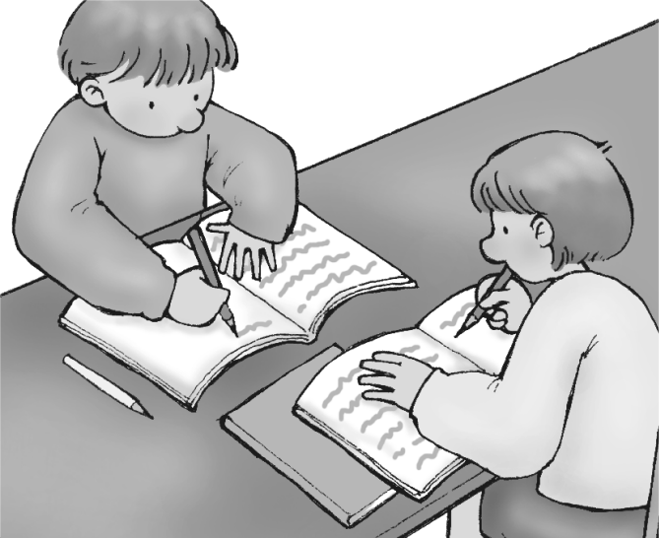  2. | 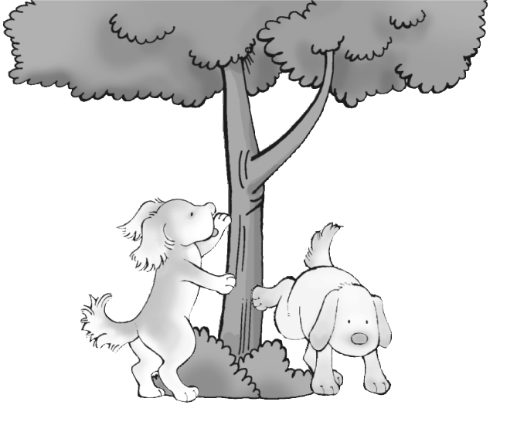  3. | 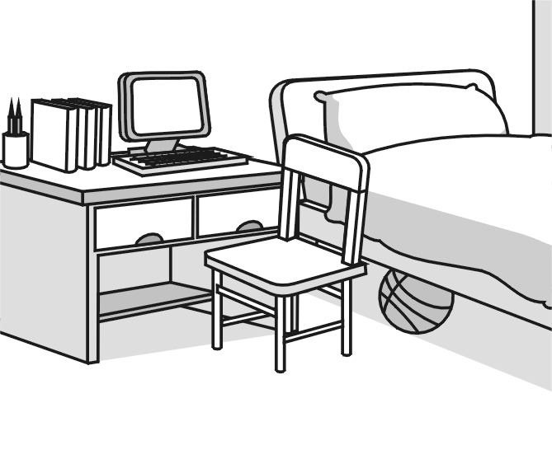  4. | 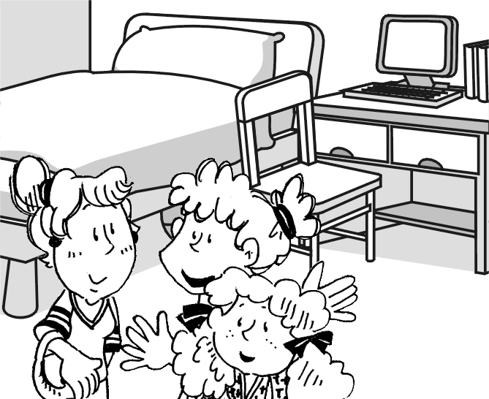  5.
A ( ✓ ) B ( ) | A ( ) B ( ✓ ) | A ( ✓ ) B ( ) | A ( ) B ( ✓ ) | A ( ✓ ) B ( )
三、聽CD的問題，選出最適當的回應：10％
( A ) 1. (A) OK. Let’s do our homework! (B) Your homework is on the desk.
(C) Let’s cook dinner. (D) I am watching a movie on TV.
( D ) 2. (A) Who are you talking to? (B) Are you talking to David?
(C) This is my new phone. (D) Hi, David. Come to the beach and play with us.
( B ) 3. (A) I am not at home. (B) From Janet’s home.
(C) She is on the phone. (D) I am from America.
( A ) 4. (A) OK. See you soon! (B) They are swimming.
(C) I’m not kidding. (D) I’m playing tennis now.
( B ) 5. (A) No, they aren’t. (B) Yes, there are two.
(C) Yes, there are two boxes here. (D) No, my computer is next to my desk.

【紙筆測驗】
四、文意字彙：10％
__________ 1. Mrs. Wells is my n_______r. She’s nice.
__________ 2. Mom is cooking in the k n.
__________ 3. My brother, Ken, is resting on the b y.
__________ 4. Let’s go to John’s p e tonight.
__________ 5. Jerry is throwing a f e with his friends.
__________ 6. Mr. and Mrs. Wu are living in Taipei with their two c n.
__________ 7. A: What’s i e the box? B: A dog.
__________ 8. There are many flowers in the y______d.
__________ 9. The TV show is b_____g. Let’s not watch it.
_________ 10. The baby is sleeping. Don’t be l______d.
五、文意填充：6％
1. Where’s Carol? Let’s call _______.
2. Is ______ a dining room in the house?
3. Listen to _____. I’m not at home. I’m in the office.
4. _______ play in the classroom. It’s dangerous.（危險的）
5. _______ write your name here. I need（需要） it.
6. I’m not studying. I’m playing _____ my cat.
六、文法選擇：20％
( ) 1. Lisa is _______ a bike with her sister in the yard.
(A) throwing (B) taking
(C) riding (D) flying
( ) 2. _________ a robot dog in the living room?
(A) Is there (B) Is this
(C) Are there (D) Are these
( ) 3. Please talk to _________.
(A) we (B) that tall boy
(C) he (D) I
( ) 4.. Don’t play baseball. __________ dinner time.
(A) That’s (B) This is
(C) It’s (D) There’s
( ) 5. A: Is there a bakery near your school?
B: Yes, _________.
(A) there are (B) there aren’t
(C) there isn’t (D) there is
( ) 6. A: What’s Mimi doing?
B: She’s going to ________.
(A) home (B) park
(C) beach (D) the movies
( ) 7. A: ________ are you looking _________?
B: Miss Huang.
(A) Where ; at (B) Who ; ×
(C) Who ; at (D) What ; to
( ) 8. A: ________ are Bob and Rachel doing now?
B: They are swimming at the beach.
(A) What (B) Who
(C) Where (D) How
( ) 9. Judy is taking a bath. She’s ________ dinner.
(A) no having (B) having
(C) not having (D) have
( ) 10. Are there any ______ with your new bike?
(A)kites (B) bears
(C)problems (D) cars

七、改錯訂正：10％
（ ）__________ 1. Katie is swim with her classmates at the beach.
(A) (B) (C)

（ ）__________ 2. Jodie, is a good girl. Help your mom, please.
(A) (B) (C)

（ ）__________ 3. A: Is Andy talking to his friend? B: Yes, he’s.
(A) (B) (C)

（ ）__________ 4. Let’s cooking lunch tonight.
(A) (B) (C)

（ ）__________ 5. Kim and Joe are in the park. And Ken is playing with they.
(A) (B) (C)
八、閱讀測驗：14％

(Ring) Sally: “Hello, this is Sally. I’m not at home now. Please leave your name and phone number after the beep.”
(Beep) Jeff: “Hi, Sally. This is Jeff. I’m playing basketball with my brother. We are in River Park. Please join us. My cell phone number is zero, nine, double one, four, seven, two, eight, five, zero.”

        ring電話鈴聲 leave留下 after在…之後 beep嗶嗶聲

( ) 1. What’s Jeff’s phone number?
(A) It’s 0911427560. (B) It’s 0941137270.
(C) It’s 0911472850. (D) It’s 0912247280.

( ) 2. What is Jeff doing in the park?


(A) (B)

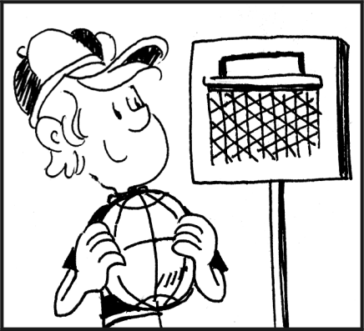

(C) (D)

Sandy: Peter, is dinner ready?
Peter : Just a minute.
Sandy: OK. Is Mike in the kitchen?
Peter : No, he isn’t. Maybe he is in the living room.
Sandy: No, he’s not. I’m watching TV here.
He’s not in here.
Peter : Maybe he is in Dad’s bedroom.
(Meow…meow…)
Sandy: Hey, here you are. Peter, he is under the sofa.
No wonder I can’t see him.
   maybe或許meow 貓叫聲no wonder 難怪 can’t不能

( ) 3. What is Peter doing?

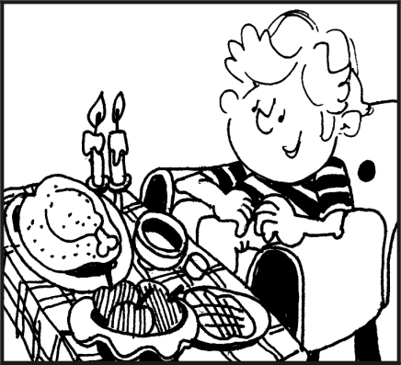
(A) (B)


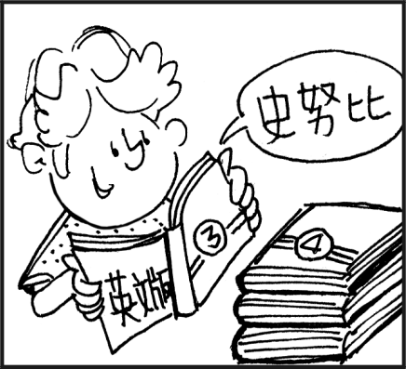
(C) (D)

( ) 4. Where is Mike?
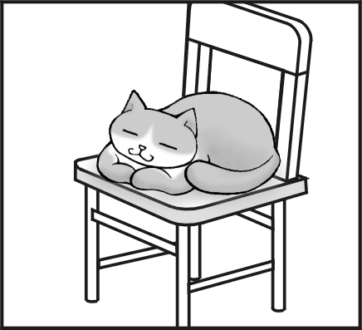
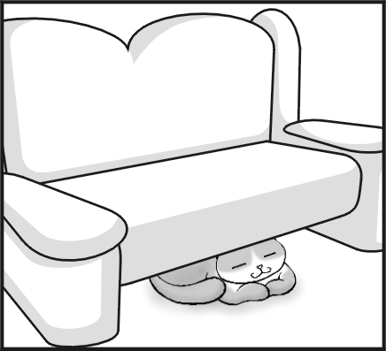
(A) (B)

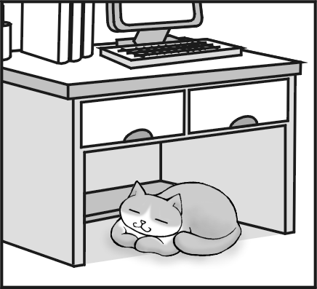
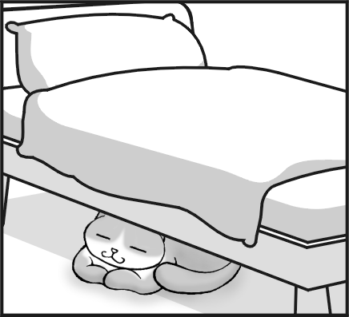
(C) (D)

( ) 5. What is Sandy doing?
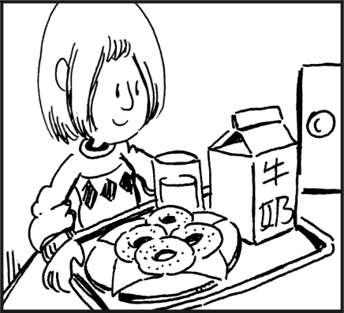
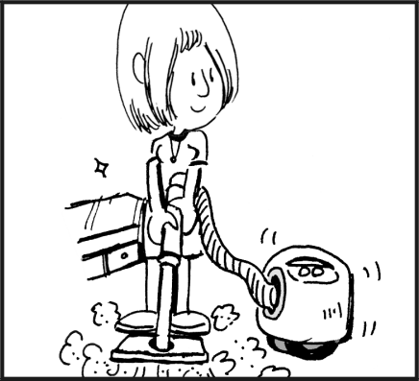
(A) (B)

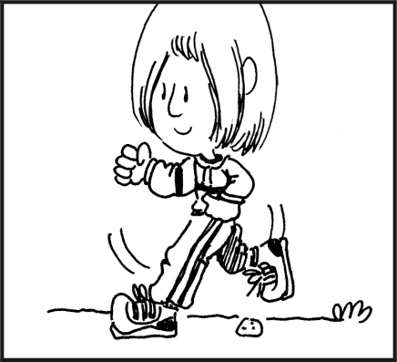

(C) (D)

Dan,
Your father and I are at work tonight. Dinner is in the microwave. Cook it just three minutes. Don’t play computer games all night. Help your sister with her homework. Take a bath and go to bed on time!
Mom
( ) 6. Who can cook dinner tonight?  can能夠
(A) Dan. (B) Dan’s sister.
(C) Dan’s mother. (D) Dan’s father.
( ) 7. Which is true about the note?  which哪一個true真的 cannot 不能
(A) Dan’s father and mother are busy with their work tonight.
(B) Dan can play computer games all night.
(C) Dan cannot help his sister with her homework.
(D) Dan can go to the movies with his friends tonight.

九、連貫式翻譯：10％

Jane: Wow, this is a beautiful beach. Look! （1）他們在海邊做什麼？
Dad: They are playing volleyball（排球）.
Jane: （2）我學校隔壁有座公園。
Many people play basketball there on weekends.
Dad: You are a junior high school student now. Study hard and don’t play too much.
（3）要聽媽媽的話，並且要主動幫忙喔！
Jane: I see. Dad, my friends are over there.
（4）Lisa正在網球場上跟Sally講話。
Dad: Go to join them. （5）我們在我的辦公室碰面吧！
Jane: Bye.
Dad: See you.

高雄縣立林園高級中學 國中部 99學年度 第一學期 一年級 英語科 第二次段考答案卷
範圍：Lesson4~ReviewII 班級： 姓名： 座號：
【聽力測驗】
一、選出出現在CD句中的單字：10％
1 C | 2 D | 3 A | 4 D | 5 B
二、聽CD的二個敘述，勾選出符合圖片的句子： 10％
1 A | 2 B | 3 A | 4 B | 5 A
三、聽CD的問題，選出最適當的回應：10％
1 A | 2 D | 3 B | 4 A | 5 B

【紙筆測驗】
四、文意字彙：10％
1 neighber | 2 kitchen | 3 balcony | 4 place | 5 frisbee
6 children | 7 inside | 8 yard | 9 boring | 10 loud
五、文意填充：6％
1 her | 2 there | 3 me | 4 Don’t | 5 Please | 6 with
六、文法選擇：20％
1 C | 2 A | 3 B | 4 C | 5 D
6 D | 7 C | 8 A | 9 C | 10 C
七、改錯訂正：10％【更正答案及英文代碼各一分】
1（A） swimming | 2（A） be | 3（C） he is | 4（A） cook | 5（C） them
八、閱讀測驗：14％
1 C | 2 C | 3 C | 4 B | 5 D | 6 A | 7 A
九、連貫式翻譯：10％【錯一個地方，扣一分】
1 What are they doing at the beach?
2 There is a park next to my school.
3 Listen to Mom/your mother and be helpful.
4 Lisa is talking to/with Sally on the tennis court..
5 Let’s get together at/in my office.

