高雄縣立林園高級中學 國中部 99學年度 第一學期 一 年級 英語 科 第三次段考考卷
範圍：L7~Review3 班級： 姓名： 座號：
一、聽力測驗
- 選出出現在CD句中的單字【答案依序劃於答案卡上第1~5題】：（10%）
( ) 1. (A) playing (B) an (C) brother (D) piano
( ) 2. (A) soccer (B) basketball (C) also (D) tennis
( ) 3. (A) fun (B) can’t (C) sports (D) aren’t
( ) 4. (A) swimming (B) pen (C) and (D) fly
( ) 5. (A) speaking (B) can’t (C) isn’t (D) father

- 聽CD的二個敘述，勾選出符合圖片的句子【答案依序劃於答案卡上第6~10題】：（10%）
1.  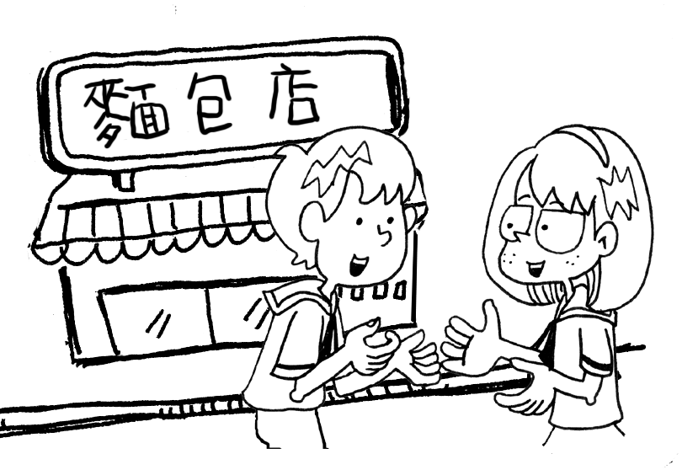  A ( ) B ( ) | 2.  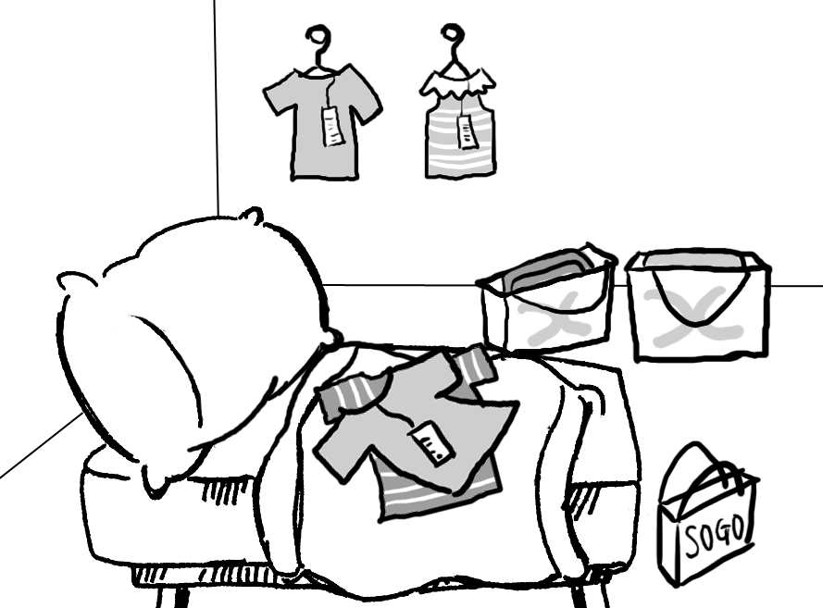  A ( ) B ( ) | 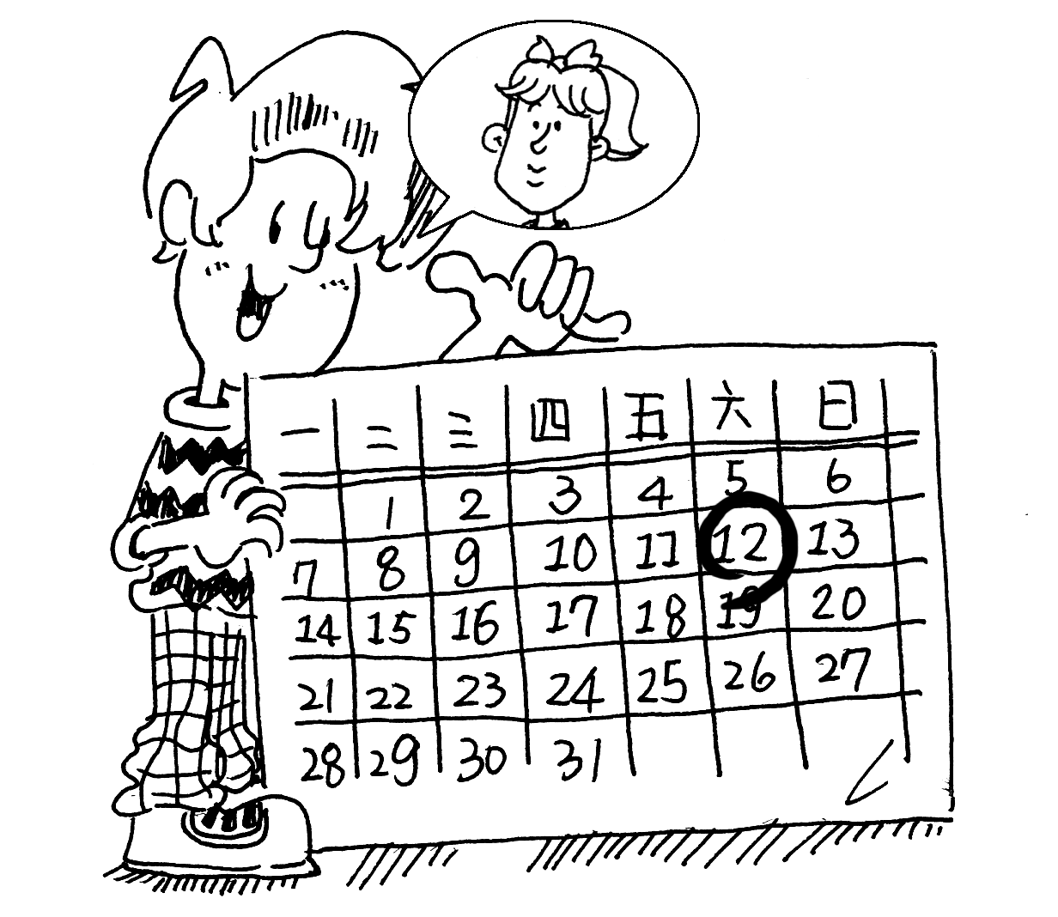  3.  A ( ) B ( ) | 4.  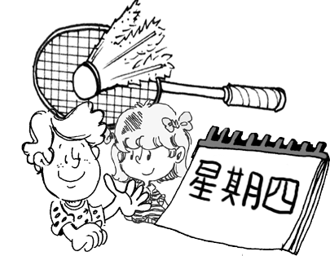  A ( ) B ( ) | 5.  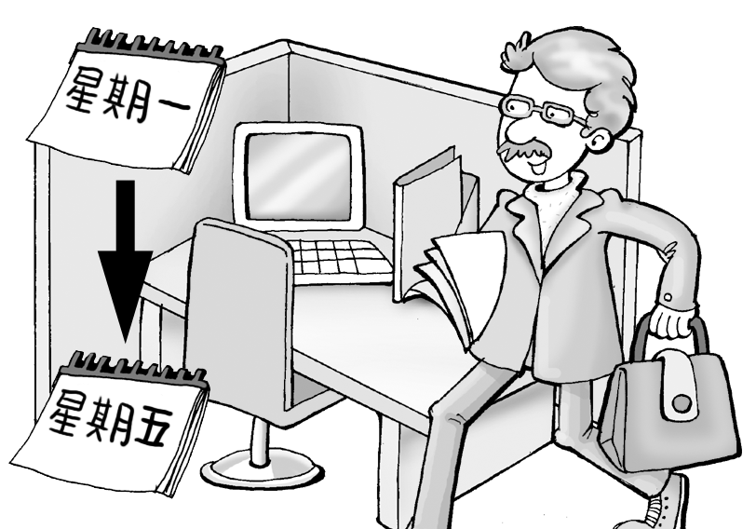  A ( ) B ( )

- 聽CD的短文後，回答下列問題【答案依序劃於答案卡上第11~15題】：（10%）：
( ) 1. (A) Next to the tennis court. (B) In the movie theater. (C) Next to the school. (D) Near the beach.
( ) 2. (A) She is studying. (B) She is swimming. (C) She is having breakfast. (D) She is watching a movie.
( ) 3. (A) Bobby. (B) Tina. (C) Wendy (D) Bobby’s brother.
( ) 4. (A) At 8:00 a.m. (B) At 8:30 a.m. (C) At 8:00 p.m. (D) At 8:30 p.m.
( ) 5. (A) 4:15 a.m. (B) 4:45 a.m. (C) 4:15 p.m. (D) 4:45 p.m.

二、綜合選擇題：(46%)
( )16.挑異，請選出跟其他三者不同的字詞：(A) black (B) little (C) blue (D) green
( )17.挑異，請選出跟其他三者不同的字詞：(A) violin (B) flute (C) guitar (D) badminton
( )18.挑異，請選出跟其他三者不同的字詞：(A) snack (B) eye (C) hair (D) leg
( )19.挑異，請選出跟其他三者不同的字詞：(A) fat (B) special (C) heavy (D) thin
( )20.挑異，請選出跟其他三者不同的字詞：(A) jacket (B) skirt (C) fan (D) coat
( )21.That’s a(n) game show. (A) favorite (B) handsome (C) exciting (D) black
( )22.Ella can play , and she can sing. (A) a chess (B) the guitar (C) the badminton (D) flute
( )23.My favorite bakery is open Monday to Saturday. (A) in (B) from (C) at (D) on
( )24.My parents aren’t at home tonight. (A) at (B) on (C) × (D) to
( )25.Can you give this old skirt? (A) we (B) he (C) she (D) her
( )26. your homework, and you can play computer games. (A) Do (B) Is doing (C) Doing (D) Are doing
( )27.There are ________ coffee shops near our house.
(A) no any (B) not a (C) no (D) any
( )28.Marcus and Kim ________ a dog. The dog ________ a fat body and long ears.
(A) has ; has (B) have ; has (C) has ; have (D) have ; have
( )29.Can you and Lisa ________ there on time tomorrow? (A) are (B) is (C) do (D) be
( )30.Amy:Can you play the flute? Mark:No, but Tony . (A) isn’t (B) can (C) can’t (D) is
( )31. A: _______ can Sally go to the beach with us? B: On Friday.
(A) What (B) What day (C) What time (D) How
( )32.A: What color is your hair? B:
(A) It’s long. (B) I have blue eyes. (C) They are black. (D) It’s brown.
( )33.A: The TV show is at ten o’clock. What time is it now?
B: It’s . We still have twenty minutes.
(A) twenty past nine (B) a quarter to ten (C) ten twenty (D) twenty to ten
( )34.Ivan: What time is the movie? Lynn:
(A) It’s on Saturday. (B) It’s tomorrow. (C) It’s ten. (D) At nine.
( )35. Jenny: Can’t you swim, Jimmy? Jimmy:
(A) Yes, I can. (B) No, she can’t. (C) Yes, he can. (D) No, Jimmy can’t.
( )36.釋義：It’s ten fifteen a.m. now.
(A) It’s fifteen to eleven in the evening. (B) It’s a quarter past ten in the evening.
(C) It’s a quarter after ten in the morning. (D) It’s fifteen to ten in the morning.
( )37.選出錯誤的句子：
(A) A: What day is it today? B: It’s × Monday. (B) It’s × four twenty. Let’s fly a kite in the park.
(C) Rita, get up. It’s half past six now. (D) A: What time is the baseball game? B: It’s × 3 p.m.
( )38.選出正確的句子：
(A) There’s a good cartoon on TV for the morning. (B) Let’s play soccer in the weekend.
(C) We can go to the beach on Saturday afternoon. (D) I’m looking at Sam. Where is he?

三、閱讀測驗(24%)
(一)
Mr. Hill: What can you do for the show?
Kevin: I can play badminton!
Mr. Hill: No! You can't play badminton for a talent show! Can you dance?
Kevin: No, I can't dance at all.
Mr. Hill: Are you a good singer?
Kevin: No, I'm not.
Mr. Hill: Can you play any instruments?
Kevin: Well, I can play the violin.
Mr. Hill: OK, Kevin. You're in the show. Maybe you and Lisa can play together for the show.
( )39. What can Kevin do for the show?
(A) He can sing. (B) He can play music. (C) He can play sports. (D) He can dance with Lisa.
( )40. What can we know about Lisa?
- She is a violin teacher. (B) She is Kevin's sister. (C) She can play the violin. (D) She is a good singer.
(二)
閱讀下面文章，並選出他們的桌號：
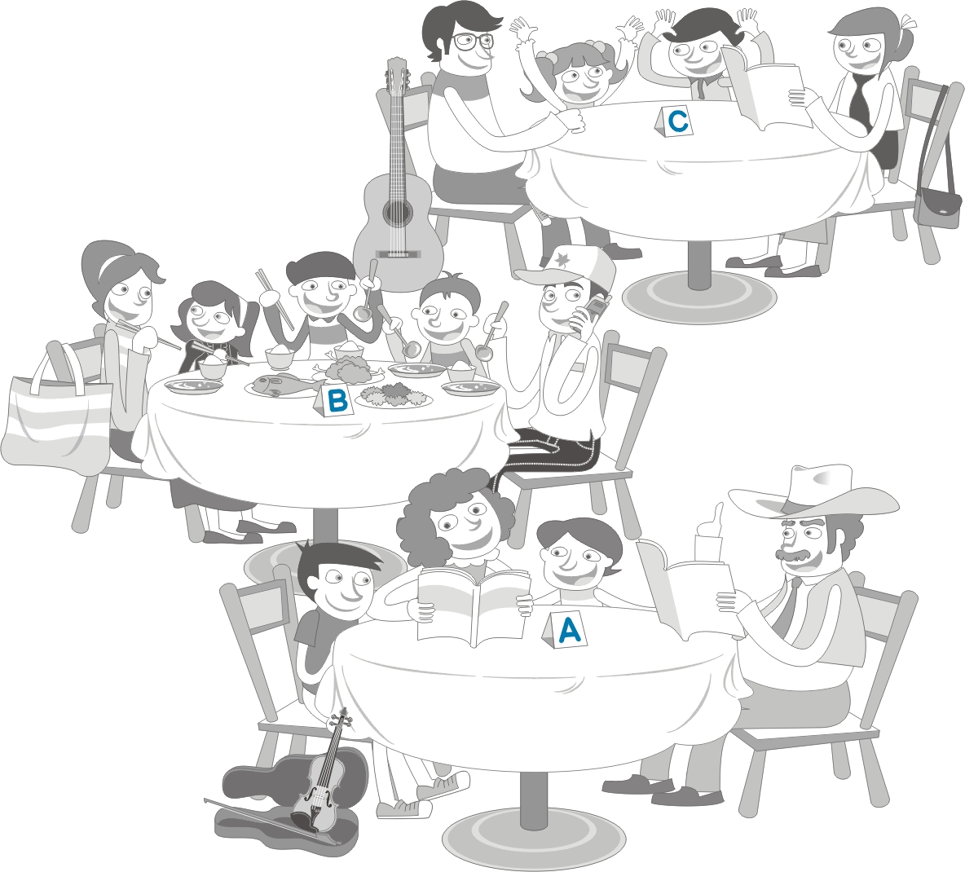 | ( )41. Mr. and Mrs. Hill have three children. Mrs. Hill has a big bag.  Mr. Hill is talking on his cell phone.  = Table .(A) A (B) B (C) C  ( )42. Mr. and Mrs. Fisher have two children. Mr. Fisher has a guitar.  The boy and girl are listening to music.  = Table . (A) A (B) B (C) C  ( )43. Mr. and Mrs. Wells have two children. Mr. Wells has a big hat.  Mrs. Wells is reading a book with the boys.  = Table . (A) A (B) B (C) C
(三)
(Linda is a new student in Lin Yuan Junior High School. She is talking with Sally.)
Linda: Nice to meet you. I am Linda.
Sally: Nice to meet you, too. My name is Sally.
Linda: Sally, what time is our English class today?
Sally: Today is Monday. Our English class is at eight and our Chinese class is at ten.
Linda: Thank you. Is the music class at one thirty?
Sally: No, we have music classes on Tuesday morning and Thursday afternoon.
Linda: Isn’t our PE class at two o’clock this afternoon?
Sally: Yes, we can play basketball and soccer.
Linda: Great. Who can we play with?
Sally: Little Mark.
Linda: You mean Mark Wells?
Sally: Yes, we have two Marks in our class. One is short and thin; the other is tall and a little heavy.
Linda: Hah. That’s funny.  PE 體育 mean 意指 the other 另一個
( )44.What day is tomorrow?
(A) It’s Tuesday. (B) It’s Monday. (C) It’s Wednesday. (D) It’s Thursday.
( )45. Is Linda and Sally’s English class at eight on Monday?
(A) No, it’s at 1:30 p.m. (B) No, it’s at 10. (C) Yes, it is. (D) No, it’s at 3:30 p.m.
( )46.What time is their PE class today?
(A) It’s at 2:00 a.m. (B) It’s at 1:30 p.m. (C) It’s at 2:00 p.m. (D) It’s at 1:30 a.m.
( )47.Who is “Little Mark”?
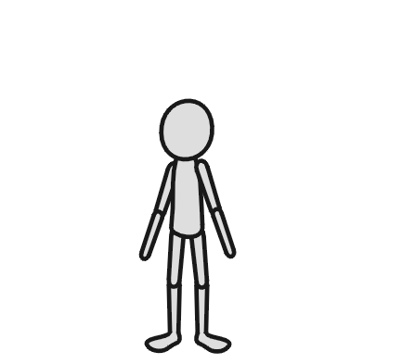
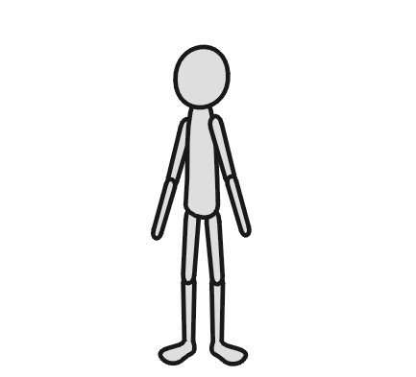
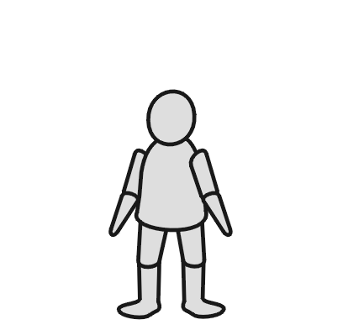
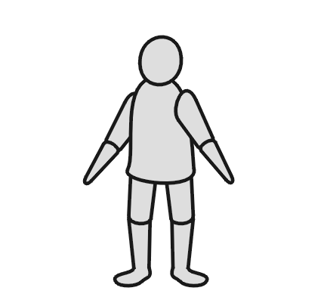
(A) (B) (C) (D)

( )48. Which is true?（何者為真？）
(A) Linda is 17 years old. (B) Linda and Sally have a music class on Thursday afternoon.
(C) Sally is on the school soccer team. (D) Mark isn’t Linda’s classmate.
(四)
Happy Music Class
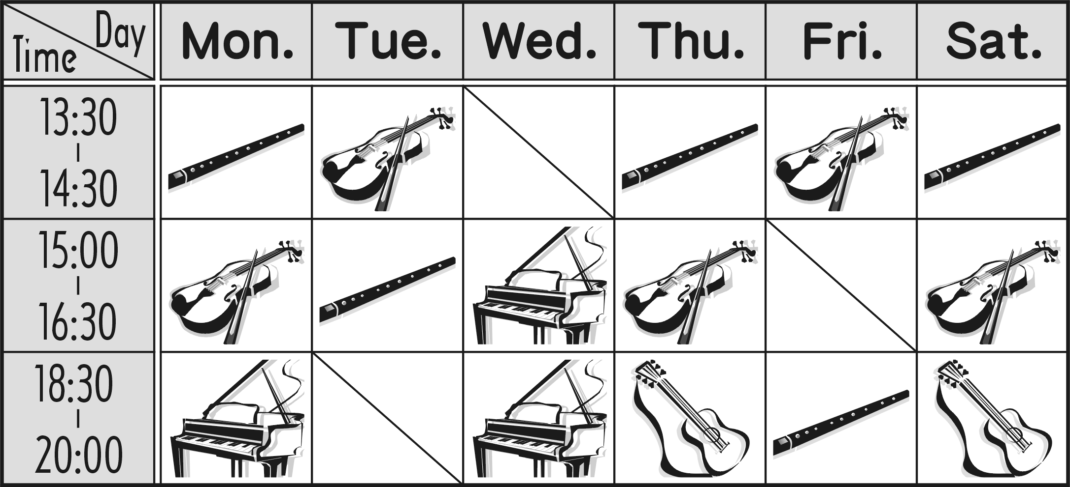

( )49.Miss Lee is a piano teacher. She has a piano class today. What day is it?
(A) Monday. (B) Saturday. (C) Thursday. (D) Friday.
( )50.Today is Friday. Andy is in flute class. What time is it?
(A) 3:30 p.m. (B) 5:30 p.m. (C) 7:30 p.m. (D) 8:30 p.m.

一年級英語科 答案欄 （年級、科目請標示清楚，謝謝！）
1~25：DACDB BAABA DAACC BDABC CBBCD
26~50：ACBDB BDDDA CDCBC BCAAC CDBAC
聽力錄音稿：
（一）選出出現在CD句中的單字：（10%）
1. My sister and I can play the piano.
2. Can you play soccer and badminton?
3. My brother isn’t a sports fan.
4. My pet can’t swim, but she can fly.
5. My mother can’t speak English.
(二)聽CD的二個敘述，勾選出符合圖片的句子【答案依序劃於答案卡上第6~10題】：(10%)
1. A: Let’s go to the park.
B: Let’s buy snacks.
2. A: There are a lot of things in my bedroom.
B: There are a lot of skirts in my bedroom.
3. A: We can meet on Saturday.
B: We can meet on Friday.
4. A: Let’s play badminton on Tuesday.
B: Let’s play badminton on Thursday.
5. A: The office is open from Monday to Friday.
B: The office is open on the weekend.
(三)聽CD的短文後，回答下列問題【答案依序劃於答案卡上第11~15題】：（10%）：
(W): Hello, Bobby. This is Tina.
(M): Hi. Tina. What are you doing?
(W): Wendy and I are studying at the new coffee shop.
Please come and join us!
(M): Is it next to our school?
(W): No, it’s near the beach.
(M): Cool! Maybe we can swim, too.
(W): No. There is a good movie at eight thirty
tonight. Let’s go to see a movie.
(M): Sorry, I can’t. I have a piano class at eight o’clock.
(W): That’s fine. What time can you come here?
(M): At four fifteen.
Questions:
1. Where is the coffee shop?
2. What is Tina doing?
3. Who can’t go to the movies?
4. What time is Bobby’s piano class?
5. What time can they meet at the coffee shop?

