高雄縣立林園高級中學 國中部 99學年度 第一學期 二 年級 英語 科 第一次段考考卷
範圍：英語第三冊 (L1~R1) 班級： 姓名： 座號：
- 聽力測驗 (30%)
一、字彙選擇：每題2分，共10分
選出句中聽到的單字代碼。
( ) 1. (Ａ) wedding (Ｂ) important (Ｃ) sang (Ｄ) take care
( ) 2. (Ａ) cage (Ｂ) bring (Ｃ) garbage (Ｄ) rabbit
( ) 3. (Ａ) sort ( Ｂ) sell (Ｃ) award (Ｄ) recycle
( ) 4. (Ａ) dress (Ｂ) have (Ｃ) eat (Ｄ) moon
( ) 5. (Ａ) recycling (Ｂ) take notes (Ｃ) plastic (Ｄ) take turns

二、看圖選擇：每題2分，共10分
根據聽到的內容，選出正確的圖片代碼。
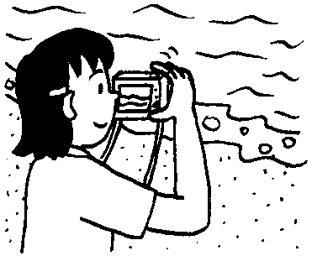
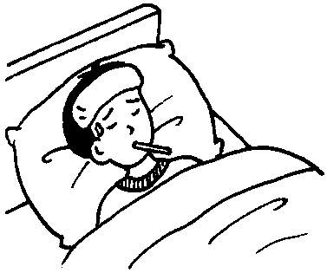
A. B. C.
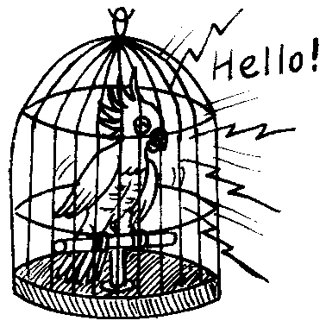

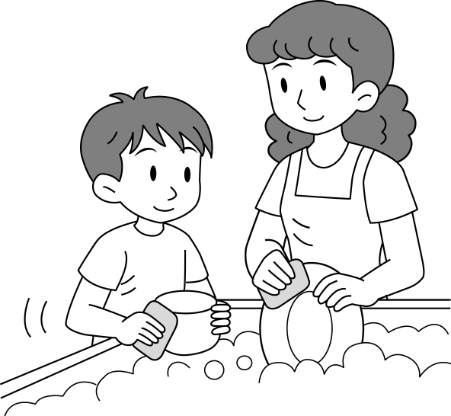
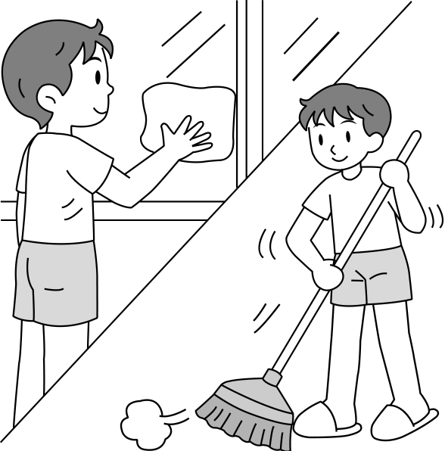
D. E.

1.  2. 3. 4. 5.

三、簡短對話：每題2分，共10分
根據聽到的對話內容與問題，選出正確的答案。
( ) 1. (Ａ) Yes, he did.
(Ｂ) No, Mary did it.
(Ｃ) Yes, he and Mary did it together.
( ) 2. (Ａ) Yes, she went to the zoo.
(Ｂ) She went to the zoo.
(Ｃ) She went to the pet shop and saw a lot of interesting animals.
( ) 3. (Ａ) He was lost.
(Ｂ) He found a bad man.
(Ｃ) He lost his camera.
( ) 4. (Ａ) Ted didn’t like Amy.
(Ｂ) He ate a lot this morning.
(Ｃ) He didn’t like beef noodles（牛肉麵） .
( ) 5. (Ａ) She was sick（生病的）.
(Ｂ) She had to visit her friend in the hospital.
(Ｃ) She didn’t like school at all.

- 筆試 (70%)
- 文意字彙 (10分)
1.We d ve to Taitung yesterday.
2.They t k many pictures last week.
3.Julia went to Bali many times. She has a lot of e ces.
4.The food in that restaurant is d s.
5.We eat moon cakes on the Moon F l.
6.We should put the g ge in the trash bin.
7.Coco’s room is a m s. She seldom cleans it.
8.Ivy is the t t of the water ballon game.
9.The basketball game a ted many students last night.
10.Jenny bought a car at a very low p ce.
- 文法 (10分)
( )1._________ you call Jeff yesterday morning?
(A)Do (B)Did (C)Are (D)Were
( )2.Fred has _________ toys in his room.
(A)a lot (B)a lot of (C)many of (D)much
( )3.Alex _______ his homework last Monday.
(A)did not (B)did not did (C)did not do (D)do not did
( )4.Harry ________ on his jacket and went out.
(A)puts (B)puted (C)put (D)putted
( )5.There was a poster on the floor. Please _________________.
(A)pick up it (B)picks up it (C)picks it up (D)pick it up
( )6.We can’t sell fried ice cream _________ no one can cook it.
(A)although (B)but (C)because (D)so
( )7.Peter was sick, ____ he still went to school.
(A)so (B)though (C)but (D)X
( )8._________ the price of the pink dress?
(A)What’s (B)What are (C)How much does (D)How much are
( )9.The prize _____ the winner is a nice hug _____ Mr. Lin.
(A)of; to (B)of; of (C)from; from (D)for; from
( )10.Tim’s father bought a new MP3 _____ him.
(A)for (B)to (C)in (D)X
- 對話選擇 (10分)
( )1.Andy: You can be the ghost(鬼) of the exciting game.
Brian: _________. We should take turns.
(A)By the way (B)No way (C)Surely (D)No problem
( )2.Judy: Didn’t you ride a bike to school this morning?
(A)Yes, I took a bus to school. (B)No. Iwent to school by bike.
(C)Yes, I rode my motorcycle to school. (D)No. My mother drove me to school before work.
( )3.Lisa:_____________________
Jean: I studied English in the library.
(A)When do you go to the library? (B)What do you do on Saturdays?
(C )What did you do last night? (D)Where are you going?
( )4.Amy: What did they bring for their grandmother?
Eric: __________________.
(A)A parrot (B)Yes, a cake and some cookies
(C)Right now (D)They will(將) give her a cat tomorrow.
( )5.Alice: What about seeing the movie next Sunday?
Julia: ____________________________.
(A)You’re welcome (B)OK. It’s great.
(C)Let’s take turns (D)I didn’t have time.

- 文意填充 (8分)
(將下列字詞改成適當形式，並填入正確空格中：make; wash; give; read)
Sally and I went to help my neighbor, Mrs. Lin. She lives alone in a big house. Sally ___1.____ the windows and cleaned the floor. I __2._____ her some tea and ___3.___ her some news. Mrs. Lin was happy and __4.___ some gifts to us.
- 閱讀測驗 (8分)
Where are your friends traveling to next year? Paris, London or Tokyo? When they’re surrounded by tourists with cameras, why don’t you go somewhere else? How about the moon?
Space Adventures is the only company that can make space travel a reality for you. There are only a few people who have been to space, and now you can be one of them.
Space adventures offers these different trips:
*A week on a space station- this includes an unforgettable space walk.
*A trip to the moon. (We’ll bring you back, too.)- you will orbit the moon in a spacecraft.

travel 旅行 surround圍繞 tourist觀光客 adventure冒險 company公司 reality真實 offer提供 unforgettable難忘的 orbit依軌道運行 spacecraft太空船
( )1.How many trips does the advertisement offer?
  - Many. (B)One. (C)Two. (D)We can’t know.
( )2.Are there many people who have been(曾經去過) space tourists before?
- One. (B)Many. (C)None. (D)Only a few.
( )3.What will you be able to do on one of the trips?
- See space creatures. (B)Walk outside of your spacecraft (C)Be the only person in space. (D)Take pictures of your friends.
( )4.What won’t you be able to do with Space Adventures?
(A)Return(返回) to earth. (B)Travel around the moon. (C)Set foot on the moon. (D)Take a spacewalk.
- 依提示造句 (6分) (每題2分，錯一字扣一分)
1. Yes, they went to Japan last summer. (依畫線部分造問句)
2.Give me the camera. (直接受詞與間接受詞交換位置)
3.Linda had to help her mother.
She stayed home. (用so合併成一句)
- 翻譯 (18%) (每題6分，錯一字扣一分)
- Paul的兒子精通科學。 Paul以他為榮。
- Dean昨天把一些垃圾分類成不同類別。
- 我上週日游泳和跑步。

高雄縣立林園高級中學 國中部 99學年度 第一學期 二 年級 英語 科 第一次段考答案卷
範圍：英語第三冊 (L1~R1) 班級： 姓名： 座號：
- 聽力測驗 (30%)
一、字彙選擇：每題2分，共10分
1. A | 2. B | 3. D | 4. D | 5. D
二、看圖選擇：每題2分，共10分
1. C | 2. A | 3. D | 4. E | 5. B
三、簡短對話：每題2分，共10分
1. B | 2. B | 3. C | 4. B | 5. A

- 筆試 (70%)
- 文意字彙 (10分)
1. drove | 2. took | 3. experiences | 4. delicious | 5. Festival
6. garbage | 7.mess | 8. target | 9. attracted | 10. price
- 文法 (10分)
1. B | 2. B | 3. C | 4. C | 5. D
6. C | 7. C | 8. A | 9. D | 10. A
- 對話選擇 (10分)
1. B | 2. D | 3. C | 4. A | 5. B
- 文意填充 (8分)
1. washed | 2. made | 3. read | 4. gave
- 閱讀測驗 (8分)
1. C | 2. D | 3. B | 4. C
- 依提示造句 (6分) (每題2分，錯一字扣一分)
1. Did they go to Japan last summer?

2. Give the camera to me.

3. Linda had to help her mother, so she stayed home.

- 翻譯 (18%) (每題6分，錯一字扣一分)
1. Paul’s son is good at science. Paul is proud of him.

2. Dean sorted some trash into different kinds yesterday.

3. I swam and ran last Sunday.

