高雄縣立林園高級中學 國中部 99學年度 第一學期 二 年級 英文 科 第二次段考考卷
範圍：Lesson 4 ~ Review II 班級： 姓名： 座號：
Part I. 聽力測驗 （30%）
一、字彙選擇：每題2分，共10分
 選出句中聽到的單字代碼。
( ) 1. (Ａ) though (Ｂ) repeating (Ｃ) semester (Ｄ) mistakes
( ) 2. (Ａ) difficult (Ｂ) simple (Ｃ) radio (Ｄ) practice
( ) 3. (Ａ) on-line (Ｂ) important (Ｃ) interesting (Ｄ) convenient
( ) 4. (Ａ) information (Ｂ) convenient (Ｃ) look for (Ｄ) difficult
( ) 5. (Ａ) planning (Ｂ) Easter (Ｃ) cranberry (Ｄ) inviting

二、圖文配合：每題2分，共10分
根據圖片，聽完敘述後勾選出正確的答案。
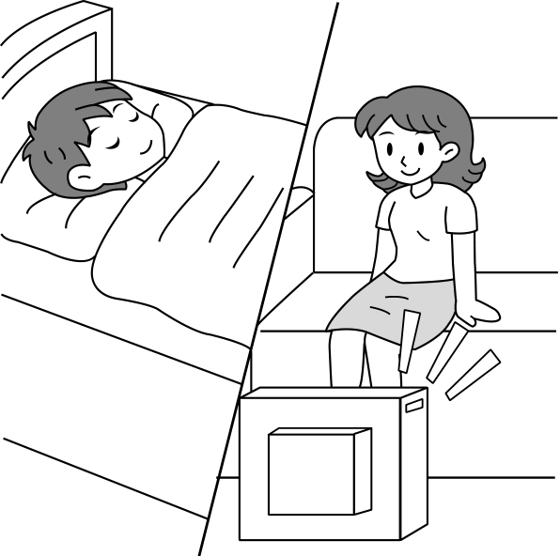

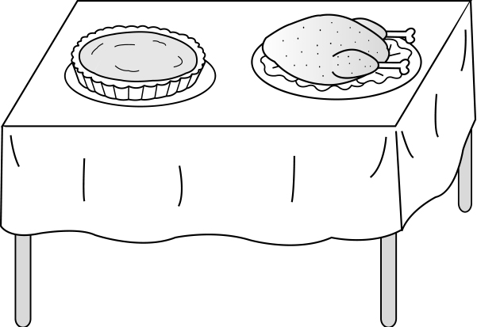
1. 2. 3.



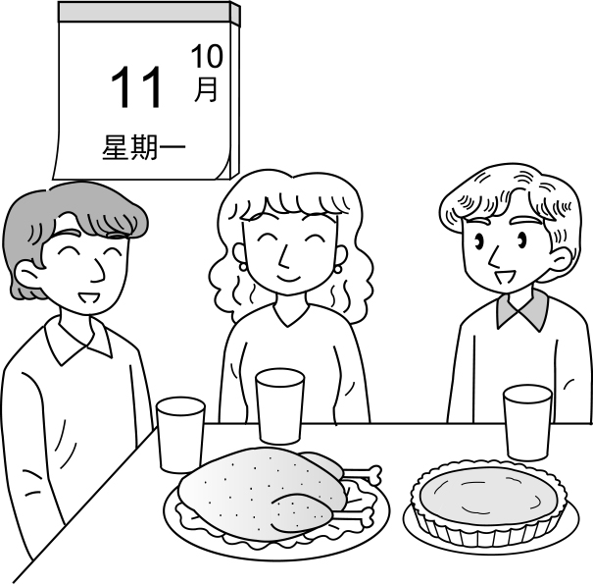
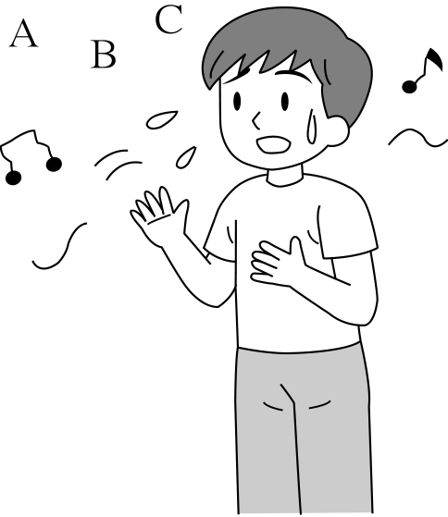
4. 5.

三、簡短對話：每題2分，共10分
根據聽到的對話內容與問題，選出正確的答案。
( ) 1. (Ａ) He wanted to play baseball with her.
(Ｂ) He wanted to look up new words with her.
(Ｃ) He needed her help with his English homework.
( ) 2. (Ａ) She wanted to read comic books with him.
(Ｂ) She wanted her comic books back.
(Ｃ) Tom asked her to call the boy.
( ) 3. (Ａ) No, it’s difficult for her.
(Ｂ) Yes, it is easy for her to sing English songs.
(Ｃ) Yes, it is difficult for her.
( ) 4. (Ａ) Creating a blog is easy for the girl.
(Ｂ) Creating a blog is difficult for the girl.
(Ｃ) Creating a blog is difficult for the boy.
( ) 5. (Ａ) He walks to school.
(Ｂ) He goes to school by MRT.
(Ｃ) He rides his bike to school.
Part II. 筆試 （70%）
- 文意字彙：(10％)
1.Dad is reading the m ne in the living room now.
2.Ms. Wang: Excuse me. Where is the teacher’s office? Mark: F w me, please.
3.Jane wants to share some i n with us. So please listen.
4.They had a party to c e Angel’s birthday.
5.People g ered at the hotel and waited for the coming of the movie star.
6.In Taiwan, a school year has two s rs .
7. O r 10 is our National Day. We don’t have to go to school that day.
8.This is my e-mail address. You can send me m es.
9.Thanksgiving dinner is a t n in North America. People want to give thanks.
10.Congratulations！(恭喜) You c ed your own company (公司)last week.

- 根據文意填入正確的介系詞：in, at, on, x (5％)
Mr. Adams usually gets up around 6：30. Then he goes to his office by MRT and begins to work 8：30. He works hard all day and goes back home around six the evening. But today he didn’t go home after work. He did some shopping because he wanted to buy presents for his wife. Also, he planned to take his wife to a concert Saturday evening. He even planned to take his wife to Alishan July. He wants to give his wife a surprise this weekend.

- 文法選擇：(10％)
( )1.Many young students enjoy ________ on-line games their free time.
(A) to play ；in (B) played ；on (C) playing ；in (D) playing ；for
( )2. is one thing, and is another thing.
(A)Say ；to do (B)Says ；doing (C) Saying ；to do (D) To say ；to do
( )3.Amy TV at 9：30 this morning.
(A)watches (B)was watching (C) watched (D) watch
( )4. Many of the students ________ to join the English club because English is their favorite subject.
(A) want (B) has (C) enjoy (D) keep
( )5. Peter liked to play baseball and ________ to the music the radio .
(A) listening ；on (B) listen ；on (C) listening ；in (D) listened ；in
( )6.Everyone likes Charlie because he always good jokes.
- tells (B) says (C) speaks (D) talks
( )7. very difficult Nora up early every morning.
- That’s ；for；to get (B) That’s ；for； getting (C) It’s ；for；to get (D) It’s ；to；to get
( )8.Playing computer games and surfing the Internet , but we shouldn’t spend too much time
on them. (A) has very fun (B) have much fun (C) are very fun (D) are much fun
( )9. Dick: Who will you send these cards ________? Mia: My aunt and uncle.
(A) by (B) to (C) with (D) 
( )10. The weather ________ March to April is nice, not too cold and not too hot.
(A) in (B) at (C) on (D) from
四、對話選擇：(20％)
( )1. Mrs. Wu: Sorry, I don’t have any coffee. But I can give you a cup of tea. Jean:
(A)That’s fine with me. (B)Not really. (C)Not at all. (D)That’s a lot of food.
( )2. Alice: We often book the tickets to the movies on the Internet.
Rose: ________ Can you teach me how to book them?
(A) What did you book the tickets for? (B) How convenient! (C) Where do you want to do? (D) Why not?
( )3. Ted: ________ Wendy: It’s July 21.
(A) When is your birthday ? (B) What month is it? (C) What date is today? (D) What day is today?
( )4. Lora: Tomorrow is my birthday. I was just thinking about inviting you. ________
Amy: You are so kind. Thank you a lot. I will be there.
(A) Please don’t come here anymore (B) Can I join you? (C) See you later. (D) Please do come to my birthday party.
( )5. Sue: Do you enjoy reading these English novels?
Nana: They’re too difficult for me.
Sue: ________ They’re quite simple. You can try to read them. In fact（事實上）,they are interesting.
(A) Sure! (B) Not really! (C) Not yet! (D) No problem.
( )6. Ella: Are you sleeping by yourself at night?
Sam: Yes, I am. That’s why I always sleep with my parents.
(A) good at (B) bad at (C) afraid of (D) tired of
( )7.Bill: Please wait for a while . I’ll be back in ten minutes. Benson: Take your time（慢慢來）.
(A) I’ll stay here and wait for you. (B) Let’s go to that restaurant now. (C) Hold on, please. (D) How can I get there?
( )8.Andy:How was your trip to America? Tina:
(A) It’s great. (B) Have a good time . (C) Of course. (D) It was fantastic.
( )9.Tom:Can I join the school soccer team? Mrs. Lin: Maybe later.
(A) Of course not, you can. (B) Not yet. You should practice more. (C) You have to buy a gift for me. (D) What a mess!
( )10.Kathy:Why is your teacher angry with you? Tean: Because I
(A) planned to be a good student. (B) didn’t go to school late.
(C) didn’t remember to do homework. (D) get up early every morning.

  - 閱讀測驗：(10％)
Jerry： | Wow! Your room is so nice. I just moved into mine. It’s empty(空的). I love your furniture(家俱).
Kathy： | Thanks, I bought most of it all at IPEA. I just finished putting it together now!
Jerry： | Oh! I never shop there. Everything is DIY.
Kathy： | DIY?
Jerry： | Yeah, Do-It-Yourself. I don’t like to do anything by myself.
Kathy： | Really? It’s fun. My friend Shelly bought a nice computer desk at IPEA. She put it together herself.  She is already for classes on Monday.She is very excited about them.
Jerry： | She should be proud of herself. You too! So what furniture here did you put together yourself?
Kathy： | The bed, the desk, the chair, and the small table. Have a seat, please.
Jerry： | Thanks. Wow! Oops... I think I broke your chair. I am so sorry.
( ) 1. | Where are Jerry and Kathy?  （A）In a student’s dormitory（宿舍） room.（B）In a coffee shop.（C）At the IDEA store.（D）At Jerry’s house.
( ) 2. | What month do you think it probably （可能）is?  （A）November（B）March（C）July（D）September
( ) 3. | What does Jerry like to do by himself?  （A）Anything.（B）Nothing.（C）Everything.（D）Something.
( ) 4. | What did Kathy do by herself?  （A）She made the cookies. （B）She put together a nice computer desk.  （C）She put together the bed, the chair, the desk and the table. （D）She put together all the furniture.
( ) 5. | Do you think Kathy did a good job when she put together the furniture?  - Yes, it looks nice. （B）Yes, she should be proud. （C）Maybe not. The chair broke the first time someone tried  to sit down. （D）No, she didn’t really put it together. Shelly did.
六、翻譯：(15％；每題5分)
1. 他每天都在字典裡查閱一些生字並一直(keeps..)在日記裡使用它們。
2. 在我兒子四歲生日那天，我買了一隻八磅的火雞來煮並且邀請好朋友們來吃。（請用過去式）
3. 同時，Nora的爸爸正在為大家的杯子斟滿飲料，而Nora的媽媽在切火雞。

高雄縣立林園高級中學 國中部 99學年度 第一學期 二 年級 英語 科 第二次段考答案卷
範圍：英語第三冊 (Lesson 4 ~ Review II ) 班級： 姓名： 座號：
Part I：聽力測驗 (30%)
一、字彙選擇：每題2分，共10分
1. D | 2. B | 3. D | 4.A | 5. D
二、圖文配合：每題2分，共10分
1. C | 2. B | 3. A | 4. C | 5. B
三、簡短對話：每題2分，共10分
1. C | 2. B | 3. A | 4. B | 5. C

Part Ⅱ：筆試 (70%)
- 文意字彙：（10﹪）每題1分，共10分
1. magazine | 2. Follow | 3. information | 4. celebrate | 5. gathered
6. semesters | 7.October | 8. messages | 9. tradition | 10. created
- 根據文意填入正確的介系詞：（5﹪）每題1分，共5分
1. at | 2. in | 3. on | 4. in | 5. ×
三、文法 ：（10﹪）每題1分，共10分---學生作答卷的配分寫錯，請記得更改，謝謝！
1. C | 2. D | 3.B | 4.A | 5. B
6. A | 7. C | 8.D | 9.B | 10. D
- 對話選擇 ：（20﹪）每題2分，共20分
1. A | 2. B | 3.C | 4.D | 5. B
6. C | 7. A | 8.D | 9.B | 10. C
- 閱讀測驗：（10﹪）每題2分，共10分
1. A | 2. D | 3. B | 4. C | 5.C
- 翻譯：（15﹪）每題5分，共15分 ※※ 請依配分標準進行扣分，全對才給1分，勿用扣0.5分的方式。
1.He looks up some new wordsin a /the dictionary and keeps using them in a / the / his diary every day.
1分 1分 1分 1分 1分
2.On my son’s fourth birthday, I bought an eight-pound turkey to cook and invited （my）good friends to eat.（請用過去式）
1分 1分 1分 1分 1分
3. At the same time, Nora’s dad was / is filling up everyone’s glass with drinks, and Nora’s mom was / is cutting the turkey.
1分 1分 1分 1分 1分

