高雄縣立林園高級中學 國中部 99學年度 第二學期 一 年級 英語 科 第一次段考考卷
範圍：L1~Review1 班級： 姓名： 座號：

【第一部分 聽力測驗 30％】
一、選出句子中聽到的單字 (每題2分，共10分)
( ) 1. | (A) this | (B) fifty | (C) cent | (D) fifteen
( ) 2. | (A) we | (B) eye | (C) pants | (D) glasses
( ) 3 | (A) when | (B) are | (C) go | (D) jog
( ) 4 | (A) are | (B) have | (C) read | (D) early
( ) 5. | (A) mother | (B) goes | (C) this | (D) Wednesday

二、聽CD的兩個敘述，勾選出符合圖片的句子 (每題2分，共10分)
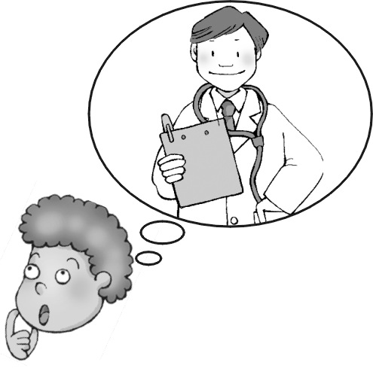  1. | 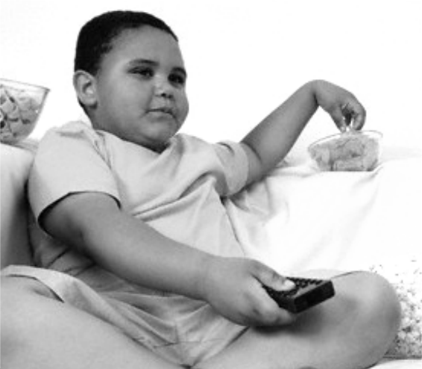  2. | 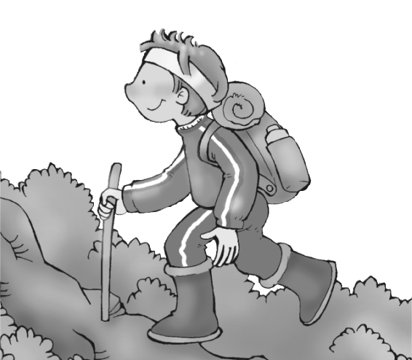  3. | 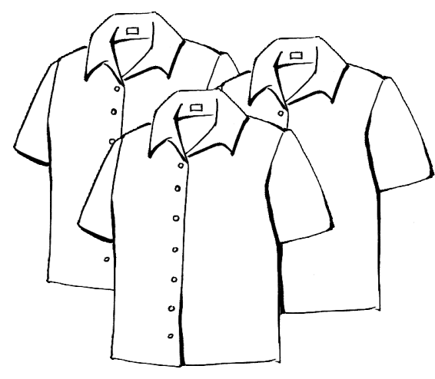  4. | 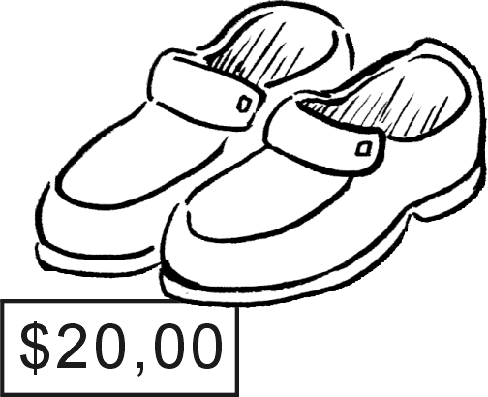  5.
A ( ) B ( ) | A ( ) B ( ) | A ( ) B ( ) | A ( ) B ( ) | A ( ) B ( )
三、聽CD的問題，選出最適當的回應 (每題2分，共10分)
( )1. | (A) No, she doesn’t. | (B) Yes, I do.
 | (C) I don’t eat breakfast today. | (D) I like bread, too.
( )2. | (A) He is at home. | (B) No, she isn’t.
 | (C) Yes, we live in Taipei. | (D) I like Taipei very much.
( )3 | (A) No, I walk to school. | (B) Yes, he only drives my sister to school.
 | (C) No, but he gets up late, too. | (D) Yes, he drives to work.
( )4 | (A) She doesn’t want to be a baker. | (B) A tennis player.
 | (C) She doesn’t want to have her own bakery. | (D) A department store.
( )5. | (A) They are $14. | (B) No, it’s 14 dollars.
 | (C) Yes, it’s $14 | (D) It’s $14.30.
.
.
.

【第二部分 紙筆測驗 70％】
一、書寫體辨識：將下列人名以印刷體寫出，大小寫須一致，全對才給分。 (每題1分，共5分)
1.  2.Michael 3. Emily 4.Thomas 5.Catherine
二、文意字彙 (每題1分，共10分)
1. You can look up (查閱) new words in the d y.
2. I get 100 on the English test. It is very s e.
3. All students have to wear u s in the junior high school.
4. That movie is really i g. You should go to watch with us.
5. Mom likes to go shopping in the d t s e.
6. My g s are broken(破掉). I can’t see you clearly(清楚地).
7. I don’t want to cook today. How about eating out in a r t?
8. It is very d s to swim in the river.
9. The reporter is i g President Barack Obama.
10. Jenny is my c n. She comes from the USA.
請翻頁繼續作答
三、文法選擇 (每題1分，共10分)
( ) 1. | Jenny goes swimming on Sunday morning, and Sandy , too.
 | (A) do | (B) does | (C) is | (D) goes
( ) 2. | We don’t have time dinner tonight.
 | (A) to | (B) on | (C) for | (D) with
( ) 3. | Mike is writing, and Joe and John , too.
 | (A) do | (B) are | (C) can | (D)does
( ) 4. | A: Who shopping with you on Sundays?  B: My sister, Lisa.
 | (A) goes | (B) going | (C) is going | (D) are going
( ) 5. | A: does your father read the newspaper?  B: After work.
 | (A) What | (B) When | (C) What day | (D) What time
( ) 6. | Emily has breakfast _________ next to her books.
 | (A) one day | (B) everyday | (C) every day | (D) every days
( ) 7. | your homework and you can play the computer games.
 | (A) Do | (B) Does | (C) Doing | (D) To do
( ) 8. | How much the bread? NT$ 100.
 | (A) is | (B) do | (C) are | (D) does
( ) 9. | I need socks inside my shoes.
 | (A) wear | (B) wears | (C) wearing | (C) to wear
( ) 10. | How much your sweater (毛衣) cost? NT$ 600.
 | (A) is | (B) do | (C) does | (D) doing

四、對話測驗 (每題2分，共10分)
( ) 1. | A: Do you go swimming on weekends? B: ________________________.
 | (A) Of course, I go. | (B) Of course, I do.
 | (C) Of course, I can. | (D) Of course, I am.
( ) 2. | A: ________________________. B: Yes, there are.
 | (A) Do you have any milk? | (B) Does she have any eggs?
 | (C) Is there any milk on your table? | (D) Are there any eggs on your table?
( ) 3. | A: What do you do? B: ________________________.
 | (A) I am a teacher. | (B) I am Lisa’s brother.
 | (C) What do you do? | (D) I am doing my homework.
( ) 4. | A: ________________________. B: I drive to work.
 | (A) How do you work? | (B) How is your work?
 | (C) How do you go to work? | (D) How about your work?
( ) 5. | A: Are you and Tina schoolmates? B: ______________. But we are neighbors.(鄰居)
 | (A) Yes, she is my sister. | (B) No, I don’t know her.
 | (C) Yes, we are from the same school. | (D) No, we are from different schools.

五、克漏字測驗 (每題1分，共4分)
Daisy doesn't have a busy schedule. She doesn't get up early. And she doesn't have to 1.
or wash her face. She just eats breakfast. After breakfast, she stays home with my mother. In the afternoon, my mother takes Daisy to the 2. . She likes to play with her friends there. She also loves to play frisbee with people. In the evening, I have to do homework, but Daisy 3. . She just watches TV. And at 9 o'clock, Daisy goes 4. . Daisy does the same thing every day. How can Daisy have an easy schedule? Well, she is my dog!
schedule 行程

( ) 1. | (A) go jogging |  | (B) wear glasses
 | (C) brush her teeth |  | (D) wash her hands
( ) 2 | (A) park | (B) beach | (C) office | (D) kitchen
( ) 3 | (A) don't | (B) doesn't | (C) doesn't have | (D) don't have to
( ) 4. | (A) to work | (B) to sleep | (C) to the game | (D) to the dentist

六、閱讀測驗 (每題2分，共16分)
(一)
Lin Yuan Junior High School’s Clothes Shop
 | 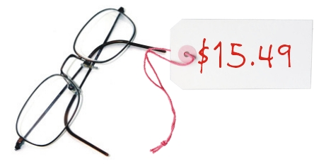 |  | 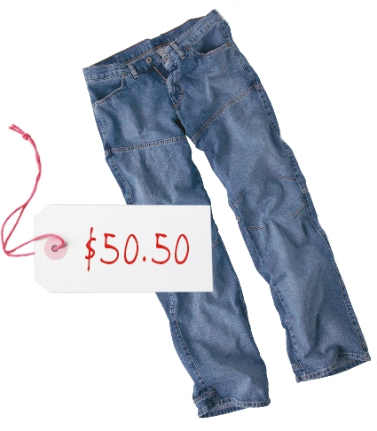 | 
 | 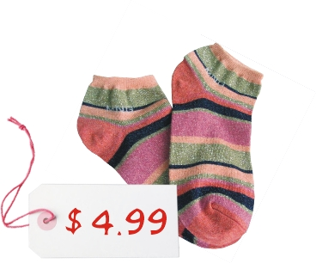 |  | 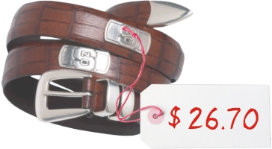 | 
( ) 1. John only has fifty dollars. What can he buy in the shop?
(A) a hat and a tie (B) a skirt and a tie (C) twelve pairs of socks (D) a pair of glasses and a belt
( ) 2. Matt is a player in the basketball team. He wants to buy a new pair of shoes and two T-shirts.
How much does he have to pay?
(A) eighty dollars (B) eighty-five dollars (C) eighty dollars and five cents (D) eighty-four dollars and fifty cents
( ) 3. Miss Wang buys a skirt and a jacket, and she gives $100 to the clerk(店員). How much does the clerk have to give her?
(A) eighty cents (B) ninety dollars (C) nine dollars and eighty-two cents (D) ninety dollars and eighteen cents
(二)
Mandy is an elementary school (小學) student at Lin Yuan. This is her timetable(課表) for a week.
Time & Day | Mon. | Tue. | Wed. | Thu. | Fri.
08:05 ~ 08:50 a.m. | Chinese | Math | English | Art | Chinese
09:05 ~ 09:50 a.m. | English | Music | Chinese | Art | Math
10:05 ~ 10:50 a.m. | Math | English | Computer | Chinese | Class Meeting
11:05 ~ 11:50 a.m. | P.E. | Chinese | P.E. | Math | English
( ) 4. What day doesn’t she have an English class?
Class Meeting 班會
P.E. 體育
Art 美術
(A) Monday (B) Tuesday (C) Wednesday (D) Thursday
( ) 5. What does she do at ten thirty on Wednesdays?
(A) She plays basketball with classmates. (B) She draws her family members(成員).
(C) She does her computer homework. (D) She plays the flute in the music classroom.
( ) 6. Which is true about her timetable?
(A) She has a math class at eight five p.m. on Tuesday. (B) She has a class meeting on Friday morning.
(C) She has to sing songs on Tuesday afternoon. (D) She has two art classes on Tuesday.
請翻頁繼續作答
(三)
Fanny’s father is very friendly and nice. He likes his job very much. He has a job in the hospital and makes a lot of money.
He has to work for a long time and wears a white shirt and pants. His working time is about ten hours a day. He works from Monday morning to Saturday evening. Sometimes he is tired. He is still very happy, because he likes to help people. What does he do in the hospital? Well, his job is to look after people’s teeth. If there are some problems with your teeth, you can go to see him. He is a great person to help you.
hospital醫院 sometimes有時候 look after 照顧 if 如果 because 因為

( ) 7. What does Fanny’s father do?
(A) He is a farmer. (B) He is a nurse. (C) He is a dentist. (D) He is a mailman.
( ) 8. Which is not true about Fanny’s father?
(A) He makes a lot of money. (B) He works for five days a week.
(C) He likes his work so much. (D) His working time is long.

七、依提示作答 (每題2分，共6分)
1. He likes to go fishing in his free time? (造原問句)
2. I get up at 6:30. (造原問句)
3. My father is a bus driver. (造原問句)

八、翻譯 (每題3分，共9分)
1. 他在傍晚運動。他不在早上運動。
2. 我不喜歡穿制服。我想要與眾不同。
3. Ben何時去書店? 我不知道。

高雄縣立林園高級中學 國中部 99學年度 第二學期 一 年級 英語 科 第一次段考答案卷
範圍：L1~Review1 班級： 姓名： 座號：

【第一部分 聽力測驗 30％】
一、選出句子中聽到的單字 (每題2分，共10分)
1. |  | 2. |  | 3. |  | 4. |  | 5.

1. | A ( ) B ( ) | 2. | A ( ) B ( ) | 3. | A ( ) B ( ) | 4. | A ( ) B ( ) | 5. | A ( ) B ( )
二、聽CD的兩個敘述，勾選出符合圖片的句子 (每題2分，共10分)

三、聽CD的問題，選出最適當的回應 (每題2分，共10分)
1. |  | 2. |  | 3. |  | 4. |  | 5.

【第二部分 紙筆測驗 70％】
一、書寫體辨識：將下列人名以印刷體寫出，大小寫須一致，全對才給分。 (每題1分，共5分)
1. |  | 2. |  | 3. |  | 4. |  | 5.

二、文意字彙 (每題1分，共10分)
1. |  | 2. |  | 3. |  | 4. |  | 5.
6. |  | 7. |  | 8. |  | 9. |  | 10.

三、文法選擇 (每題1分，共10分)
1. |  | 2. |  | 3. |  | 4. |  | 5.

四、對話 (每題2分，共10分)
1. |  | 2. |  | 3. |  | 4. |  | 5.
6. |  | 7. |  | 8. |  | 9. |  | 10.

五、克漏字測驗 (每題1分，共4分)
1. |  | 2. |  | 3. |  | 4.

六、閱讀測驗 (每題2分，共16分)
1. |  | 2. |  | 3. |  | 4. |  | 5. |  | 6. |  | 7. |  | 8.

請翻頁繼續作答
七、依提示作答 (每題2分，共6分)
1. __________________________________________________________________________________________________
2. __________________________________________________________________________________________________
3. __________________________________________________________________________________________________

八、翻譯 (每題3分，共9分)
1. __________________________________________________________________________________________________
2. __________________________________________________________________________________________________
3. __________________________________________________________________________________________________

