高雄市立林園高級中學 國中部 99學年度 第二學期 一 年級 英語 科 第二次段考考卷
範圍： Lesson 4~ReviewII 班級： 姓名： 座號：
壹、聽力測驗：30%
一、選出出現在CD句中的單字：（每題２分）
( ) 1. (A) never (B) come (C) seldom (D) early
( ) 2. (A) warm (B) Taiwan (C) cool (D) cold
( ) 3. (A) brother (B) in (C) January (D) thirtieth
( ) 4. (A) door (B) noise (C) blue (D)nose
( ) 5. (A) twice (B) every (C) once (D)times
二、聽CD的二個敘述，勾選出符合圖片的句子：（每題2分）
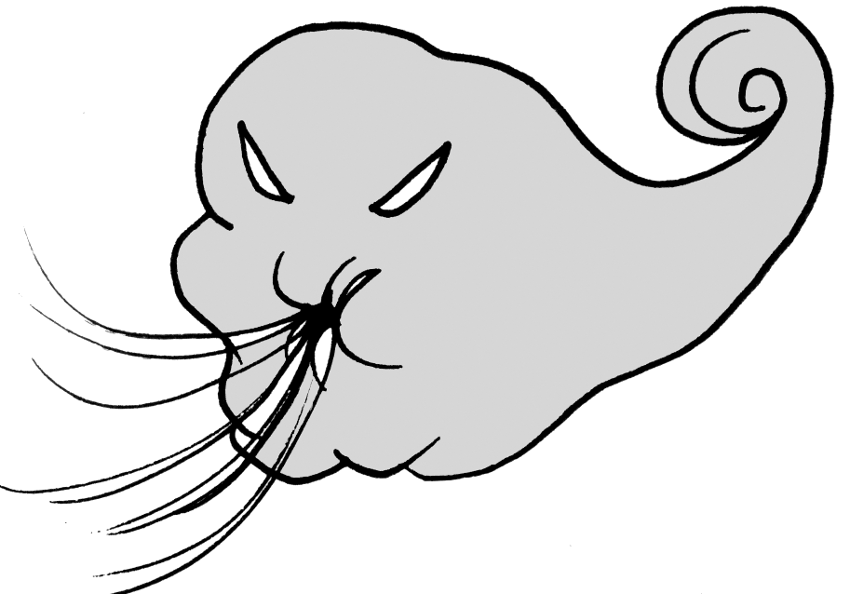
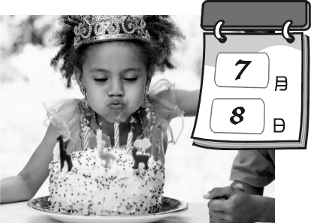

1.. 2. 3.

A ( ) B ( ) A ( ) B ( ) A ( ) B ( )

4. 5.
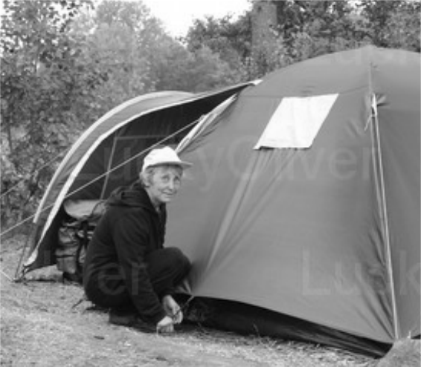

A ( ) B ( ) A ( ) B ( )
三、聽CD的問題，選出最適當的回應：（每題2分）
( ) 1. (A) I’m usually on time. (B) I don’t have enough free time.
(C) I usually go out with my friends. (D) I don’t like to cook at home.
( ) 2. (A) Yes, it’s fall. (B) I like the beach very much.
(C) I like it. It’s warm. (D) It’s fall.
( ) 3. (A) It’s on March 8th. (B) It’s tomorrow evening.
(C) It’s cloudy today. (D) It’s my birthday, too.
( ) 4. (A) I go fishing three times a month. (B) Yes, I often do.
(C) I like to go fishing with my friend. (D) On Sunday.
( ) 5. (A) Yes, please buy some. (B) No, we don’t.
(C) No, thanks. I’m fine. (D) Yes, you don’t have to buy it.

貳：紙筆測驗：70%
一、文意字彙：10%（每題1分）
1. I have a s____ throat(喉嚨) because I have a cold.
2. When you are sad(傷心的) and need a s r to cry on , I will (將) be there.
3. It’s c y outside. Maybe, we will have rain soon.
4. My a r to the math question is right, but yours(你的) is wrong.
5. My father will (將) give me a bike as(當作) a birthday p __t .
6. The shortest (最短的) month of the year is F______y.
7. The Midnight Music Club is my favorite radio p_______m.
8. My parents are not at home. They are on v_______n.
9.Peter always likes to tell a lie(謊言). I don’t b_____e him.
10. In Taiwan, A____t 8th is Father’s Day.
二、填充(填入介係詞)：10%（每題1分）
1. William is going to Taipei the evening of June 5th .
2. What are you waiting ?
3. He likes to go camping his free time.

-1-
4. The party is September 22nd.
5. Don’t watch TV and study ______ the same time.
6. I like to take part _______ outdoor activities on the weekend.
7. My mom is very busy ______ Monday to Friday.
8. They have a lot of work ______ October and November.
9. Sherry has some questions _____ you.
10. This is my first time ______ the radio.
三、文法選擇：20%（每題2分）
( ) 1. Every student in my class good.
(A) are (B) is (C) do (D) does
( ) 2. It never in summer in Taiwan.
(A) snowy (B) snow (C) snows (D) snowing
( ) 3.A：Does your father ever (曾經) go home late? B：Yes, he _________.
(A) usually does (B) usually is (C) does usually (D) is usually
( ) 4.In spring, you can see beautiful flowers.
(A)much (B) a lot (C) lots of (D) any
( ) 5. is it from your house to our school?
(A) How often (B) How much (C) How far (D) How about
( ) 6. I get up late, I am late for school today.
(A) so (B) because (C) but (D) and
( ) 7. Mandy is eleven years old. Tomorrow is birthday.
(A) the twelfth (B) twelve (C) her twelfth (D) her twelve
( ) 8. is Mother’s birthday? Is it this Saturday?
(A) What date (B) What time (C) Why (D) When
( ) 9. We often have snow in winter, the days are usually sunny.
(A) so (B) because (C) but (D) and
( )10. me now and you can get a special prize.
(A) To call (B) Call (C) Calling (D) To calling
四、改錯訂正：10%(選項1分，訂正1分)
( )____________ 1. Because the weather is cold outside, and I have to wear
(A) (B) (C)
my jacket.
( )____________ 2.Jenny: Is Andy usually helpful?
(A)
Mark: Yes, he usually does. He helps a lot.
(B) (C)
( ) ____________ 3. We can’t go outside because the weather is raining now.
(A) (B) (C)
( ) ____________ 4. How is the weather like in Bear Mountain in winter?
(A) (B) (C)
( ) ____________ 5. Ellie is the twenty player on the game show.
(A) (B) (C)
五、閱讀測驗:10%（每題2分）
(I)
I’m Jessie. I am from a beautiful island, Formosa. I want to tell you about the four seasons here in Formosa. The first season is spring. It can often rain in spring. But it is usually warm and sunny. There are many beautiful flowers, like cherry blossoms. Summer is often very hot. It’s a great time to do water sports. It never snows in summer, but it can sometimes rain. Fall is a pleasant season. It is neither hot nor cold. Besides, for many people, it is a great season to eat delicious crabs. Then winter, my favorite season, comes. It is usually cold and sometimes it snows in the mountains such as Mountain Jade. I think it is wonderful to eat a hot pot and take a hot spring with your family or friends in winter.
island 小島 Formosa 福爾摩沙 cherry blossom 櫻花 water sports 水上活動 pleasant 令人愉悅的 neither ….. nor既不… 也不 besides 此外 delicious 美味的 crab 螃蟹 such as 像 Mountain Jade 玉山wonderful 很棒的 hot pot 火鍋 hot spring 溫泉

-2-
( ) 1.. Jessie is .
(A) Japanese (B) Taiwanese
(C) Canadian (D) American
( ) 2.. Jessie likes best.(最)
(A) spring (B) summer
(C) autumn (D) winter
( ) 3.. Which isn’t true?
(A) Spring is a beautiful season.
(B) People can enjoy delicious crabs in autumn.
(C) It’s never snowy in Formosa.
(D) It’s often very hot in summer.
(II)
Judy: You look strong and helathy. How do you keep in shape?
Peter: I exercise every day.
Judy: What kind of exercise do you take?
Peter: Just walking.
Judy: Just walking? How long do you walk a day?
Peter: I walk to school every morning and walk home every afternoon. It takes me about 30 minutes to walk to school.
Judy: Wow! That’s a lot of time. My mother drives me to school every day. I don’t have a chance to exercise.
Peter: Why don’t you walk to school?
Judy: Well. I feel tired after walking. I don’t like to exercise.
Peter: Oh, I see. Don’t be as heavy as a pig.

strong 強壯的 healthy健康的 keep in shape維持身材 kind種類 take花~時間
chance 機會 as……as 像……一樣
( )4. Which is true about this article? article文章
(A) Peter’s mother drives him to school.
(B) Judy becomes strong and healthy. become變成
(C) Judy likes exercise very much.
(D) Peter walks about one hour a day.
( )5. What kind of ball does Peter need when he exercises every day?
(A) Baseball.(B) Nothing. (C) Basketball. (D) Badminton.

六、依提示作答及整句翻譯：10%（每題2分）
1. We have a lot of rain here in fall. ( 用 rain 當 動 詞 改 寫 )

2. I walk to work because I need more exercise. ( 用 so 改 寫 )

3. Ted goes swimming once or twice a week. ( 請根據劃線部份造原問句 )

4.為何你必須告訴我日期呢?

5.我們通常有很棒的天氣，但現在有颱風。

-3-

高雄市立林園高級中學 國中部 99學年度 第二學期 一 年級 英語 科 第二次段考答案卷
範圍： Lesson 4~ReviewII 班級： 姓名： 座號：
壹、聽力測驗：30%
一、選出出現在CD句中的單字：10%（每題２分）
1. | 2. | 3. | 4. | 5.
二、聽CD的二個敘述，勾選出符合圖片的句子：10%（每題2分）
1.  A ( ) B ( ) | 2.  A ( ) B ( ) | 3.  A ( ) B ( ) | 4.  A ( ) B ( ) | 5.  A ( ) B ( )
三、聽CD的問題，選出最適當的回應：10%（每題2分）
1. | 2. | 3. | 4. | 5.
貳：紙筆測驗：70%
一、文意字彙：10%（每題1分）
1. | 2. | 3. | 4. | 5.
6. | 7. | 8. | 9. | 10.
二、填充(填入介係詞)：10%（每題1分）
1. | 2. | 3. | 4. | 5.
6. | 7. | 8. | 9. | 10.
三、文法選擇：20%（每題2分）
1. | 2. | 3. | 4. | 5.
6. | 7. | 8. | 9. | 10.
四、改錯訂正：10%(選項1分，訂正1分)
1.  ( )____________ | 2.  ( )____________ | 3.  ( )____________ | 4.  ( )____________ | 5.  ( )____________
五、閱讀測驗:10%（每題2分）
1. | 2. | 3. | 4. | 5.

六、依提示作答及整句翻譯：10%（每題2分）
1.

2.

3.

4.

5.

高雄市立林園高級中學 國中部 99學年度 第二學期 一 年級 英語 科 第二次段考答案卷
範圍： Lesson 4~ReviewII 班級： 姓名： 座號：
壹、聽力測驗：30%
一、選出出現在CD句中的單字：10%（每題２分）
1.  A | 2.  D | 3.  C | 4.  D | 5.  C
二、聽CD的二個敘述，勾選出符合圖片的句子：10%（每題2分）
1. A (ˇ ) B ( ) | 2. A ( ) B(ˇ ) | 3. A (ˇ ) B( ) | 4. A (ˇ ) B( ) | 5. A (ˇ ) B( )
三、聽CD的問題，選出最適當的回應：10%（每題2分）
1.  C | 2.  D | 3.  A | 4.  A | 5.  B
貳：紙筆測驗：70%
一、文意字彙：10%
1.  sore | 2.  shoulder | 3.  cloudy | 4.  answer | 5.  present
6.  February | 7.  program | 8.  vacation | 9.  believe | 10.  August
二、填充(填入介係詞)：10%
1.  on | 2.  for | 3.  in | 4.  on | 5.  at
6.  in | 7.  from | 8.  in | 9.  for | 10.  on
三、文法選擇：20%
1.  B | 2.  C | 3.  A | 4.  C | 5.  C
6.  A | 7.  C | 8.  D | 9.  C | 10.  B
四、改錯訂正：10%
1.  ( B )__ X_______ | 2.  ( B )__is_______ | 3.  ( B )__it_______ | 4.  ( A )__What___ | 5.  ( B )_twentieth_
五、閱讀測驗:10%
1.  B | 2.  D | 3.  C | 4.  D | 5.  B

六、依提示作答及整句翻譯：10%(分段給分)
1.
It rains / a lot here in fall.
2.
I need more exercise/, so I walk to work.
3.
How often does /Ted go swimming?
4.
Why do you have to/ tell me the date?
5.
We usually have great weather/, but there’s a typhoon now.

