高雄市立林園高級中學 國中部 99學年度 第二學期 一 年級 英語 科 第三次段考考卷
範圍： Lesson7---- Review Ⅲ
班級： 姓名： 座號：
(一) 聽力測驗 30%
一 選出出現在CD句中的單字：（每題2分）
( ) 1. (A) week (B) study (C) bookstore (D) Wednesday
( ) 2. (A) after (B) before (C) was (D) ago
( ) 3. (A) told (B) said (C) spoke (D) wrote
( ) 4. (A) own (B) one (C) look (D) refrigerator
( ) 5. (A) nose (B) buy (C) next (D) last
二、聽CD的二個敘述，勾選出符合圖片的句子：（每題2分）

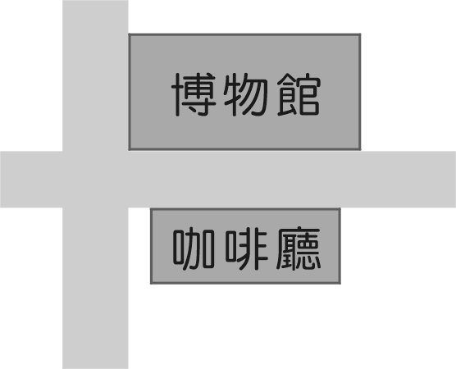
6.

A ( ) B ( )
7.
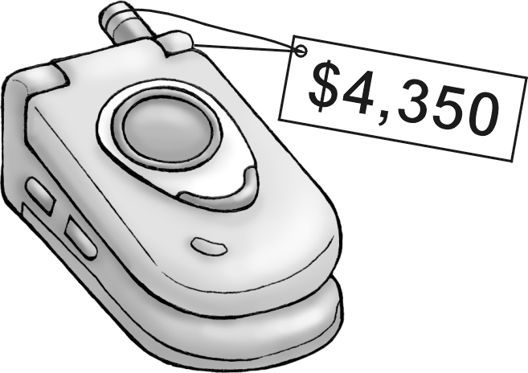

A ( ) B ( )
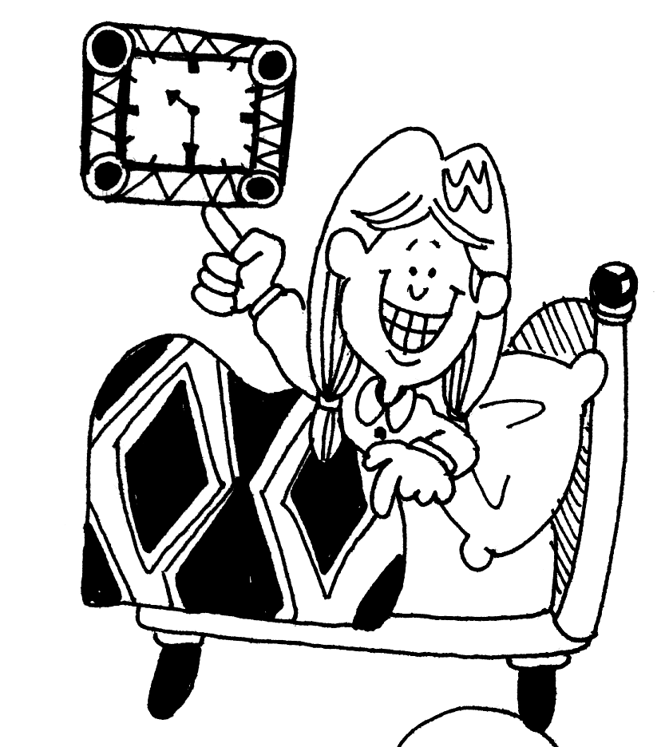
8.

A ( ) B ( )

9.
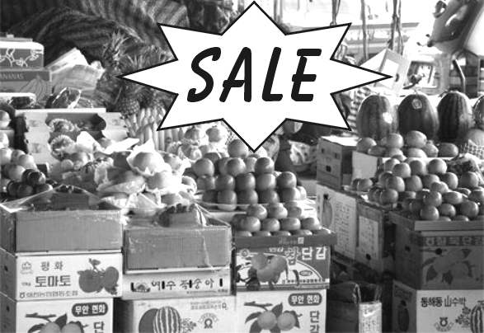

A ( ) B ( )
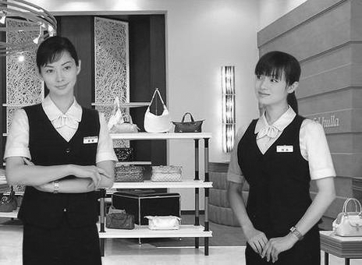
10.

A ( ) B ( )

三、聽CD的短文後，回答下列問題：（每題2分）
( ) 11. (A) Danced. (B) Slept. (C) Talked. (D) Cooked.
( ) 12. (A) The monkeys were dangerous.
(B) They had only a little food.
(C) They didn’t have any bananas.
(D) They didn’t like the monkeys.
( ) 13. (A) At 16:00 (B) At 17:00. (C) At 18:00. (D) At 19:00.
( ) 14. (A) A story about a cook.
(B) A student’s family.
(C) A story about a teacher.
(D) A doctor’s family.
( ) 15. (A) The writer’s parents are teachers.
(B) The writer cooks at home every night.
(C) The writer’s sister is a cook.
(D) The writer doesn’t want to be a cook.
(二) 筆試部份

16題—35題 每題1分 (20%)
(A)
( ) 16.___ cheese is there in the refrigerator? (A) How many (B) How much
( ) 17.___ money is there in your bag? (A) How many (B) How much
( ) 18.___ cups of tea are there on the table? (A) How many (B) How much
( ) 19.___ bread is there in the kitchen? (A) How many (B) How much

( ) 20. (A) is (B) are (C) was (D) wasn’t
(B) Yesterday 20.___ Saturday, so Mrs. Fisher 21.___ at work. She 22.___ at home. Mr. Fisher goes to the library on Saturdays, but he 23.___ at the library yesterday. He 24.___ at home with Mrs. Fisher, but their children 25.___ at home. They 26.___ at their aunt's house.
( ) 21. (A) is (B) are (C) was (D) wasn’t
( ) 22. (A) was (B) wasn’t (C) were (D) weren’t
( ) 23. (A) was (B) wasn’t (C) were (D) weren’t
( ) 24. (A) was (B) wasn’t (C) were (D) weren’t
( ) 25. (A) is (B) are (C) wasn’t (D) weren’t
( ) 26. (A) was (B) wasn’t (C) were (D) weren’t

( ) 27. (A) take (B) taken (C) took (D) played
(C) I 27.__ a trip to the zoo with my family yesterday. We all 28.___ a great time and saw lots of different animals. First, we 29.___ at the reptile house. We saw the turtles and the snakes. Then, we visited the elephants and the zebras and took some pictures there. We also watched the lions at30.___ time. They ate big pieces of raw meat. We wanted to see the koalas, but the koala house wasn't open. Finally, we 31.___ to the gift shop and bought some souvenirs.
( ) 28. (A) played (B) had (C) have (D) saw
( ) 29. (A) stop (B) stoped (C) stopped (D) look
( ) 30. (A) feeding (B) the feed (C) the fed (D) feed
( ) 31. (A) go (B) went (C) goes (D) walk

(D) ( On Sunday morning, Matt and his sister, Kate, are in the kitchen. )
Matt: Let's make an omelet for Mom. That's her favorite breakfast.
Kate: Sure. 32 __eggs do we need?
Matt: We need two or three eggs. And let's put 33.____ potatoes in her eggs.
Kate: But Mom doesn't like potatoes in her eggs.
Matt: Oh, you're right. How about a little ham? There's 34.__ ham in the refrigerator.
Kate: OK. And 35. __ cheese do we need?
Matt: We just need a little cheese. Now let's cook!
( ) 32. (A) How many (B) How about (C) How old (D) How much
( ) 33. (A) any (B) a lot (C) a little (D) a few
( ) 34. (A) some (B) any (C) a few (D) a lot
( ) 35. (A) How many (B) How about (C) How old (D) How much

文法選擇 30%
( ) 36. The poor woman ___ at the door every day after her husband left. But her husband didn’t come back again.
(A) waits (B) is waiting (C) was waiting (D) waited
left 離開
( ) 37. I ___ such a big turtle before.
such 如此地
(A) didn’t see (B) don’t see (C)was see (D) never see
( ) 38. Joe drank ___ because he was thirsty.
(A) two glass of milk (B) two glasses of milk (C) two glasses of milks (D) two milk
( ) 39. We always have lots of ___ in the refrigerator.
(A) fish (B) tomato (C) omelet (D) vegetable
( ) 40. Because they worked all morning and ___ very tired , they __
(A) are ; stop to rest (B) are : stop resting (C) were : stoped to rest (D) were ;stopped to rest
( ) 41. There are ___people in the library at lunchtime. It’s so quiet.
(A) much (B) little (C) a lot (D) few
( ) 42.There are ___books in the library.
( A) thirty thousand (B) five thousands of (C) thousands of the (D) five thousands
( ) 43 Paul ___exercise in the park when he was young.
(A) often does (B) seldom did (C) is always doing (D) was
( ) 44. A: How often do you go shopping?
. B: ___ times a month.
(A) A few (B) Much (C) Any (D) A little
( ) 45.選出正確的句子
(A) Peter wanted to be a engineer last year.
(B) Who were with you at home last night? My cousins and my granpa were.
(C) $1254: One thousand two hundreds and fifty- four dollars
(D) How many cans of cola did Mom buy in the supermarket?
( ) 46. A : Is there any juice in the bottle? B: ___
(A) Yes ,there is some (B) Yes, there is many (C) Yes, there is any (D) No, there is some
( ) 47. A Did Mom buy any bread? B: Yes, she bought ___
(A) a few (B) so few (C) a little (D) many
( ) 48 A : ___ a week do you eat beef?
(A) How many time (B) How much time (C) How many times (D) How
( ) 49. A: How much fruit do you need to put in the cake? B: ___
(A) I need a little. (B) I don’t need many. (C) I need any (D) I need one or two.
( ) 50. Why did you buy so much ice cream? B: ___
(A) Because they were on sale. (B) Because they were for sale (C) Because it was on sale (D) Because it had a big sale

閱讀測驗 20%
(一)
Dear Sally, Friday, April 18
John and I are having a great week in Hawaii. The weather here is great! On Monday, we visited Honolulu. We went shopping in the morning and visited a museum in the afternoon. On Tuesday, we went to the beach. On Wednesday, we took a trip to the mountains. On Thursday, we went to a party at a club at night. Today, John went to the beach, but I stayed at the hotel.
See you next weekend.
Lisa
Hawaii 夏威夷 Honolulu 檀香山

( ) 51. When did Lisa go to the beach?
(A) On Friday.
(B) On Tuesday and Friday.
(C) On April 15.
(D) On April 16.

( ) 52. What day did John and Lisa take a trip to the mountains?
(A) Monday.
(B) Wednesday.
(C) Tuesday
(D) Thursday.

(二)
Tommy was five.He didn’t like to sleep.He always asked for things when he was in bed. And this often made his busy mom angry.
One evening, when Tommy was in bed at half past seven, his mother was busy in the kitchen, he shouted, “ Mommy,
I want a glass of water!”
His mother brought him one,and then she went down to the kitchen again. A quarter of an hour later, he again shouted down
to his mother and asked for another glass of water, but his mother was angry now and shouted back,” You don’t really want any more water, Tommy. Be quiet or I’ll come upstairs and smack you.”
Tommy didn’t say anything more for a few minutes, but then he shouted again,” Mommy, when you come up and smack me, please bring me a glass of water.”
shouted 大叫brought 帶來 another 另一 upstairs 樓上 smack 賞個巴掌
( ) 53. What time did Tommy ask for
another glass of water?
(A) At 7:30 (B) At 7:15 (C) At 7:40 (D) At 7:45
( ) 54. Where was Tommy’s mom that night?
(A) In the living room (B) In the bathroom (C) In the kitchen (D) In her room
( ) 55. How many glasses of water did Tommy need that evening?
(A) A glass of waters (B) Two glasses of waters (C) Two glasses of water (D) Three glasses of water
( ) 56. Did Tommy’s mother smack him at last?
(A) Yes, she did. (B) Yes, she was. (C) No, she wasn’t. (D) We don’t know.
( ) 57 Did Tommy’s mom believe Tommy really needed water?
(A) Yes, she did. (B) No, she didn’t. (C) Yes, she was. (D) No, she wasn’t.

(三) Sally’s birthday was this week. Ted was having a really hard time deciding what to give, because he also wanted to
ask her to marry him.
Sally never ate candy.And last time he already gave her a new dress. Finally, he decided on perfume.But, what kind
of perfume? He couldn’t ask her, because this wouldn’t make a surprise.
At last Ted came up with an idea. He went to Sally’s house and asked her to let him take her dog for a walk. But, in fact
they went to the town’s biggest department store. There was lots of perfume there! He asked the clerk to open a lot of bottles
and wave them under the dog’s nose. Suddendly, the dog barked excitedly when the clerk waved one bottle under its nose. “I
want to take this one,” said Ted.
“My favorite perfume!” said Sally when she unwrapped the gift.”How did you know?” she asked.”Intuition I guess,”
answered Ted. Ted might tell
came up with 想到 clerk 店員 wave 揮動 decide 決定 perfume 香水
surprise 驚喜 biggest 最大的 bark 狗吠 intuition 直覺 truth 事實
Sally the truth some day.

( ) 58. What does the word “unwrap” mean?
(A) To open (B) To touch (C) To guess (D) To buy
( ) 59. How did Ted find the perfume?
(A) The clerk helped him choose. (B) He guessed right.
(C) With the help of Sally’s pet. (D) By his intuition.
( ) 60. Which of the following is true?
(A) Sally loves to eat candy. (B) Ted walks Sally’s dog every day.
(C) Sally doesn’t like dresses. (D) Sally wears perfume quite often

一年級 英語 科 答案欄 （年級、科目請標示清楚，謝謝！）
(一) 聽力測驗 30% 每題2 分
1—15題 BDDAD BABAA CCCBD
(二) 筆試部份
16—35 題 BBABC DABAD CCBCA BADAD
36—50題 DABAD DABAD ACCAC
51—60題 CBDCC DBACD

