高雄市立林園高級中學 國中部 99學年度 第二學期 二 年級 英語科 第三次段考考卷
範圍：L7-L9 班級： 姓名： 座號：
聽力測驗
一、看圖回答：每題2分，共10分
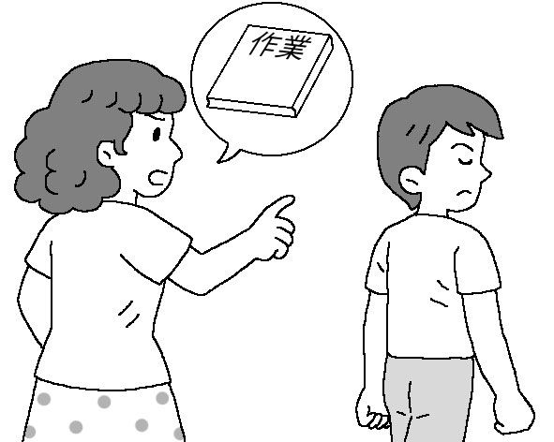
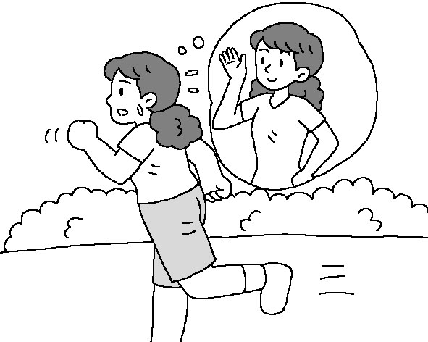
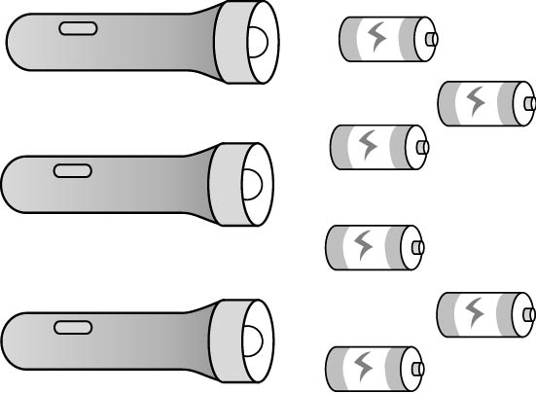
1. 2. 3.


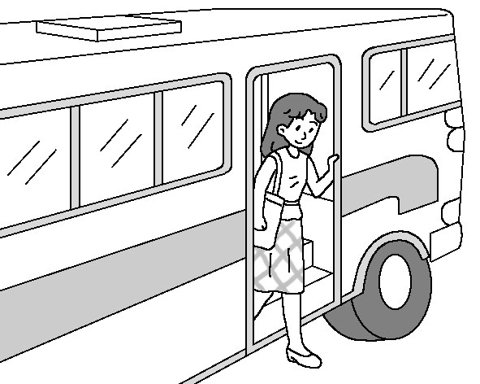
4. 5.
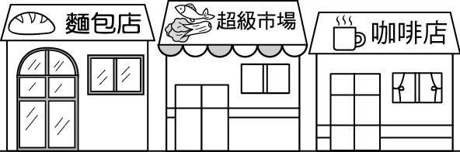

二、對話選擇：每題2分，共10分
 根據聽到的內容，選出合適的回應。
( ) 6. (Ａ) You got the wrong map.
(Ｂ) It’s the world’s biggest train station.
(Ｃ) You can take Bus 101. It’s the best way to get there.
( ) 7. (Ａ) Oh, no. I’m tired of playing baseball.
(Ｂ) No way. It’s far away from here.
(Ｃ) I have to stand in line for a long time.
( ) 8. (Ａ) Yes. We need to store more food.
(Ｂ) No, don’t take any chances.
(Ｃ) Sure. What kinds of instant noodles do you want?
( ) 9. (Ａ) He felt tired.
(Ｂ) He likes his job very much.
(Ｃ) He will go to a movie after work.
( ) 10. (Ａ) It’s safer to take a bus.
(Ｂ) We need to store some clean water just in case.
(Ｃ) It’s important to avoid car accidents.
三、簡短對話：每題2分，共10分
根據聽到的對話內容與問題，選出正確的答案。
( ) 11. (Ａ) The man is looking for the MRT station.
(Ｂ) The man and the woman are going together by MRT.
(Ｃ) The MRT station is too for to walk to.
( ) 12. (Ａ) Yes, he will go with her right now.
(Ｂ) No, he’s too tired to do anything.
(Ｃ) No. He just wants to move a finger.
( ) 13. (Ａ) They’re asking the directions.
(Ｂ) They’re talking about the movie tonight.
(Ｃ) They’re talking about how to lose weight.
( ) 14. (Ａ) It’s interesting to go there by bus.
(Ｂ) It’s so far that the man doesn’t want to walk there.
(Ｃ) It’s good exercise for the man to walk everywhere.
( ) 15. (Ａ) They’re in the zoo.
(Ｂ) They’re in the restaurant.
(Ｃ) They’re in the library.
紙筆測驗
一. 字彙選擇：
16. There is a river between the two cities. And there is a ________ on it.
(A) road (B) street (C) bridge (D) station
17. Don’t play on the ________ because there are many cars running around.
(A) station (B) map (C) block (D) road
18. We have another name for Taiwan－Formosa. Its meaning（意義）is “A beautiful ________.”
(A) island (B) people (C) picture (D) countryside
19. When we take a trip for more than three days, we should bring an extra ________ for our cellphone just in case.
(A) battery (B) flashlight (C) phone (D) candle
20. The earthquake（地震）________ the house to fall（倒下）.
(A) happened (B) caused (C) fought (D) excused
21. Sue got hurt and a few ________ because she fell off her bike.
(A) scratches (B) bushes (C) brushes (D) benches
二. 文法選擇：
22. The jacket is so small that Shelly can’t ________.
(A) wear (B) wear it (C) wearing it (D) wearing
23. The bag is too heavy ________.
(A) for me to carry (B) I can’t carry it (C) that I can’t carry (D) for me to carry it
24. Ken: Can I walk to Central Hospital? Joy: I don’t think so. ________
(A) It’s too far to walk there. (B) You are too tired to do it. (C) It’s not so far that you can’t walk there.
(D) It’s far enough for you to walk there.
25.We won’t have the Sports Day if it ________ tomorrow.
(A) will rain (B) is going to rain (C) rained (D) rains
26. Edison: Let’s go to the department store.
Coco: But it _________ open until eleven o’clock.
(A) won’t (B) was (C) will (D) didn’t
27. All of you are fifteen years old. You can take good care of ________.
(A) you (B) yourself (C) yourselves (D) themselves
28. ________ of fireflies fly here and there on the farm. It’s so beautiful.
(A) Thousand (B) Thousands (C) A thousand (D) Two thousands
29.Cathy saw the car accident while she ________ the road with her cousin.
(A) is crossing (B) crosses (C) was crossing (D) will cross
30. Why didn’t you stop when you heard someone _________ your name?
(A) to call (B) was calling (C) calling (D) called
31. How are you doing? ________ with you?
(A) Are everything fine (B) Is everything fine (C) Does everything fine (D) Does everything be fine
32. ________ to see them getting along so well with one another.
(A) I have surprise (B) I am surprise (C) It is surprise to me (D) It’s a surprise for me
33.________ Jay ________ on the stage was really a great experience for Jolin.
(A) Watching; sing (B) To watch; to sing (C) Watch; sing (D) Watched; singing
三. 克漏字選擇：
John worked in an office in a small town. One day his boss said to him, “John, will you go to an office in London and see Mr. Green for me? Here’s the address.” John took the first (34) to London the next morning. He left the station, and thought, “The office isn’t far from the station. It’s easy to find.”
After an hour he was still looking for it, so he stopped and asked an old woman for (35) . She said, “Walk two (36) along this street and turn right. You’ll find it on your left.” John went and found it. A few days later, he went to the same city, but (37) he couldn’t find the office, so he asked someone for help. It was the same old woman! She was very surprised and said, “Are you still looking for that place?”
(34) (A) truck (B) plane (C) train (D) boat
(35) (A) directions (B) drawers (C) donuts (D) dolphins
(36) (A) bridges (B) roads (C) courts (D) blocks
(37) (A) luckily (B) again (C) therefore (D) everywhere
Tony: There’s a typhoon coming.
Jeff: When will the typhoon come?
Tony: No one knows. I hope it’s not going to be a serious one.
Jeff: I don’t like the typhoon season.
Tony: I don’t, either. A typhoon usually causes great (38) , and it makes a lot of people homeless（無家可歸）.
Jeff: That’s right. I think we’d better (39) . Look at those clouds. It’s going to rain soon.
Tony: There’s not much wind yet.
Jeff: Don’t take (40) . It’s safer to stay at home.
Tony: Yes, I think so. There’s one thing I like typhoons.
Jeff: What’s that?
Tony: We may get (41) tomorrow and don’t need to go to school.
(38) (A) success (B) news (C) damage (D) convenience
(39) (A) hang out (B) go home (C) keep fishing (D) stay healthy
(40) (A) a rest (B) any chances (C) a break (D) any medicine
(41) (A) a day off (B) hurt (C) off the bus (D) well
At ten o’clock yesterday morning, Henery and his family were on a farm. They saw many animals there. They (42)
some rabbits eating and some pigs sleeping. While the cow (43) , a turkey was walking around by (44) .
When Henery saw the turkey, he (45) at it. The turkey got angry, and it ran after Henery. Henery ran away and fell
on the ground. He hurt (46) . He didn’t have a good time.
(42) (A) see (B) saw (C) sees (D) will see
(43) (A) drank (B) was drinking (C) drink (D) will drink
(44) (A) itself (B) himself (C) herself (D) themselves
(46) (A) itself (B) himself (C) herself (D) themselves
四. 閱讀測驗
It is not just a machine. It is a world. Since iPad came into the world in 2010, the changes it has brought to people
are uncountable. All the work computers do can be finished by iPad. What’s better, iPad doesn’t show the
shortcomings(缺點) other computers have.
First, it is very small and easy to carry. Even more, you can hold it in different directions, and the screen will
change its direction itself. That is to say, people don’t need to worry that they will read iPad from wrong direction when
they are busy. Next, iPad’s finger-touch screen makes people use the screen easily and read more clearly. It is designed (設
計)quite big. Last, iPad is designed with “i-work” inside. It is a special program which can help people catch up with other
business programs.
Because iPad has so many great works, it has a “great” price, too. It is not cheap at all. So, if people really want to
have iPad, they still need to think about that twice.
(47) What might “uncountable” mean in the reading? (A) Few (B) Little (C) Some (D) Many
(48) What might “it” be in the reading? (A) iPad’s price (B) iPad’s screen (C) iPad’s size (D) iPad’s work
(49) What can i-work do for iPad’s users?
(A) Have no directions. (B) Read the screen clearly. (C) Let go of the pen. (D) Catch up with other programs.
(50) What can we know about iPad from the reading?
(A) It is big. (B) It is expensive. (C) It is beautiful. (D)It has a keyboard.

二年級 英語科 答案欄 （年級、科目請標示清楚，謝謝！）
1.(C ) 2.(C ) 3.(C ) 4.(B ) 5.(A ) 6.(C ) 7.(B ) 8.(C ) 9.(A ) 10.(B )
11.(A ) 12.(B ) 13.(C ) 14.(B ) 15.(A ) 16.(C ) 17.(D ) 18.(A ) 19.(A ) 20.(B )
21.(A ) 22.(B ) 23.(A ) 24.(A ) 25.(D ) 26.(A ) 27.(C ) 28.(B ) 29.(C ) 30.(C )
31.(B ) 32.(D ) 33.(A ) 34.(C ) 35.(A ) 36.(D ) 37.(B ) 38.(C ) 39.(B ) 40.(B )
41.(A ) 42.(B ) 43.(B ) 44.(A ) 45.(D ) 46.(B ) 47.(D ) 48.(B ) 49.(D ) 50.(B )

